The Retail Item Class

In Programming Challenge, Chapter 6, Challenge 4

**Problem Domain:**

Determine what the class is: A collection of real world items in the store such as:

Clothing Items to buy. The Retail Item class has to know three things about the Clothing:

* Clothing Description
* Units on Hand
* Clothing Price

**Developing the Classes:**

We must determine what the class is responsible for doing, and what it must know to do it’s intended job. We have already determined the Retail Item Class must know these three things:

* Clothing Description
* Units on Hand
* Clothing Price

These are the three fields we KNOW and they can be Strings to hold their value. Now we can determine the other class’s will need an Object of the RETAILITEM Class to be created so we can DO the things it needs to. We will start by creating a file called RetailItem with the three fields the class must know: Description, Units On Hand, and Price. We have already determined they will be of the String variable type, an integer, and a double. The file name will be called RetailItem.

01/31/2020 9:30 PM I’m having issues with the Clothes.java file. I then tested the RetailItems file and the Jacket item works, then the jeans item works, but the TOTAL is all wrong, it’s not adding the two together.

2/1/20 6:45AM- I might try a WHILE Loop to keep the program running as long as the user selects “Y” for another item.

9:05 AM: That didn’t work as intended. I’m going to try a Do-While post test loop. If the user enters Y for Yes, the loop keeps going. If the user enters N the loop terminates. See pages 204-206. This is known as a “Post Test Loop”. This way it will go through a whole iteration before testing the condition again.

02/03/2020 3:00 PM

After much trial and error I got Clothes and Clothing to work kinda. The totals are wrong though, and if I select the second or third item first it bombs out. I’m going to try a different approach. I created a ClothingDemo file with 3 objects created from Clothing file named Item1,2, & 3. With the fields description, units, and price. Made two files, one called Clothing Demo and Created 3 Clothing Objects in that file and got the 3 items to print out like this:

item1.setDescription("Jeans");

item1.setUnitsOnHand(10);

item1.setPrice(34.99);

For description, units, and price I set them manually then printed to the console.

I created a ClothingObjects file and put the Constructors in there(setters and getters).Now to figure out how to do it dynamically.

2/2/20 7:37 DUH! It was printing to the console from my other statement from ClothingDemo! I removed them,now I’m getting a error at line 49, IF statement.

8:00 PM The clothes file works as is but I have to put UNITS in manually.

Also Total needs work yet.

2/5/20 9:15 AM -I was reading and checking out the Clothes and Clothing file, and realized I could solve my unit problem by doing a pre-test increment, by putting two – signs in front of units, it deducts one from the total! Another DUH moment. As I was doing that I took another look at the Course, Instructor, and CourseDemo file and realized the reason instructors name was not printing was because I needed to make them String Literals by placing quote marks around them and it worked! Proud of myself! Sometimes its good to step away from a problem for awhile then start again fresh. As I was dissecting the CourseDemo and the files associated with it, I got an idea for the RetailItem problem. Maybe make a Class file for each item, then a copy Object for each in the RetailItem file, instead of having them in the file as one, going to have to examine the course, instructor, textbook files closely and see how they all come together in the CourseDemo using Copy Object Constructors.

**Chapter 6 Retail Item Class-Round 2**

I have three retail items: A Jacket, Pair of Jeans, and a Shirt. Each item has three fields:

* Description
* Units on hand
* Price
* Amount Purchased-Maybe use this for the Cash Register file later.

These will be my fields in each file. I think I’ll use a JOption pane with a drop-down menu for the user to select the item they want and a quantity. What to name the files? I want the RetailItem file to be the main one that puts together the selections from the drop-down menu. Guess I’ll start out with 3 classes named Jacket, Jeans, and Shirt. See how that goes.

Trying out the auto generated Constructor, Setters, and Getters in the Item Class file. Works pretty well, except when I println it prints only the Shirt. I did get the unitsOnHand to subtract items when it prints with the “—” in front. Trying to use the JOption Pane to print out the Item Object after user selects it.

Studying Chapter 12 to figure out the Windows I want and how to gather user input to print out the right Item fields.

02/06/20 8:45AM-Checked the files so far to refresh myself. Clothes and Clothing files, and Item and ItemDemo I’m going to keep. Before I start adding GUI’s to Clothes and Clothing, I should copy them to a new file set and mess around with the GUI’s in those.

02/06/20 10:30 AM- Saved the ItemDemo file to ItemDemoWindow to mess with. I examined the KiloConverter file along with the book to get a feel for how everything is built and labeled. I remember a lot of this from my class at CCAC that I took over a year ago or so. It’s nice to refresh the brain! LOL.

Next is the Event Listener which will handle any calculations and such. There is a ton of information in Chapter 12 about GUI’s and how to arrange them, what actions to perform on button clicks, drop down lists, etc… It’s going to take awhile to digest all this and figure out what I want the layout of RetailItem to look like, and what I want it to do!

2/8/20 1:30PM-Well I get it figured out. I was having a problem with “static” fields again, but after much time looking over my code I saw the error. Silly me forgot to change the Method call name at the very end to create an instance of the Class. Now to get the prices to show up after the user selects the Retail Items they want. Going to copy the file over to RetailItemComboBoxRev1 and mess with that. If I figure that out, I’m a step closer to the Cash Register Class.

2/8/20 8:10PM-I got the PriceBox working, excepts it’s a dropdown ComboBox. I deleted the RetailItemComboBoxRev1. Couldn’t find the error, I’m sure it was something stupid.

It wanted me to add this  ***serialVersionUID*** = 7156837300857687268L

I wonder if I screw the whole file up I can revert back to this number,,,hmmm,,

2/9/20 9:00AM-I’m thinking I need an event handler to display the price of the item selected. Possible inner class of the actionperformed method?

2/9/20 11:00AM- Trying various code to get it to print price, no luck yet!

// Display the selected Item in the text field.

*selectedItem*.setText(selection);

//I get no errors with this code, but it still doesn't print in price field // }

**if**(selection == "Denim Jeans")

{

// JTextField.selectedPrice = 59.99;

**double** jeansPrice = 59.99;

}

Think I need to write a Method to get the right price based on selectedItem??

What to call it? selectedItemPrice?? Declare a double field?

1:30PM-I tried copying buildSelectedItemPanel and change it to PricePanel,still no go.

Might have to go with the Method.

7:50PM- Pretty crazy, my eyes are going buggy from staring at the screen writing code.

Wrote a Method to try print price based on item selected, got errors of course. I think the problem is where I put the Method in the code. Tomorrow I might try a listListener on page 857. Although, I did get the GUI to show a price text field but the price doesn’t get put in the text box. Guess I’ll mess with it more tomorrow.

2/10/20 10:30 AM- I messed something up, no price field now! DAMNIT! Going to try the IF statements again in line 217.

10:45AM-YES! I got the selected price panel to show up! Silly me didn’t have them in the RetailItemComboBox method correctly. They were // commented out. I deleted the // and WALA! Got it back! I’m still back to having it show in the Price Field though. I’m going to try the ComboBoxListener

Method in line 204.

2/20/201:00PM-Took out line 117 PriceBox = new JComboBox(price) from buildRetailPanel. Added it to buildSelectedItemPanel. Also took out the PriceBox addActionListener and added it to buildSelectedItemPanel.

This doesn’t work: String price = (String)PriceBox.getPrice();

selectedPrice.setPrice(price);

1:35PM-As of right now, I’m back to having the Item selected showing up in the text box but not the price.

Perhaps I should make another ComboBoxListener for the selected price from the dropdown menu see if I can get that to print in the price field. I named the Listener2 and still no go.

So I decided to try a method this way:

**private** String[] getItemPrice()

{

*ItemBox*.setSelectedItem(*item*);

**return** *price*;

}

Trying to capture the Item selected from the dropdown box, no go. Back to square one trying to get the price to show up in the text field, here’s where I’m at 2/10/20 4:00PM. I used the Snip Tool to capture this of the screen:

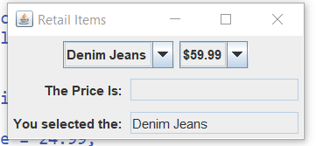

6:10 PM-I think I’ll try the valueChanged method on page 857 or the index (of) method.

7:10PM-Tried to use another ComboListener with an ActionListener, nope.

I was checking out the EventObject file, might have to try that one. It shows a window popping up when a button is clicked with whatever message.

2/11/20-9:00AM-I’m missing something stupid in the Retail Item file. It shouldn’t be so hard to figure out, select an item in the drop down list, and the Price goes in the price field. I’m looking at chapter 10 and reading about Inheritance. There’s a demonstration in the GradedActivity file, which shows a user entering a score, then a numeric grade pops up using the IF, ELSE IF statements like I originally tried. I might go back to this and have a message box asking the user which item they want then another message box with output of user selection and the price.

Some might wonder why I’m doing this at all since I could probably find the whole code on the internet and be done with it. That’s not the point of this exercise. If I learn how to do this myself I’ll know the code inside and out. Once I have the base of Retail Shopping App, I’ll know and understand EXACTLY what it dose. Then I can easily expand upon it, which I intend to do for the helluvit! If there’s an issue during expansion, I should be able to track it down easily and fix it.

11:00AM- HAHA! Well that didn’t work! I got the window to popup with selected item and the price, but when I added a return method to grab the price I got this error:

ClothingChoice.ButtonListener must implement the inherited abstract method ActionListener.actionPerformed(ActionEvent)

Going to have to investigate that. I want to send the button selection to another method to add everything up.DUH! I changed the method header return type to void, works good now.

2/11/20 7:35PM- I almost got it. Messing with the ItemDemoWindow file, it’s not printing the fields.

I created 3 instances of the Clothing Item, one for each, still not printing the info. I found an interesting file on StackOverflow that uses buttons for a calculator and prints them out in a textbox, might have to digest that tomorrow, as well as go over Chapter 10 where it talks about inheritance.

2/12/20 8:36AM-Going through my files I created so far, they need cleaned up and delete all the comments in them so I can better see where I’m at and focus on one file. I was checking out the ItemDemoWindow. And it’s just not working like I want. Trying to get print outs dynamically based on which item come back from the user selection, For example:

System.out.println(**null**, "You selected the ITEM " + *description* + "for" + *cost* + "and we have" + *unitsOnHand*);

I have the 3 clothing objects created in the file with data in each field, but it doesn’t pick it up on Console or JOption. Only getting null and zero’s. Then I realized I have 3 method headers, one Class Name, one Constructor, and a Main. Maybe that’s my problem, separate out the main?

So I took another look at the ItemDemo file, and it prints the Shirt item to the console no matter what you which Item you type in.

2/12/20 1:PM- I decided to keep the ClothingChoice file for the Retail Item Project. It works really well for now, except if you start with the first Item(Jeans) the Total Sale is zero. I can fix that though, but if you jump around and start with another Item it screws up, oh well! I’m going to rename all the old files as “Old” filename. On to reading the Inheritance chapter.

The most important concept of Inheritance:

Inheritance involves a superclass and a subclass. The superclass is the general class and the subclass is the specialized class. You can think of the subclass as an extended version of the superclass. The subclass inherits fields and methods from the superclass without any of them having to be rewritten. Furthermore, new fields and methods may be added to the subclass, and that is what makes it a specialized version of the superclass.

2/13/20 8:30AM- Reading up on SuperClasses and SubClasses gives me ideas for the RetailItem class. I could break it up into several classes. One Super to collect the Items from a Subclass, and total up the number of items, total with tax, etc…. I could even go so far as having an Inventory Class to keep track of what items were sold and how many, a size class to capture the size of the Item, and so on..but I’m getting ahead of myself, slow down!

2/13/20 1:PM- YAY! Got myself a sandbox to play in! I should actually make another folder called Sandbox and put the files there. Now that I have two identical files that work exactly the same (NewRetailItem & ClothingChoice), I’m going to try a SuperCass ClothingChoice and a subclass ClothingOrdered file to see if I can capture how many button items the user clicked on and what Items were ordered using a JPanel off course.

2/14/20 3:30PM- WOW!! After much trial and error and frustration, I sort of have the ClothingOrdered file going:

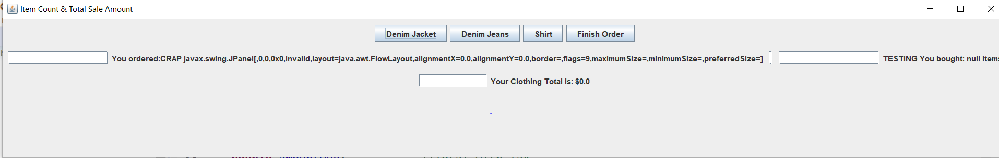

Looks ugly yet, I need to get the Sub Total from ClothingChoice in one box, then add the SalesTax, and final Total or Amount Due.

02/15/20 7:00AM-I need to find that file that had the text that the user selects from a drop down list entered into a text field. Also read up on advanced GUI applications in Chapter 13. The Bagel House APP is kinda what I’m shooting for. In the ClothingChoice file, the EXIT button works pretty good to get the subtotal from the items selected in the drop-down. The idea is to expand on that and have a text field or another screen that shows the items selected and the price with a subtotal, plus tax, etc,,

7:15AM - I found it! ComboBoxDemo. Going to study this for awhile. I decided to start another Retail file and as I’m studying, start a new file from scratch since I kinda know how it works. I’ll use the KiloConverter file to start with since it has basic components. I’ll put a bunch of notes in along the way.

11:00AM-Created MyRetailPanel File and added basic components to it. Looks pretty good so far. Going to put an Event Object & Event Source, & Event Listener and reference the JButton. Create a method to respond when button is clicked known as Event Firing. Writing an Inner Class and class definition (Method) as a Private Class. Then register an Event Listener to perform an action for the button.

4:15PM- DAMIT!! I fucked it all up playing around, going to have to start over with the RetailItemComboBoxRev1 file. There’s some good information about action listener’s and actions performed on page 783. Also changing background and fore ground colors on page 784.

8:20PM- FUCK! I did it again! Screwed with the REV1 File so much, I hosed it up! Oh well back to the drawing board! I found the OldRetailItemComboBox file thank GOD it works! It even has a price field! LOL. But it’s blank of course when I use the drop down box. I did learn a lot though of what NOT to do!

Two files I based this test on: EventObject2 and ComboBoxWindow files. I can always get those back though from the download.

Actually I like the file NewRetailItem, the window is good size,it has the 3 buttons on it, the price and total pop up in another window as you select them work good.

The ColorCheckBoxWindow file is a keeper also, it has multiple check box listeners.

Check out the EventObject2 file also. It shows how to have 3 buttons with different events.

More playing in the SandBox tomorrow!

2/16/20 7:10AM- I’m going to try another idea. In the OldRetailItemComboBox file when a user selects an Item from the drop-down menu, it’s placed in a JText field box. There is another drop down box to place a price in a text field, but it doesn’t work. In the NewRetailItem file, there is 3 boxes with the items, when a user selects one item another window pops up with the item name and price, but there is no JTextField to place the selected item text in with the price. My goal is to figure out how to take pieces of each so the item selected shows up in a text box which would be the OldRetailItemComboBox file, then modify the file to incorporate parts of the NewRetailItem, specifically the JText Boxes.

NewRetailItemTextField is my base file today. KEEP THIS FILE!

8:30AM-Tried adding the JTextField to the content pane, no go. Going to try and add them to their individual panels.

I have an idea, what if I took itemSelected and selectedPrice and put them in their own panel?

Going to try to cut and paste the items into their own methods.

☹11:10AM-Tried everything I could think of,, NOTHING! I’m missing something stupid!

1:30PM- I copied the OldRetailItemComboBox file to NewRetailItemComboBox. At least I have two Combo Boxes and two Text Fields with the proper text. Now to get the PriceBox to put the price in it’s text field. Done!

2:40PM-SelectedRetailItemPrice is new with the 3 item boxes. I’m copying NewRetailItemComboBox to NewRetailItemPriceBox.

😊 YEAH!! IT WORKED! The Price from the Drop Down box goes into selectedItemField, I’m getting there!

YES!!! It works! Now to clean up this file and figure out how to add them together.

3:45-Cleaned up both files they still work perfectly. Copied them into the Sandbox folder to be safe.

2/16/20 7:30PM-I’m going to paste some code here in case I need it later: 😉

private void buildShowPricePanel(String selection)

{

if(selection.ItemBox == "Denim Jeans”) //2/9/20 7:20PM- Selection and Denim Jeans are Strings, so they are compatible.

{ //

// JTextField.selectedPrice = 59.99; //2/10/20 4:20 Changed the IF method to

double jeansPrice = 59.99;

System.out.println("$" + jeansPrice);

}

if(selection == "Jacket ")

{

double jacketPrice = 34.99;

System.out.println("$" + jacketPrice);

}

// }

if (selection == "Shirt ")

{

double shirtPrice = 24.99;

System.out.println("$" + shirtPrice);

}

2/17/207:30AM- I’m not sure how I want to approach the merge of the two files yet. I should probably make a third file that gets the number of items selected and the subtotal, then multiply it by the tax rate. I’ll study the Brandi’s Bagels app and get ideas.

9:AM-I was right, you make different components for the eventlisteners such as menu items, buttons, and lists. Then pull them all together into one JFrame (container). There is probably a way to have more than one eventlistener in one file, but that’s a bit more advanced for me yet. After reading Chapter 12 and examining the Bagel Ordering app I have a few ideas to get closer to finishing mine. First I want to try a component that will total everything up, add the tax, and the quantity of items. That would wrap up the Cash Register Class exercise. HAHA! Maybe that’s what I’ll call the next file. 😊 Eventually I want a size component also to print out, and the inventory to add up what item and size were bought and how many of each are left. Once I have that all figured out I can link up with a Database in SQL to grab fields from there. That would be awesome!

9:36AM- I just realized I’m going to need a quantity Field. Multiply Quantity by price. But to do that I’m going to need to get the Item Field to link up with the Item Price Field. This may require an array to set the position of Item ordered to a number in the Array that corresponds to a Number in the position of the Item. If user selects an Item in position 1, the Price in position 1 will be set to it…hmmmm. Wow! I’m going to have to make a call to the methods in the other files.

11:AM-Created RetailItemCashRegister file, added the fields I think I’ll need:

**private** NewRetailItemComboBox selectedItem;

**private** NewRetailItemPriceBox selectedItemPrice;

**private** JPanel fieldPanel;

**private** JButton subTotalButton;

**private** JTextField total;

**private** JTextField addTotalTax; /

**private** **int** totalRetailItemsBought;

Will probably add to this later as I develop the Cash Register file.

2/17/20 8:PM-Well FUCK! After much trial and error, I got a little tiny window from the CASHREGISTER file. Also when I run the COMBOBOX file. I get the same small window because I have a main method that calls the CASHREGISTER file. OK well, after I took the CASHREGISTER file out of main on COMBOBOX file and also the add(cashRegister) statement it’s fine. They both are working again thank God I didn’t hose them both up! They make it sound so easy when you’re reading a book but not so easy when you try it on your own. I’m still liking the NEWRETAILITEMTEXTFIELD file with the three JButtons. Oh well tomorrow’s another day.

2/18/20 9:00AM- Starting over this morning. After more studying the Bagel app, I think the NEWRETAILITEMTEXTFIELD file is cleaner and probably be easier to work with.

I tried adding the selectedItemPanel method to the NEWRETAIL file, no go, I’m very close though! I had better copy the file to another one so I’ll have a backup cause I know I’ll screw it up 😉!

10:30AM-Oh wow! I just discovered the GridPanelWindow file, it’s perfect for what I want to do. It has 6 buttons across it, and my file has 3. I can change the other buttons to suit my needs hopefully. It has six JButtons numbered 1-6, Six labels saying “This is cell 1,2,..etc, Create the 6 Panels numbered 1-6, Add the Labels 1-6, add the Buttons to the Panels numbered 1-6, then add the Panels 1-6 to the content pane. Sound easy enough, but I’ll have to add the Button Listeners with an Action Event. I copied the file over and named it RETAILGRIDPANELWINDOW. Guess I’ll be playing around with this file for days! 😊

DAYUM! I’m switching back to NEWRETAILITEMTEXTFIELD!

2/19/20 7AM-Trying again! To get a text field into the RETAILITEMTEXTFIED file, from the RETAILITEMCOMBOBOX. I got the selectedItem JText field to show up on the panel, but it doesn’t fill it in yet. Using the panel(add)selectedItem; statement. I can’t add the whole panel it errors out.

9:30 Got the selectedPrice JText field to show up also. Tried to change button1 price to string, but if I do that, it errors out on totalSale.

10:44-HAHA! I set Button1 to setText in the EventListener, now its like giving me the title and the file name NewRetailItemTextField as the button label. Hmmmm,, so it’s getting the title of the file.

12:30PM-WooHoo! Managed to get labels on the panel for the JTextFields! Still never got the text field to fill in. Going to save all the Retail Item files to Backup folder and start over with Brandi’s Bagel House demo files.

3:15PM-Well copied the BagelPanel file to RetailClothing. Here we go again! 😉

2/20/20 8:30AM- I need to study EventObjects and ActionListeners. Well this is really weird, I copied the NewRetailItemTextField over to a new file RetailItemTestField and it’s giving me errors. WTF!

10:37-selectedItem JTextField MUST be in the Container or it fails, also it can be eliminated from the build panel and still work. ALSO I discovered when you save as same file name into the Backups directory it shows an error, it must be copied back into working directory Chapter12/src.

ALSO watch for an import statement at beginning of file.

BUT if you change package (line 1) to source directory “package” it’s fine.

JButton Examples:

package javatutorial.net;

import java.awt.FlowLayout;

import javax.swing.JFrame;

import javax.swing.JTextField;

public class Example {

static JTextField textfield1, textfield2, textfield3;

public static void main(String[] args) {

JFrame f = new JFrame("Text Field Examples");

f.getContentPane().setLayout(new FlowLayout());

textfield1 = new JTextField("Text field 1",10);

textfield2 = new JTextField("Text field 2",10);

textfield3 = new JTextField("Text field 3",10);

f.getContentPane().add(textfield1);

f.getContentPane().add(textfield2);

f.getContentPane().add(textfield3);

f.pack();

f.setVisible(true);

}

}

JButton Examples:

import java.awt.*;

import java.awt.event.*;

import javax.swing.*;

/**

 * This simple Swing program demonstrates how to use Lambda expressions in

 * action listener.

 *

 * @author www.codejava.net

 */

public class ListenerLambdaExample extends JFrame {

    private JButton button = new JButton("Click Me!");

    public ListenerLambdaExample() {

        super("Listener Lambda Example");

        getContentPane().setLayout(new FlowLayout());

        getContentPane().add(button);

        button.addActionListener(new ActionListener() {

            public void actionPerformed(ActionEvent evt) {

                System.out.println("Handled by anonymous class listener");

            }

        });

        button.addActionListener(e -> System.out.println("Handled by Lambda listener"));

        button.addActionListener(e -> {

            System.out.println("Handled Lambda listener");

            System.out.println("Have fun!");

        });

        setDefaultCloseOperation(JFrame.EXIT_ON_CLOSE);

        setSize(300, 100);

        setLocationRelativeTo(null);

    }

    public static void main(String[] args) {

        SwingUtilities.invokeLater(new Runnable() {

            public void run() {

                new ListenerLambdaExample().setVisible(true);

            }

        });

    }

}

And Another:

import java.awt.event.ActionEvent;

import java.awt.event.ActionListener;

import javax.swing.JButton;

import javax.swing.JFrame;

import javax.swing.JLabel;

import javax.swing.JOptionPane;

import javax.swing.JPanel;

public class myTest {

public static void main(String[] args) {

final JFrame frame = new JFrame();

JPanel panel = new JPanel();

JButton button1 = new JButton();

final JLabel label = new JLabel("Hello World");

label.setVisible(false);

frame.add(panel);

panel.add(button1);

panel.add(label);

frame.setVisible(true);

button1.addActionListener(new ActionListener() {

public void actionPerformed(ActionEvent arg0) {

//JOptionPane.showMessageDialog(frame.getComponent(0), "Hello World");

label.setVisible(true);

}

});

}

}

2/20/20-1:30PM-WOW! Learned something new today! All I had to do is set it as a TextField not JTextField!

Excellent! There are so many properties available for Java elements you can set, impossible to know them all but I did know it was just something stupid like that. Within a half hour of searching on the internet for the right code, BOOM! It worked instantly! YAY! Now to add a “Submit” button, or something like that to add it to a list and clear the text and price area to add another item. I’m thinking of building a Get Items and Get Price panel. Then add then to a list of items. Then add the prices and descriptions of items selected and display on a Place Order Panel, or something like that 😊 !

3:00PM-Everything is working fine, each button selected puts the Button Text and Price in the appropriate boxes. I’m going to save this to the Backup folder, then see if I can add the itemCount field on the panel to view total items selected.

HAHA! I must be on the right path, I tried commenting them out of the container just to see and got errors.

Trying this for integer conversion to text for JTextField:

price.addActionListener((ActionEvent e) -> {

String inputText = price.getText();

// do the conversion and other processing here...

});

public class BoxListener implements ActionListener {

public void actionPerformed(ActionEvent event) {

String s= price.getText();

if(s.matches("[0-9]+")) //Perform validation before parsing string

inputPrice = Integer.parseInt(s);

}

}

Or This:

public static void main(String args[])

  {

    int i1 = 10;

    String str = String.valueOf(i1);

    System.out.println("int i1 in string form is " + str);

  }

I added these code snippets to test the itemNumber Text Field tomorrow. The field and label are already on the JFrame. Yes I found them on the Internet, hopefully they can turn the item count number into text to put in the JField.

2/21/20 6:00AM- I added a selectedItem.getText() statement to capture the button clicked, I guess I could also add a getPrice statement, and save them with each button click to add up totals of both for a printed receipt. I wonder if I can stick a printToFile statement in there? Yeah I gotta check that out today.

9:24AM-Well I got the Prices of the buttons and the item description using the getText() method. Easy enough now to save it and get the number of items.

4:30PM-Deleted my old files and going to clean up the RetailItemJava file (TYPO on file rename) and then break it up into different files to make it easier hopefully do it right this time! I’m going to keep the RETAILITEM file as it is in case I really screw up the other one.

7:00PM-I decided I need more studying to broaden my Java skills, I never did finish the Inheritance chapter, so I’ll be doing that for awhile.

2/22/20 9:00AM-After going through the Inheritance chapter today, I’m going to attempt the concepts with the RetailItem file again.

6:00PM- Playing around with sticking a Text Field on the panel again, Damn! LOL :

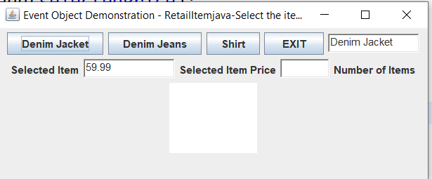

HAHA! Fucked up my whole layout! Oh well easy enough to fix.

2/24/20 11:AM- Trying to get the selected item into a list, close but no cigar!

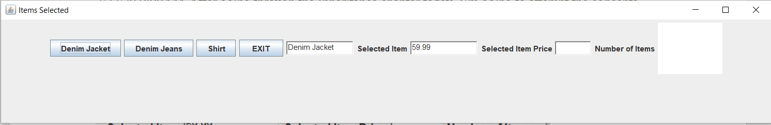

Needs work obviously! 😊 It errors out when I try and put the selected Item into the JText Area.

2/25/20 9:15AM- Well after several attempts to get the button selections saved, I’m going to try a different route. After reading through the Multiple Interval Selection Mode for a JList and using the getSelectedValues method and the getSelectedIndex method, I could hopefully capture the user selected items that way, then have them display in a text box or text field. So I’ll take the MultipleIntervalSelection file and modify it for my retail Items. Hopefully I can adapt the methods learned to my retail file. I had already thought of using this method and the indexOf to get the item position then return it. Hopefully I can link the selected item up with the price of the item to display in a field. Interestingly, you can add items to an empty JList, this technique is shown on page 863. Perhaps I will try that eventually for the hell of it. I’ll save the MultipleInterval file to RetailItemSelection and start with that.

9:00PM-I got the RetailItem file going, and it works good after I added STATIC in the header of the MAIN file.. Tomorrow I’m going to figure out how to get the prices for the items selected in a pane. Should be fun and frustrating! 😊

2/26/20-9:00AM Starting a new file-RetailPriceList. I’m not sure how I’m going to do this yet, make it a subclass of RetailItemSelection I guess. Or just make a stand alone price panel and call it in the retail panel,,,,hmmmm..

A good code to try and know on JList.

***Creating, Adding and Deleting Elements from a JList***

JLists may be initialized with a set of strings using the constructor

public JList(Object[] listData)

for example, you can supply an array of Strings:

String[] ar = {"one", "two", "three"};

JList list = new JList(ar);

However, JList has no method to add or delete items once it is initialized.  Instead, if you need to do this, you must use the ListModel class with a JList.  Think of the ListModel as the object which holds the items and the JList as the displayer.

1. Declare an instance of *DefaultListModel*:

DefaultListModel listModel;

2. Create it:

listModel = new DefaultListModel();

3. Populate it (now or later):

listModel.addElement(“item 1”);

listModel.addElement(“item 2”);

etc.

4. Use the *DefaultListModel* in the constructor of a *JList* (instead of a *String* array):

JList list = new JList(listModel);

5. Now to add additional elements at any time during execution, use *addElement()* again:

listModel.addElement(“new item”);

and it will show up in the JList. (You can also use *add(int index)* where you specify the 0-based position of the element to be added.)

6. To delete an item, just call

listModel.remove(n);

where n is the 0-based index of the item to remove.  It will disappear.

7. To delete all the items, call

listModel.clear();

***Other Notes:***

To highlight (i.e. select) an item in a *JList* use

list.setSelectedItem(n);

To return the currently selected *String* in a *JList*, use

s = (String) list.getSelectedValue();

(This method is defined to return *Object* because *JList* actually can contain object types other than *Strings* (for example, small images know as *Icons*.  Therefore you must typecast the returned value.)

More interesting text methods to try:

**public** **class** **TextAreaGetContent** **extends** **JPanel** {

**public** **TextAreaGetContent**() {

initializeUI();

}

**private** **void** **initializeUI**() {

**this**.setLayout(**new** BorderLayout());

**this**.setPreferredSize(**new** Dimension(500, 200));

**final** JTextArea textArea = **new** JTextArea();

*// Set the contents of the JTextArea.*

String text = "The quick brown fox jumps over the lazy dog.";

textArea.setText(text);

textArea.setLineWrap(**true**);

textArea.setWrapStyleWord(**true**);

JScrollPane pane = **new** JScrollPane(textArea);

pane.setPreferredSize(**new** Dimension(500, 200));

pane.setVerticalScrollBarPolicy(

JScrollPane.VERTICAL_SCROLLBAR_ALWAYS);

JButton button = **new** JButton("Get Contents");

button.addActionListener(**new** ActionListener() {

**public** **void** **actionPerformed**(ActionEvent e) {

*// Get the contents of the JTextArea component.*

String contents = textArea.getText();

System.out.println("contents = " + contents);

}

});

**this**.add(pane, BorderLayout.CENTER);

**this**.add(button, BorderLayout.SOUTH);

}

**public** **static** **void** **showFrame**() {

JPanel panel = **new** TextAreaGetContent();

panel.setOpaque(**true**);

JFrame frame = **new** JFrame("JTextArea Demo");

frame.setDefaultCloseOperation(WindowConstants.EXIT_ON_CLOSE);

frame.setContentPane(panel);

frame.pack();

frame.setVisible(**true**);

}

**public** **static** **void** **main**(String[] args) {

SwingUtilities.invokeLater(**new** Runnable() {

**public** **void** **run**() {

TextAreaGetContent.showFrame();

}

});

}

}

The code above works perfectly! Definitely a keeper!

2/27/20 7:00AM- Well I got the RetailItemSelection file back to where it’s working as intended! LOL After all that playing around yesterday. Here’s a quick screenshot:

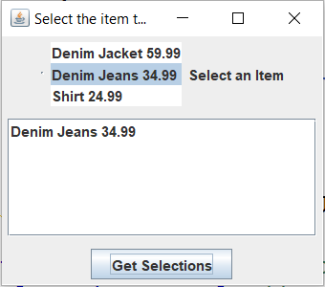

Not quite what I want but I’m learning what NOT to do! HAHA! Now back to a Cash Register file to figure out total with tax. What I need to do is figure out how to save the selectedItemList and send it to the Cash Register file, or have the file Update the list as user selects items,,,,hmmm…I need to get the selectedItemList from here and update the subtotal, add tax,,,etc,,trying it again. I still like the Item Button Selection file, Still I need to figure out how to update the data in the Cash Register.

9:00AM Before I do the Cash Register, I’m going to need a size selector to, maybe add another window? Oh Shit! I just realized it’s not going to work the way it’s set up now. I have the Item Selected and the Price in one field so I’ld have to use a char at method to extract those from the string, for example: "Denim Jacket 59.99". Screw that, I need to break them up again. Looks like I’m back to adding a price field in the ItemSelected, sounds like I need another JPanel!

11:00 AM DAMNIT! Took another look at the NewCashRegister file and tried a few things, still not adding the selected item price, I’m so close!

3:15PM-Time to get organized again! Get rid of the junk files and only keep these:

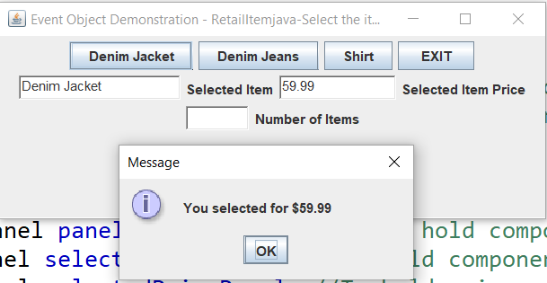

This is RetailItemJava file. I like this one but still trying to get the final steps of having a CashRegister file to collect the price and items. As it stands now is what you see.

Here is RetailItemText file, looks the same:

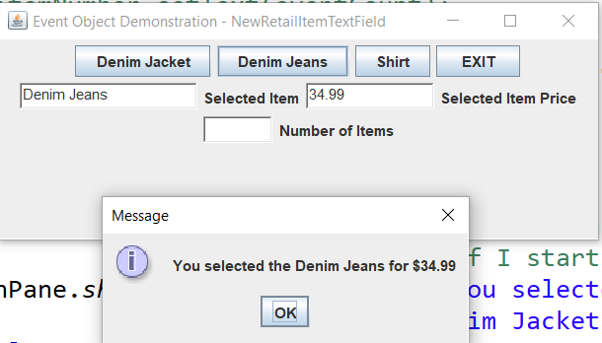

I deleted RetailItemSelection file, it wasn’t working at all I’m not even going to mess with it.

I can’t even get RetailClothing to work, I’m trying Radio Buttons with it, not sure if I want to play with it anymore. The NewCashRegister file is garbage too! Don’t feel like messing with that one either, DELETE!

4:00PM-After reviewing the code in both the RetailItemTextField file and the RetailItemJava file. I discovered the major flaws in each. All the code is in the Constructor, DUH! I have the two panels commented out. I need to separate this shit! I have a RetailPriceList file also with errors, going to take a look at it.

5:30-Well I looked at the ClothingSize file again. It seems to be ok, no errors at least. Until I try and add it to the main panel of course.

7:30PM- Well that went as expected..LMAO errors everywhere! Nullpointerexception blah blah..

I added the ClothingSize panel in the Content Pane of RetailItemJava. I added this statement into the Content Pane: size = **new** ClothingSize(); and panel.add(size); in the Constructor, nothing but errors on the line 32 of the ClothingSize constructor and the 61 line in the RetailItemJava file when I create an instance of the ClothingSize. There’s definitely something going on in the Clothing file. So Close!!! Oh well tomorrow’s another day.

Exception in thread "main" java.lang.IllegalArgumentException: adding a window to a container. Found this interesting error also.

2/28/20 8:45AM-Going to try and figure out the error, adding a window to a container. I suspect it has something to do with the layout and where I’m trying to place things.

10:30AM-HAHA! I removed all references to ClothingSize in RetailItemJava, and now it comes up with just a content pane, nothing else,,LOL HAHA! I added a pack() statement in the content pane, and now it comes up as a very small window…LMAO!

10:45-Well ain’t this some shit! Now it won’t run at all saying main can’t be static in header. GRRR! I’ve ran into this before and forgot what I did to fix it. ☹

If I remove “static” from main, it runs the RetailItemTextFile…HAHA! Putting it back.

1:00PM- I looked over the file and didn’t see anything that would cause the content pane to show up empty, so screw it! I’m going to delete the file and copy one from backup that works. OOPS!

I’m such a dumbass! I looked at the file in Eclipse’s Project Explorer and saw the red x that points out where the problem is and walla! It’s good! I then removed the FlowLayout method and it screwed it up so,,,back to the beginning again! That’s why they call it learning I guess. So I’m going all radical here again. In the OrderCalculatorGUI file, there is a Calculator Button section of code. I’m going to copy it over to the ClothingSize file and see if I can get anything to print out, then I’ll be able to see where a problem is hopefully,,,haha!

I added the panel but I got the error again “adding a window to a container”. I think this means I can’t add two files together, I need to make a single file with just a Frame and content pane maybe? Hell if all else fails I’ll just Google the error,, 😊

3:10PM I checked the error file Eclipse shows and found this:

Appends the specified component to the end of this container.

* This is a convenience method for {@link #addImpl}.

* <p>

* This method changes layout-related information, and therefore,

* invalidates the component hierarchy.

So looks like I was right, I should probably stick these files into a pretty much blank console pane?

4:00PM- OMG!! I am so close! I did not set any kind of input to even select a size,,so it didn’t do anything! DUH! So I added a JOptionpane input, it works fine but It kept telling me to set Size to ‘Dimension’ no. it’s a string, I managed to get the user to select a size, but the return of size selected is fucked up:

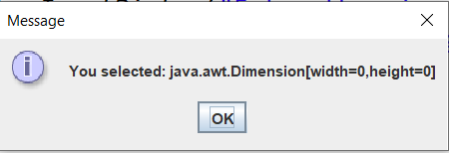

It still doesn’t want to confirm selection, I can’t see where Dimension is coming from. Also String returns love the null; return first LOL.

8:00PM-Finally! After playing around with the input/getSize/setSize to get the user selected size to print,I’m getting an M no matter which one I select,,,weird, Can’t find the stray M anywhere HAHA! Such fun! OMG! I found it! I had the default selection set to medium “M”. HAHA! Now I’m just getting the infamous NULL.

It has to be something wrong with my input statement,,,,at least I’m getting something!

2/29/20 9:00AM- Well here we go again! It wants me to change bg (ButtonGroup) to Component, but then it throws errors. DAMIT! Here we go again, I did everything the error told me to, and declared the variables as Small = (“”) etc.. It says the method name is not correct setClothingSize, getClothingSize, I’m returning the size (S,M,L) to the window asking the user to select one.

3:00PM- I tried everything, nothings working. Don’t know what I’m going to do now,,,step away for a bit. I may just scrap both files and start over ☹ .

3:30PM-I decided to check out the RetailClothing file more closely since it won’t even start, it just terminates with nothing, no errors, no window, probably another stupid thing I’m missing.

I changed RetailItemTextField to KeepRetailItem, so I know not to delete it, and I’ll save it as after I fuck it up again..HAHA! I’m starting over with the TextField one and try again!

7:30PM-GRRRRR I am so frustrated! I tried everything I could think of to get the size input but the damn file would not start! I was about to give up for the night, then I decided to go for it and I put extends NewRetailItemTextField in the header of the ClothingSize file and I got this:

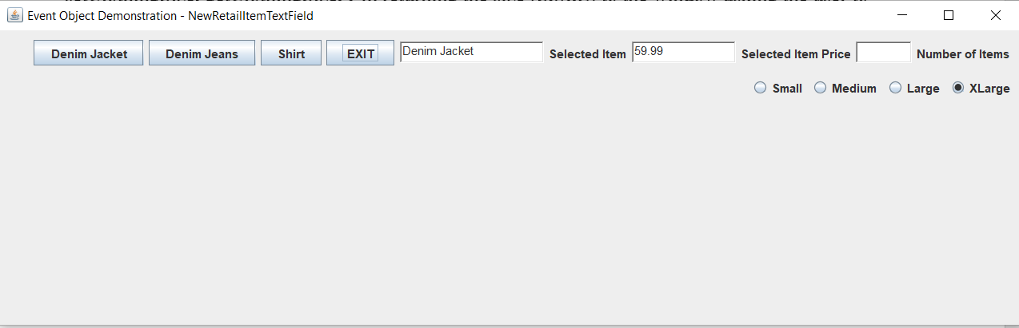

Yeah Me! I should immediately save both of these into the Backup Folder before I fuck them up 😊. HAHA! I gotta mess with the layout of course, and make sure my size Radio Buttons are returning the right Size. I’m so excited and proud of myself! Just a few minutes ago I was ready to give up!

Reminder to self, while putting a JOption Pane in RetailItem asking to select a size, it said make it “static” Then all my method setSize screwed up. I tried getting the size to print in both files, I only get the default “M”. I’m done for the night.

3/1/20 8:30AM- Another day! Had to check out the files and see where I left of. Probably should work on the selected size portion since I’m only getting a “null” reference. Hopefully that goes well, then I’ll create the JPanel that does all the Subtotal,Tax, and Final amount due. Once I get that going, I’ll try and print it out to a text file like a receipt. That’s the end goal anyways, not too concerned with the layout at this point until I get all the PJanels working together.

DAMIT! I just realized something, I have clothingSize declared as a JPanel, not a String, and silly me didn’t put it in the Constructor! So I created a JPanel ClothingSize and added it into the constructor. Now my Size RadioButtons show up right under the JButtons,,,Cool!One of my goals today is to get a Title above the size buttons.

10:30AM-Damit! So close again, I had to make size Static and getClothingSize static. OMG I’m such a dumbass! I need a JButton Listerner on those size Buttons DUH! I created a size field in RetailItem and changed the getClothingSize method in ClothingSize to return size, and set the Statement asking for it to ClothingSize.get ClothingSize, still get null.

12:45-DAYUM! Changed the field to static, tried GET and Set,size, put file name in front, nothing! GRRRR. I tossed a constructor getClothingSize and return size in RetailItem and get all kind of errors, accessControl, and it called out a ButtonListener.ActionPerformed error in the file on the line the statement is on. Well I narrowed it down a bit, the first size statement in ClothingSize is returning “null” first then the RetailItem file is returning the dimension error, wonder if I should change the name of “size” to something else,,hmmm,,,,

2:30PM- I’m going to go all in here and try a JRadio Button Listener in the NewRetailItem file.

I tried changing the “size” field to clothingSize to get rid of the dimension shit first. I did accomplish to get a JLabel for the radio buttons,,LOL! It looks decent to on the panel. I saved the files to my backup folder first cause I’m sure I’ll screw this up 😉 .

7:00PM- I just realized something, In this layout:

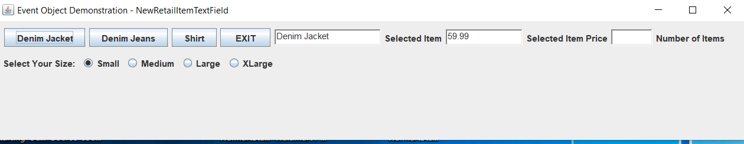

Ideally I want the Text Boxes to be below the buttons like the size ones, not on the side. That means I would have to make a labels pane just for them and put that below the buttons, or mess with the Layout methods. I’m not going to fool with that until after I make the ButtonListener for the RadioButtons. I’m sure there’s an easier way of doing it but that’s all I can think of for now. I just happen to have an example in Chapter 12 Page 814. I seriously need to clean up the RetailItemTextField file after studying the MetricConverter file.

8:00PM-WOW! I’m getting there! The correct size is printing out in the ClothingSize file statement. The RetailItem file has a few kinks to work out yet returning the correct info in JOptionPane but that should be easy to fix. Once I get that ironed out, I should be able to print out a toString method for the whole sale. Well I’ve had enough for today, got a lot accomplished I think, proud of myself 😊 .

3/2/20 9:00AM-Had to take a look at the program so far again. Not sure where to start today, but the subtotal multiplied by the tax, then added together for a total amount due. I should write the pseudo code something like this:

totalSale multiplied by taxRate = totalAmountDue. I already have the totalSale figured out. I’m going to attempt another JPanel with the buttons to total everything, and possibly a TextField listing the Description of the Item, (already have that in a TextField) along with each Items Price, (already have that also in a TextField), add theTax, and TotalSale. This will be challenging; I better save them in the Backup Folder first.

9:30AM-Made a new Class called RetailItemTotal with Constructors, and a Main generated automatically from Eclipse.

10:45AM- Wow that’s really cool! Eclipse adds the new ButtonListener class for you, complete with ActionEvent, Just have to modify it a bite and add the code you want it to do. I’m all about that because I misspell a lot! 😊 Eclipse made me set totalSale to “static” in KeepRetailItem file. Weird, since I was using extends NewRetailItemTextField in the file header, but I did rename that file under the old RetailItem. I’ll investigate that later.

2:30PM-GRRR! Trying to add the TotalSaleButtonListener in NewRetailItem file, not working to well. Even tried importing from the RetailItemClothing file, nothing yet but I’ll get there. I’m going to attempt to add it in the NewRetailItem.

3:30PM-Almost there! I put the totalSale button and the ActionListener in the NewRetailItem file and it works so far in that file, except the RadioButtons are missing, but when I run the RetailItemClothing file all the buttons are there! HAHA! So,,,if I move the totalSale Button to the RetailItemClothing file, they should all show up. HAHA if I run the new file RetailItemClothing, I get the totalSale button, but not the RadioButtons,,LOL I know what the problem is. I forgot to add the RetailClothingTotal file in the ClothingSize constructor. Here’s where I’m at:

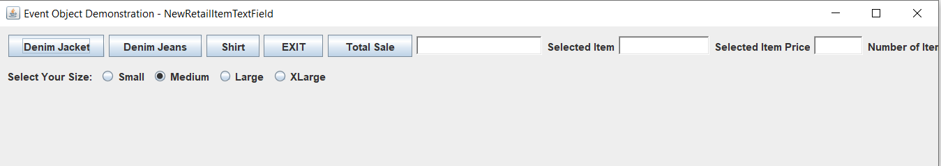

This is after iI stretched out the panel outline a bit so the RadioButtons would appear. The Title shows the file name & the new Total Sale button. Now comes the tricky part, add a list with the Items Selected and a Total Field. I’m going to save these 3 files in the Backups Folder first. That RetailClothingTotal file has some serious layout issues 😊 HAHA deal with that later.

7:00PM-HAHA! I was playing around with the file headers and changed one to extends JFrame instead of a file, I got a small panel with a blank screen.

8:00PM- LMAO! I saved the files to the Backup Folder, now I’m having issues, it wants to import the old one.HAHA! The one I want to keep has two size statements in the console, “You selected some size: null” and another says, “You selected another size”. This is fucked up! LMAO! I changed the class in RetailItemTotal to extend NewRetailItemTextField, I HAVE to use the one that’s in the SRC folder with the two size statements. I’ll deal with this tomorrow. I should swap the class extends statements and see what happens…LMAO!!

3/3/20 9:00AM- I really like the ClothingSize file in the Backups package. Right now it just has extends JFrame, not the file RetailItemTextField. When I run the file the window almost comes up in the size I need to show all the buttons, I said almost, I have to stretch it manually so I may play with the Widow Size a bit:

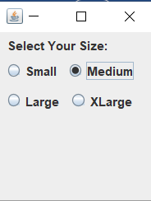

I’ld love to figure out how to get this RadioButton layout next to the JButtons layout, but that’s some other time. Right now I need to focus on how I went wrong when saving the files to Backup. Right now the NewRetailItem file comes up without the size Radio Buttons, that’s easy to fix but I want it a certain way.

11:05- Ok got it figured out, I need to make sure I open the 3 files in the Chapter 12//Default Package directory, ClothingSize file extends RetailClothingTotal, RetailClothingTotal extends NewRetailItemTextField. And NewRetailItemTextField extends JFrame, HAHA! I guess I have to be careful when opening/saving files I guess. As far as the Layout problem, right now I have ClothingSize – FlowLayout-Leading; NewRetailItemTextField – FlowLayout – Center; and RetailClothingTotal as Trailing. Yeah, good thing I’m documenting everything it’s so easy to get confused 😊 ! So my task today is to get the TotalSale button to display in a TextField or something, and the Items Selected with the Sizes in another. HAHA This will be fun! Could take days to get it right! The trick I believe is to have the fields in their individual Panels. For Instance, I get the Items selected and Item Price to show up fine in the NewRetialItemTextField file, so I’ll start there and build a List of the Items Selected I guess.

3/3/20 4:00PM-Dam! When I try and add the ClothingSize panel to the content pane in RetailClothingTotal, it wants me to import the file from the Backup folder, even though it’s in the same folder,,,hmmm,, no wonder I had issues last night, HAHA! Oh well I’ll deal with that later too. Remember to always create the panel in the content pane, then add them to it. Also they must be in the field declarations. Now I’m confused, since I did all that I’m getting errors,,,SHIT! I better just walk away for a bit.

7:30PM-Dayum this sucks! Only the files in the Backups folder are working as expected.

NewRetailItemTextField, RetailClothingTotal, and ClothingSize. I screwed up on saving them into Backup…oh well I’ll straighten it out in the AM.

8:30PM- KEEP THE FILES AS THEY ARE. It’s better for now.

3/5/20 6::00AM- After further review, I decided to scrap the whole project and start over. Something got corrupted in the files. Yesterday when I was trying to straighten everything out all day, I was getting weird results running the files. A window would popup and be flashing with a bold black line around it, LMAO!! It was like my screen was flickering! I even re-installed Eclipse thinking maybe it was the software itself, Nope! It was me! Ever since I started renaming files in different directories, I was getting errors all over the place, and for the life of me I could not see it. Some of the errors were pointing to a line I had commented out while messing around!

So instead of racking my brain and getting frustrated I’m just going to start over. After I save some of the files code that I liked and maybe use it later,,HAHA!

1:30PM-I started a new project with its own folder “Retail Item”. That way it’s separate from everything. I started a basic RetailItems file with my fields and Constructors. Then I tested it with another file using JOption Pane as the input, and have that print out on the screen with the input answers. Files named ItemConstructor. I created a reference to the RetailItems file that has the item constructors in it. Seems to be working ok so far,,LOL. I’m creating a SelectItems file with JButtons for the user to select what they want again. I’m attempting to build a JList with itemsSelected and the Prices.

3:30PM-I have the SelectItems file going good with the 3 JButtons. I tested them but the TextField won’t fill in till I add them to a JFrame hopefully.

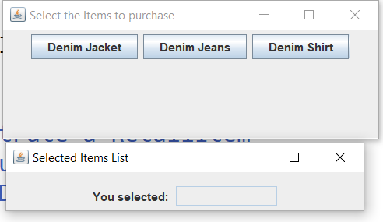

Figure 1The windows come up at least!

Hey cool! I figured out how to add captions to picture files! HAHA now if I can only get them to show up on my WordPress blog.

Now I need the Size JRadio Button file, then maybe a final panel with a list of items selected, quantity, and prices. That will be challenging if I can pull it off.

8:30PM- Well here we go again! Having a problem getting all the panels on the same frame.

ItemsList file, SelectedSize , ClothingSize comes up very small. ItemList does not like the add.selectedItem statement in it, but if you look at the ItemConstructor file, it uses JOption Pane for user input and builds a list, I just have to add those to a list. I just thought of something, I should change description to just ITEM?? Hmmm…..I’ll try it tomorrow.

3/6/20 7:30AM-So much to do! I think my first thing is to get my selectedItem List working. I’ll have to take a look at the code in the ComboBox file which puts a selected item in the textfield, but doesn’t add to it. Looking at the SelectedItems file, when you hit a certain button, it sets the selectedItem to a String and adds it. I just noticed, it’s adding selectedItems! NOT selectedItem! Yeah there’s something going on with that. Playing around with the ListListener with different combinations still nothing. I’m thinking I should save the file before I guck that up too! 😊 Maybe add the ListListener code to the SelectItems file where the ButtonListeners are?? That’s were I get the selectedItem. Maybe I can put this code in it’s own file and call it?

import javax.swing.event.ListSelectionEvent;

import javax.swing.event.ListSelectionListener;

public class SelectedItemListener implements ListSelectionListener {

public SelectedItemListener() {

// TODO Auto-generated constructor stub

//String selectedItemList.add(selection);

}

@Override

public void valueChanged(ListSelectionEvent e) {

//Object selectedItemList;

//String selectedItemList.add(selection);

// TODO Auto-generated method stub

//selectedItemList.set

// Get the selected month.

String selection = null;

selectedItemList(selection);

// ((Object) selectedItemList).getSelection();

// Put the selected month in the text field.

// ((Object) selectedItemList).setText(selection);

}

//Have to create the Method

private String selectedItemList(String selection) {

// TODO Auto-generated method stub

return null;

}

Going to have to see if I can follow this code and make it work. I took a snapshot for a sanity check before I really start messing around:

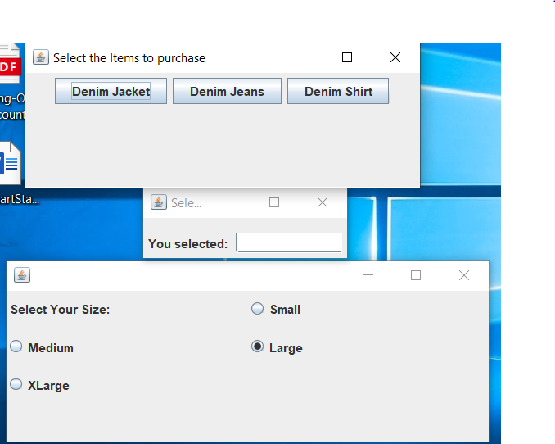

Figure 2. Getting there! Layout needs work obviously.

11:00AM - These are from one file: ClothingOrder. Things left to do: Get the Item of clothing selected to appear in the Text Box, get the Size Selected to appear, and finally the Amount total with Tax. Yeah,,,Good Luck! 😊 I figure if I can get the Selected Items List working correctly first, the rest should be cake! HAHA! I get the error “ArgumentException("adding a window to a container") but they still appear at least.

So I’m examining the ClothingOrder and the errors, I noticed I’m adding Panels to the content pane, I think that might be the answer. Also I see my panels I’m adding have “extend JFrame” in the class name header. Probably should make them all “extend JPanel”. NOPE doesn’t work. Also I had to remove this statement from SelectItems ButtonListener:

selectedItemList.add(selectedItem, selectedItemList);

1:00PM-Confirmed! I’m getting the errors in ClothingOrder where I add each panel to it. It still works but that’s why they come up like Figure 2. At least I fixed one thing, the ClothingSize file looks better after I set a WINDOW_WIDTH and WINDOW_HEIGHT declaration.

1:30PM-OH WOW! I just noticed I forgot the pack() and setVisible(true) statement in the ClothingOrder panel! Now I have 4 Panels that show up,,,,,getting a little closer…

5:00PM Dumbass me! I Already have an ItemList going, I need to take a look at how that file and the SelectItems file, I think I have repeat fields! HAHA!

8:00PM-It really helps with Eclipse, after you put the dot after the field, A list will popup showing the available options. Now I have to add those to a list. Going to have to check out the ComboBoxWindow and ListWindow files in the morning with some coffee. 😉

3/7/20 10:30AM – Not going as well as I had hoped this AM. I did manage to square away my Size Panel, looks fairly decent now:

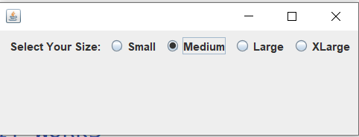

I need to research how to add selectedItems to a list, that’s my goal since I tried several methods and none worked. I’m going to check the SelectItems file again see if I can get a list going there.

This code sounds promising:

void append(JTextArea area, String newText){

area.setText(area.getText() + newText)

}

Maybe this one:

1. **package javatutorial.net;**
2. **import java.awt.FlowLayout;**
3. **import javax.swing.JFrame;**
4. **import javax.swing.JTextField;**
5. **public class Example {**
6. **static JTextField textfield1, textfield2, textfield3;**
7. **public static void main(String[] args) {**
8. **JFrame f = new JFrame("Text Field Examples");**
9. **f.getContentPane().setLayout(new FlowLayout());**
10. **textfield1 = new JTextField("Text field 1",10);**
11. **textfield2 = new JTextField("Text field 2",10);**
12. **textfield3 = new JTextField("Text field 3",10);**
13. **f.getContentPane().add(textfield1);**
14. **f.getContentPane().add(textfield2);**
15. **f.getContentPane().add(textfield3);**
16. **f.pack();**
17. **f.setVisible(true);**
18. **}**

Or this one:

/ Java code to illustrate add(Object o)

import java.io.*;

import java.util.*;

public class ArrayListDemo {

    public static void main(String[] args)

    {

        // create an empty list with an initial capacity

        List<String> list = new ArrayList<String>(5);

        // use add() method to add elements in the list

        list.add("Geeks");

        list.add("For");

        list.add("Geeks");

        // prints all the elements available in list

        for (String str : list) {

            System.out.print(str + " ");

        }

    }

}

Maybe this one too:

1. **import** javax.swing.*;
2. **class** TextFieldExample
3. {
4. **public** **static** **void** main(String args[])
5. {
6. JFrame f= **new** JFrame("TextField Example");
7. JTextField t1,t2;
8. t1=**new** JTextField("Welcome to Javatpoint.");
9. t1.setBounds(50,100, 200,30);
10. t2=**new** JTextField("AWT Tutorial");
11. t2.setBounds(50,150, 200,30);
12. f.add(t1); f.add(t2);
13. f.setSize(400,400);
14. f.setLayout(**null**);
15. f.setVisible(**true**);
16. }
17. }

JTextArea Example:

1. **import** javax.swing.*;
2. **public** **class** TextAreaExample
3. {
4. TextAreaExample(){
5. JFrame f= **new** JFrame();
6. JTextArea area=**new** JTextArea("Welcome to javatpoint");
7. area.setBounds(10,30, 200,200);
8. f.add(area);
9. f.setSize(300,300);
10. f.setLayout(**null**);
11. f.setVisible(**true**);
12. }
13. **public** **static** **void** main(String args[])
14. {
15. **new** TextAreaExample();
16. }}

Oh wow these are exactly what I was looking for! Check out this one called ItemTextArea:

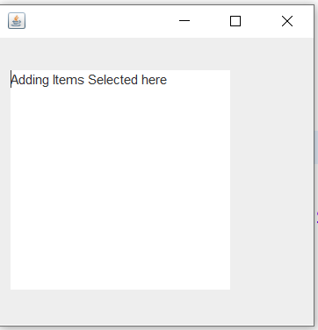

That will come in useful I’m sure, maybe as a receipt file, I can add everything bought, sizes, quantity, subtotal, tax, and amount due!

I love this one too, it’s what I was trying to accomplish called Example:

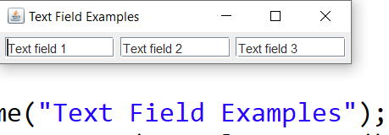

I could use this too for displaying after the items are selected. YAY! And the code is really simple, it uses code keywords that exist already. This is what I mean by there being so much available that I don’t know of yet 😊

It’s a thing of beauty! Racking my brain for days, and I found just what I needed in 5 minutes by googling it 😊 HAHA Gotta love the Internet! Check this out:

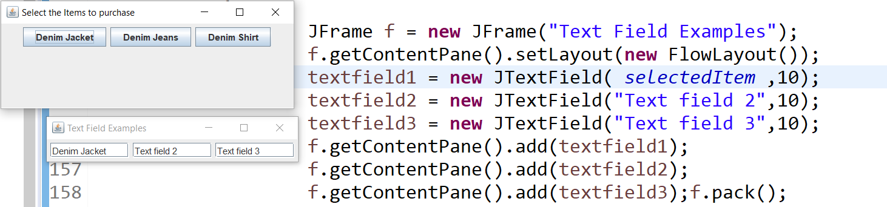

It worked perfectly when I modified the code to selectedItem, returning the Item that JButton1 was set too,,,awesome! Right now I have the textFields declared locally right after the ButtonListener. What if button2 and button3 are selected? Just as I thought, it fills in all three text fields with the same item string.

4:00PM – Well that didn’t work quite as planned ☹ But I did come up with a better idea maybe, it just takes more code:

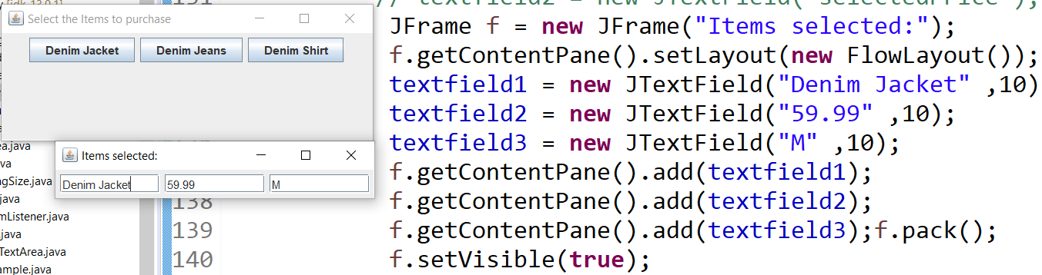

I can use the other two fields to fill in the Price and Size hopefully,,HAHA!

Well it works, just had to copy the chunk of code into each ButtonListener selection:

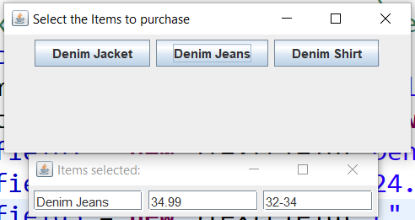

I made more work for myself, getting the Size Field from the RadioButtons.

8:45PM - SHIT! Almost fucked myself up! I was adding 3 more text fields 1-6 and somewhere I hosed it up! LMAO! Had to be another freaking curly bracket I’m sure. Luckily I restored one back from previous history, and it’s back to normal. THANK GOD!

I recovered:



Another task now is to set it up so its 3 across and 3 down for all 3 items if need be. Right now its set up as a FlowLayout. A BorderLayout might work and set it (3,3) for three across and three down. I could really get fancy and have a DropDown List with the various sizes in it. The ButtonPanel for calculating the total with Tax Needs more work, it’s not showing up at all.

10:00PM – Everything is working good! Except getting them on the same JFrame? Hmmm… I added a JFrame called ClothingOrder and added it, but still no panels in it.

10:30PM – I might be onto something, when I click an Item Button, the Items Selected panel comes up, if I click another, a new one pops up HAHA! I better get to bed.

3/8/20 2:30PM – Another thing I noticed, when I use the SelectItemsTextArea file to click on an item first before the other files, it comes out nice without errors. If I use the ClothingOrder file first, I get an error: “illegal argument selection” at the statement that adds it to the content frame. Oh well, I’ll keep that as my backup cause I don’t feel like messing with it. I guess I’ll be studying Content Panes and JFrames to see if I can figure out why they all aren’t in one Pane, even though I’m calling them in one.

SANITY CHECK:

SelectedItemsTextArea-Has the 3 clothing buttons, click one and it brings up the JFrame ItemsSelected, and the ClothingSize panel. So that my main files. Now to get the Calculate button Panel to show up!

Keep the Example File, ItemTextArea, ItemConstructor file, TextExample, TextAreaExample, ComboBoxWindow, ItemList file, RetailItems has methods in it. SelectItems file is a basic 4 JButtons.

7:30PM – I found some interesting files on JavaTutorial.net with examples of using JFrames. I think that’s my problem when I get the errors. Hopefully it will help me out with putting all the files in one Frame. Took a look at the Example file and try that tomorrow.

3/9/20 9:00AM- Starting out this morning with the Example file. I’ld like to modify the ItemsSelected to show 2 columns not two rows together. Yeah well that’s not going to work, adding two frames in one file. Probably need to separate them and only call the second or third if needed. I might try that.

4:00PM – I added an Instance of the ItemTextArea file to the to the SelectItemTextArea. I plan on using as a final receipt. It only comes up on the “Denim Jacket” file though. I even changed the code in the JButton ActionListener for each item, didn’t work. At least not yet! LOL

3/10/20 8:00PM – Spent the day mostly reading and going over other peoples code and understanding how they did it and what they did. Pretty interesting, gave me more ideas for my own little project. Created a new folder called Retail Item Object. The primary files are: RetailObject - the primary constructor method, A ButtonListener file I’ve been experimenting with, ItemTextArea I’ve been playing around with for a possible receipt, ItemsForSale file that doesn’t start, LOL! SelectItemsTextArea the main file for now, and the ClothingSize file, it works but needs tweaked.

3/11/20 9:00 AM – I need to work on selecting a RetailObject, then filling in the fields, and printing it out. I kinda have it going now but not quite. I want the item to inherit the fields from RetailObject the generic constructor file. I have that figured out but the output to another file to total everything up is what I really need to do. Checking out those other files I downloaded was helpful to see how others do things, although it was a little more advanced for where I’m at now. There’s a file called TextAreaGetContent that may be worth studying.

3/11/20 2:30 PM – Things aren’t going so well today. I’m reverting back to SelectedItemsTextArea. In this file I have 3 frames F,G, & H which show the Item, Price, and Size.

NOTE TO SELF: The file SimpleJButton gets user input and displays it.

3/12/20 11AM – Reading up on JFrame, JPanel, and how they all come together. I noticed that in the Brandi’s Bagel House folder that the OrderGUI file extends JFrame, and the other ones extend JPanel, I’m going to try that. Didn’t work of course LOL! Spent my time looking at options that are available after the “dot” operator. Pretty wild! I think I’m going to redo the whole project and start over,,,LMAO! Interestingly, I played around with the ItemTextArea file, and made another frame. That may come in handy eventually. A teacher told me “The best advice I can give you is don’t give up. If you get stuck and frustrated it’s best to walk away for awhile.” Boy was he right! 😊

4:00PM - I was playing around with the TextAreaGetContent file, this may be useful as a receipt. Also the ItemTextArea.

I’m getting the ClothingSize by making it static in the Size file. Also created a new file called SelectClothes, and calling the ClothingSize file. Interestingly, I found if I click the same item twice, it makes two fields in the selected items popup.

3/13/20 – 7AM- Trying to track down why the size window pops-up 3 times. I think I found it, I put all the button selected action listeners in the same frame (f). Changing back to f,g,h.

9:00AM – After much trial and error trying to add selected items to a JList, I finally got something:

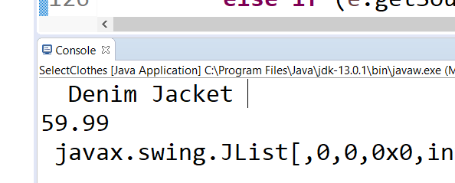

I have this as the code to try and add to the list:

String[] items = { "Denim Jacket","Denim Jeans","Shirt" };

**void** setListData(String[] selectedItem) {

Then a System.out.println of course to get the console printout of what item was selected.

11.30AM – Trying like hell to get a list of selected items going. Not working. I may have to make another file to do it. Might be easier anyways. I’m studying the ListWindow file, but I’ll be using a ButtonListerner for the List generation, could be rough! LOL. What to call the file? If I can pull this off, that will solve my problem of 3 selectSize windows popping up, hopefully,,,LOL I think it’s time to clean up the SelectClothes file first. I think I’ll call the file ClothesSelected.

2:45PM - Well that didn’t work to well 😊! HAHA! I got the List come up, but then it would not appear in the old popup. Hmmm….funny! I’m going to clean up the files. The second item(Denim Jeans) isn’t working, I’m not getting the pop-up. Well, I tried everything I can think of, nothing. Got the file back to the beginning though! Maybe I should just do a JComboBox, but I know it can be done. Not giving up yet. Still can’t get the jeans to popup yet, Oh well tomorrow’s another day. I may work on doing a read only text field to simulate a receipt. I forgot about the Listdemo file from the Oracle site, going to have to dissect it tomorrow.

3/14/20 7:30AM – After reading up on JFrames and JPanels, the examples show creating a new JPanel in the Frame for each element, then placing the elements into the same JPanel(Buttons, Labels, etc..) then adding the JPanels to the Frame. I’m not sure I like the idea of having the file extend JFrame yet, but I need to figure out how to get everything together instead of popping up in different panels. Also, I need to address the Jeans portion, its not working like the others and I can’t find the problem. So I may create a new folder, and put files in there in case I fuck them up…LOL! 😊 If you look at the Bagel house application, the OrderCalculator extends JFrame, and the other files extend JPanel. You create an instance of the JPanel files in the JFrame file. The JFrame file holds everything together, that’s where I screwed up the first time through. So I think I’ll make a new folder and work from there.

9:15AM – I think I’ll use the RetailObject file to start with since it’s the Constructor that builds the 3 objects. Jacket, Jeans, Shirt.

itemDescription = "Denim Jeans";

itemSize = " " //+ ClothingSize.getClothingSize();

itemColor = " ";

itemcost = 34.99;

itemsOnHand = 20;

I’m going to use item fields, makes more sense, since they are retail items. I made a new folder RetailItemsRev1. Then use the GridPanelWindow file which extends JFrame, saved as ItemGridWindow. I’ll change the button labels to my three items. I’m going to take a different approach this time. When a user clicks one of the items, the RetailItems file creates a new object with the appropriate fields. I’ll need some Button Listeners, and JTextFields, see if I can get this figured out HAHA! Oh Wait! I have the ButtonListener file already with the objects created.

3:00PM – Well that didn’t work out as planned, but then again it never does! 😊

So….back to the drawing board! I’m starting with the SelectItemsTextArea file again. At least I get all three Items Selected to show decently! LOL

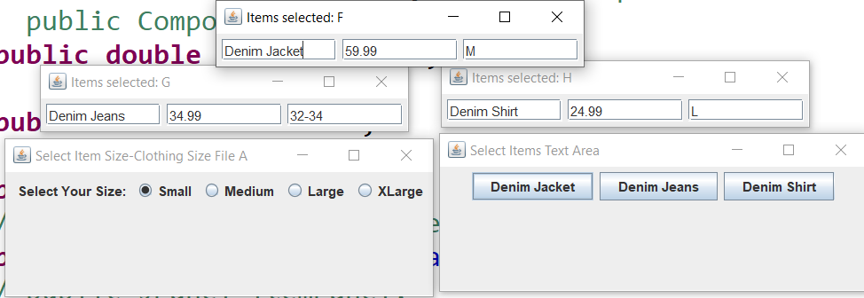

I’m going to save it as NEW SelectItems. I’m going to attempt to break it up into 3 JPanels so I can get the Items Selected on one. The GridPanelWindow file has 6 buttons on it, each as individual Panels. Actually I should just remove 3 buttons maybe? FlowWindow file has 3 buttons in the Frame, so that’s a possibility. I think I will, renamed Flow to RetailFlowWindow. See if I can take elements from the NEW Select Items and add them. Copied ClothingSize file to RetailClothingSize. So far so good. The buttons even work! 😊

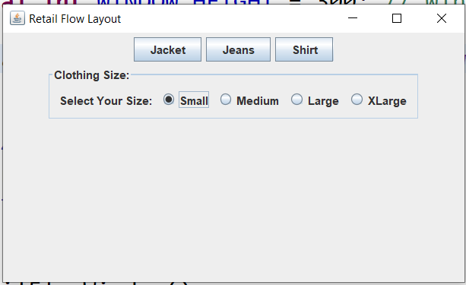

Now the fun part, add a Calculate and Exit button. I should put them on the Frame, at the SOUTH end, OR make a new JPanel and add it,,,,,hmmmm. I’m going to attempt JTextFields to gather the Item Selected, Size, and Prices maybe?? Pretty ambitious HAHA! That’ll take weeks! I took the ComboBoxWindow and copied it over to RetailTotalWindow.

3/15/20 6:30AM – YAY ME! I figured it out! I had the buttons and textfields in the content pane, not a JPanel. After I looked at it again this morning I saw my mistake, cut and pasted some code to the wrong place of course! HAHA Don’t put the ActionEvents or ButtonListener registers in the content pane. I guess I’m learning fairly well:

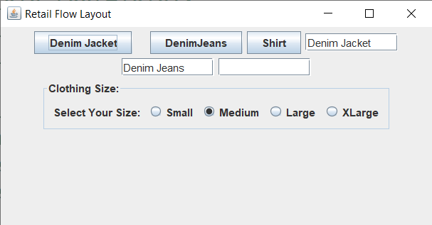

That’s the type of traditional look that I wanted for now at least. I can always adjust it later. Now onto the Price Fields! Interestingly, my theory was right! I moved TextField1 to right under Button1, It was where I put the ADD TEXTFIELD statement, Have to remember that. LOL Guess I need to make a text field panel to have more control over it.

7:30AM - Wow! I’m getting it! Price fields are in and looking good:

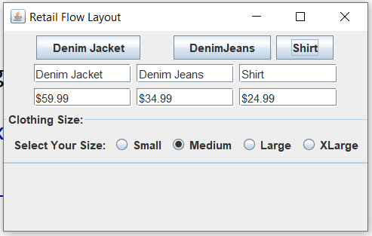

Just goes to show ya, keep at it and it will come together 😊. The positioning needs adjusted but the Technical part is almost done. Now onto the Price Fields, add tax, number of items, etc,, I should make a whole new JPanel separately, then add it in the Content Pane like I did the Size Panel.

8:00AM – I’m going to use the RetailTotal file for the Price Totals.

12:30PM – Going to have to mess around with getting the fields I need to show up. I created the RetailFlowWindow object, can’t get a reference to the field I want yet. So I started monkeying around with the ClothingSize file to get some size text boxes, looks like shit though:

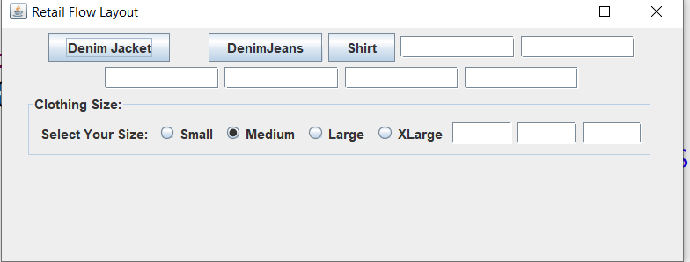

I’m just going to hide those in the file for now. Have to get the prices fields first.

8:30PM – DAMIT! Having a rough time with getting the RetailTotal panel integrated into the mix. Looked it over, tried everything, still nothing. Oh well, there’s always tomorrow!

3/16/20 10:00AM – GEESH what a rough morning! Tracking down mistakes I made, why the Calculate and Exit buttons weren’t showing up,,,,blah blah, here’s where I’m at:

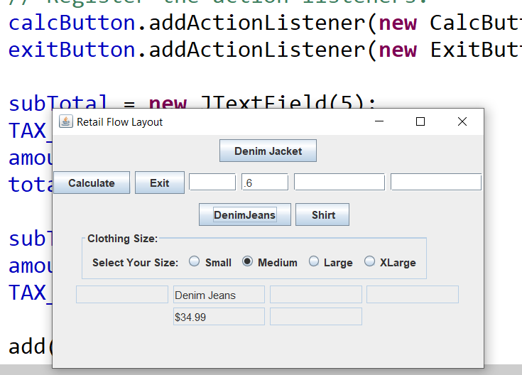

I need to fix that layout among other things..LOL So I’m going to SAVEAS Rev1 files so when I screw up I have something to fall back on! 😊.

Well I can see this is going to be a pain in the ass! LOL I set everything to FlowLayout and adjusted window sizes:

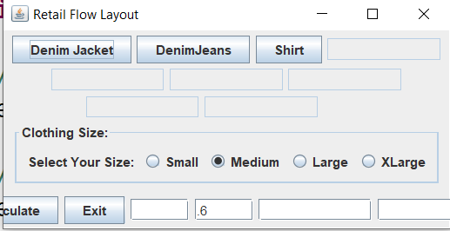

I took out the ClothingSize and ClothingTotal panels, and set the FlowLayout LEFT @ 10& 10:

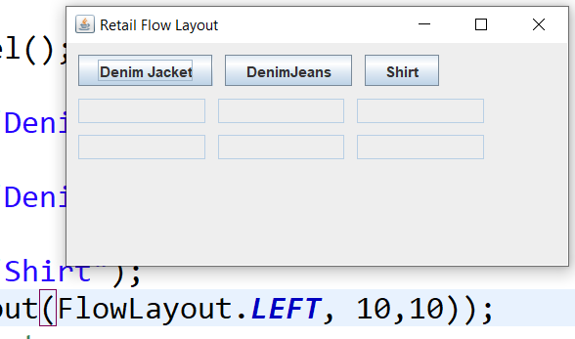

It’s getting there, I’m going to move the Buttons to the right some more. Notice the missing components I commented out. After I get this squared away I’ll add and adjust those hopefully.

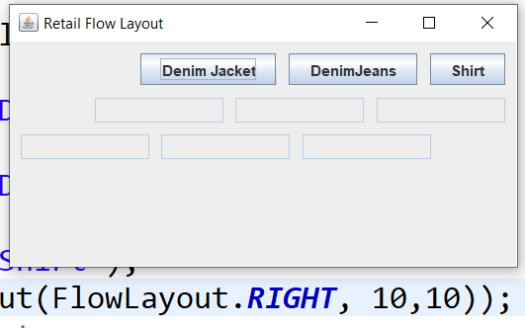

Little more to the LEFT please?

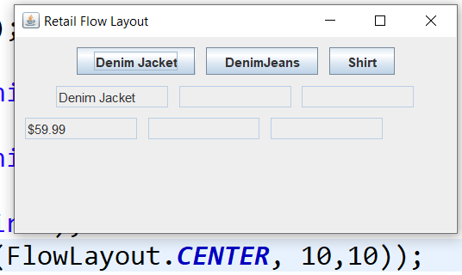

Almost there! The Text fields could go right a little, but the Price definitely needs Right about 10 Pixels:

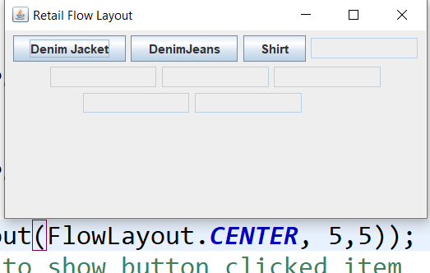

I’m going back to CENTER 10,10. Well this is as good as it’s going to get for now:

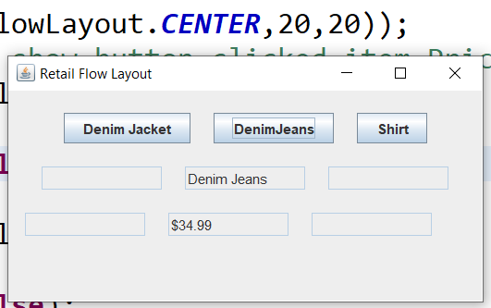

Another lesson learned, if I made everything their own component, I could have more control over them. Now to add the other two panels one buy one.

2:00PM – Almost there! I learned a lot from this one about layouts. It’s probably best to break each component separately as possible so you can tweak the Layout better.

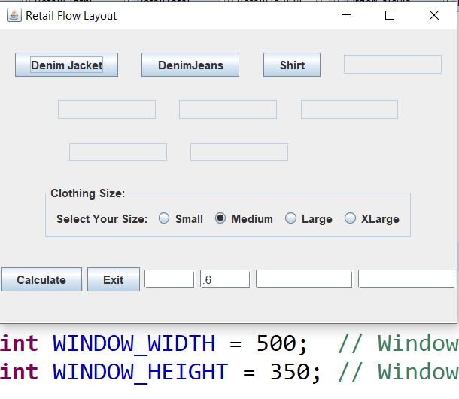

Figure This is after tweaking the layout int():

That text box is way to high, it’s for the Denim Jacket, not sure if I can tweak some more, move the Calculate button and TextBoxes around I guess.

3/17/20 6:00AM – Cleaned up each file from general notes. I think I better update the backups before I tweak them some more. I need to capture the sizes of each item selected. I already have a JOption Pane that pops up so should be easy to get that on a receipt type file. Saved all 3 files to a REV2 name.

6:30AM – I have two files to monkey around with as receipts: TextAreaReceipt file:

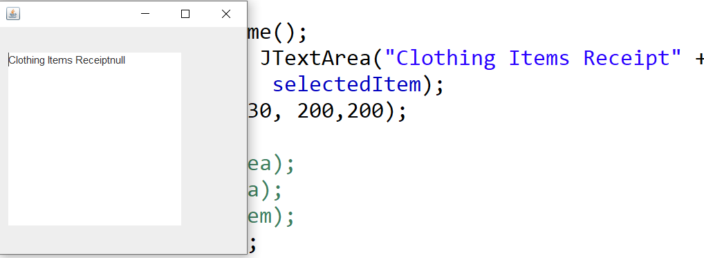

Figure : Receipt file name: TextAreaReceipt

Here’s the other file TextAreaGetContent, although it uses SwingUtilities and Frames. Not sure I’m ready for all that yet,,LOL!

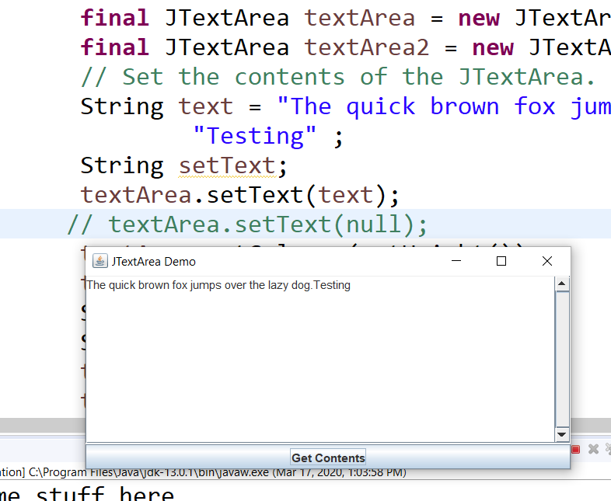

Figure 5: This may come in handy someday!

I’ll have to dissect that sometime, when you hit the Get Contents, it shows the TextArea. I need to learn more about the Properties of JTextArea’s.

9:00PM – Played around with the Layout’s, couldn’t get anything descent. I’ll try again in the morning over coffee 😊.

3/18/20 6:45AM – Well ain’t this some shit! Trying to track down where RetailFlowWindowRev2 is getting its Calculate code from. I changed titles and comments on each panel to try and figure it out. I got the Size Panel as RetailClothingSize. I think I found it, it’s SerialVersionID 1L, RetailTotal is 1L, RetailClothingSize 1L,. Confirmed, the three files are : RetailFlowWindowREV2, RetailClotghingSize, and RetailTotal. They all have the SerialVersionUID = 1L. DAMN! That’s confusing, I wonder if I should delete the other files? NO better not. Here’s a sanity snapshot after removing all FlowLayout statements for the 3 files:

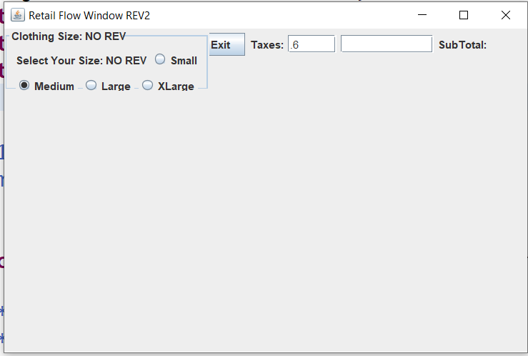

Figure 6 No Layouts Specified

I’m afraid to delete or move any files yet so I don’t screw anything up. I assume the SerialVersionID numbers link all 3 files together. I set all 3 files to FlowLayoutCenter:

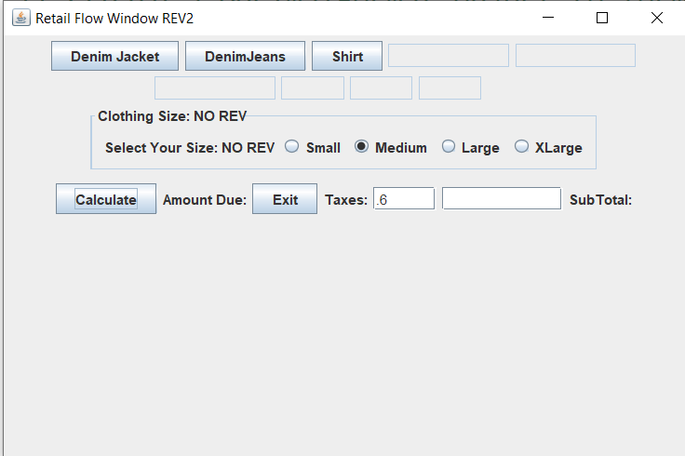

Figure 7: Center Layout w/No Adjustments

Well, here’s one Flow Layout. At least the Cal button shows up,,LOL!

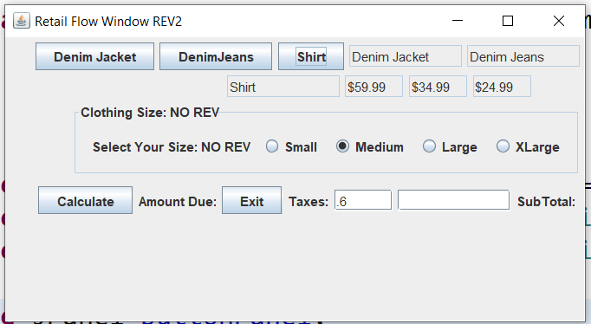

Figure 8: Flow Layout 5 file

This is the best I got so far using a FlowLayout every which way:

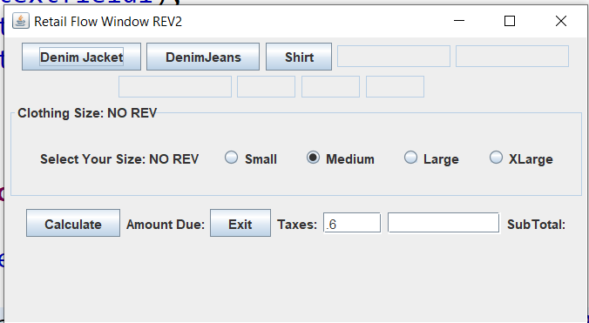

Figure 9: Flow Layout 6, needs work!

Needs a lot of tweaking! I hate the way the TextFields are but, 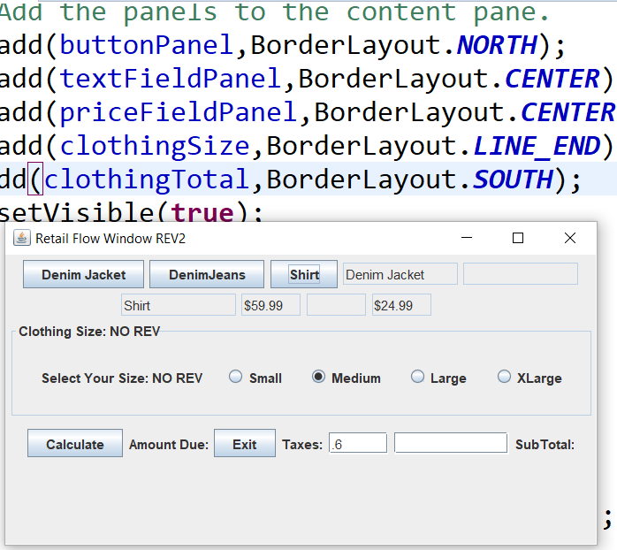

Figure 10: Border Layout on Components

Going to tweak some more. As I said earlier, my next round I’ll break it up into more JPanels so I can have more control.

5:00PM – Well I’m tired of messing with the layout. I should just break it up. Put the buttons and their corresponding text fields in one JPanel. Here’s a snapshot of the current state:

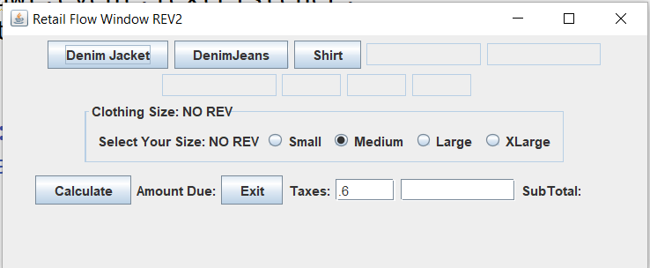

Put the Calculate Button with it’s corresponding field in one JPanel. The NO REV text is there so I know which file it is,,LOL.

3/19/20 7:30 AM – Speaking of redoing everything, I was thinking this morning that it stands to reason that I can make a “Retail Item” clothing class, with these properties: a description, a price, a size. Three basic things. Then you can just reference the object :Retail Item” and crete an object. I tried this before and I’m going to try it again. I’m going to use RetailObject file again and take out the Color and Units On Hand fields, not required at the moment. I should make another folder to start out clean again. I set up a Retail Clothes folder and started adding files: RetailObject and SelectClothes. Basically back to the beginning again! 😊 . I liked how this file came up before, but I’m going to remove the Frames so the items selected show up in one list hopefully.

3:00PM – Well I find myself back to the beginning again! HAHA! Why not I need the practice.

3/20/20 3:15PM – Again with the EventObject file as a starting point. Why not it has three JButtons and action listeners. I created a PriceFieldPanel file with 3 empty TextFields. Saved it to

ItemFieldPanel. They both work and show 3 text fields each, one for item selected, one for price. The three fields work fine:

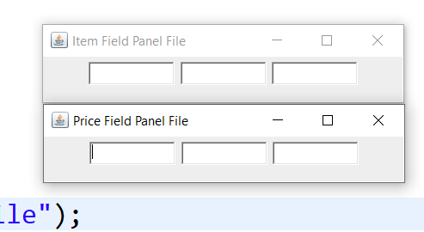

It’s like that one file I had except it was 3 across cause it was done with frames. The buttons are made and set to go:

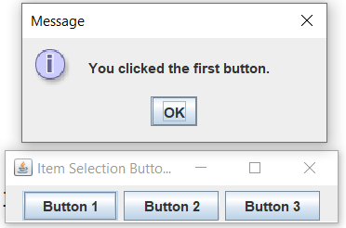

So it’s a good head start, just need to modify a few basic things. The 3 files are: ButtonPanel, ItemFieldPanel, and PriceFieldPanel saved in the Retail Clothes Panel.

7:45PM – YES! I did it! Looking a lot better after I broke them up and added them. The trick is to declare the Reference Panels in the Field Section of the Class, then create NEW ones in the Constructor and add them to the Content Pane like this:

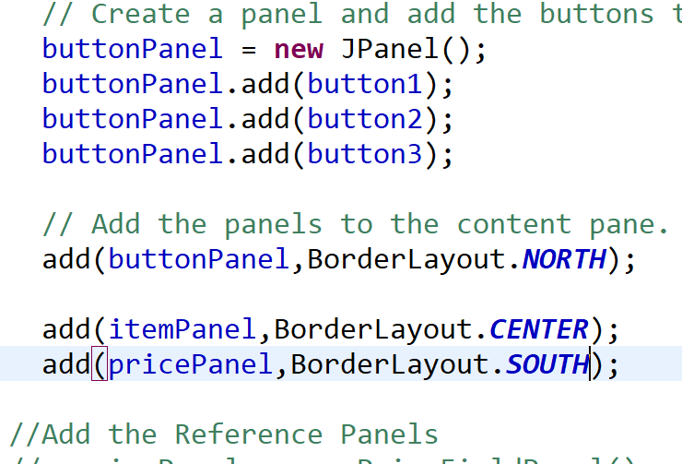

Figure 11 The Statements to Add the Panels. I used a BorderLayout for now.

I guess you could just add the TextFields from the two panels also. Another reminder, make sure the Panels you are adding are just EXTEND JPanels and the one you’re adding to is a EXTENDS JFrame. Also be careful of specifying the Window Width’s and Heights in each panel. Here’s a sanity check so far:

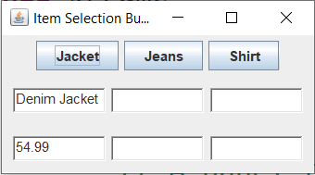

I was right, I needed to break it up into 3 separate Panels. This is exactly the look I want to achieve, a simple user interaction. Now the fun part, adding the SIZE field , Calculate, and EXIT. I have the other Size Panel I may try,

3/21/20 11:00AM – I almost got it! I used ClothingSize file, copied it over to the Retail Clothes Directory, Created 3 fields, sizeField1,2,3,. Then added those fields to ButtonPanel and added the ClothingSize file as sizePanel. Again have to be careful with getting the text from the TextField to a String into another TextField. Basically they are both TextFields in each panel and I used the getText method. Here’s where I am now:

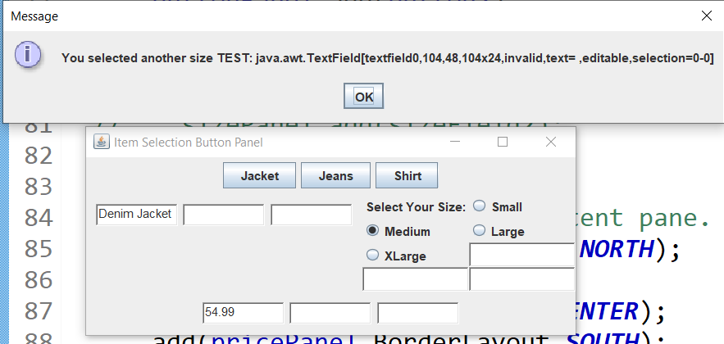

Figure 12: First pass at adding the Size Panel, at least it's working! LOL

Now here we go with figuring out the Layout:

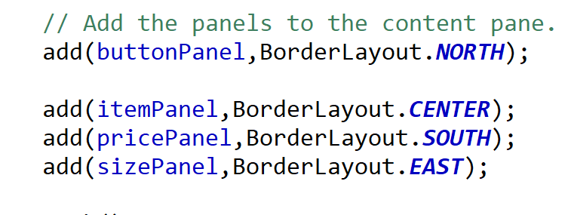

Figure 13: Current BorderLayout settings 3/21/20 11AM.

I’m digging it so far! I must be learning it’s getting closer! I’m getting the usual “adding a window to a container error” on the sizePanel position, so far here’s where I am:

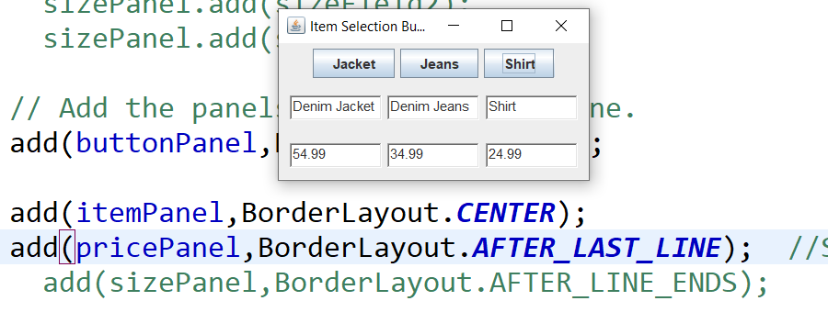

Figure 14: Sanity check

I have the ClothingSize panel set to a GridLayout (4,2).

2:15PM – YAY! Making some progress today! I got the Size Fields to fill in:

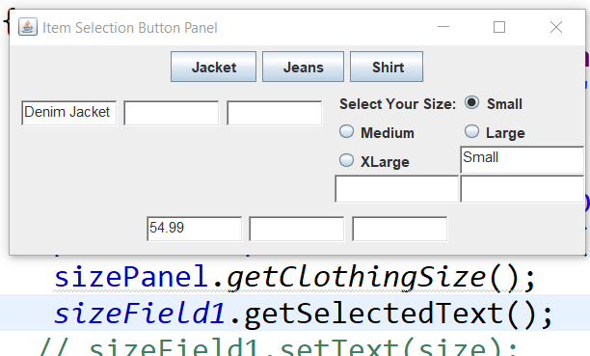

Figure 15: Size Field fills in.

Copy the code over to the other fields and that part’s done. Now another thing I realized I have to do, get the Item,Price, and Size fields to print out to the receipt file and clear the fields afterwards. Don’t really feel like messing with the Layout again, I still need to add the Calculate Total and Exit buttons yet. I’m going to do a popup JOptionPane with the final info hopefully 😊 . I wish I had a printer here to play around with printing a receipt in the end. I copied in the RetailItemReceipt file to Retail Clothes to play around with later.

3:00PM – WOW That was fairly easy, I modified the Receipt file a little and now I got something to work with later:

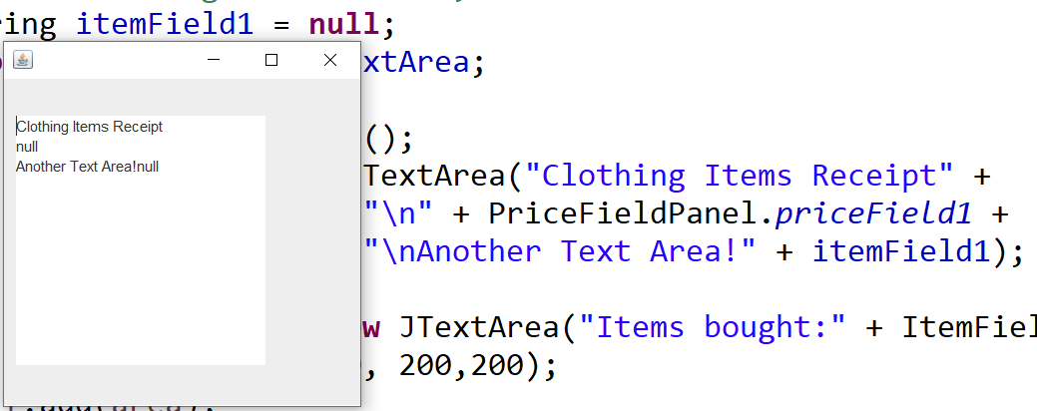

Figure 16: A Receipt File started.

I think I’ll copy over the OrderCalculaterGUI file to RetailItemTotal since it has the Calculate and Exit buttons already on it 😊. Now the big question, do I want to leave it as a JFrame and Reference the other Panels in it? OR make it a JPanel and reference it into the ButtonPanel? Hmmm,,,have to think about this a bit. On a side note, I found a 1,500 Page PDF file from 2003 on the Java Swing Classes. It’s old, but it is still relevant today. I’m sure it will come in handy!

5:00PM – Another sanity check before I fuck it up 😊

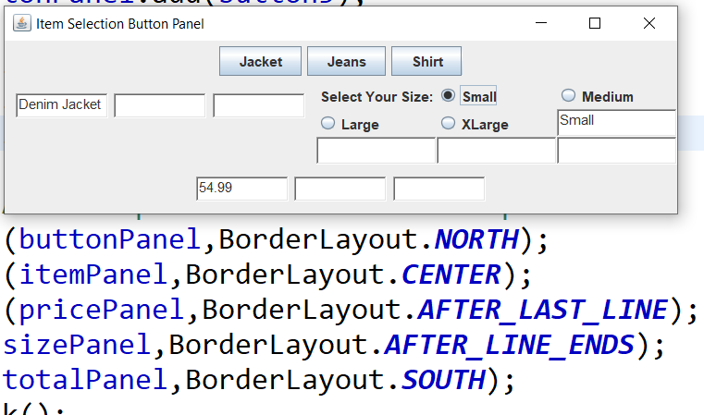

Figure 17: Getting there, but the Calculate and Exit Buttons don't show up!

9:00PM Sanity Check:

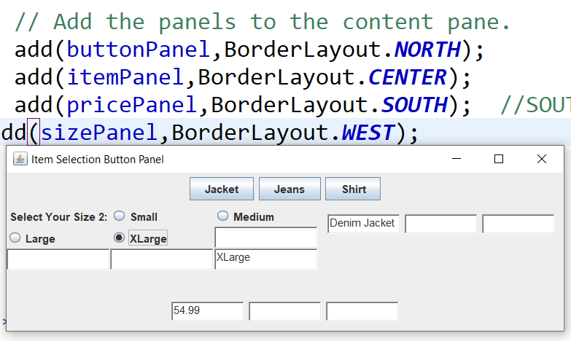

Figure 18: Sanity Check

Well I’m going to quit for the night. There’s my layout, with the SizePanel set to Grid 4,3. Here’s another one and I’m done!

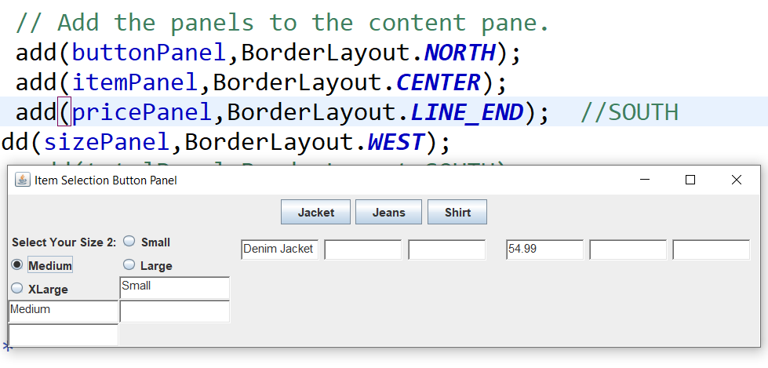

Figure 19: Almost! If I can get that PriceField Panel lower.

What if I did a Grid Layout 3,1 on the Item and Price Field Panels? Hmmm,,,,I’ll try it in the morning.

3/22/20 6:30AM – Here’s my starting point for today:

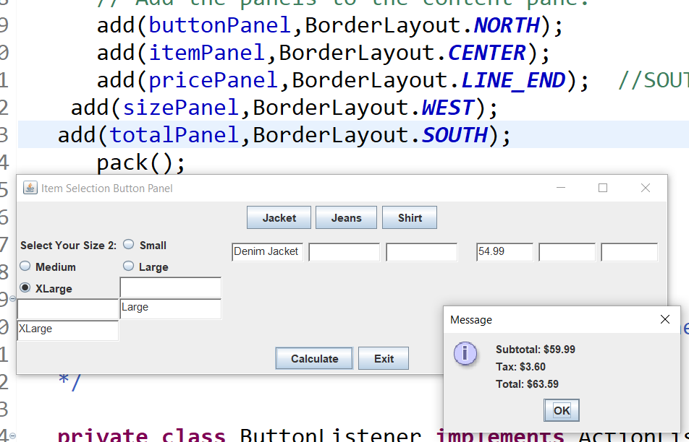

Figure 20: Working Prototype

I like the Grid Layout idea, Going to try that first. I need to get the ButtonPanel, ItemFieldPanel and PriceFieldPanel aligned together in the Center, with the Calculate and Exit buttons below like they are now. I need this snapshot of the file names before I get too crazy:

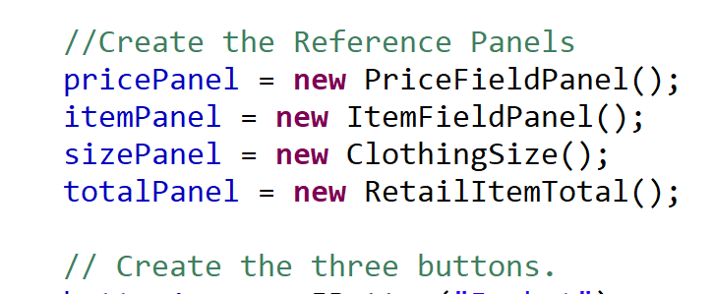

Figure 21: Panel Names

All these files are located in the Retail Clothes folder. There’s also a RetailObject file as a Constructor for items.

Ran across some interesting Frame examples will reading, this one here is interesting:

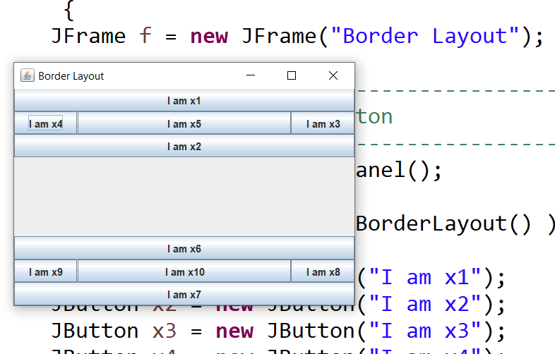

Figure 22: A layout using two Frames.

Interesting Layout using 2 Frames. I think what I’ll do is leave the Project as it is for now, and work on the final steps. The Receipt file. I plan on having 3 Fields referenced in it. The Item, the Price, and the Size Fields. We’ll see how it goes. Here’s another one I may try. Add the Panels one by one:

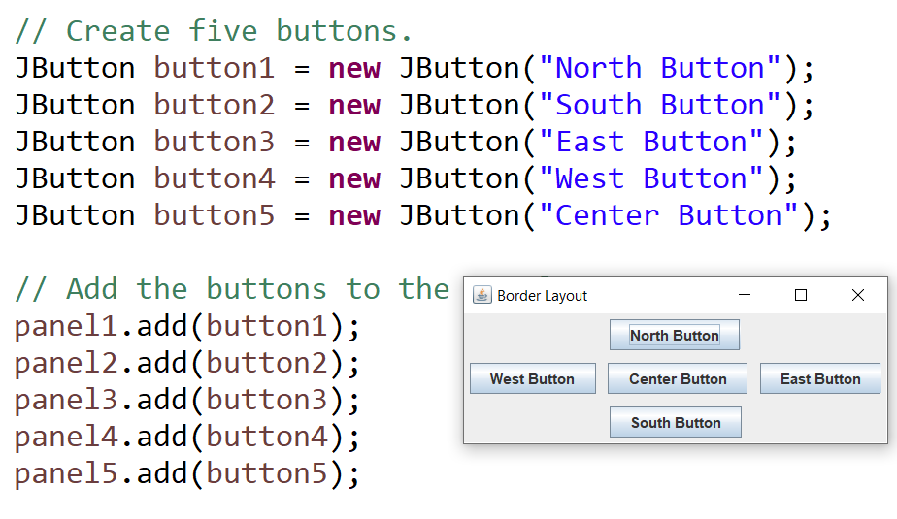

Figure 23: A Border Panel Layout

What if I copied this layout and added my JPanels to it instead of the buttons? Let’s find out. I’ll have to take the Reference’s out of the ButtonPanel file and place them in this one: RetailBorderPanelWindow.

11:00AM – I commented out all the References to the other panels in the ButtonPanel file, but I think I need to move them all to the FIELDS under the Class. In the ButtonPanel file, I had to change the References in the ButtonListener from itemPanel, pricePanel & sizePanel to the actual Panel Names. Changed ButtonPanel to extends JPanel not JFrame. Here it is:

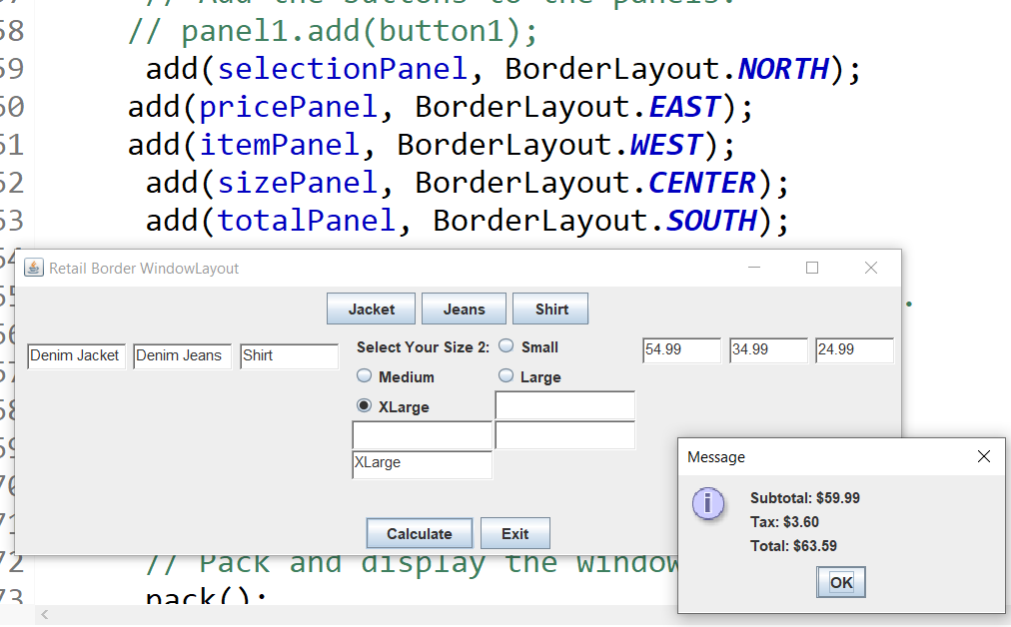

Figure 24: Not Much Different

I’m going to try sizePanel West,itemPanel Center and pricePanel Center.

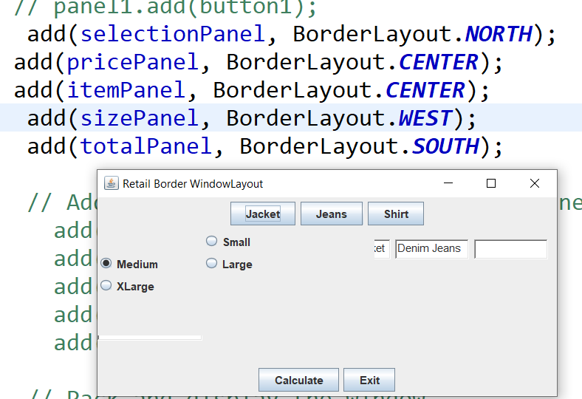

Figure : Well that didn't work out well!

Back to the beginning! LOL!

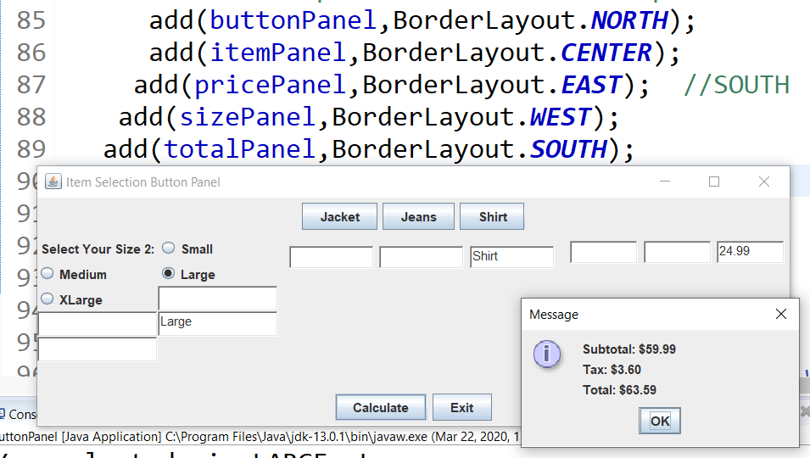

Figure 26: Reset to beginning!

Another sanity check, I’m not sure which one I like better yet:

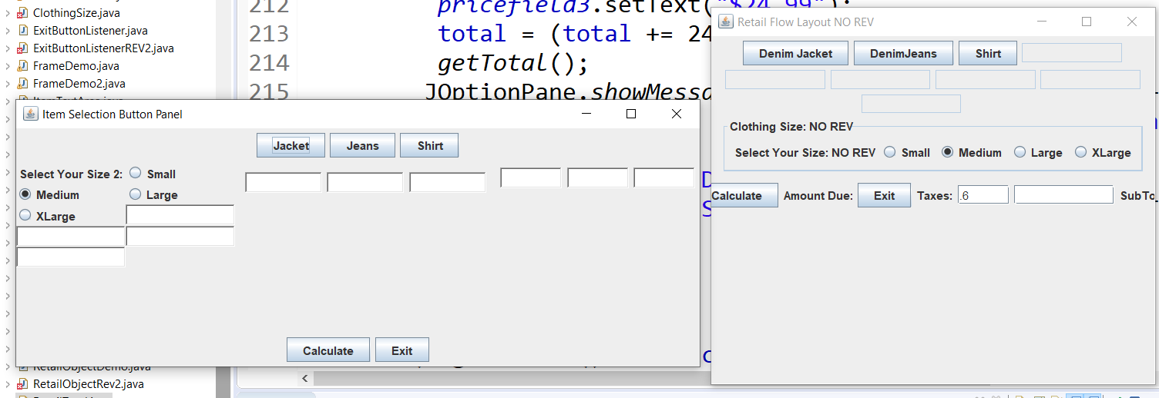

Figure 27: Two Layouts, but which one?

There are elements in each I like and don’t like. The one on the right doesn’t have the TextFields lined up correctly, and the Calculate & Exit are not centered. The one on the left has at least some of them lined up LOL 😊. The one on the right is RetailFlowWindow, with RetailClothingSize, and RetailTotal, all in the Retail Item Object directory. The left one is the newest in Retail Clothes directory with files ButtonPanel, ItemFieldPanel , PriceFieldPanel, RetailItemTotal, ClothingSize and RetailItemReceipt.

8:10PM Ok well, I took out the CalcButtonListener in the RetailItemTotal file, and Pasted the one from the RetailItemObject since the one wasn’t doing anything. At least now I get errors! LOL.

9:00PM – Well I’m back to where I started! 😊 Oh well off to bed, maybe tomorrow will be a better day.

3/23/20 6:30AM – So I was kinda right when I wrote a few days ago about breaking up the components into separate files. I like how the Size fields show up on the right side one, looks a lot better. The buttons on the left look better also. Guess I’ll see which layout managers I used and see if I can combine them. Still not getting the subtotal, Tax and Total to come out correctly either. Maybe if I nested the price fields into the item fields? Hmm…

So,, the Clothing file I want to try is in the Retail Item Object folder, and has no Layout specified. The one I’m using now has a GridLayout (8,2). I’m going to first remove that statement see what happens.

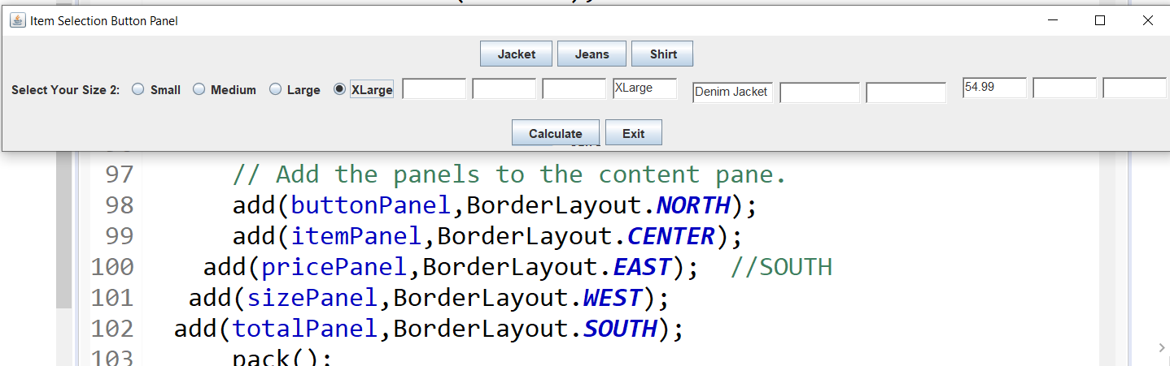

Figure 28; Size Layout change

Well that sucks! So I saved that Size file into Retail Clothes and going to attach it to ButtonPanel.

That sucks too!

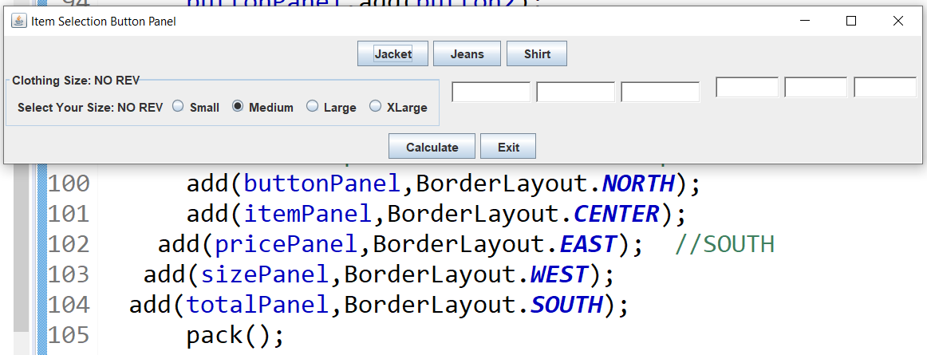

Figure 29: Another Size Layout change

Switching back. HAHA Tried to get cute and tried using a Border AND Flow Layout on the individual Price Fields, I got an “ illegal component position” error…LOL! Again I tried mixing up the Layouts of the Price Panel with the Item Panel, same error. I found a few PDF’s online from 2002 talking about AWT and Swing when it first came out. I should probably review those and get Layout ideas. But, I need to fix the Total/Subtotal issues first I think, then the Receipt. I always get sidetracked,,LOL! You know what else I just thought off? Making the Widow sizes blank in the files and only leaving the ButtonPanel with a size. Funny, it didn’t seem to make a difference. Amazingly, even removing the sizes from the ButtonPanel didn’t do anything. I had an idea! What if I left it as is, and stuck a receipt panel on the lower right?

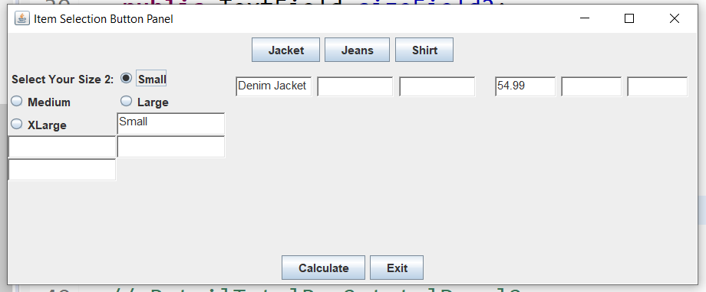

Figure 30: 3/23/20 9:30AM Layout

Well at least I got the EXIT button working again. When it says “you must declare in separate file” you are missing a curly bracket as usual.

1:00PM – I created another ItemPanel2 in the ItemFieldPanel and gave them both a FlowLayou, that didn’t work. I get the same layout as above. If I remove the Item and Price Panels. I get this:

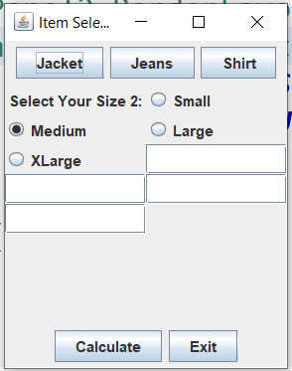

Figure 31: Item and Price Fields removed

I wonder, what if I went ahead and stuck them in the ButtonPanel directly like before? Hmm.. I’ld have to figure out which code to copy, and how to get it back when I fuck up! LOL. I removed all the PricePanel references in ButtonPanel and got this of course:

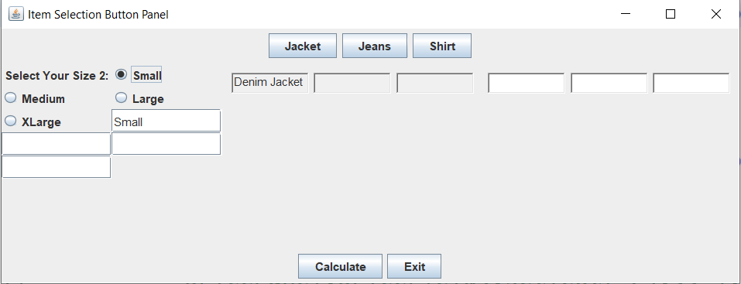

Figure 32: Back to square one again!

HAHA! I’m such a dumbass sometimes! Why do I have 4 size fields? I can put the size selected in one field,,DUH! Another thing that’s going to be tough, is clearing out the fields and put the selections in the receipt file, once I get the subTotal/Total shit figured out. Well that was easy enough to remove the extra Size Fields:

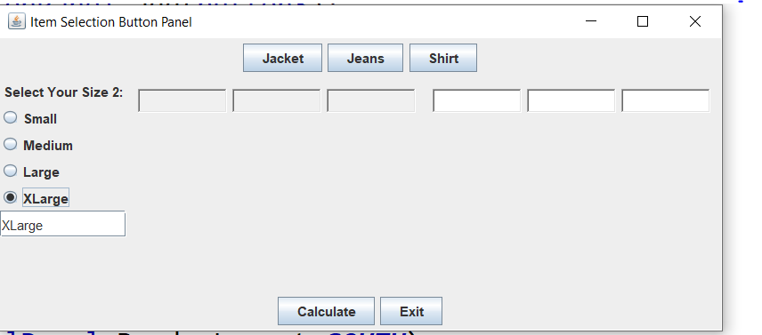

I like that! Now if I can get those damn Price fields figured out! WAIT! That brings up another point, Why do I have 3 Fields for each anyways? I only need a Item Selected Field, and the Item Price! DUH again! Here I go thinking ahead again, having a confirm button popup, then when the user clicks it, it sends the data to another file to gather up the items and a total price,,,hmm,,,,,that would be nice. It just so happens I was checking out the free PDF reference I downloaded on SWING and it talks about such things 😊. That seems a lot better:

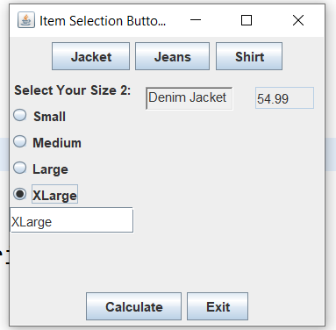

Figure 33: Panel Layout 5

That seems more like it, except the Size Panel needs mover over a bit. Now what I can do is clean up the Price and Size files, maybe even combine the Price into the Item Panel, then use the Price Panel for my List That will show up on the right hopefully. Then add another button for check out or something. I went ahead and changed the Price JText Field to just a TextField so it looks just like the Item Field, look good! 😊 All I have to do is capture these 3 Fields in another file, clear the fields after that, and see if the user wants another Item, sounds easy enough,,,,RIGHT….

itemPanel.*itemField1*.setText("Denim Jacket");

pricePanel.*priceField1*.setText("54.99");

sizePanel.*getClothingSize*();

sizePanel.*sizeField1*.setText(" ");

Ultimately I want these fields filed in Dynamically from an SQL database, but I’m getting ahead of myself,,baby steps Marky Mark,,HAHA!

Here’s my first pass:

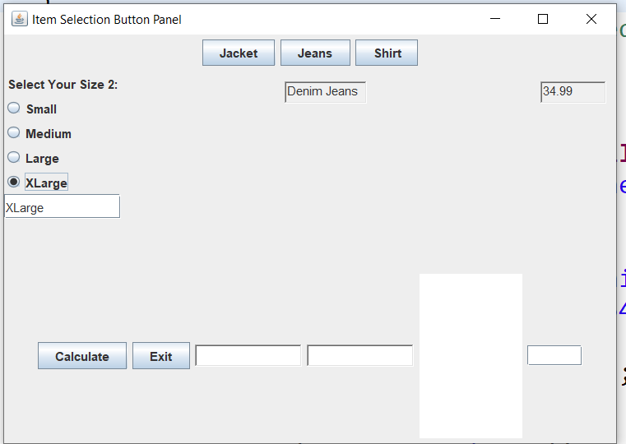

Figure 34 First Pass

I don’t like it so far, again with the PriceField, and the JTextArea, not sure about this. Well I got the ButtonPanel file squared away almost..LOL

3/24/20 7:00AM –

I’m determined today to get a handle on the CalcButton and why they aren’t adding up. I have them printing out in the Console, but the JPane is not. I took the CalcButton Listener out of the ButtonPanel. And here we go this morning already,,,LMAO!

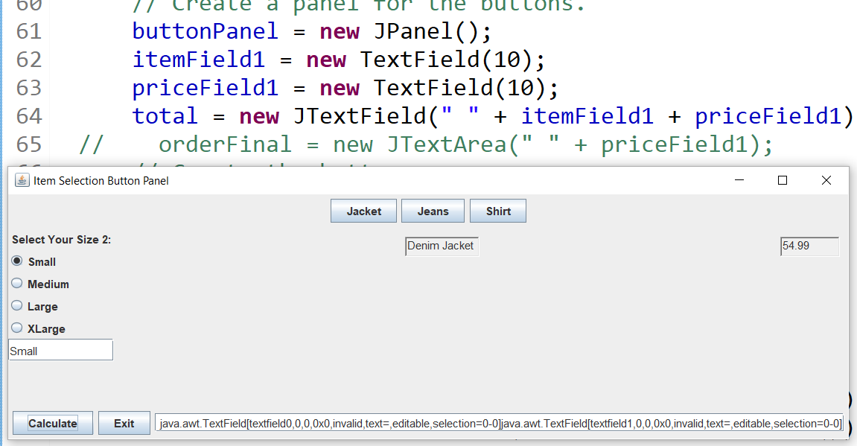

Figure 35: Gotta love it! Look at that TextField! LOL 😉

3/24/20 - 5:00PM WOW! I finally did it! Got something workable and it looks halfway descent! LMAO! Only took hours and hours of tweeking and tweeking the code till I got it right, but here it is:

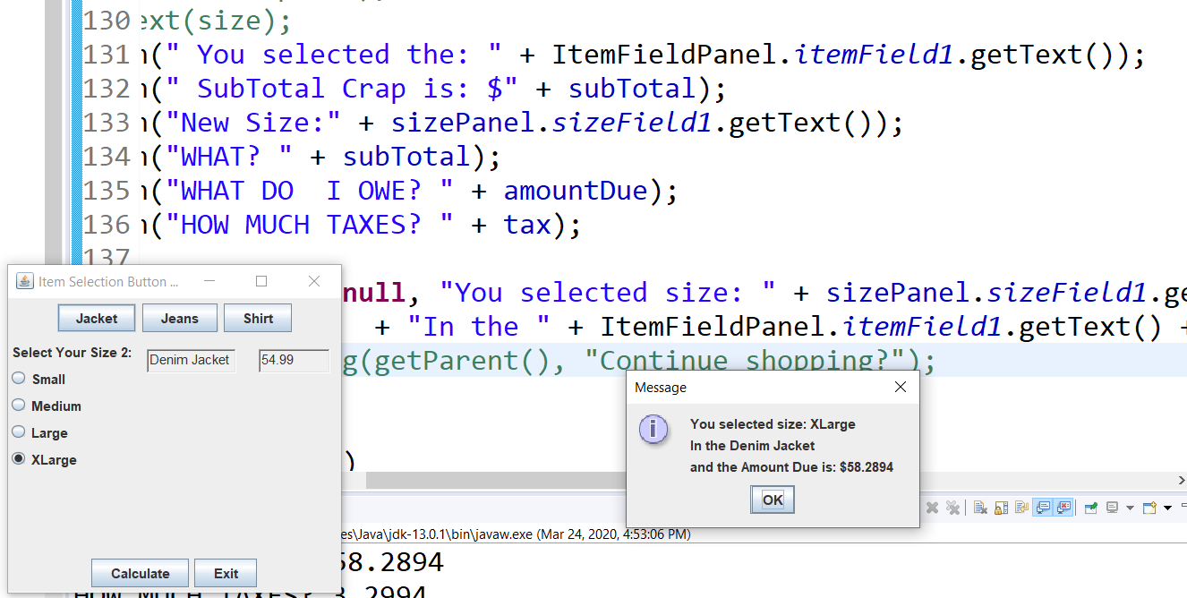

Not too shabby for a novice beginner! 😊 I used the console print out to make sure I was capturing the fields correctly as I was building and tweeking the confirm message. I even got the Tax right! WHEW! Just have to shorten up the decimal places to two. I’m up to 64 Pages and 15,339 Words of documentation! LOL! Now, I wonder if I can take this code and make it shorter for the other Items and Prices,,,hmmm,,,

3/25/20 8:30AM – I noticed something, the getText method must be used along with the (fileName.fieldName.getText()); I guess when you have to since the fields you may want are in a different file,,DUH. As long as they are in the same directory I suppose, but you could also supply a /directory/location. But I digress. What I hope to accomplish today is, after the pop-up message comes up with the Item,Price,Size, I want to send that info to another file to keep a running Total of number of Items,Sizes, etc,, Just like a normal receipt. Eventually go as far as subtracting the Items from the UnitsInStock. That would be awesome! I ‘m not sure I can use a TextArea, formatted into Columns and Rows,,,etc,,but I guess so. I’ll be looking for information from the Oracle site and my PDF files to get ideas. One thing I just noticed, after you select Calculate, it doesn’t clear the fields for another item. I do have a pop-up ready that asks “Would you like to continue shopping?” So there is my answer, when a user clicks “YES”, that triggers the Event that sends the information to the Receipt file and clears the fields for the next entry. If he selects “NO” the receipt file will pop-up with the all the information. Sounds easy enough! Yeah,,RIGHT….. 😊

Oh Shit! My Calc Button isn’t working! LOL I need to attach that pop-up to it. The RetailItemTotal file has the Calc button in it and the ActionListener so,,,here I go!

11:30AM – I guess I’ll try ad build a list from the selected Items, It’s either that or some sort of TextField to add the Selected Items to. So I’ll be spending all day studying up on that. I’m assuming I could make 3 rows and 3 columns to add the Items Selected to. HAHA! I have the Oracle tutorial docs to work with. I copied over ListDemo file to ItemListDemo.

3:00PM – There is some really good tutorials in the Oracle Demo Files. I played around with the TextAreaDemo, but it’s not quite what I was looking for. I’m going to attempt a JTextList, and add the Items to it.

9:00PM – Trying to build a Frame and add Components to it, not working so far. I get a blank frame, even when adding Components to the ContentPane,,,GRR

3/26/20 8:30AM – I just realized, why am I racking my brain trying to get another Frame or Panel built, I can do it in the JOptionPane I already have! DUH!

3/27/20 – 9:00 AM – I finally figured out a Frame and adding components to it. You need to add them to a contentPane reference. I did figure it out and managed to have this so far:

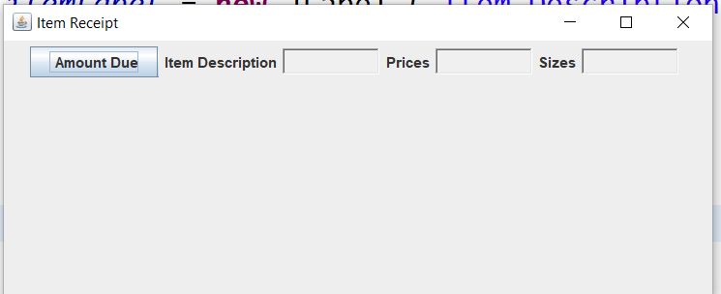

Still haven’t got them to fill in yet, plus I want have to work on the Calculate Button, perhaps make it a “Add Item” then have a “Checkout Button that pops this screen up with the list filled out, total items, items selected, final price,,blah blah,, so,, guess I need to examine a JList and see how to populate it. Right now these are just TextFields. I did get the Items TextArea to show up, looks like shit though:

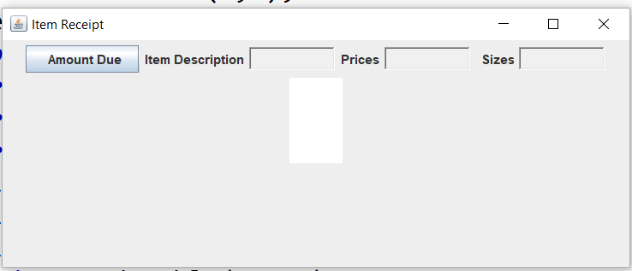

Figure 36: FinalWindow

So,, that’s my goal over the next few days. Oh, and do something with the buttons,,LOL!

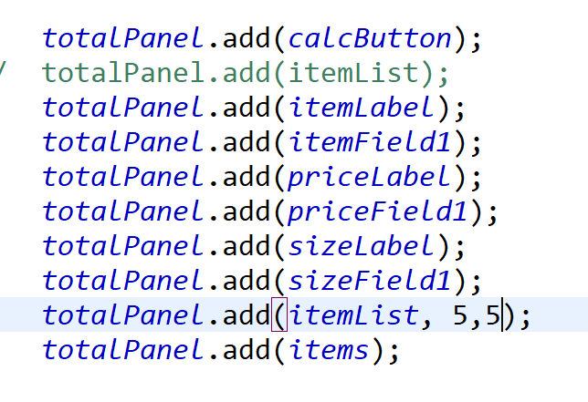

Figure 37: These are the Items added to the Frame

Oh! Awesome! I have this ListModelExample file from the Oracle site. I can work with this with some modifications of course:

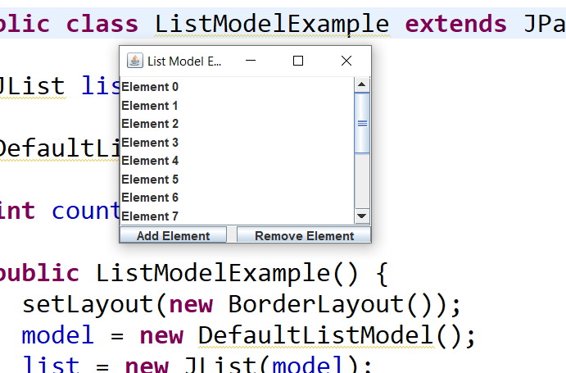

Figure 38: List Model file

Oh yeah this should be fun! I like how it calls the ListModel Method and adds it right to the Frame, interesting:

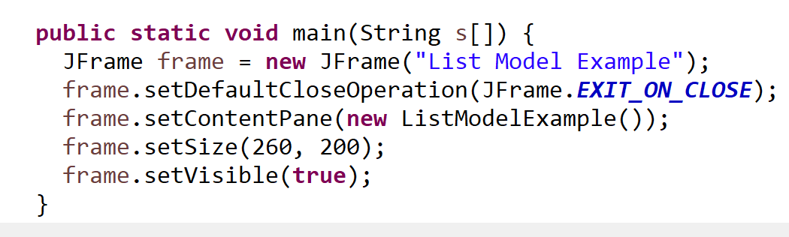

Figure 39: Code adding the ListModel Method right to the Frame.

Oh I like this, maybe if I do it right, I’ll just delete my current FinalWindow file and use this. Oh wow! That was strange, as I was renaming things an error was generated. After reviewing the file and comparing it to the original, I discovered it didn’t like the “public” declaration in the method header. Maybe cause this was created on Java 1.2 version? Hmm..

1:00PM – If I remove the ScrollPane, the Buttons fill up the space. Might have to change the Layout, or give the Buttons a Size parameter?

4:30PM – Almost got it:

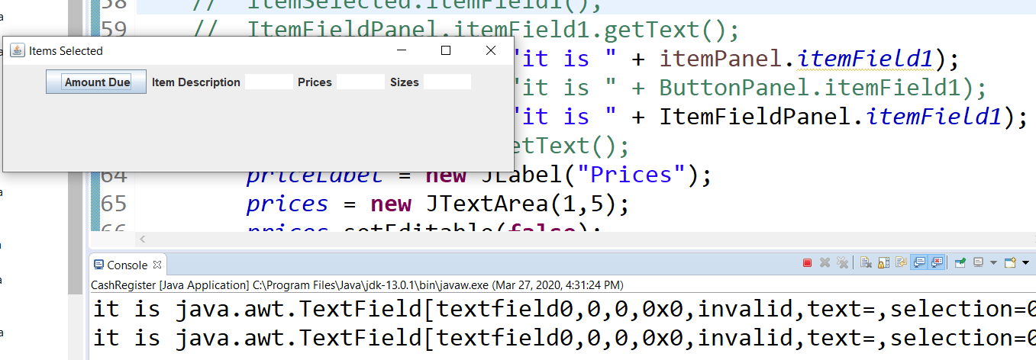

Figure 40: Almost captured the Text I need.

So Close! Maybe I should go the other way, and reference the CashRegister file into the ButtonPanel, then add it to the JPanel? Hmmm…

UhOh! Problem,,LOL Referencing in the CashRegister file, it wants to change it to a Component? Might be because that Panel is in a Frame? Hmmm… ClothingItemTotal does not like the statement that adds ButtonPanel.ItemField1.getText. DAMNIT!

3/31/9:00AM – All I can say is, WOW! I’ve been messing around with NetBeans Java IDE all weekend, and I’m really impressed. At first it seemed pretty daunting with all the available toolbars and menu’s, but after I went through several tutorials I really like it! It’s very powerful and makes the Layout Design so much easier. Today I’m going to work on doing the Retail Item project with it. One thing I learned is, it’s good to have a pretty good grasp of manually coding in Java.

4/4/20 – 9:30PM – Well, I finally got something I can work with! 😊 After a week of going through tutorials and playing around with Apache NetBeans IDE, I kinda got it figured out:

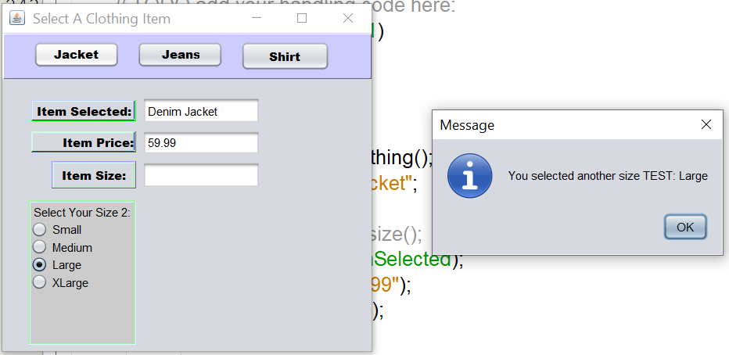

Figure 41: This is starting to look like something!

Not bad! I kinda like the colors too! Off course it needs tweaked some more, like getting the size field in the right text box. I think I’ll mess with putting the Calc Button and Exit Button along the bottom, and have a window pop up with the final retail information. Clean it up a bit also. I’m getting closer to my goal! Retrieving Items from a SQL database and putting the sold Items in it with tax, prices, how many, etc,,then I can subtract the sold items from the inventory back into the database. That will be awesome when I get it figured out! 😊 I wonder if I could sell it to start-ups? Hmmm….Yeah right! There’s already plenty of those on the market.

4/5/20 7:30AM – I was reading up on Classes again from another study guide and realized I should make an ORDER class to hold all the necessary information like Item Description, Price, Number Ordered, Sizes etc…I think I just defined Database Tables as well as Classes! Today I think I’ll start by cleaning up the file first, then start working on an Order total popup window. I already had one here somewhere if I can find it,,LOL!

4/6/20 12:30 PM – I fixed the problem with the size fields not showing up finally! I have the Exit button working but not the calculator, at least not yet!

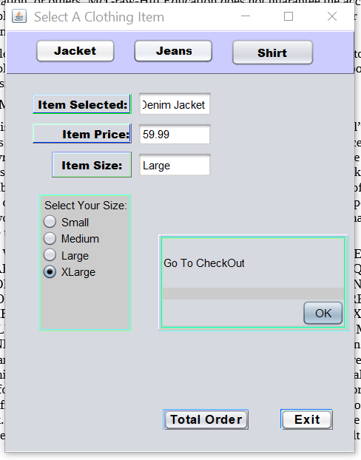

Figure : I kinda like the Raised Text and Buttons

I think I’ll attempt to have a running total TextField below the Go To Checkout text, then when the user clicks Ok, another screen pops up detailing the sale. Once I get that squared away, I can start on the Database Design. Should be fun! NOT! LOL 😊

4/8/20 – 11:00AM – I decided to get a database server up and running before I finish the Java project. That way it will be easier to change as I progress, who knows I may need to change it up anyways depending on how it goes. At least it’s working so far:

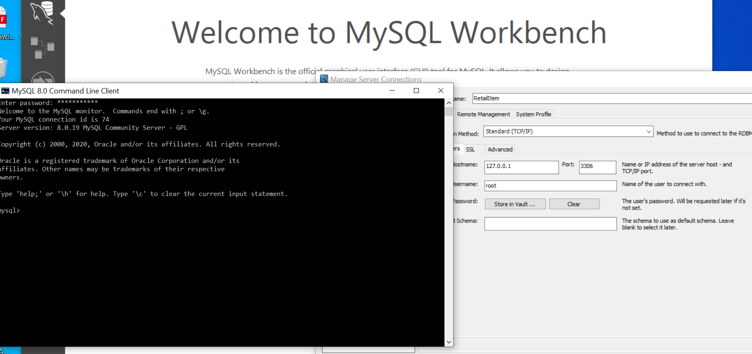

Figure 43: command line is working from Shell.

It’s been a long time since I set a server up, let alone an SQL one. Back in the day I had my website going with a form a user could fill out and it would populate from the form fields. That was with Cold Fusion though running on a Windows Server that I built myself. It took me a few days to get this one up and running correctly but it seems to be working good so far! I started an Access Database of my Retail Items to play around with. Now to go through a few tutorials to rack my brain again 😊. Ideally I will need several tables to keep track of the items, sizes, inventory, blah blah….. and here we go! It’s working great from the Workbench:

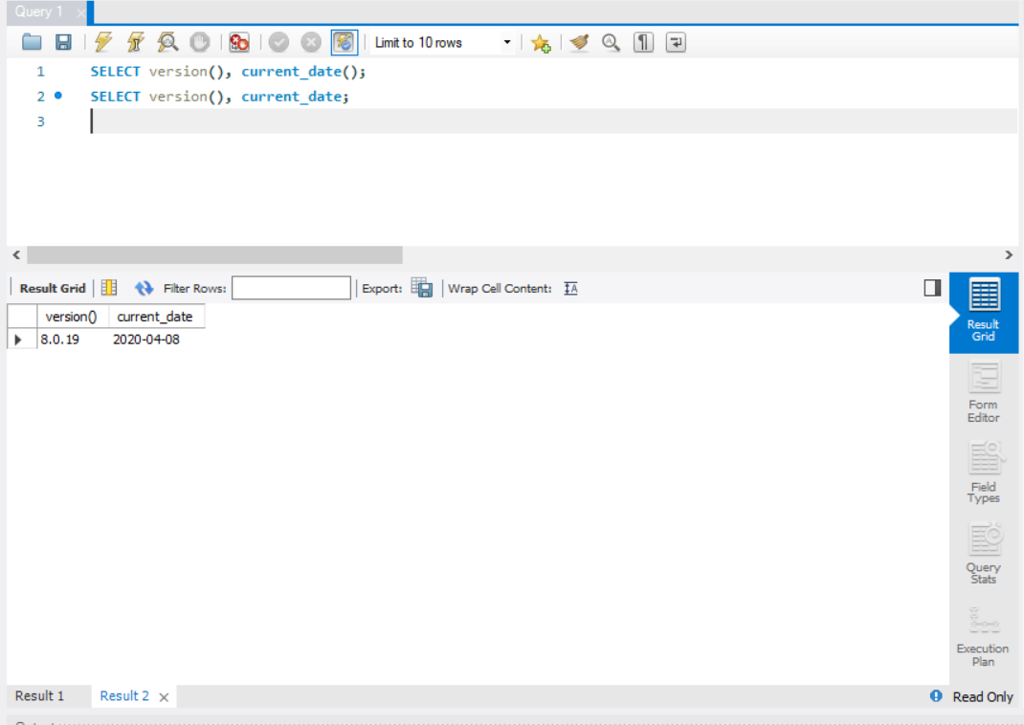

Figure 44: Here's the same query from the Workbench.

So we confirmed that it’s installed correctly and working. Now the fun part! Use the sample database to really get my hands dirty!

4/11/20 9:00PM – Well after much frustration and fooling around with MySQL software, I’m starting to get something:

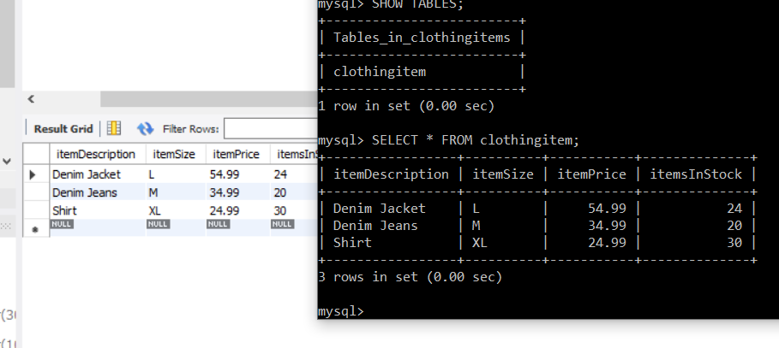

Figure 45: It's a start!

Ones the Command Line and the others the actual software. One thing I can see already as being a problem is keeping all the Fields named the same! LOL I had to enter all the data manually of course, it will probably be awhile till I get the Java and SQL to talk to each other so I can just enter Data from the Java program and it updates the SQL database. That reminds me, I have a long ways to go yet.

4/14/20 10:00PM – It’s been a long few days of experimenting, reading, going through tutorials,,etc,,I’m pretty sure I have a descent handle on MySql and the Workbench. Then I tried Microsoft SQL Server like I used to run back in the day. Damn that was really slow and a resource hog! My laptop could not handle the heavy memory load even with 64GB, it kept hanging up on me. Screw that! I uninstalled it and went back to MySql, it runs a lot smoother.

4/15/20 9:00AM – Starting out my day writing Queries in my basic database, working out well so far:

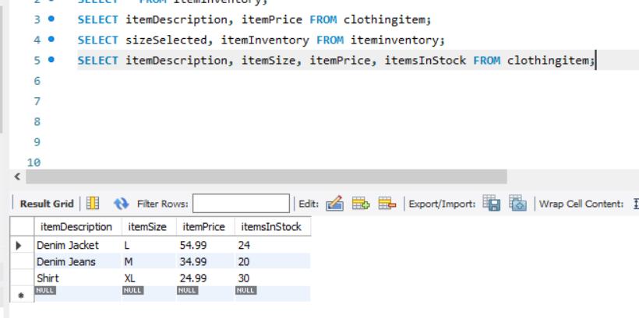

Figure 46: Basic Query Test

4/16/20 11:30AM – Yesterday went ok, did some basic queries. Today I’m going to try and connect to a database using Java. I found some good articles/tutorials on-line to learn from.

4/20/20 – 5:30PM YAY!! I finally did it! Get the JDBC Connector to work from Java to MySql! Finally! Only took days of monkeying around with it! LOL 😊.

**4/23/20 – 9:30pm** Well after several days of figuring out what files I needed to download for tutorials and just monkeying around on the SQL server, I finally got the infamous sakila database going on the server:

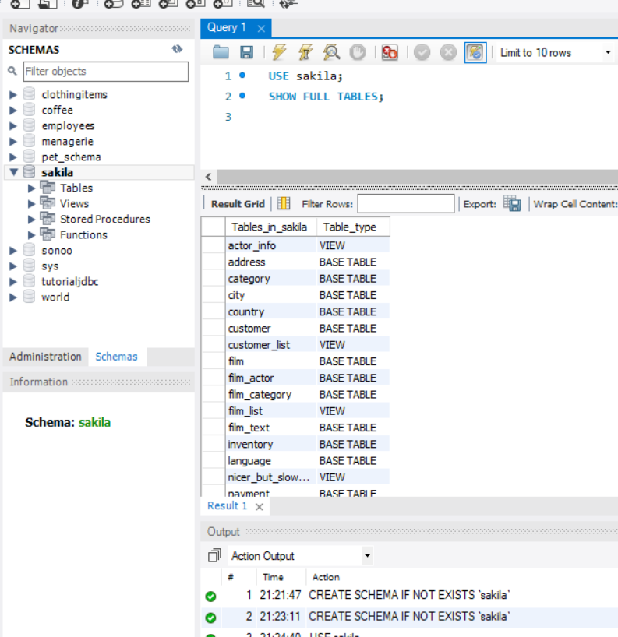

Figure 47: The Sakila database installed

I was reading the readme files(imagine that 😊) and they say you can use this for testing and practice, then use/modify the structure to suit your needs. That’s cool! As long as you don’t let anyone else know! HAHA Anyways, going to study up for weeks again I guess. Once I get a handle on working in the server environment, I’ll move on to the NetBeans IDE and start manipulating the DBase I guess.

4/25/20 – 9:30PM Well I think I have something,LOL After much downloading tutorials and samples, I think I have a start project in the JavaDeskApp:

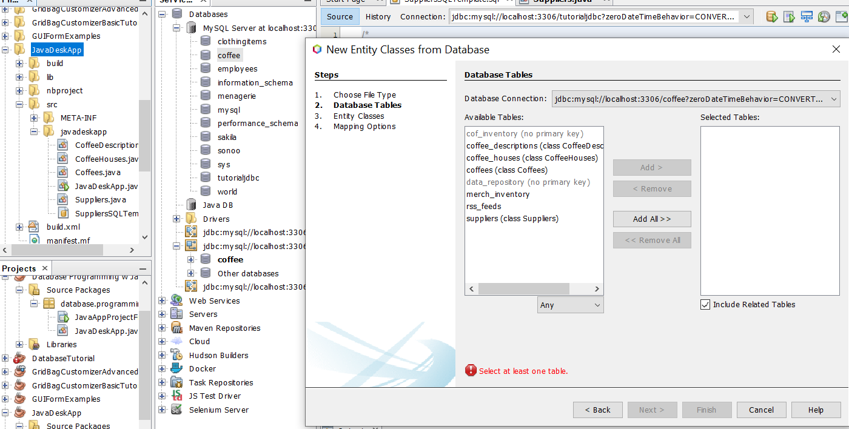

Figure 48 New Entity Class for DeskTop App

I have to remember to select New Entity Class from database, then select the columns I want.

10:20PM - Damit! Getting some errors! Imagine that! I’m getting this error:

[Exception, Error code 1,146, SQLState 42S02] Table 'coffee.coffeehouses' doesn't exist

I think I know why, the coffee.coffees are in different folders. Going to bed, I’ll track it down tomorrow.

04/26/20 - 9:00AM Today’s goal is already figured out “I think”. I ran some queries with coffee names, suppliers, and descriptions without errors! YAY!

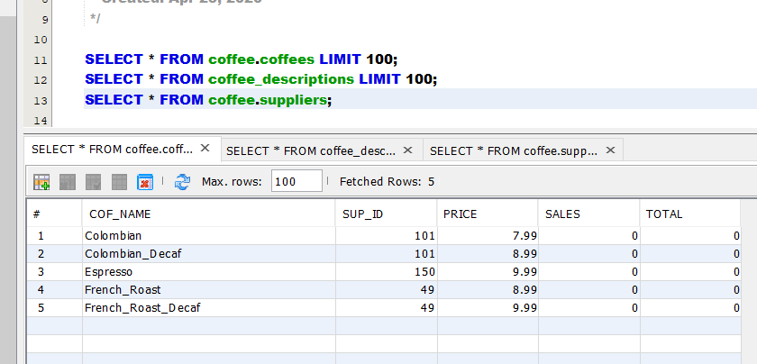

Figure 49: Select statement from coffees

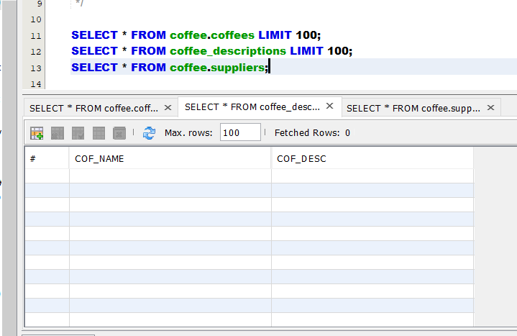

Figure 50: Descriptions Query

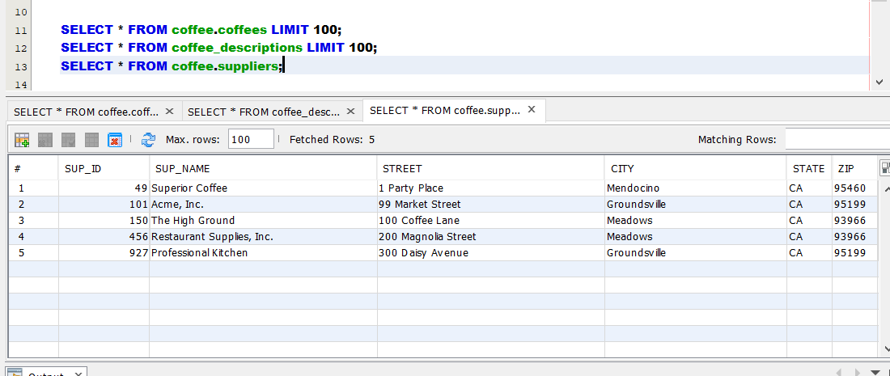

Figure 51: Coffee Suppliers Query

All three work, but the Descriptions Table is blank, kinda strange, gonna have to investigate but I assume it’s just not filled out! HAHA 😊. This is fun! Think I’m getting the hang of it!

11:00AM – I found my error! I knew it was something silly and as I suspected, the files are in separate directories! Check this out:

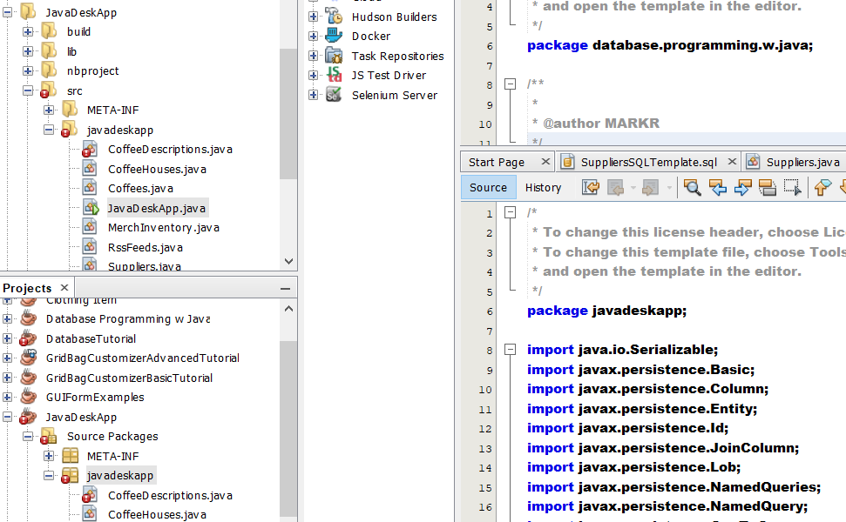



Figure 52: There is my error!

Notice the Package Definitions? They point to different folders! LOL 😊. Now the question is, which file directory to keep? Hmm..

5:00PM – I think I have a game plan:

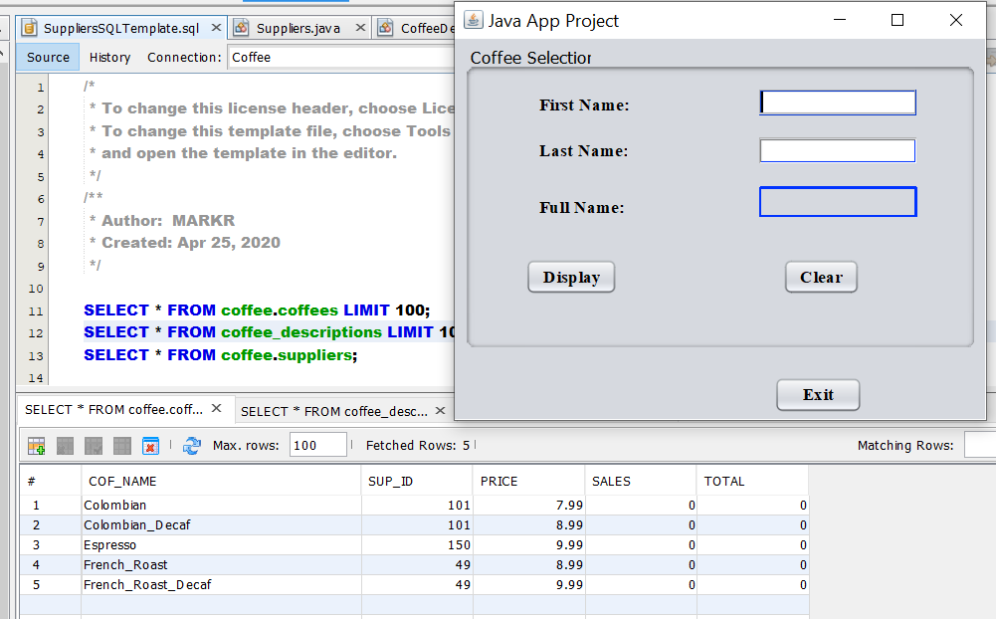

Figure 53:The Coffee Base File

First I’m going to try and base the user selection on the coffee.descriptions query. Of course the UI is going to have to change. For now though, figuring out how to link the TextFields from user description to the actual database(Data Binding I suppose). So lots of reading and testing ahead! 😊

4/27/20 9:00AM – Ran a few basic queries to make sure I am communicating with each table. Some of the tables have no info in them so:

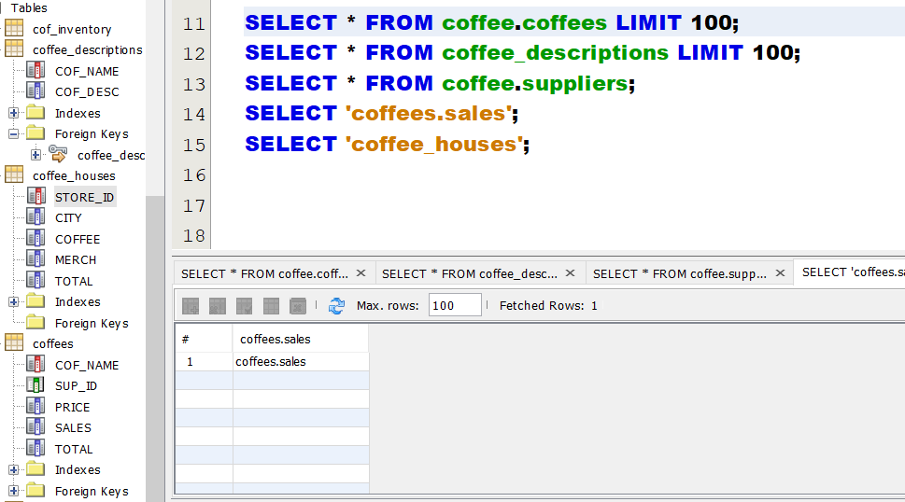

Figure 54:Testing the tables make sure I can query them.

Today’s assignment-work on the UI interface to make sure It’s pointing to the DB. Wish me luck! LOL.

9:30AM – I decided to start over instead of using the basic FirstName/LastName dialog box for my coffee User Interface. The practice will be good before I dive into my Retail Clothes App.

11:30AM – I’m stealing the ComboBoxWindow file from Starting Out With Java book. Comparing the CoffeeUI file NetBeans generated and that one from Eclipse, I see a vast difference in code styles. Luckily it still works after all it’s just a Java file. Guess I’ll copy it over to my javadeskapp folder and rename it to CoffeeUI since hopefully it will become the User Interface. This will take awhile to modify it for the Coffee Database Project LOL!

4/28/20 – 9:00PM Well after playing around a bit I finally got something at least,,LOL

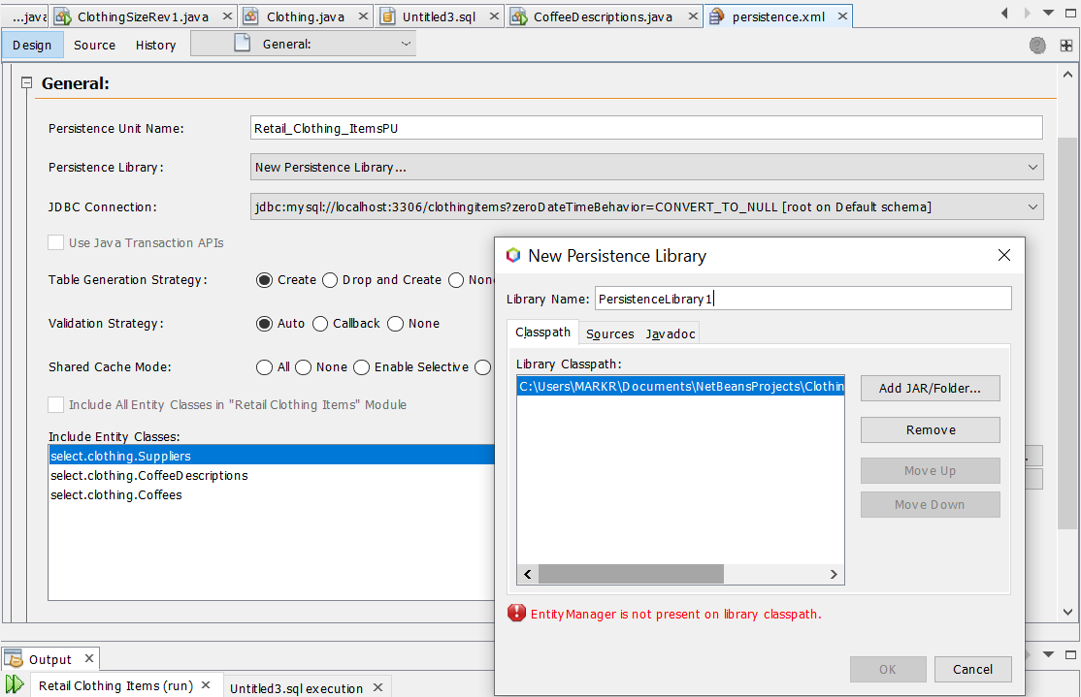

Figure 55: First shot at linking up with a DB

You need to poke around in your folders to find the Jar file and the Entity Manager error goes away. I thought this was pretty cool to:

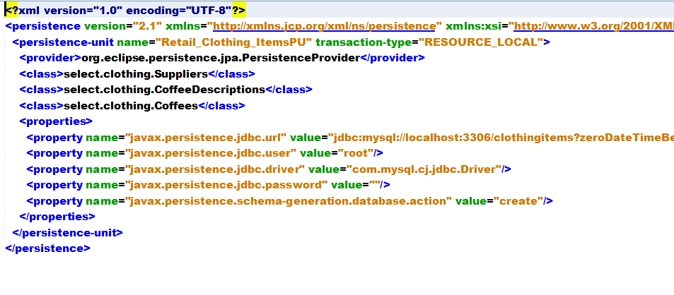

Figure 56:XML file generated from NetBeans

See the top one has the XML version, the bottom one has the Database Driver you are currently using. If your good at XML you could probably write your own. Here’s how I did it: You select file, new, scroll down to persistence in the popup menu, and select the Entity Classes From Database, click Next and you will see a list of entity’s to include. The list will depend on how you are connected to the server of course:

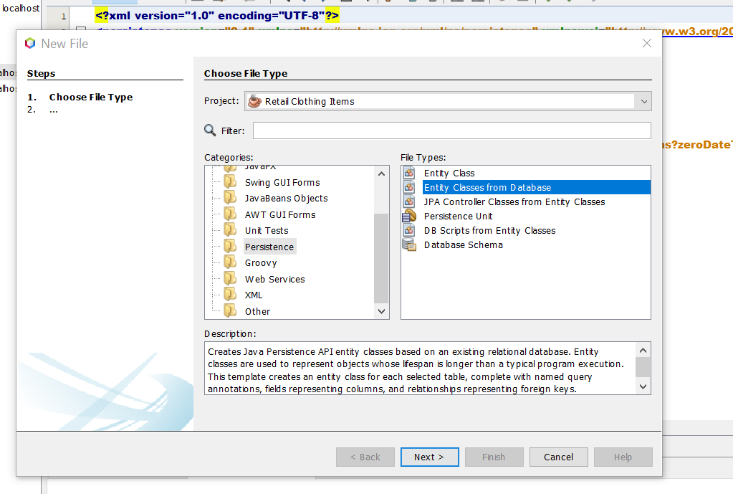

Figure :Persistance option in New File

Read the Description Pane also it gives you good info. When you click Next here you get the list of databases available to you to add. Next takes you to the Databases that are available for that connection. After you click next here you get the Mapping Options:

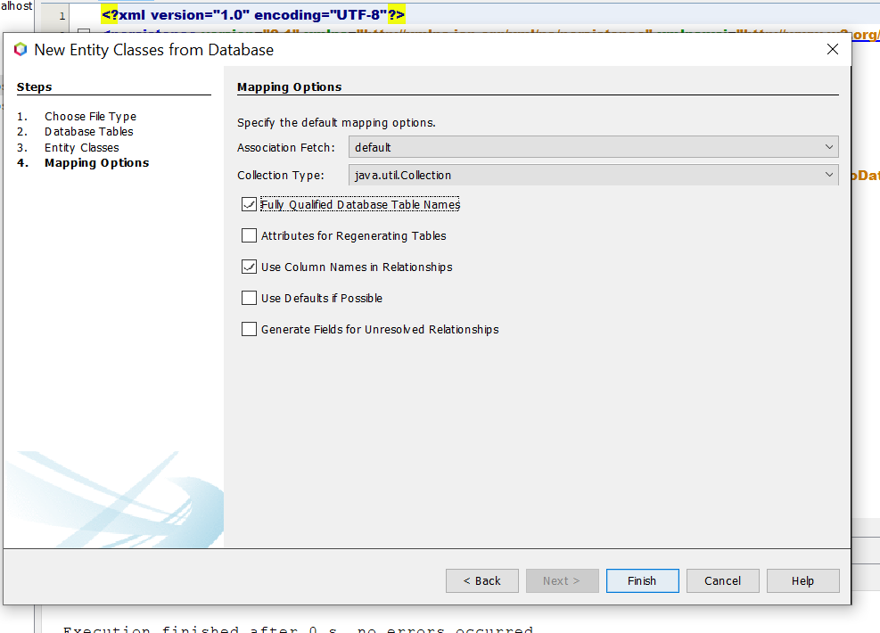

Figure 58:Last step-Mapping options

If I can get this:

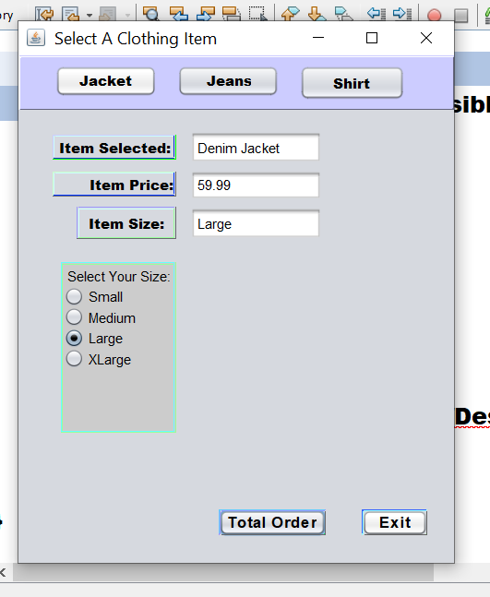

To hook up with this, I’ld be almost there! Can’t wait to play around with this some more tomorrow!

4/29/20 8:00AM – Here’s my starting point today:

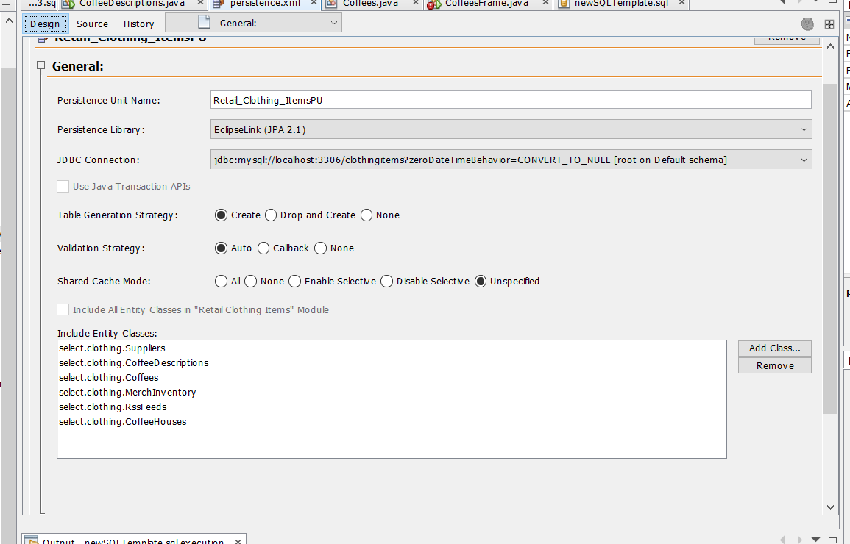

Figure 59:Design view from the Persistance XML file

When you go to the XML SQL file where the Query is you get this after the Mapping Options. If you click on the General Tab it shows you the available persistence units.

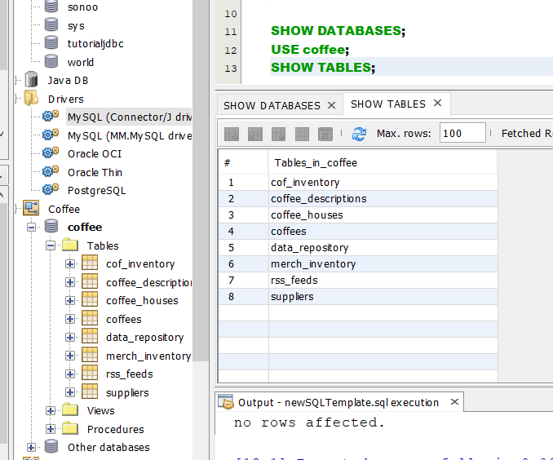

Figure 60:Coffee database is connected

Notice the coffee DB is dark, tells you the JDBC Driver is working correctly.

If you go to Properties Tab in the XML file it shows you the Units:

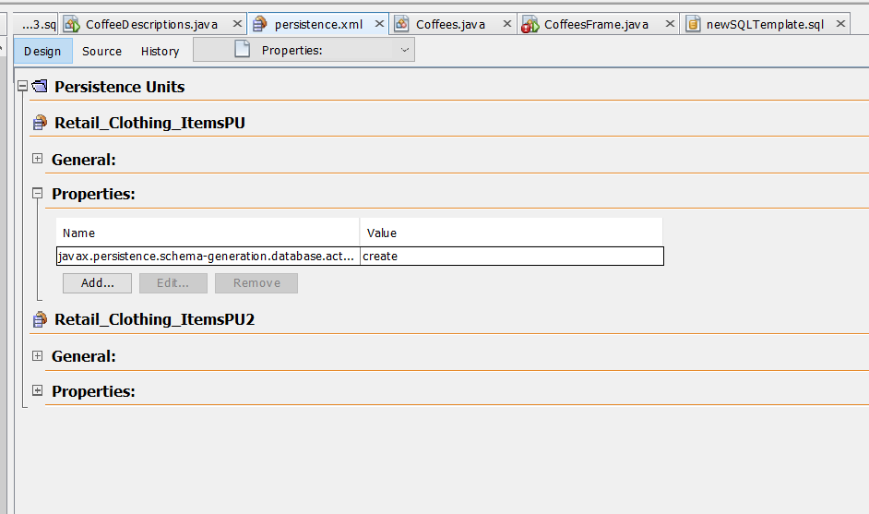

Figure 61: The Properties Tab in the XML File

There is my starting point today as a sanity check LOL! I’m going to read up on the Drive Manager and JConnector properties to get a little better handle on it.

5/7/20 – 8:30AM Been busy lately going through an interesting book I bought on Amazon called “Building Three Desktop Applications Using Java GUI and SQL”. The reason I decided to get it was to speed up my skills in Java/Database integration. One thing so far about this book is the typos and lack of a clear way of accomplishing tasks. For example: The book says make a JFrame Form and put the components needed in it, 10 JText Fields, 10 JButtons, etc,,

In the book it looks like this:

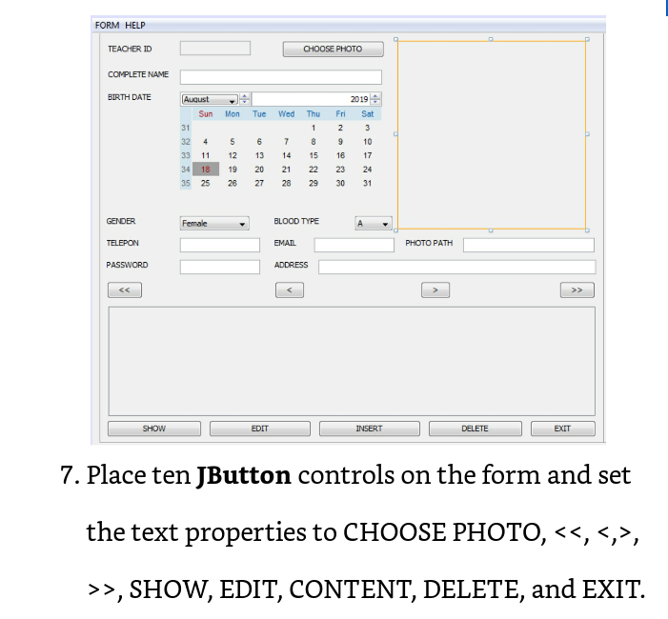

Figure 62: General Layout of Components

In reality, if you just go by what the book says (creating a Frame Form and adding so and so components with so and so buttons like the text says), in reality you get this when you compile the file for a test run:

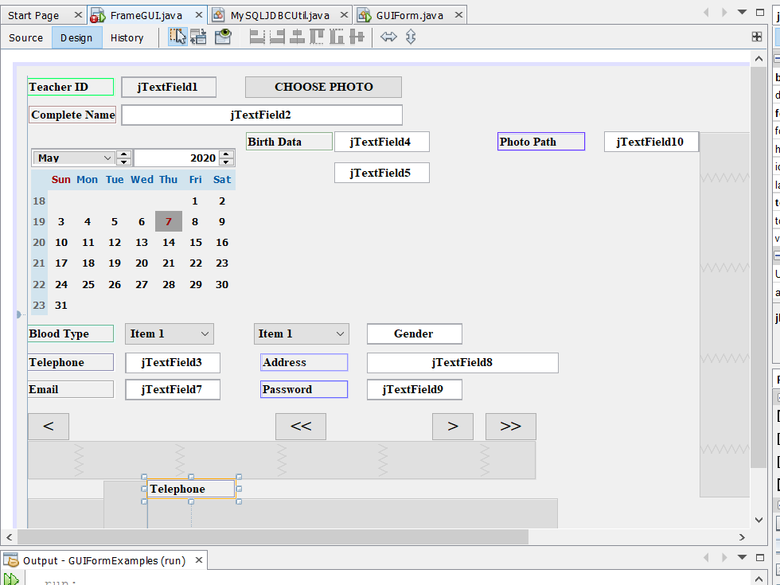

Figure 63:Actual layout using just a Frame Form

I went back over the tutorial a few times and it never really explained how the book layout was made, and believe me I tweaked the parts around several times but couldn’t get the same look, here’s a rendered layout as it stands now:

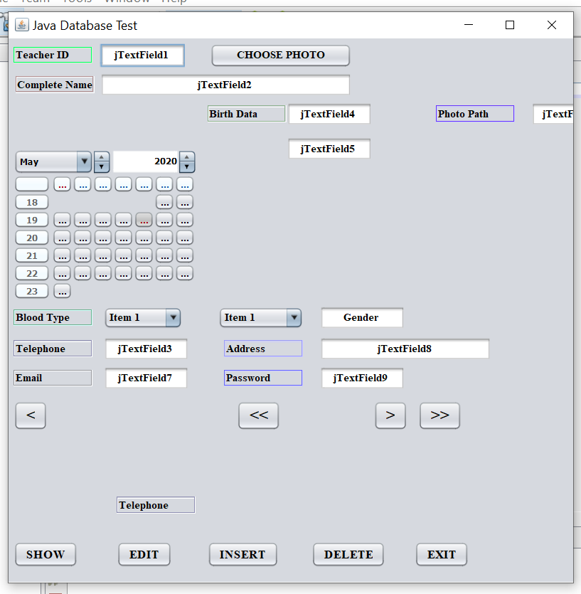

Figure 64: Layout after selecting Run File.

As you see it needs work! LOL! The book is not very old either so,, Something’s missing to achieve the desired layout. I figure I would break it up into several JPanels inside a JFrame and try it that way. If one was to try this book’s projects without a descent grip on Java coding and NetBeans they would probably have a hard time. I don’t want to get into the SQL aspect of this until the layout is halfway descent! But I can already see where this is going when changing the attribute names in the JTextFields and JButtons under the Code Tab in the properties sidebar. The book doesn’t tell you the details of accomplishing some of the tasks. So, guess I’ll spend time on re-organizing the layout on my own! Several JPanels using a Flow Layout will probably work I figure.

1:00PM- After playing around with the layout and adding the jbChoosePhotoActionPerformed event on the choosePhoto control button, it got really messed up after I pasted the code in where it’s supposed to be. So I better Save the file first right here:

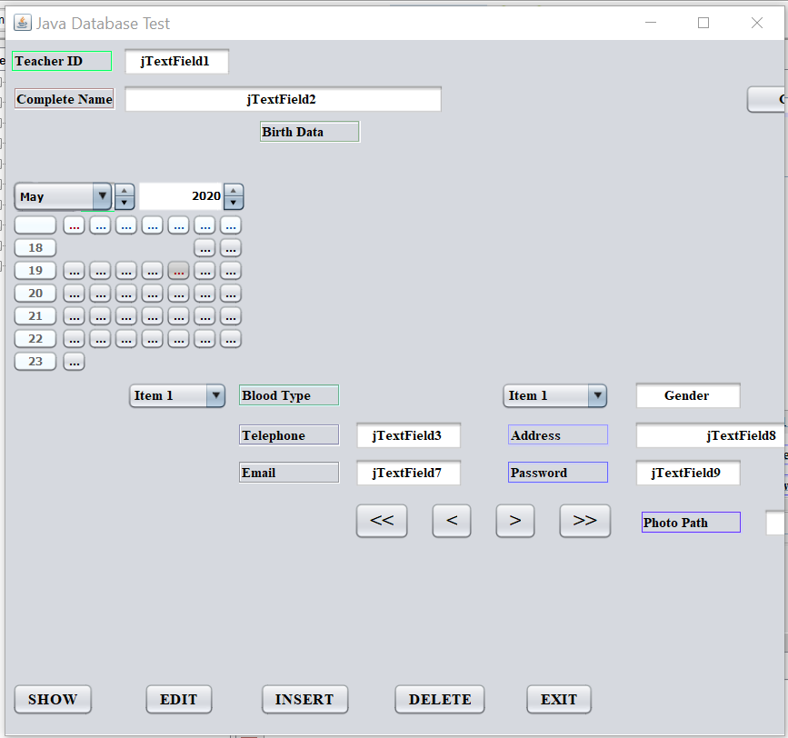

Figure 65: 5/7/20 1PM before adding photo controls

Added a Backup Folder in the Examples Directory and saved the files there under <filename>Rev1. Opened up the working files and verified they’re fine. So,, think I’ll just hand code the Action Event stuff in so when it fucks up I’ll have a better clue where it is! 😊

Holy Shit! I looked ahead to get a quick look at what all this application will do, it seems the perfect thing for me to learn a lot about my final project, check this out:

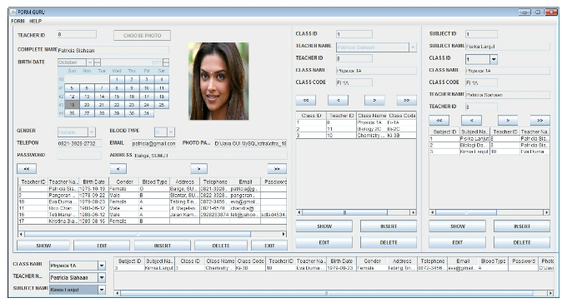

Figure 66: The final School Project App

Wow! Queries across three tables, and showing the results in one app! Hope I can do it, with all the typo’s and glossing over steps this could be tough! Let’s dig in!

05/10/20 10:00PM – Yeah, it was tough! Can not get that damn JConnector to work in Java. Tried everything I could, looked at numerous tutorials,,etc,, Nothing but errors. DAMIT! That damn book doesn’t help either, it’s so vague and I never did find the source code. So, back to square one I guess. I posted my problem in the Learning SQL forum but hadn’t heard anyone reply back yet. I might just scrap it and start over, I must have missed something stupid! 😉

05/11/20 7:00AM – After looking at a few files today and reading about J-Connector in the Java/SQL Developers guide, I might have a game plan. The FrameGUI file is screwed up I think.it has errors pointing to the JCalGuru file I got from the tutorial book. I logged into the schooltest J-Connection, it looks good school database is dark colored meaning I’m in I think? LOL So I’m looking at the MySQLJDBCUtil file:

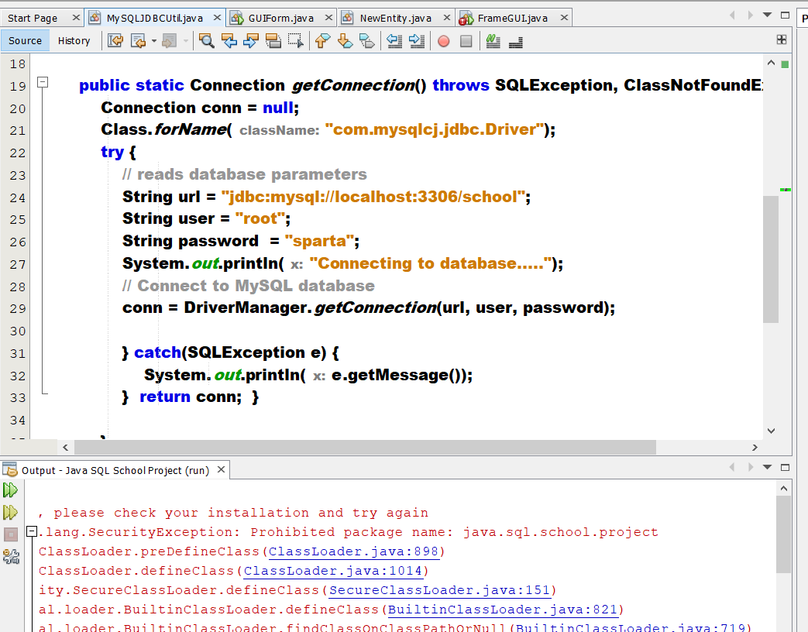

Figure 67:This file could be my new test file.

It has the Class.forName statement, I’ll go through the Java/SQL developer guide and see what I can come up with. The pathname to the driver has com.mysqlcj, I got that right from the connection properties, I think that path has something to do with it. I’m going to figure out a way to run this file. With a combination of the hello file in the Developers Guide and this hopefully something will work! 😊.

11:00AM – Yeah I got something at least! It says I’m connected so, if it doesn’t work now when I send a Query from Java, it must be my syntax. Here we go!

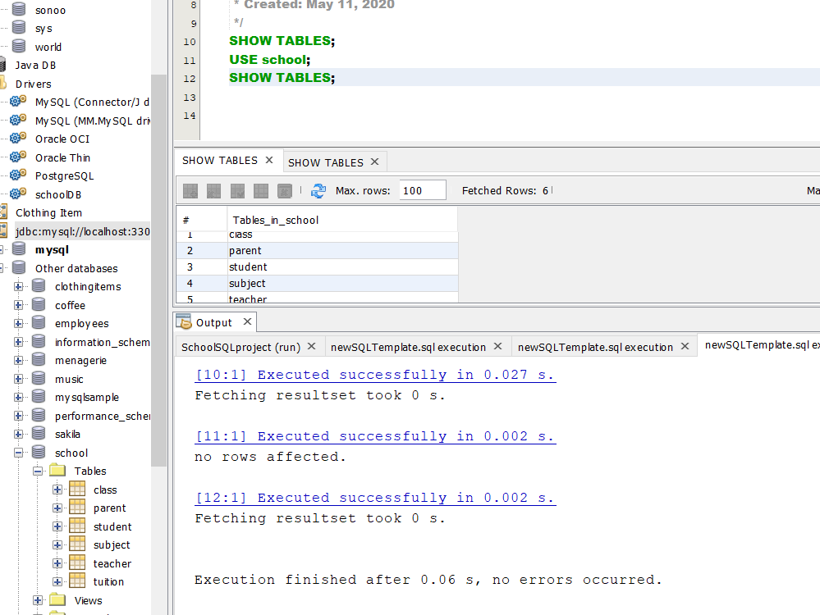

Figure 68: Confirming I am connected to the School DB with the correct driver

DAYUM! So close!

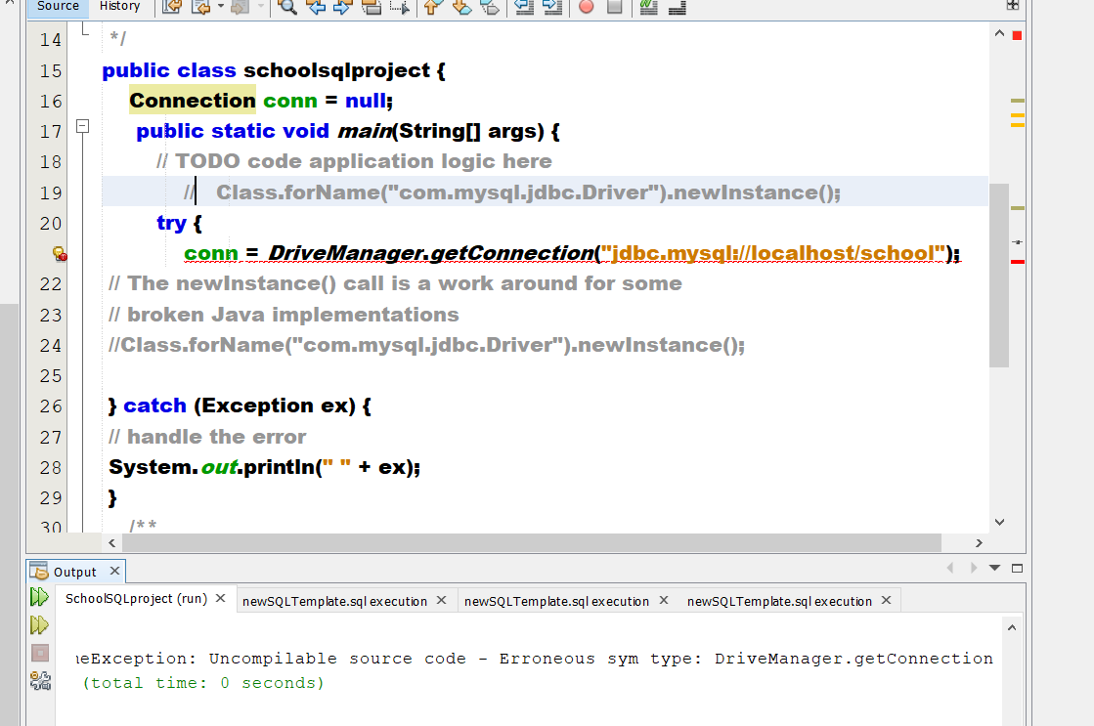

Figure 69: Almost there!

1:15PM – I think I got it! Created a new project, a new connection, went to the connection properties. Checked those out:

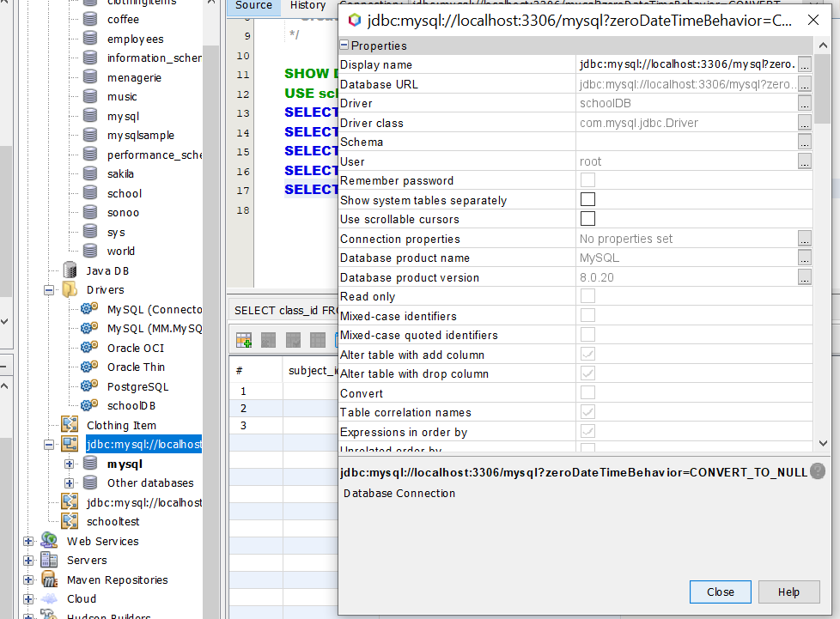

Figure :Finally! Think I got it!

YAY! Now to redo the whole tutorial in this Project Folder: SchoolSQLProject/SourcePackages/<defautpackage>. This better work damnit! 😊 OH almost forgot the most important step, putting the mysql-connector JAR file in the MySql/MySql Server 8.0/lib folder.

8:00PM – I think I have something! There was an extra curly bracket { in front of the try/catch block,,HAHA! No more errors in the Database Connection File: MySQLJDBCUtil. YAY ME! I may have figured it out! 😊 I think I still goofed it up though,I made the Container a JFrame, not a GUI Form.

10:15 – DAM I was right! I just tested a new file named “SchoolForm” and it works much better. You have to be careful which JCalender you choose and the size so it will show every day/date.

05/12/20 10:00PM – Pretty rough day of coding, didn’t get much done. Almost had the fileChooser Action Event worked out for the Teacher Photo. I was studying the Java Swing book and found the section that talks about the fileChooser and compared it to mine. Pretty sure I know what to do now after studying the SimpleFileChooser file. Hopefully I’ll have this squared away tomorrow!

5/13/20 6:00AM – Today I hope to get a handle on communicating with a database through Java. Sure I can query the database with statements right from a Java SQL file, but to do the same from a Java Application is different. In the Java Swing 2nd Edition, there is a chapter on fileChoosers, I’m going to pick up where I left off last night and modify it so suit my needs, that’s the plan anyways. Here is my starting point from SimpleFileChooser:

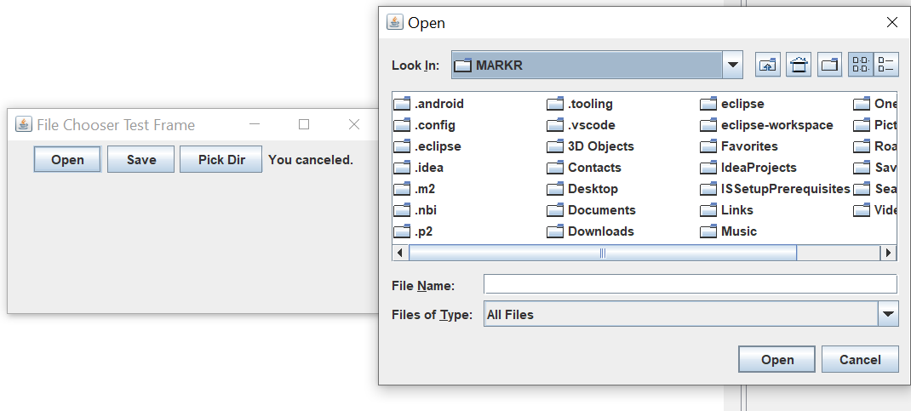

Figure 71: File Chooser Starting Point

That’s exactly what I’m looking for, change of plans though. I need to focus on interacting with the School Database from Java. then come back to this. If I don’t figure that out the whole project is for naught. I’m going to create a new file called TeacherTable, with the method show teacher table from the Desktop Application Demo and see how that goes.

11:45AM – Almost there! Check this out!

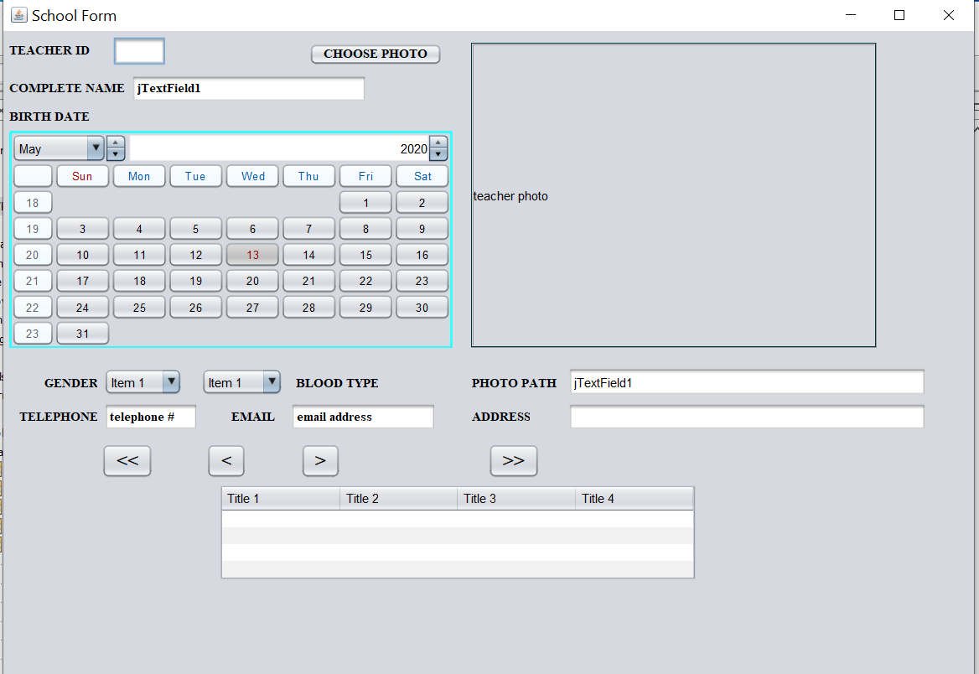

Figure 72: First Pass, the Table/DB Connection needs work

Not bad for first time! Lots of work to do yet 😊.

10:PM = Wow is al I can say! The book I bought on Amazon “Java Spring 5 Recipes” is totally awesome! Well worth the money! Spent a good bit of time checking it out, especially the Tables Section. It’s just what I need to fill in the blanks to Query a DB in SQL and spit out the result table in Java. I can see I’m going to be spending a lot of time on these tutorials then incorporate them in my other project, the School one in “Building Three Desktop Applications in Java and SQL”. This book I have now will fill in the blanks on creating Queries and Tables. Between these two I should master Java/SQL integration. Interestingly it states to build the database before the application, which kinda makes sense so you have a good idea of how the application should go. The TableFeature file is a good place to start!

* 05/14/20 7:00AM – I’m starting to see how all this integrates together. In the “Spring 5 Recipes” book, it walks you through a whole application design in Chapter 9 Data Access. Starting out with a basic Vehicle class to derive objects from for the Java/SQL tutorial. This chapter is going to be very important to grasp the concepts so, it will take awhile to get through. I’m going to use the JDBCTutorial Connection in MySql for the Vehicle Database. I’m going to take notes here for myself. The files are under Recipe 9 Vehicle.
* First you create the CLASS for the object in Java, in this case a basic Vehicle file (in the Retail Item project it would be clothes. Or item,,etc,,

11:00AM - UhOh! I hit a snag! This particular book relates to using Java with Spring Framework! Do I really want to start learning another app? GRR!! Guess I’ll have to decide where I want to go now. Oh and it uses Eclipse, which is ok with me but,,,I’ll get sidetracked again!

1:00PM – After much thought, I’m going to take a step back and use the school project and see if I can figure out getting a table on the SchoolForm, I’ll use the code showTeacherTable and put it in the form hopefully! I’ll need to get a handle on doing it in Java before I try the Spring 5 Recipes.

3:00PM – After adding code to the SchoolForm, I discovered there were no fields called out for the components.

3:30PM – Well fixed most of the errors, except the ChoosePhotoActionPerformed, guess I’ll just remove it and deal with that later.

6:00PM – Think I’m changing course again, after playing around with the school project for awhile, I could not get it all to work, I need to start simpler I guess, or another project from that book without so many typos! Or mistakes in the book, either or! I do like the concept the project portrays, I could adapt it so many ways once I get it down. I might even try small, use one of the sample files from the Swing books I have and modify it, start small. It has the Table code itself done, maybe I can get it to query a database and get a result set using Netbeans.

7:30PM – I have to keep this in mind: The **Table Feature File and Simple File Chooser are two files I need to play around with for my projects.** As a matter of fact, I’m going to save the TableFeature:

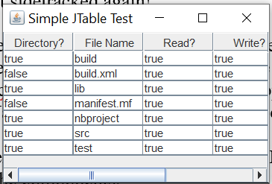

Figure 73: This is my base file for a DB Table

**05/15/20 6:30AM** - These files though are created with just a JList of items, the key is to create a Result Set from a Query in Java and build a JTable. After much playing around and trying some things yesterday, I’ve decided to give it another try with the Kindle book “Building Three Desktop Applications”. I’m hoping this part will be clearer and hopefully I’ll have a better grip on that aspect of Java and MySql integration.

**11:30PM** – Well that didn’t work out so well! Tried one more time with that book, it sucked. Never did get the STS install going, oh well some other time. I’m taking a different route. In my Java Swing book on Kindle, there seems to be some good stuff on databases and JTables. That’s my plan for tomorrow.

**05/16/20 4:00PM** – Well that didn’t work out so well either! LOL Dam I gotta stop getting myself sidetracked. I spent all day wasting my time on trying to figure out IntelliJ and how it integrates with Spring. Giving up on it for now and back to the School DB project. I’m copying files from the Java Swing book Chapter 15, good stuff on tables. I’m not going to let myself get sidetracked again! HAHA.

**5:30PM** – In the Java Database Bible, there’s an excellent section on JTables, page 180 in Chapter 5. It shows how to build a DB management system to create and edit DB’s. Exactly what I wanted to learn. I’m going to make another project named “Table Test” to mess around in, I’ll put the other table example files in there also.

**05/17/20 7:30AM** – Today I’m going to attempt to get a few files together and try a query from the Coffee DB and get a Result Set into a table. File QueryTableModel saved to CoffeeTableModel, and TableFeature saved to CoffeeTable. These are based of the Java Swing book in Kindle, MySQL JAVA Developers guide, and Java Database Bible with others mixed in. I’m having some issues getting the connection right in a java file to send a Query, but I can Query the SchoolDB from a Java SQL file. Perhaps I should make a reference to the SQL Query file, to get the ResultTable right? Hmm…

**7:00PM** – Nothing seems to be working, I tried EVERYTHING to get a SQL Query from the Java file, and I mean everything! Put the driver in different folders, changed up the DB URL and Driver so many times and combinations, nothing,,,damit!

Well, I went and did it, removed MySql. I’m tired of playing around with it, So,, my choices are Microsoft SQL or Oracle 12c hmmm,,,,

**05/18/20 11:00AM** – What a freakin’ pain in the ass! I went ahead and did it, removed MySql, Netbeans etc,, After several installs and reboots 4 hours later, I’m about to start over again! HAHA! I decided to go with Microsoft SQL Server Studio. I was really torn between that and Oracle 12c. I have more experience with Microsoft products anyways when I was running my server back in the day. I got the updates for everything I think, just need to install the JDBC driver, and hopefully get Java to work with SQL. I forgot about the Cloud for some reason, probably because of problems at this time,,LOL! I’ld like to eventually get there and use Azure or AWS services and play around with that.

**7:00PM** – Well hopefully this all works! I found a tutorial on setting the CLASSPATH for the Java DB Driver. I sure as hell hope this works! On the Microsoft Docs website there is a whole section on the JDBC Driver. Installation and usage. The code is working with the Adventure Works Sample Database. Looks like I got my work cut out for me to test the code as is, then modify it for my needs. That means I’m going to have to go through the Microsoft Tutorials and Docs which will take weeks! Oh well.

The file names I’ll use are ConnectUrl, ConnectDatabaseSource,SQLDatabaseConnection. Oh! DUH! These are in the sqljdbc folder! Dumbass! LOL I may just end up making a whole new project again ☹.

**5/20/20 2:30PM** – After a crash course in SQL Syntax I’m about ready to try the Windows JDBC Driver. I’m going to use the CoffeeDB since I think I have some good Connect files in there instead of rolling my own,,LOL I found a nice method on the internet of course abt adding it to the Classpath. It’s so easy! Just right click the project in the project pane, and click Properties. Select the Libraries folder in the Categories, and expand the button when you see add jar file, select it:

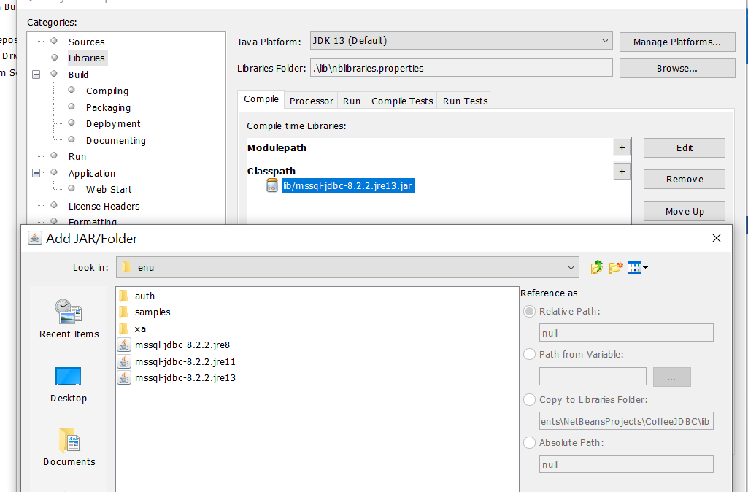

Figure 74: The JDBC Driver added to the Project Classpath

Just make sure you select the right one for your version of java, mines jre-13. Now comes the fun part, see if I can get it to work in SQL Server! 😊. I found this little blurb on the Microsoft Docs site:

*“The JDBC driver files available on the GitHub repository for the Microsoft JDBC driver are the core of the JDBC driver and are under the open-source license listed in the repository. The driver packages on the* [*Microsoft download page*](https://docs.microsoft.com/en-us/sql/connect/jdbc/download-microsoft-jdbc-driver-for-sql-server?view=sql-server-ver15) *include additional libraries for Windows-integrated authentication and enabling XA transactions with the JDBC driver”*

This is good to keep in mind for transactions I think.

**9:15** – Wow! I almost got something! Using this connection URL:

*“String connectionUrl = "jdbc:sqlserver://localhost;integratedSecurity = true";*

I’m using the ConnectURL file. Since they are both on the same machine, Log on as local machine Security. Makes sense I guess. Here’s the error code:

*“com.microsoft.sqlserver.jdbc.SQLServerException: The TCP/IP connection to the host localhost, port 1433 has failed. Error: "Connect timed out. Verify the connection properties. Make sure that an instance of SQL Server is running on the host and accepting TCP/IP connections at the port. Make sure that TCP connections to the port are not blocked by a firewall.".*

So it looks like at least its trying! Further than I ever got before.. 😊. I’ll have to check the port and the firewall. Look at this I discovered when checking the Monitor Activity:

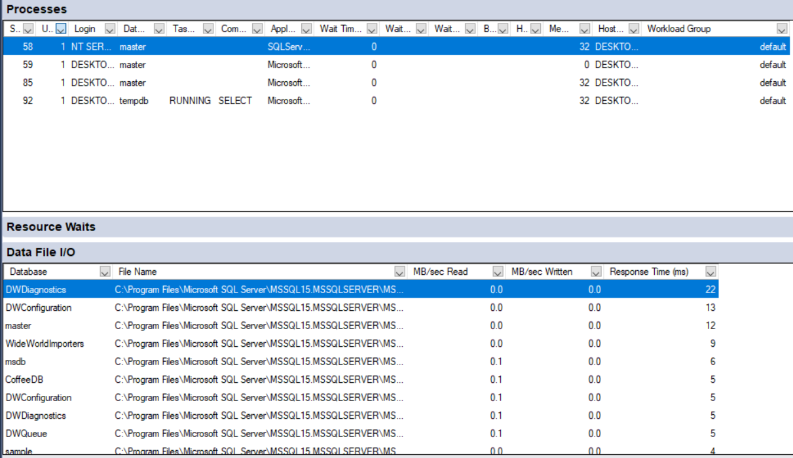

Figure 75:Confirmation of activity from my Query.

Here is where you get this pane under Window, then Windows:



Figure 76:Communication to Server

I’m going to have to investigate this further tomorrow.

05/21/20 7:30AM – Today will be frustrating, tracking down these server errors:

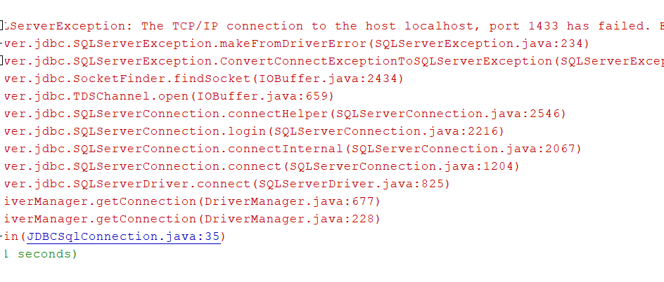

Figure 77:Port failure,connection timeout, and TCP/IP error, and Driver

This is going to be a pain in the ass I’m sure, multiple failures to fix! At least I’m actually getting a connection though! I’ll start with the TCP/IP and Port 1433 failure first, the work my way down the list.

Here’s the actual line in the code the error generated(JDBCSqlConnection.java:35):

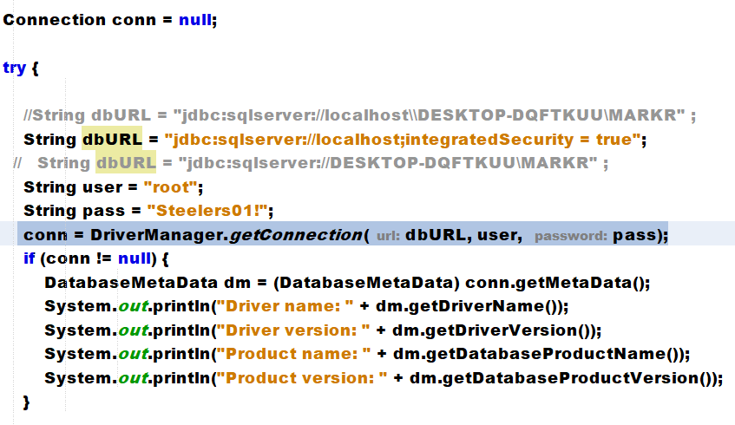

Figure 78: The Java File Statements for the driver.

I’m thinking I may have to add the port number after localhost, or point to another open port on both ends possibly, we shall see.

**05/23/20 7:30AM** – I re- discovered/remembered a few things about windows, mainly the command console. Back in the day it was called just DOS command prompt. My Java programming is taken to a new level now. I finally figured out how to set the ClassPath in these new Windows Operating Systems. You have to get to the Environment Variables in the Advanced Systems Pane through Control Panel:

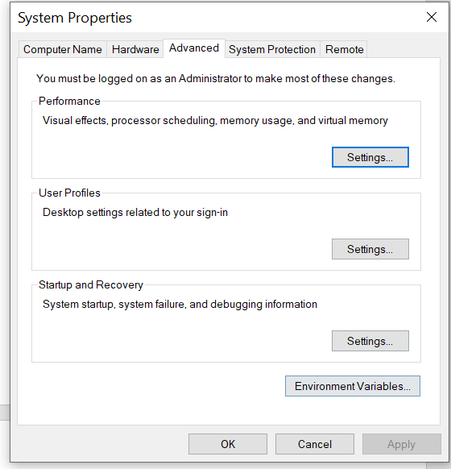

Figure 79:System Properties Pane with Environment Variables

You can get there if you type “System Properties” in the search tab, or through Control Panel, Advanced Settings. Select Environment Variables:

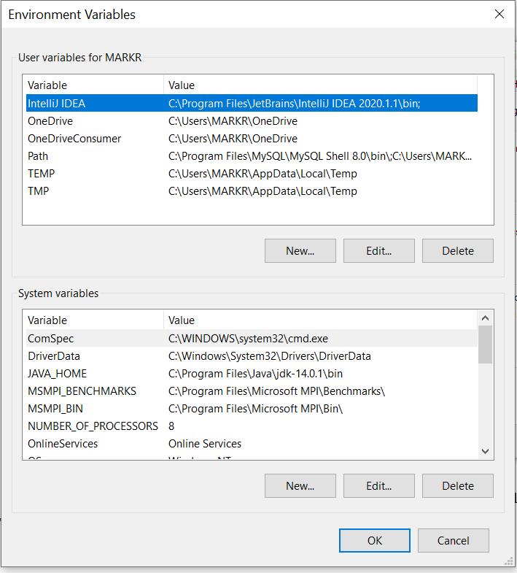

Figure : Setting ClassPaths for Java

Notice the JAVA_HOME path, you set that by navigating to the Java folder/bin path, and right click, copy address, then come back here and select New, JAVA_HOME, and paste the file Path in the URL field:

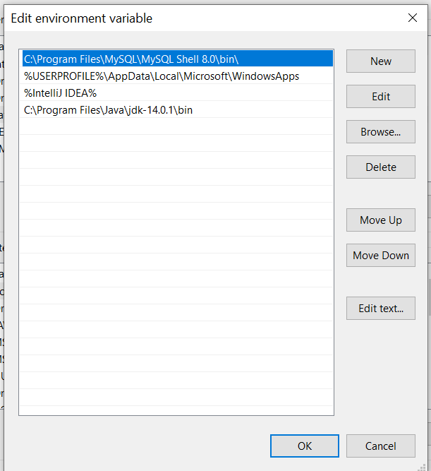

Figure 81: Setting the Java Environment Variable

The way to verify it’s working correctly is with a javac Command Prompt:

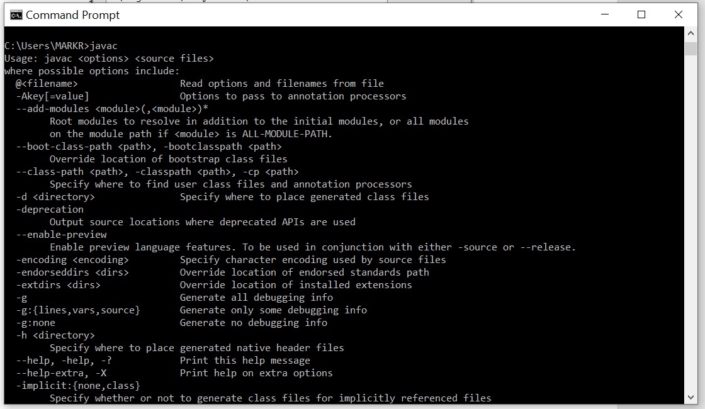

Figure 82: Verify the Java Compiler path is set correctly

I’m putting this here so I remember how to do it! HAHA! 😊 When you type “javac” in the command prompt, this verifies the compiler path is set. Also, I’m switching course and broke down and bought a class in Udemy on creating a Store Front with Java Servlets and Databases. Hey it was only 20 bucks! And I needed it to learn new tricks/methods to do Java development correctly. I’m pretty sure that’s why I was having so many problems with getting the Database talking correctly through Java statements. So far this course is great, he walks you through the theory and design phase on how to set up the structure of the project with JSP Sevlets and web pages,,etc,, This is just what I needed, some guidance as to how all the pieces fit together. ALSO, I installed Spring Boot correctly in Eclipse IDE! LOL but that’s for another day down the road aways. This will be awesome if I do it correctly locally with MySql and Apache Tomcat server installed and verify everything is good, getting some free Azure space in the cloud is next and play around with that. I’ll have the needed skills for a well paying job hopefully! LOL!

1:00PM – WHEW! That took a few hours! Getting Apache Tomcat up and running, hopefully I did it right. First I downloaded the wrong build, apparently there is a page for just a normal windows installer, somehow I missed it! Good thing the Udemy Class video helped me out! It appears to be running ok now, guess we’ll find out soon! 😊 .

I opened up the MMC snap-in and it’s looking good:

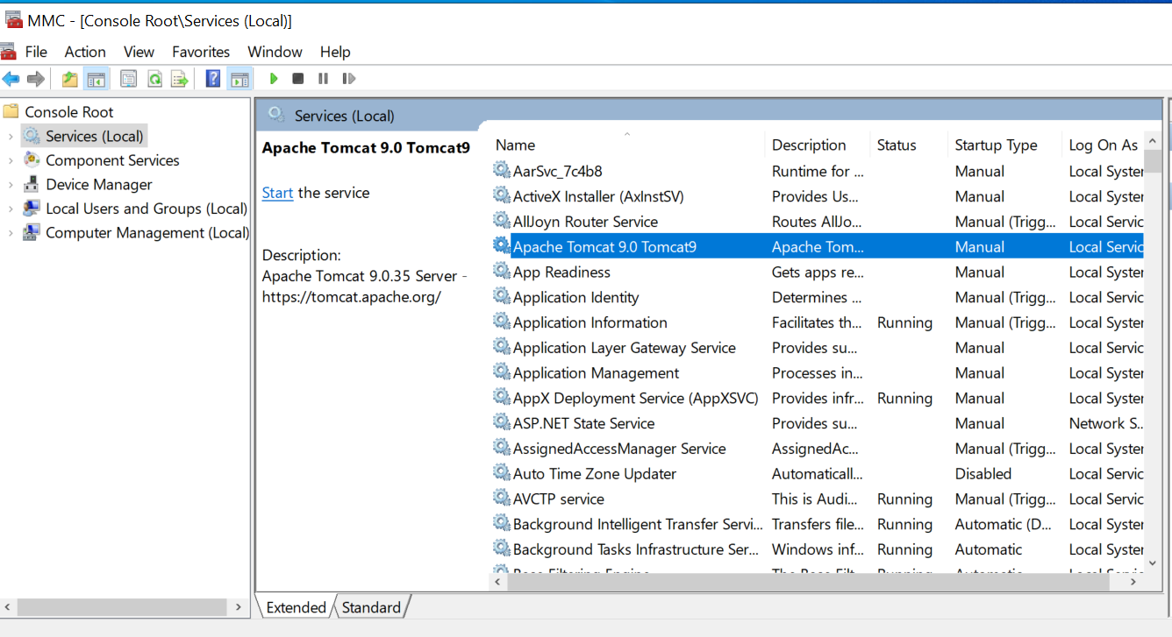

Figure 83:Apache Tomcat as a service. Manually start when needed.

Looks perfect! Just click the Start service when it’s needed for testing. Checked the resource monitor after starting the server, looks good to go!

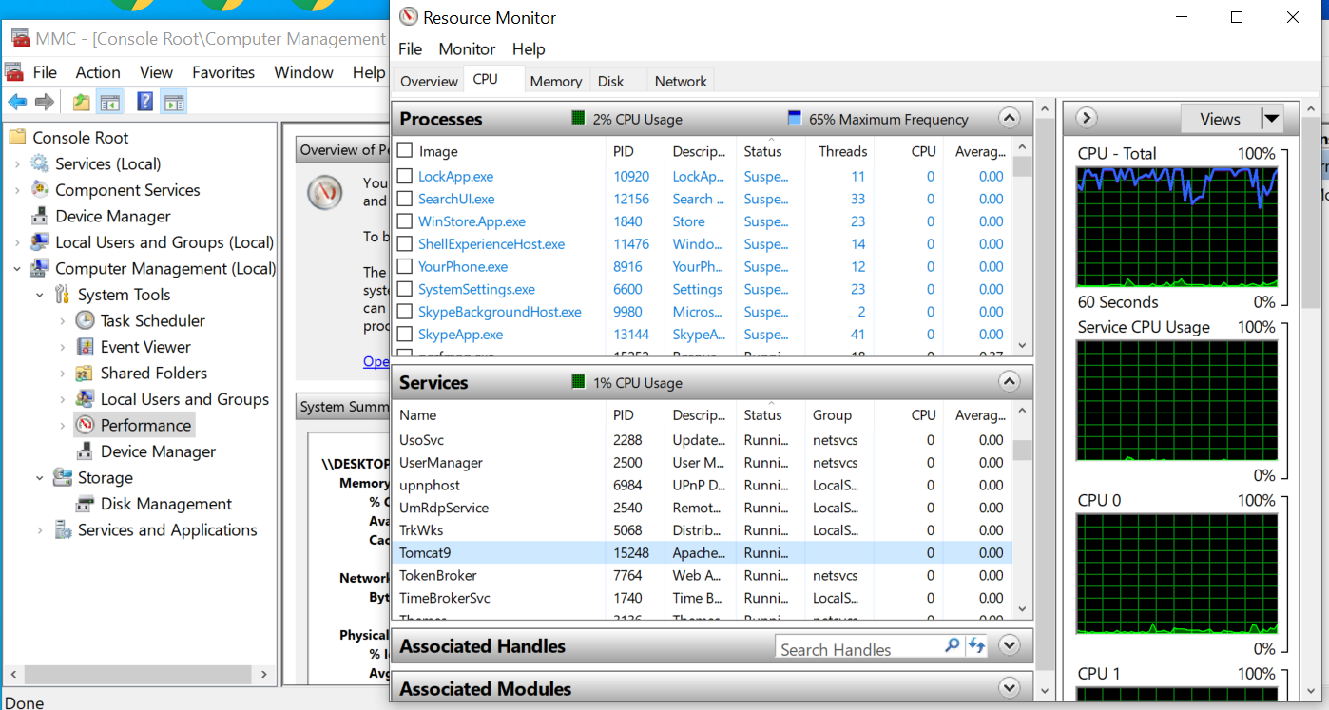

Figure 84: Resourcr Monitor from the MMC Snap-in on desktop.

I started the server and checked it by typing in http::/localhost:8080 and here we are:

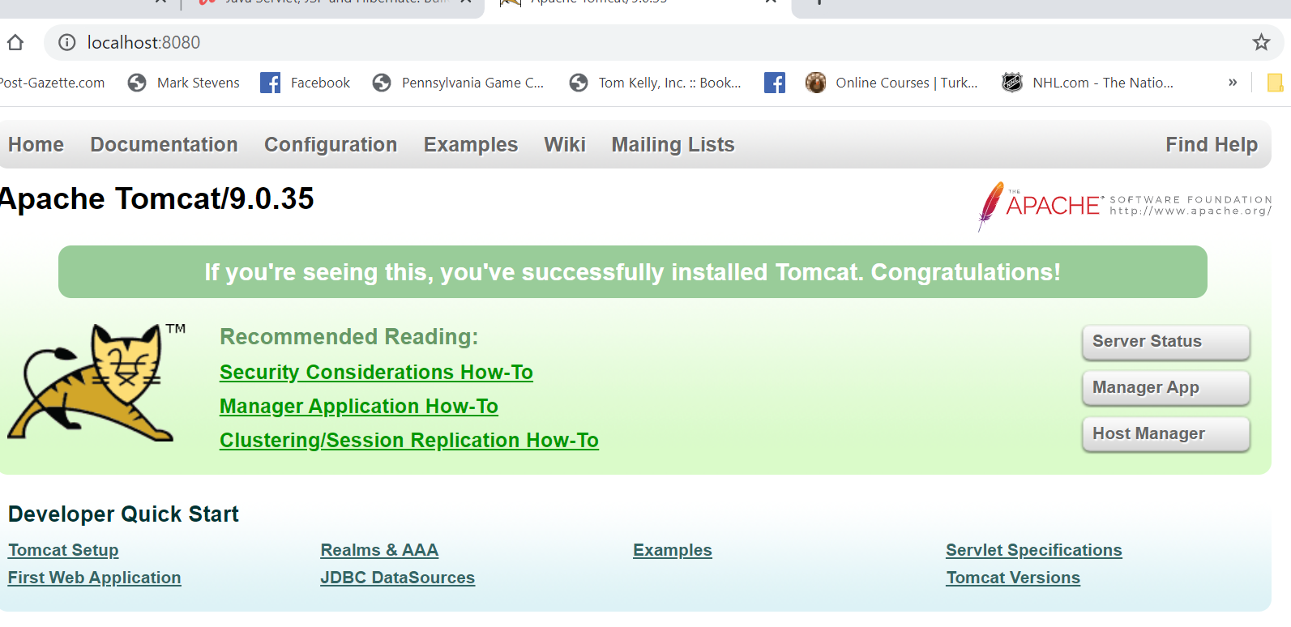

Figure 85: Verify the server and ports (8080) are working correctly.

Here’s the Admin Page after entering username/password from the setup:

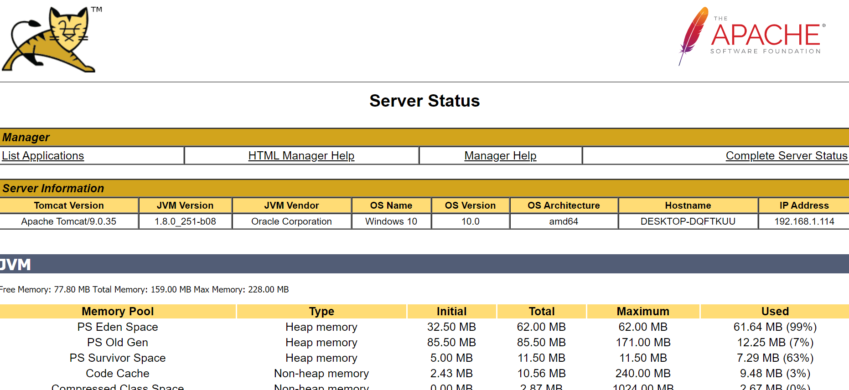

Figure 86:Admin Page after login.

**05/24/20 8:00PM** – Wow! This is pretty brutal! I think I did everything right. I’m so glad I spent the 12 bucks to get this course of Udemy, I would have never figured this out by myself!

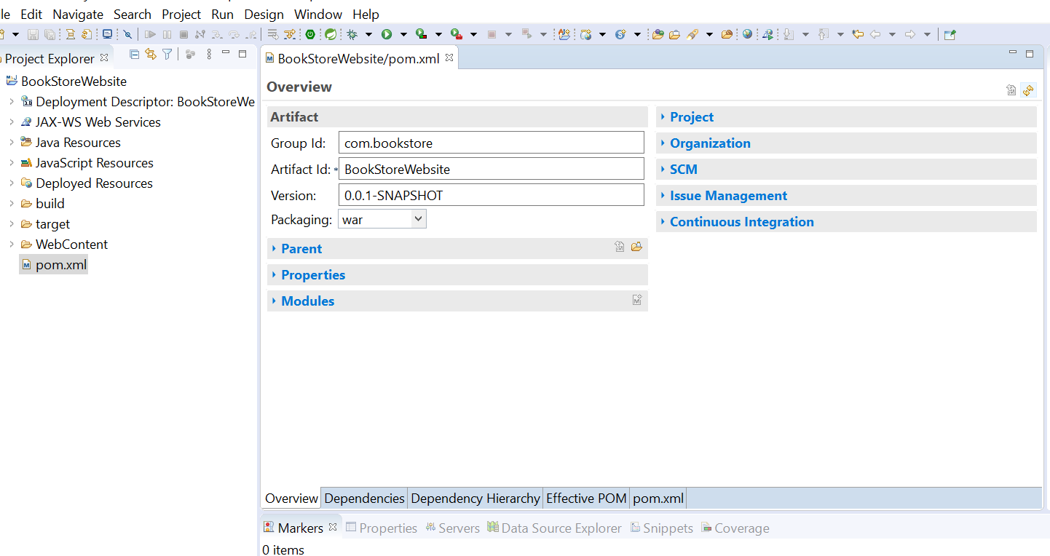

Figure 87: Pom File after clicking on Overview Tab along bottom

All those properties can be expanded, and modified I guess! DAMN you can get lost in this stuff! I’ld hate to try and troubleshoot all this stuff when it doesn’t work! I should have been taking screenshots along the way, oh well. Here is the dependencies tab which we will be adding to.

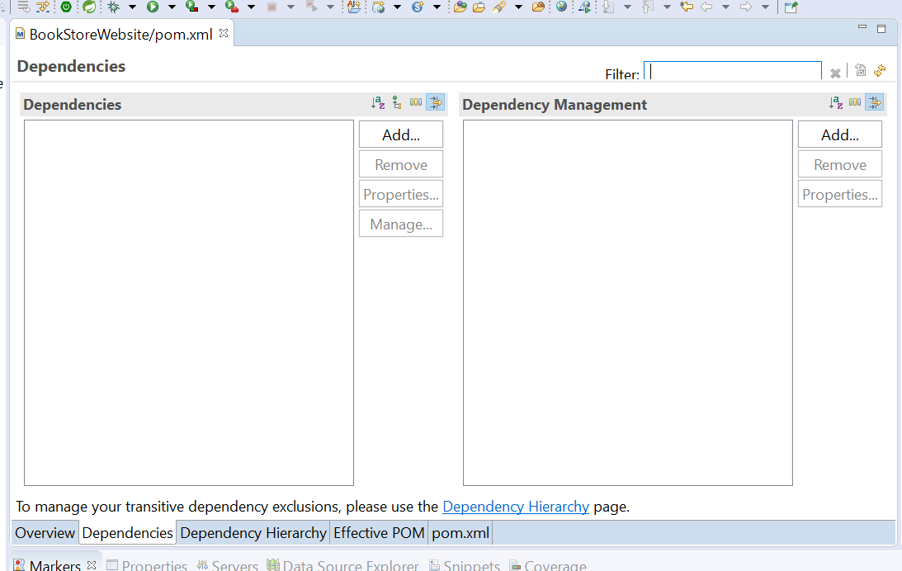

Figure 88: Dependencies Tab, empty so far.

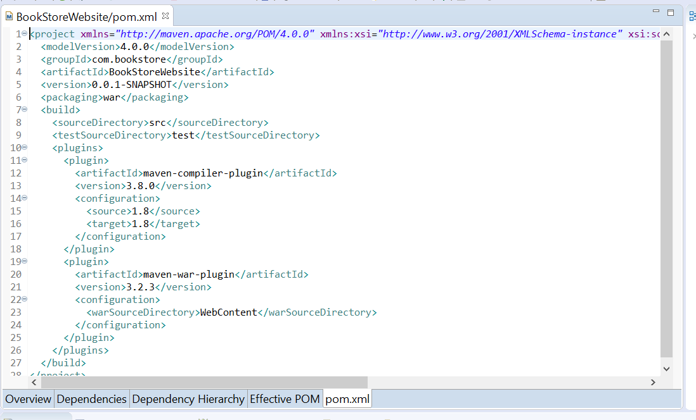

Figure 89:XML File generated with Project Settings

The settings are in there, pretty wild it generates the XML File for you! Awesome!

9:00PM – Now you have to go in and configure dependencies for Maven:

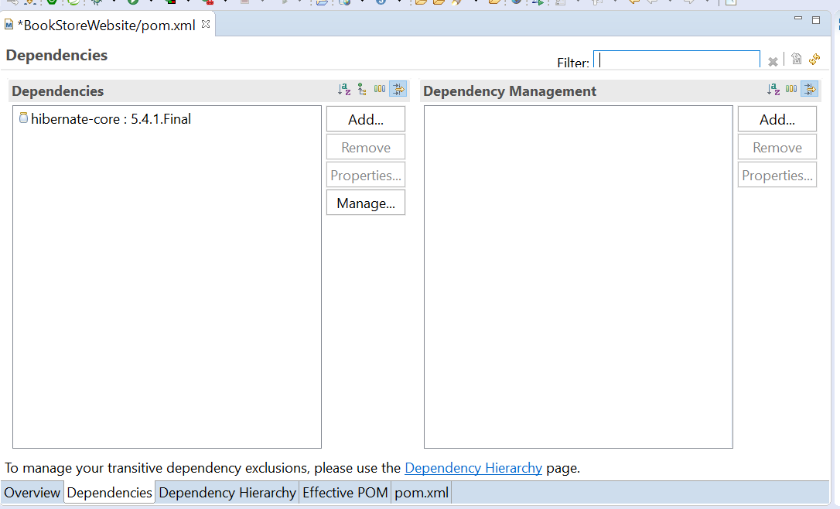

Figure 90:Maven Dependencies

It’s basically the org.hibernate, hibernate-core, and the Version from the Maven Central Depository, when you click add a panel comes up to add them and then it Adds the file to the Pom.xml file:

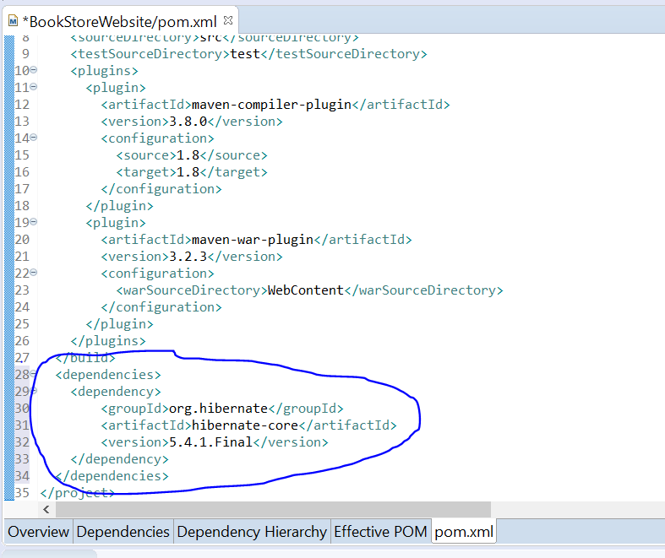

Figure 91: Dependencies added to POM file.

This is the same information you enter in the Add Pane. This is so cool if it works! LOL! 😊. Can’t wait to start the Spring 5.0 class, I’m sure it’s very similar if not directly related. If everything goes right, you will get this when you save them:

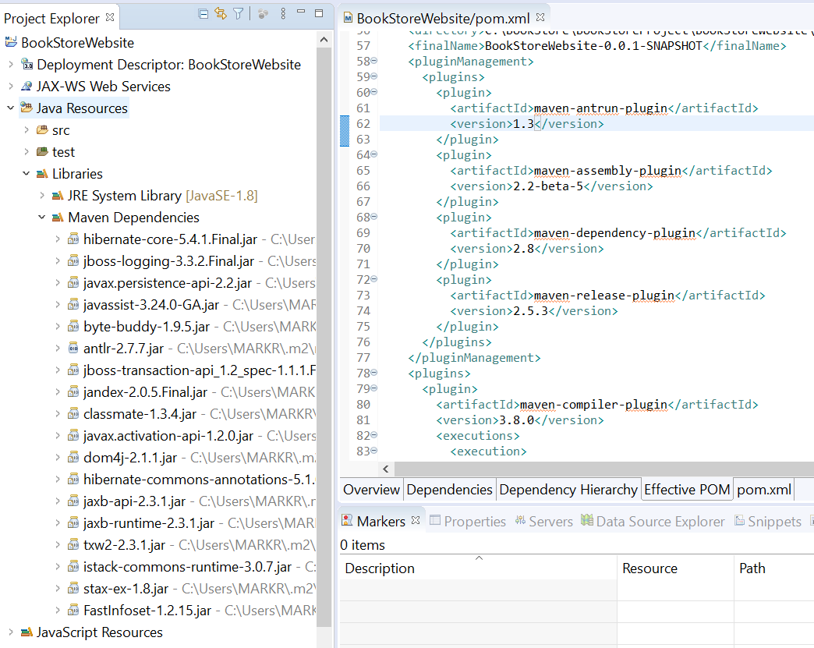

Figure 92:Maven Dependencies Added to project

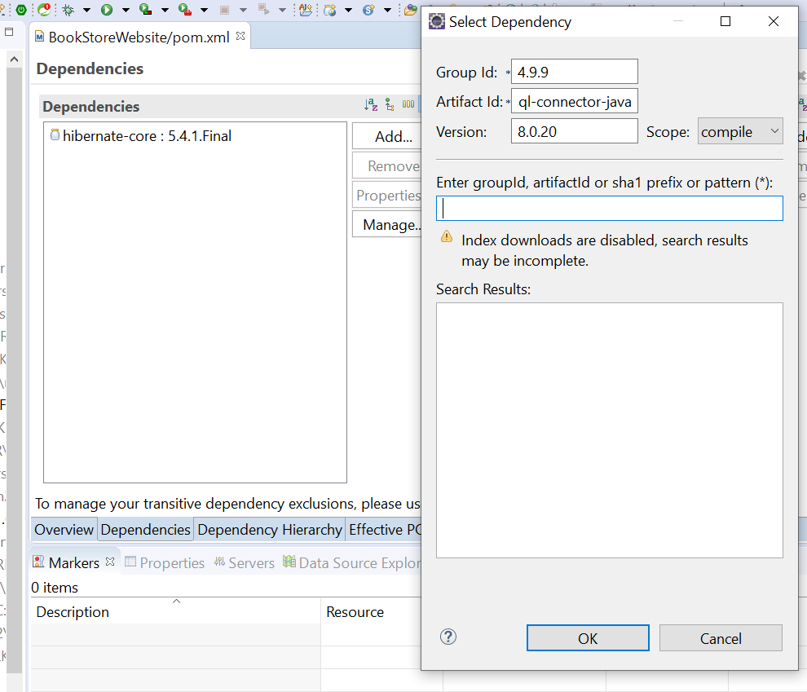

Figure 93:SQL Connector Dependency added

Well I hope I added this right! It wasn’t very clear in the video.

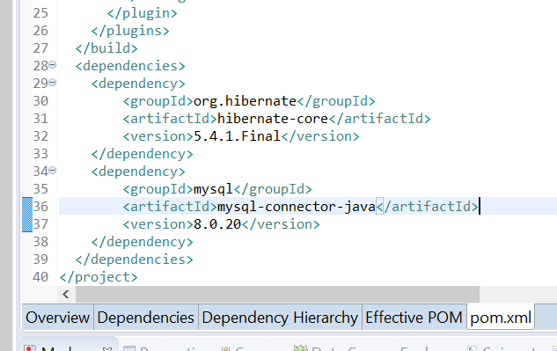

Figure 94: Inserted into Pom correctly

Have to remember to save both Pom files, I was getting an error, and make sure you type it right!

**05/25/20 – 7:00AM** – Before I get into some shit today, I’m taking a snapshot if the project so far. When you open the project up and right click on the title in Project Explorer the sub-menu comes up and click properties to get a series of context panes, click on Properties:

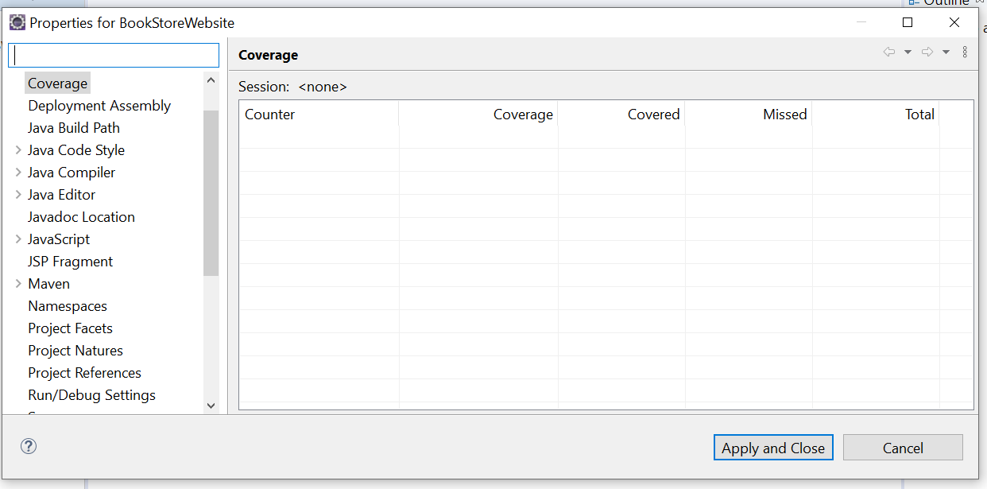

If these are not properly configured for your project, you’ll get an error on the build that appears in the console. Let’s step through them:

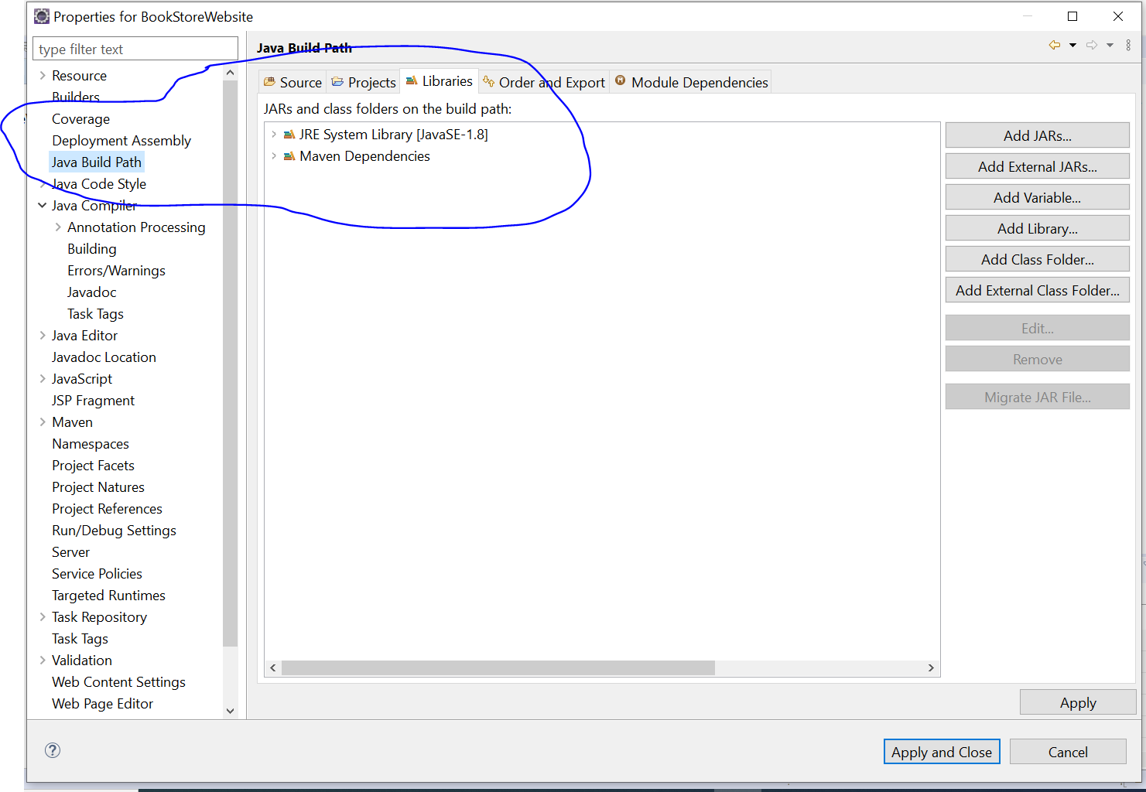

Figure 95: Right click on the Project in Project Explorer

The main thing here is the Java Build Path. The JRE/SE file must be same version as you will see, I learned this the hard way and could not find any help to resolve it but I’m pretty sure It’s right now cause I get no more errors.

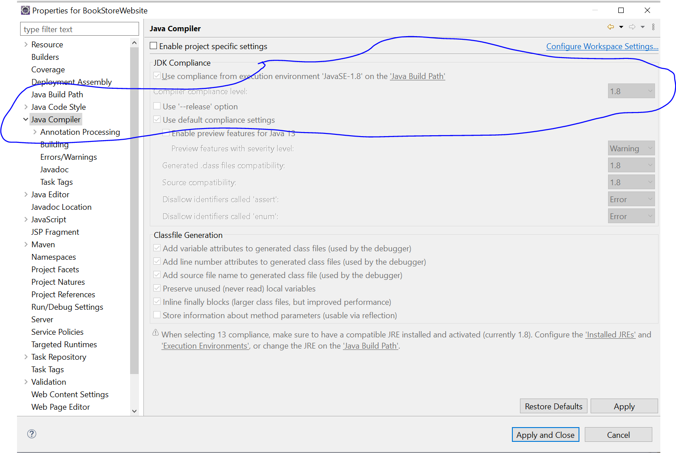

Figure : Compiler Pane

Notice the SE version is the same as the build path version (1.8).

This is the Builders Pane, It gets tricky here when you add/modify, be careful!

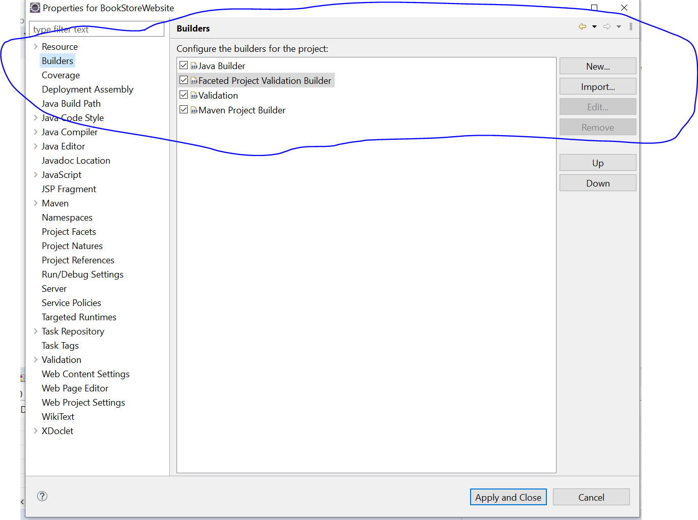

Figure 97:Builders Properties Pane

The important one here is the Faceted Builder. It was giving me errors in the console but luckily the error message points you in the direction to find it and fix it.

Here you can set your level of error warnings you want:

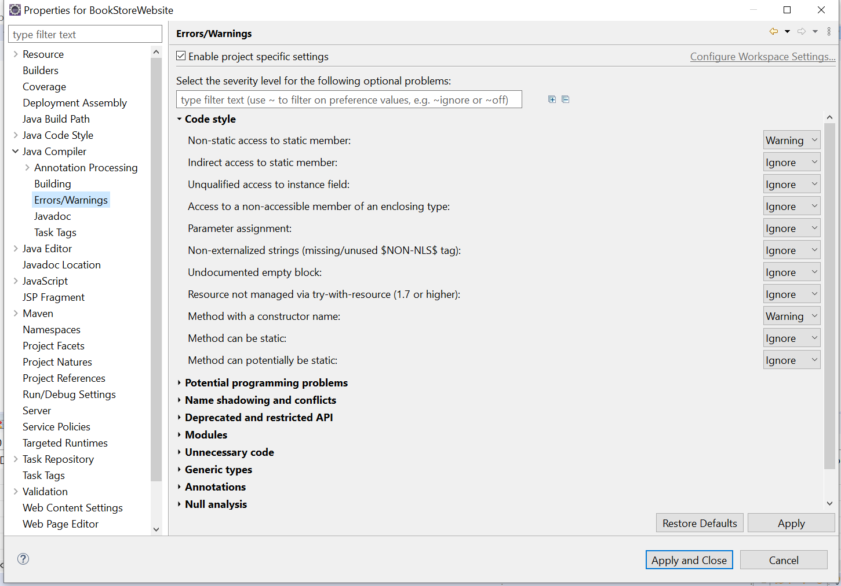

Figure 98:Error Warning Project Settings

I think this is the last pane to investigate if you get errors, notice the Facets Properties.

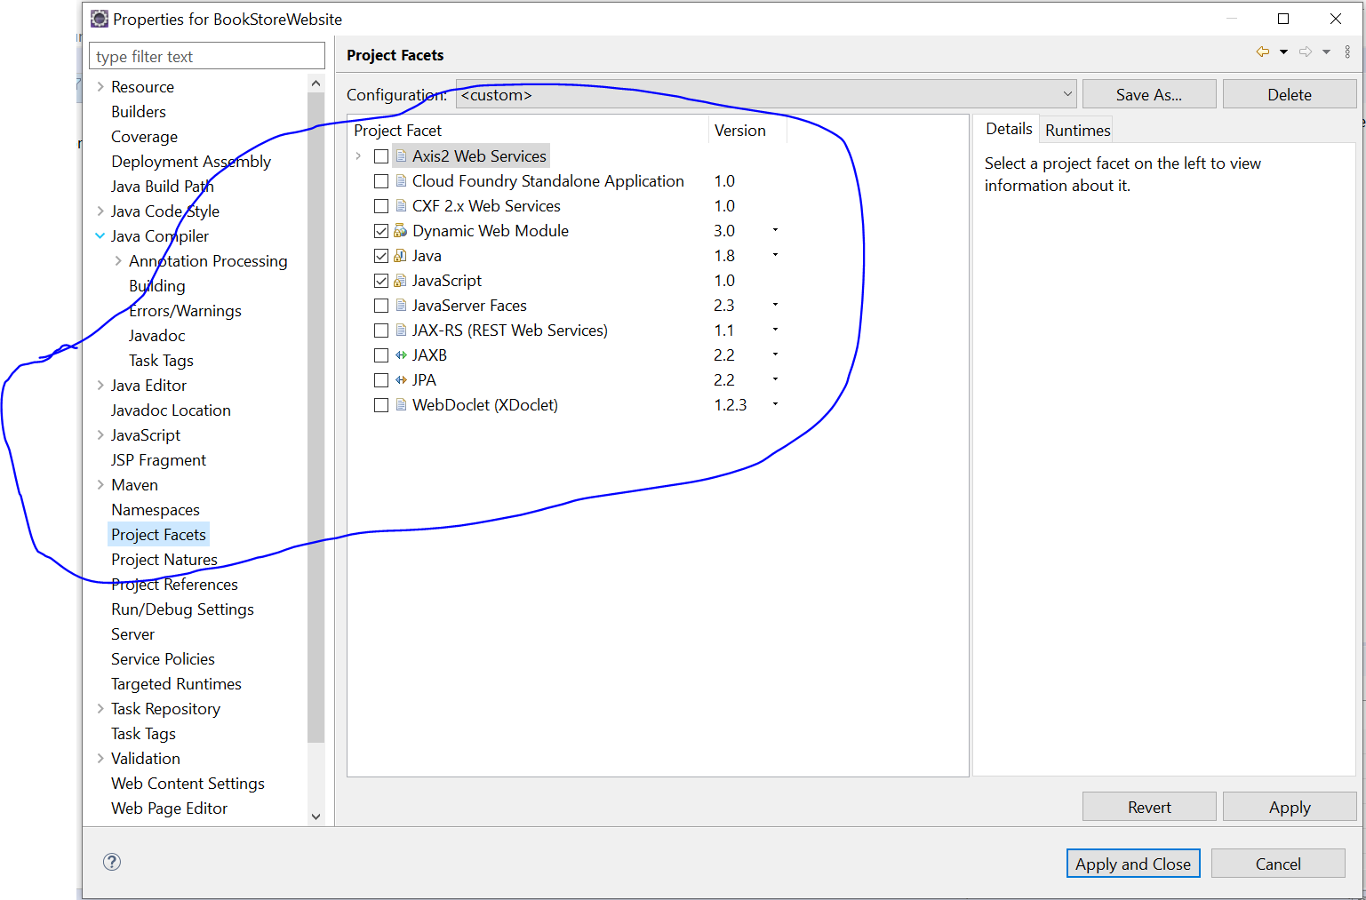

Figure 99:Project Facets Settings versions

Today I’m going to the next Phase, setting up the Tomcat Server and testing it. This should be fun!

9:15AM – Getting the Java Servlet API from the central Repository. I added the code in the POM and got an error:

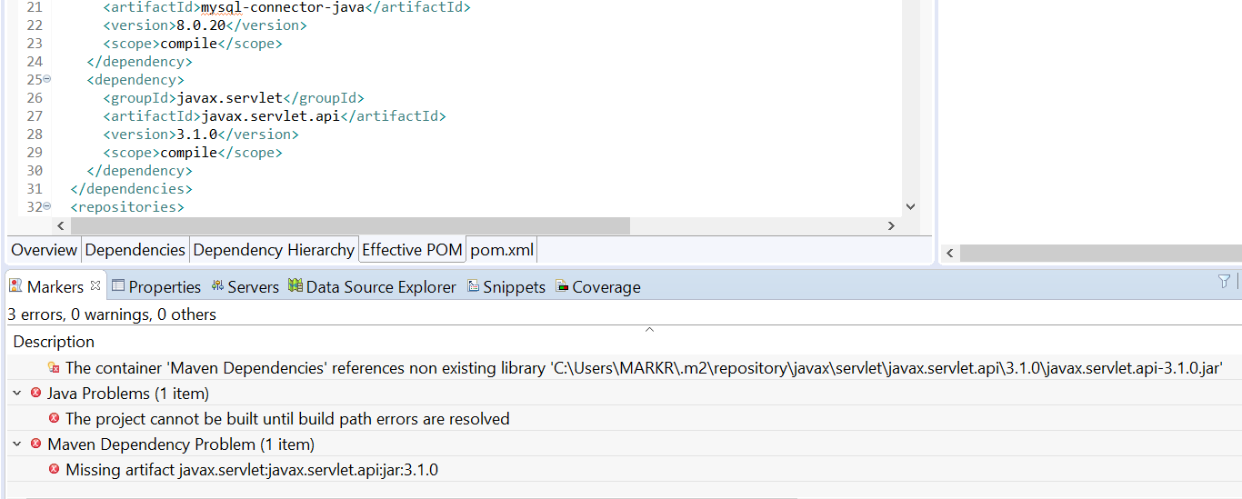

Figure :Java Servlet addition error in POM file.

…and here we go! Now to figure out how to fix the error. I think I’ll change it to the latest driver? Then update the code to reflect it? Maybe…

Hopefully this fixed it, kinda weird, you have to save everything and now it’s gone. Just make sure both POM files point to the same file,this is where it is for now on the C: drive:

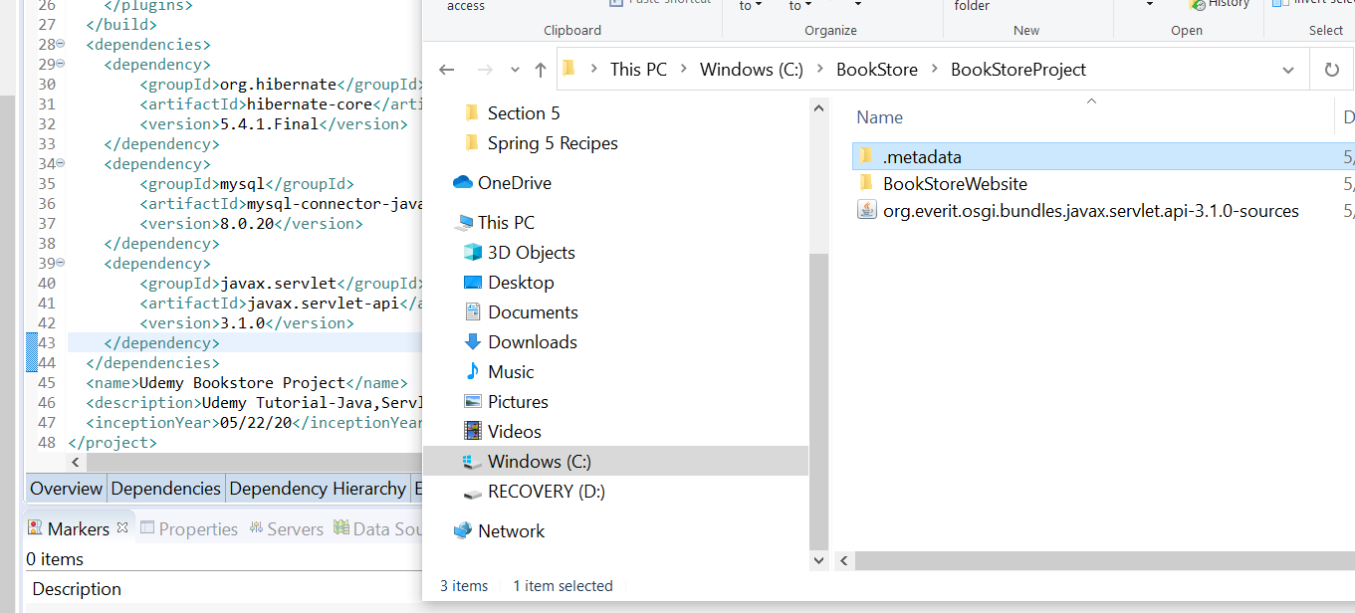

Figure 101: Current Settings and location for Servlet file in POM

Whew! I hope that worked, guess I’ll find out eventually:

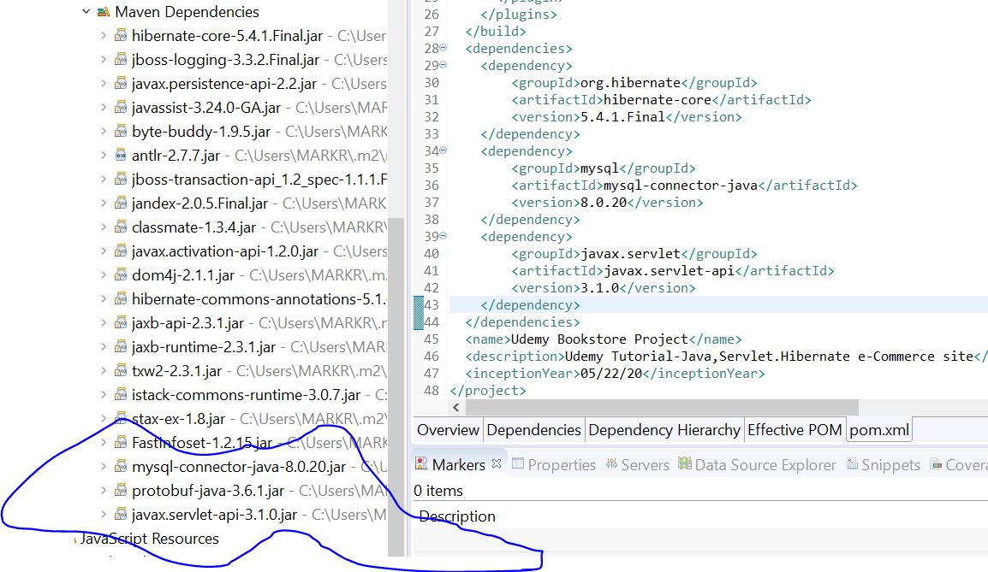

Figure 102:File in the Maven Dependencies Directory

Next is the servlet.jsp-api file. I’m not real sure about this:

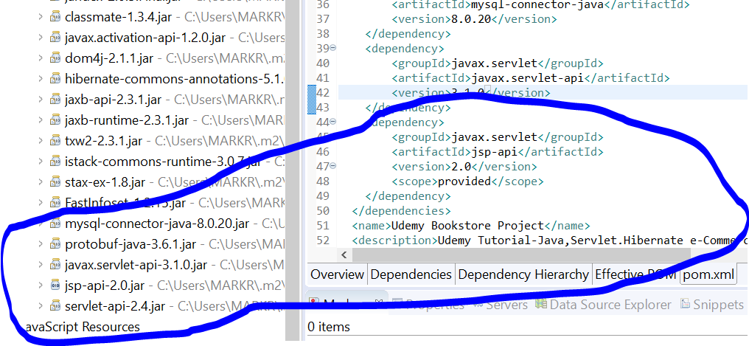

Figure 103:JSP API added to POM File

The servlet-api-2.4.jar file looks suspicious. Guess we will find out soon enough! HAHA! 😊 I removed SCOPE PROVIDED:

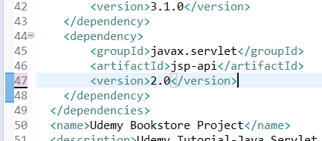

Figure 104: Scope statement removed.

Next we add the JSTL statement file(JSP Standard Tag Library) from the repository:

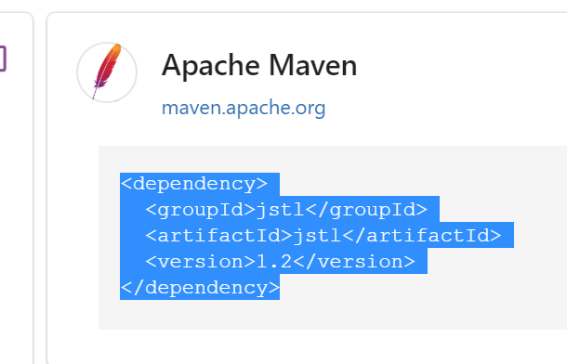

Figure 105:JSTL Code to insert in file

Well that was easy! Now to add it into POM:

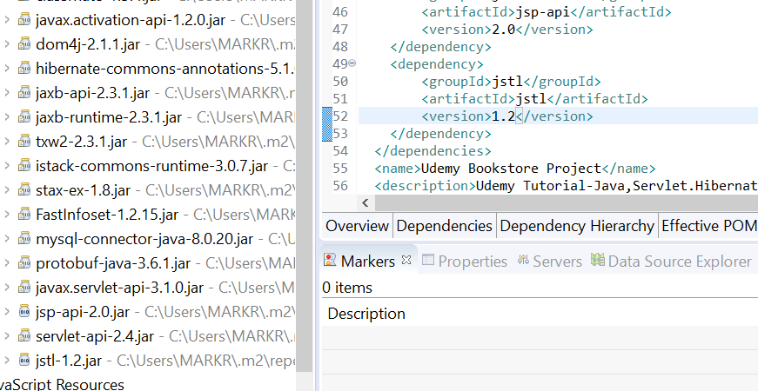

Figure 106:JSTL Code added to POM file

And no errors! Yippee! 😊. I just noticed something, the scope tag gets added to the Effective POM file after a save:

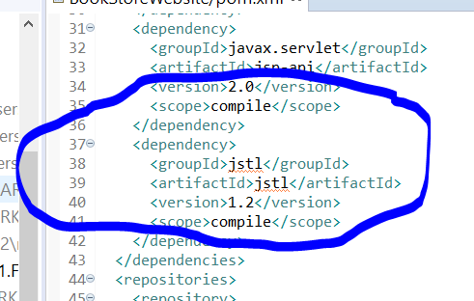

Figure 107:Scope compile added to effective pom file

So far so good I guess..LMAO! 😊

1:30PM – Damit! Error after adding changes to scope:

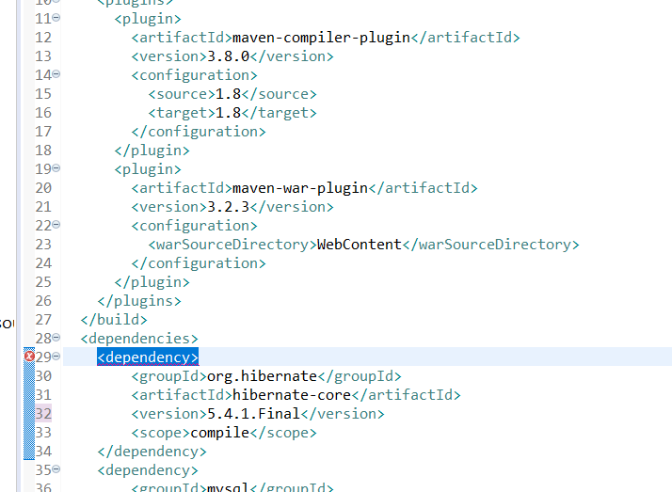

Figure 108:Damit! Error!

Went through the scopes for each and found the JSTL didn’t have a scope in it, fixed it! Thank God! This is nerve wracking!

Next we add the packages from the top level on down. Under the JavaResources src Folder:

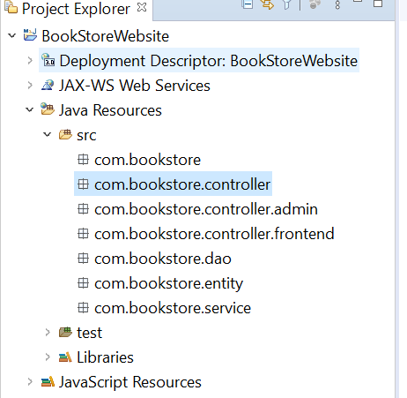

Figure 109: Seven Total Packages under src folder

Next we add folders under the Web-Content Directory for organization of files:

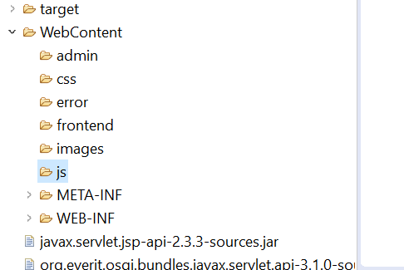

Figure 110:Web Content File Folders

Here is the contents of the Web.xml File:

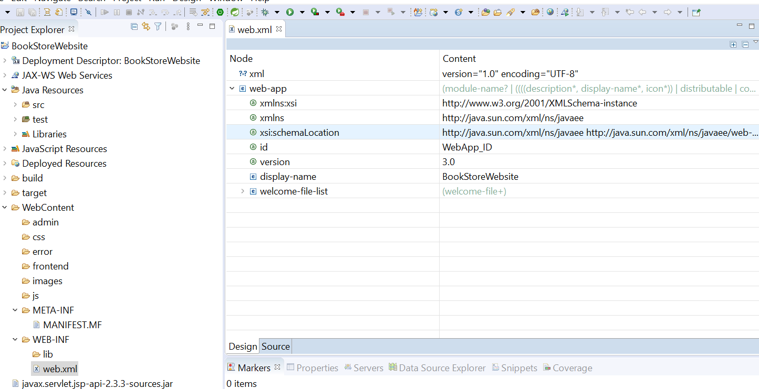

Figure 111:Web.xml file contents which can be edited.

Next we are going to add Tomcat Server:

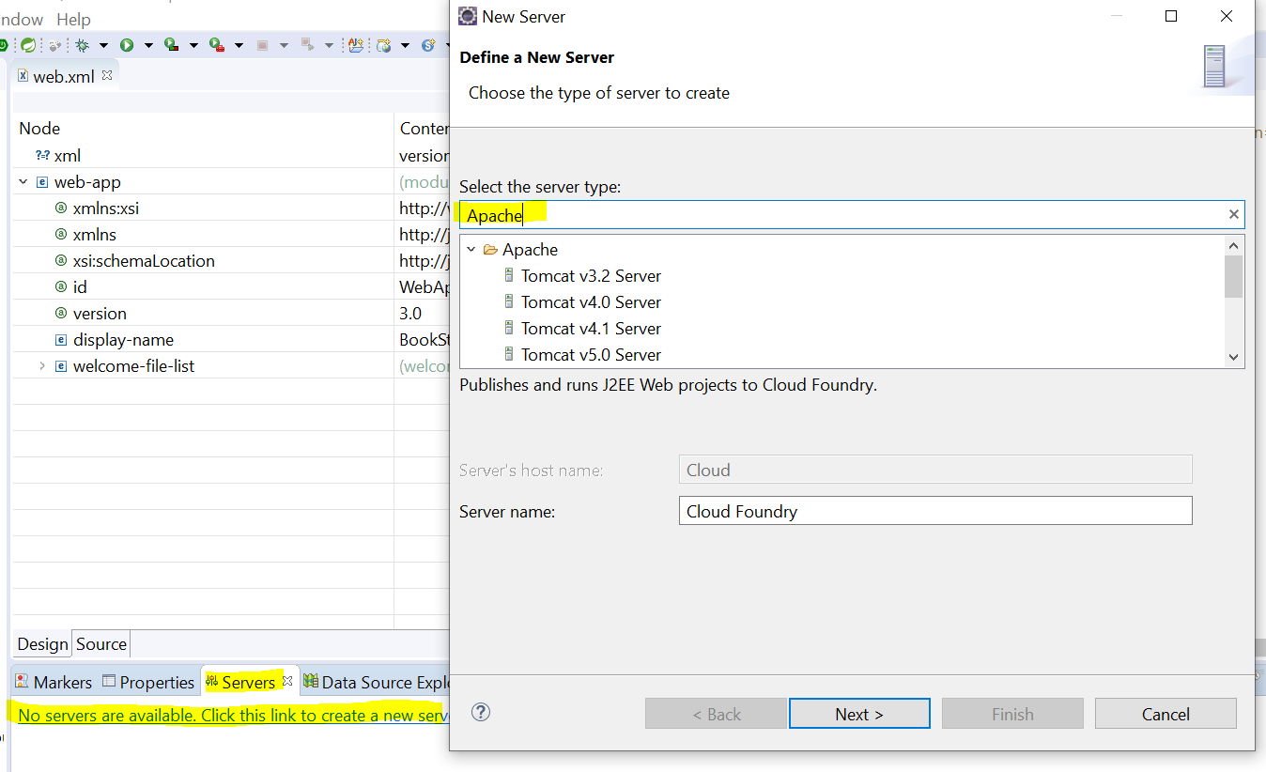

Figure 112:Server Add Tab

Select Tomcat Version 9, then you specify installation directory:

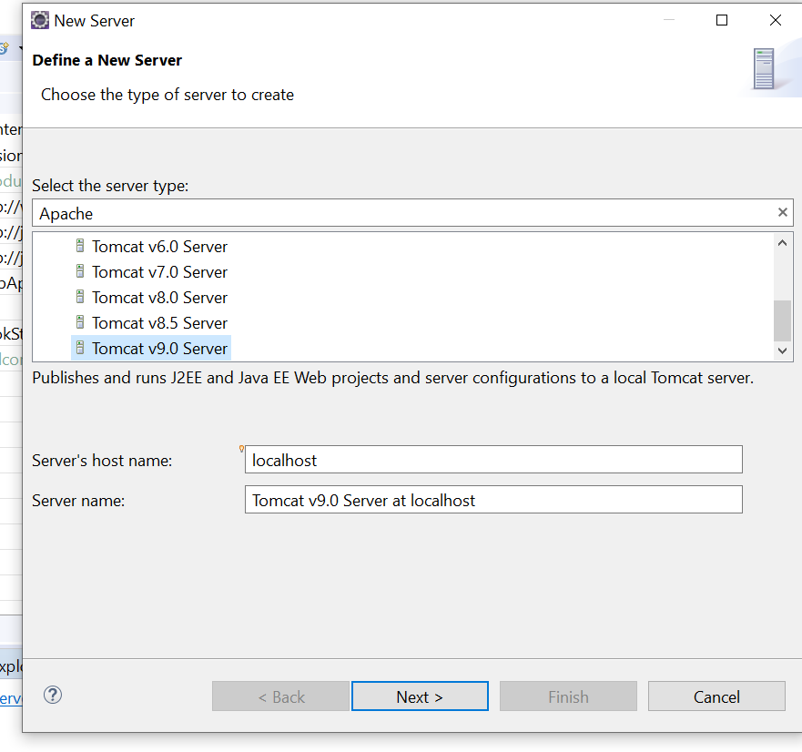

Figure 113:Add Tomcat Version

Click Next, then Add Resources:

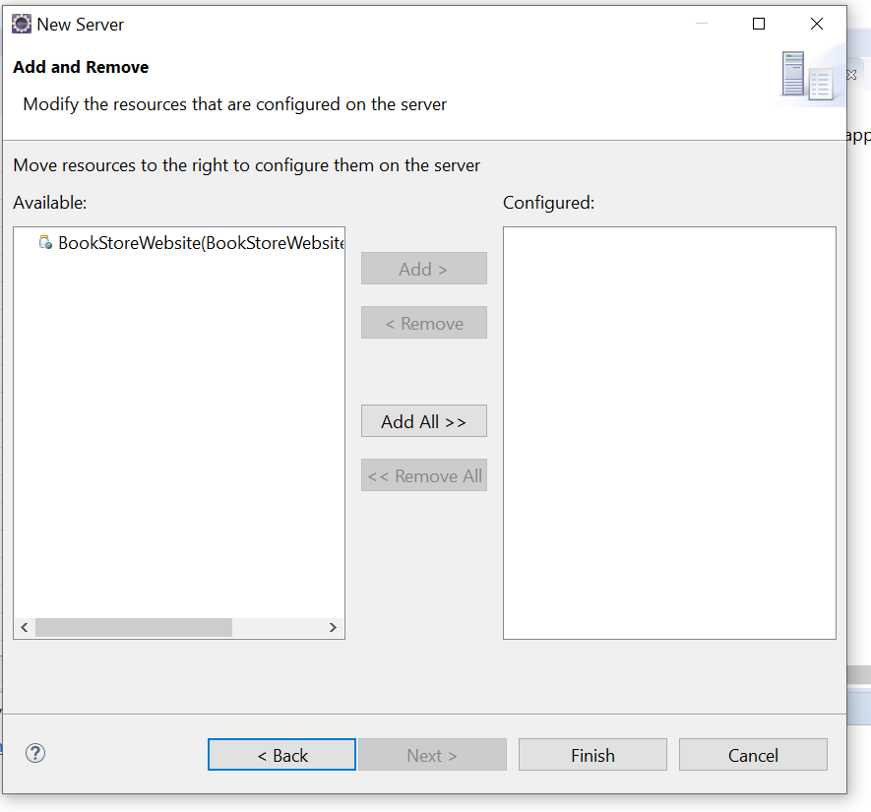

Figure 114:Resources to Add



Click add then Finish:

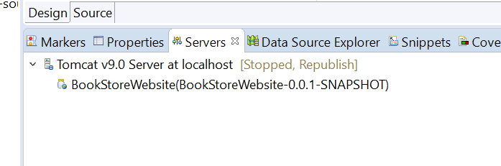

Figure 115:Correct Server Added

One thing I noticed, if the server is already running, you need to stop it, then start again in the console window. Check the console for the errors:

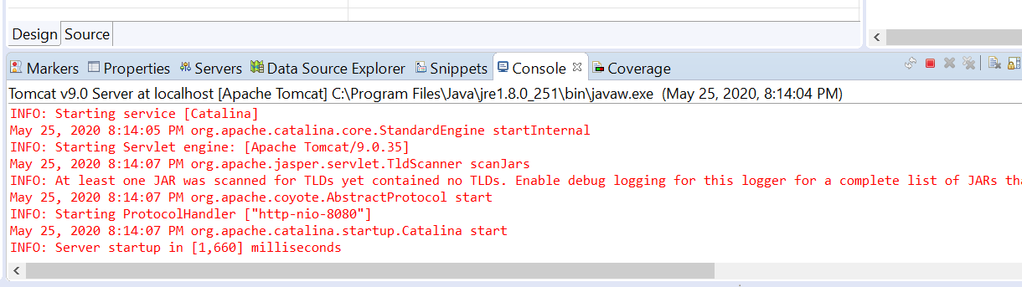

Figure 116:A jar File error

Not sure if that will be a problem or not, we shall see. You could set up an error log file if it is then track it down. Right click on WebContent and select new-file-jsp for testing the Server:

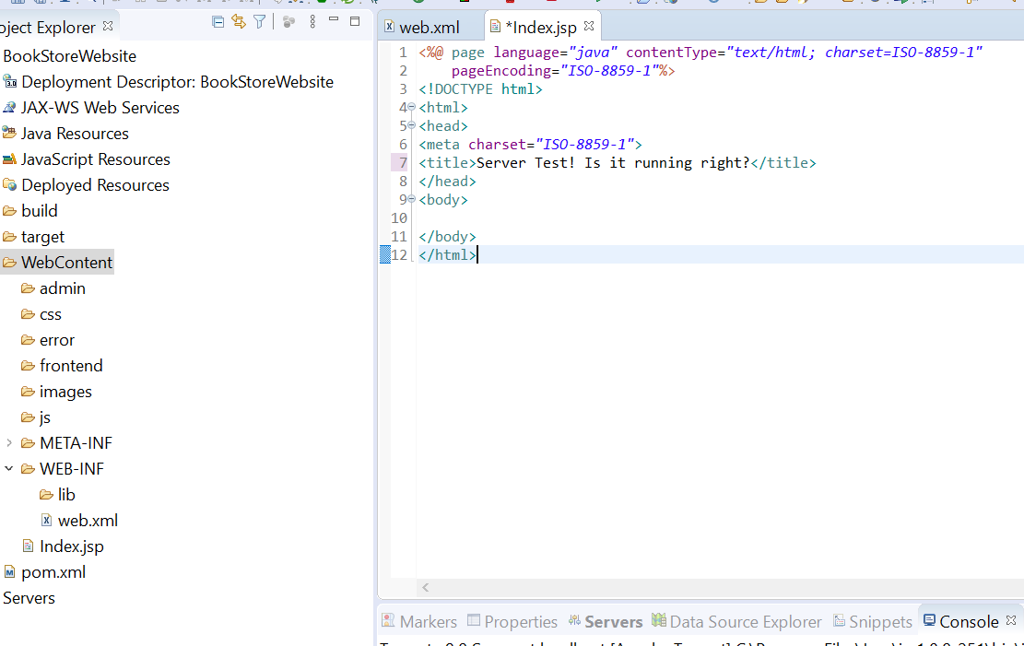

Figure 117: Server Test File

Right click on WebContent-add-JSP file:

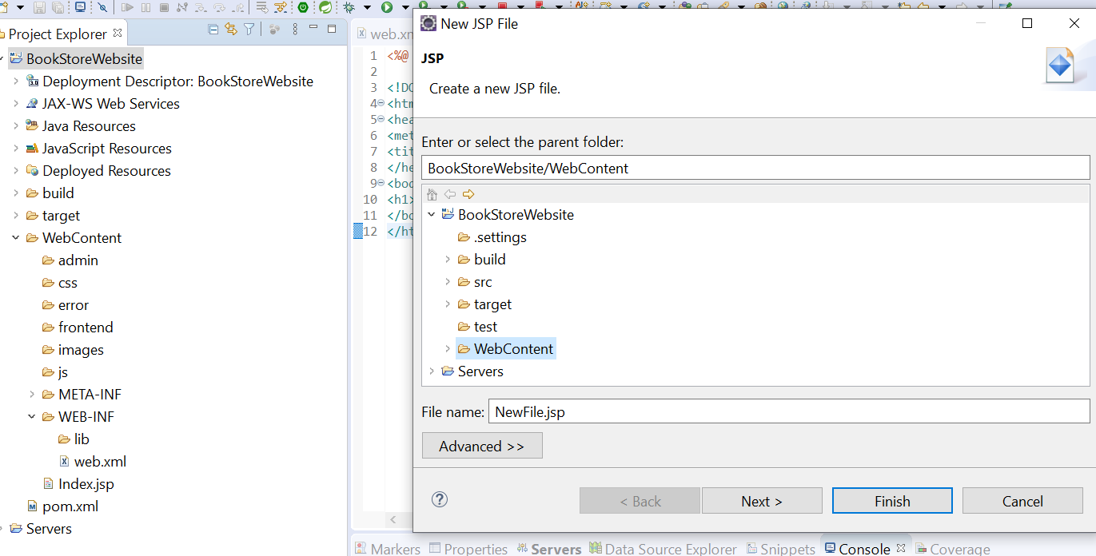

Figure 118:The JSP Index test file

Right click on the file and select Run As Server:

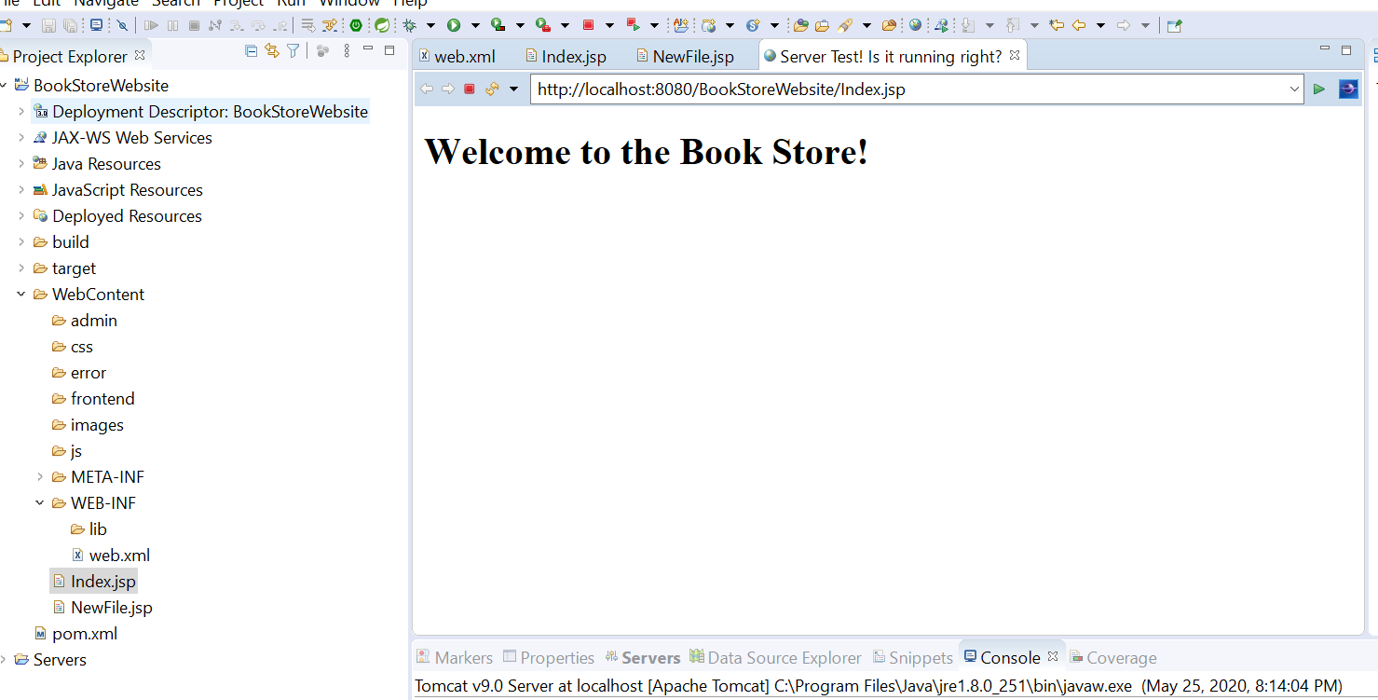

Figure 119: Success! The Server is working!

Here’s a test using Chrome to verify it’s running correctly:

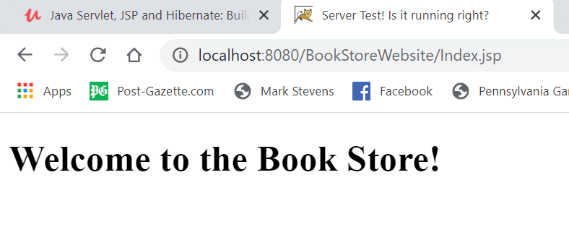

Figure 120: We Got It!

Yippee! It works great! Well that’s enough for tonight.

**05/26/20 8:00AM** – Section 6 in the tutorial talks about a very important concept: Hibernate. I’ll have to go over this a few times I’m sure.

**05/26/20 5:00PM** – Pretty weird, you have to annotate the data with an @Entity to tell it’s mapped to the ORM class users are mapped to table users, interesting. It must be placed before the class declaration, Example:

And to map a field in a Java class to a column in the database table we use the annotation @Column

This annotation is placed before the getter method of a field.

No semicolon after the @Column

If fields and columns are different names:

@Column(name = "user_Id")

User_Id

Hibernate can automatically maps Java types of the fields to the corresponding data types in database.

I’m going to have to go over this again for sure! It’s in Section 20 of the class.

**05/27/20 10:00AM** – I just discovered something BIGGLY! When testing a file on the server, make sure it’s from the Deployed Resources🡪WebContent folder. NOT the WebContent folder under main BookStoreWebsite.

**2:30PM** – Damit! I screwed up, deleted a folder I shouldn’t have then noticed my folder structure is all hosed up not like in the training video. Fuck! Hope I don’t have to start over! Yep. My sub-folders are in the wrong place,,,dayum! SHIT! I changed workspaces and the old one before I started this new one came up with errors! Oh no,,,,,SHIT! I should just start over now instead of going further down the road. Oh well, I need to practice anyways so,,,here we go! FUCK! There’s where I messed up right from the get-go, my Eclipse is a newer version so the Dynamic Web Project doesn’t show up, you have to click other>WEB>Dynamic Web Project. Good thing I started over! HAHA!

**3:30PM** – Well I don’t see the same folders as the video shows,,could be an earlier version of Eclipse. I’m going for it anyways.

**4:00PM** – DUMBASS! I looked at the package explorer and everything is at it should be!! WTF! Well I learned a lesson, make sure the project and package pane or open! LOL Here we go again! Second time around should be easier,,

05/28/20 7:00AM – Downloading the hibernate-core file, version 6.0.0, the video in packages and directories shows 5.2.12 final but I didn’t see that. It shouldn’t matter much though. I’m adding it to the dependencies in the POM file.

**9:30AM** – Shit! I could notget it to compileright without errors so hell I started over, the only thing different in my file is the versions herein the POM file:

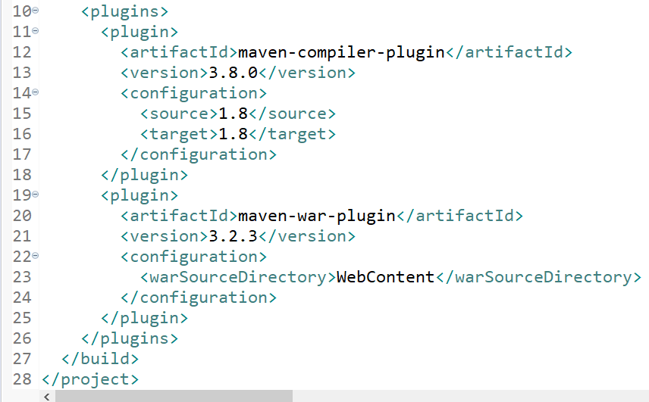

Figure :POM file version discrepancies

The project POM in the class is Compiler 3.7 and War 3.0. Hopefully it should not matter. Dependency and scope I think is where my problem is.

So far it looks alright, the dependencies match in both places:

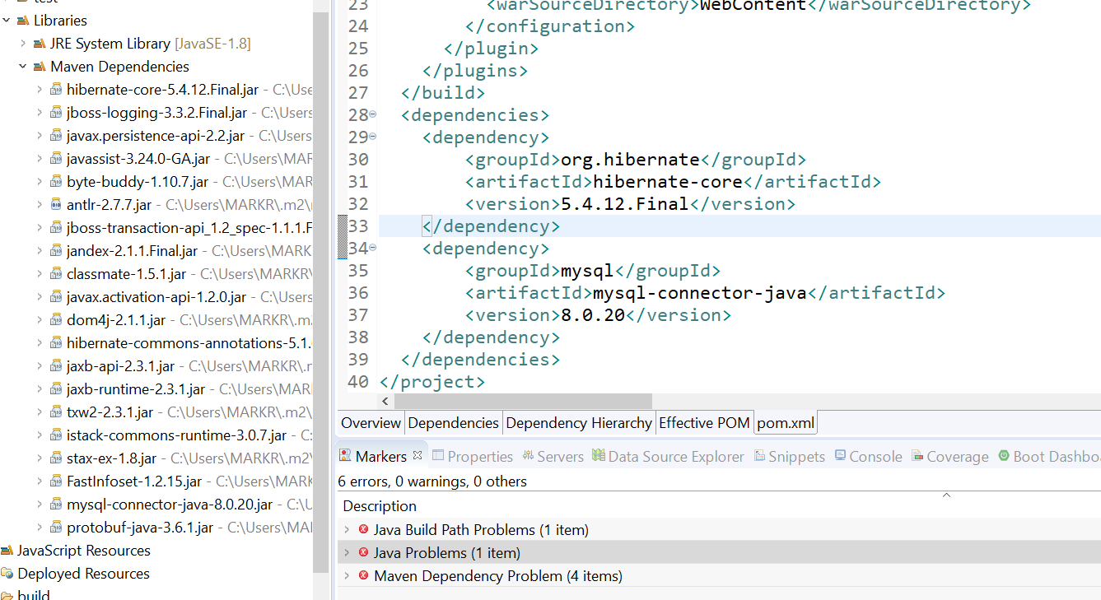

Figure 122:Hibernate and MySql Connector added.

You gotta watch when you add those dependencies that’s for sure. Here’s the final:

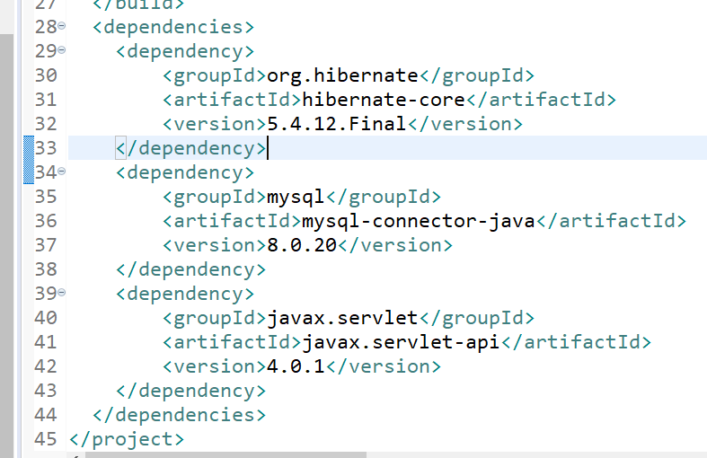

Figure 123:Dependencies in the Pom File

You have to be careful putting in the Artifact id and group id:

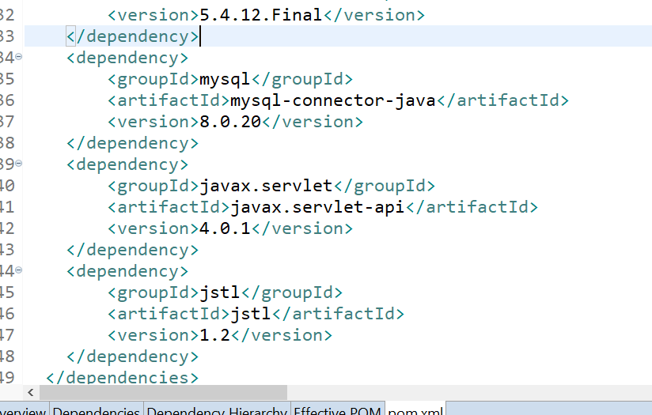

Figure 124:Current Dependencies 5/28/20

Now to add the scope of the dependencies, here is the final chunk of dependencies:

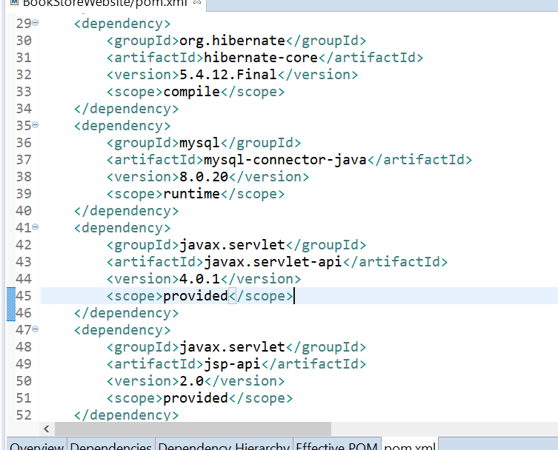

Figure 125:Final Dependency code additions

Check the Maven Java Version, in this it’s 1.8.

Next we add the packages under Java Resources🡪src: top level com.bookstore:

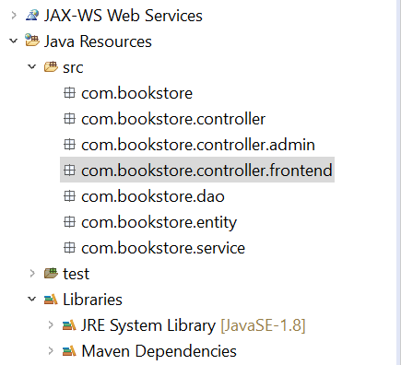

Figure 126:Sub Packages created

Next is directory structure folders under web content:



Figure 127:Web Content Directory Structure

Testing the server:

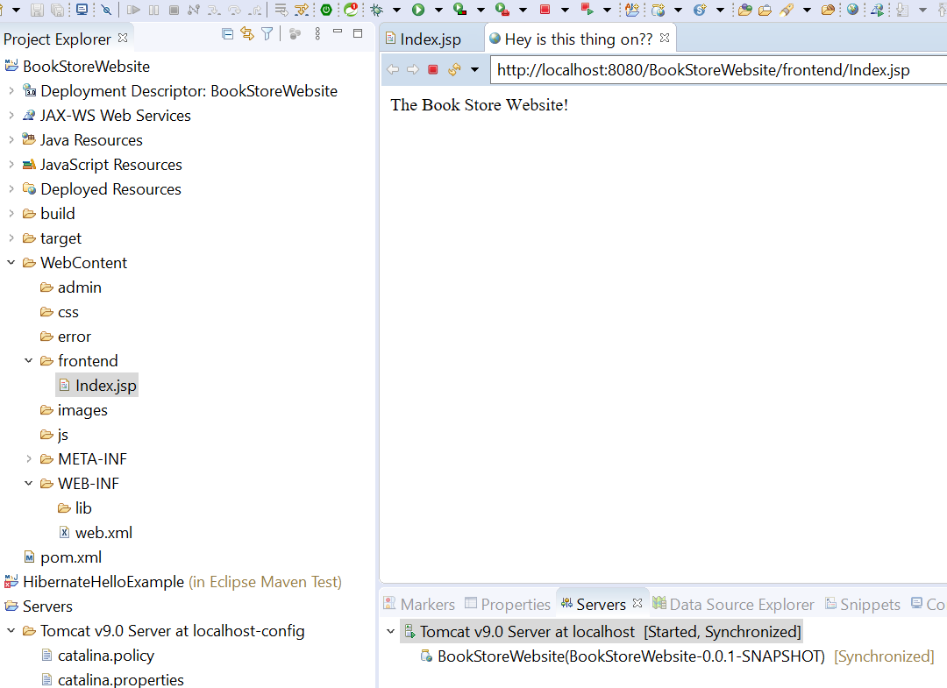

Figure 128:Server is running as expected

**1:45P** Tested and it works in google. So we’re good finally! Hopefully I don’t screw up again! HAHA!

**4:00PM** – There’s some really good info about Mapping a Model Class when it comes to databases. I’m going to have to go over this several times I’m sure, along with the provided website links.

**7:30PM** – Got the first data model done, The users table/class. Lots to learn here with the @ statements that map to a Table/Column in DB. Man, that next section, 21 Create JPA Config file is pretty cool! And powerful! It creates an XML file for you!

Java Resources🡪src🡪New🡪 File🡪Navigate to New Folder🡪Create “META-INF.

Then create an XML File under that folder called persistence.xml🡪Finish.

**Make sure you select the Source tab not design!**

**Then do the Google search for the code block to insert into file. Use JPI 2.1.**

**This is the code added into the xml file. Hope it works and I didn’t misspell something or a missing “ LOL.**

<persistence-unit name=*"BookStoreWebsite"*>

<properties>

property name = "javax.persistence.jdbc.url" value ="jdbc.mysql://localhost:3306/bookstoredb" />

property name = "javax.persistence.jdbc.user" value ="root" />

property name = "javax.persistence.jdbc.password" value ="password" />

property name = "javax.persistence.jdbc.driver" value ="com.mysql.jdbc.Driver" />

</properties>

</persistence-unit>

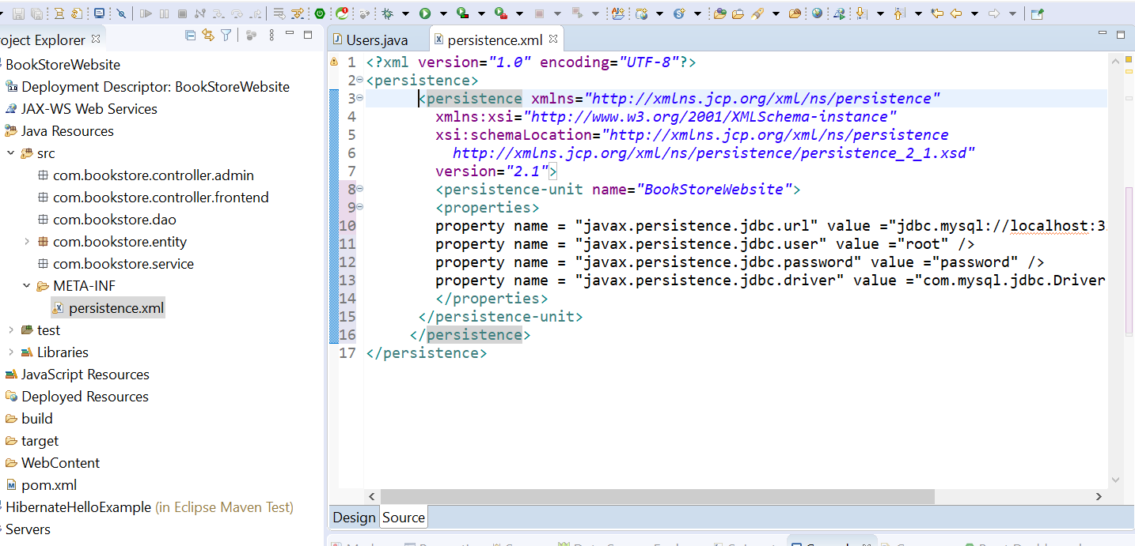

Figure : Persistence XML File in META-INF

**05/29/20 1:00PM** – Going to make and run a test file (UsersTest) under the Java Resources folder.

**05/30/20 9:30AM** – Here we go again! Have to play detective and figure out what’s going wrong. I get this error when I test the “UserTest” file:

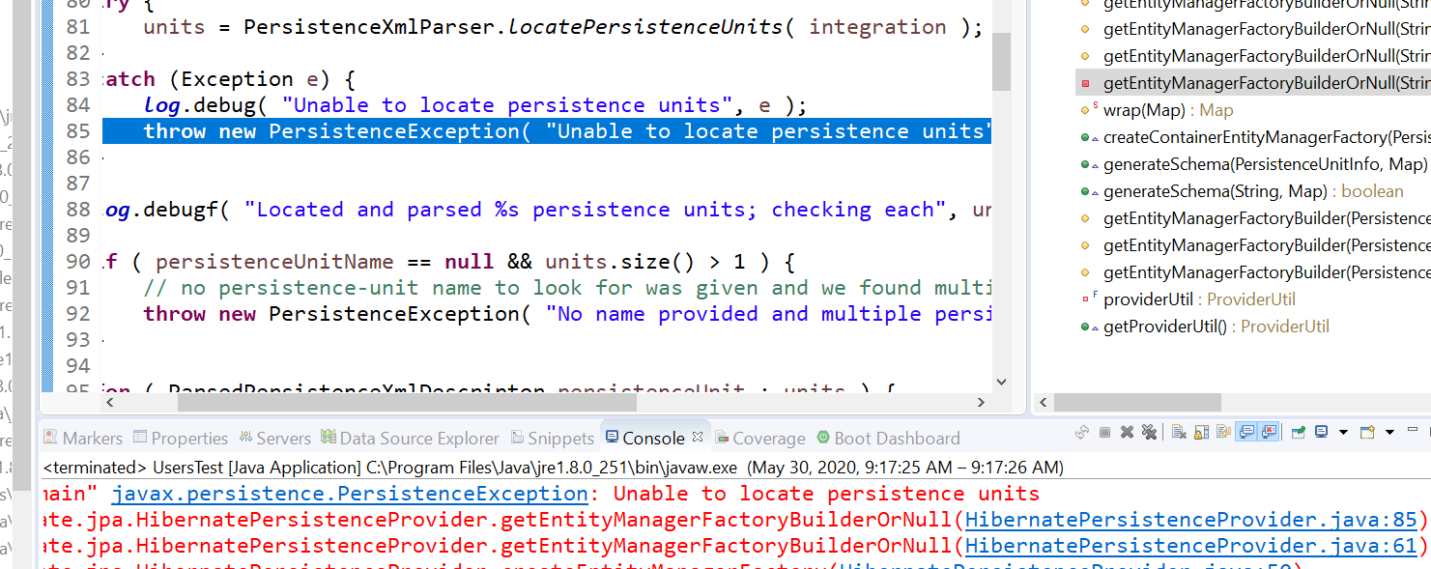

Figure 130: Persistence Error

I think I’m narrowing it down. There’s several UsersTest files in WEB-INF subfolders, the one under Web-Content seems to be the one that runs cause I changed the user # to user2:

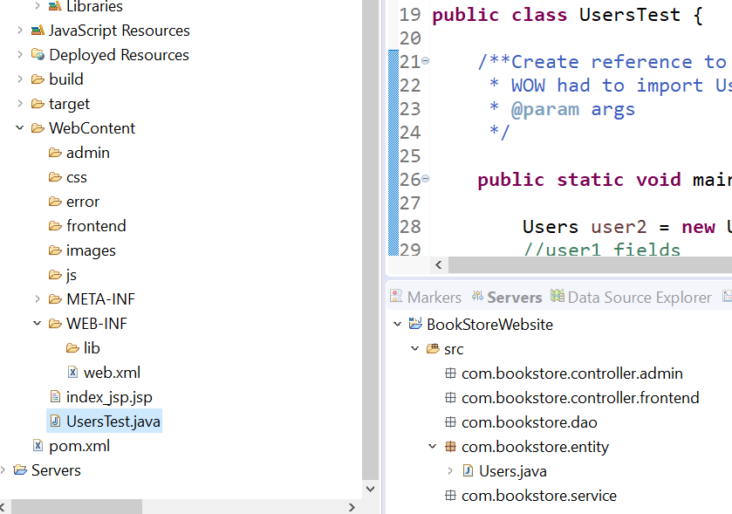

Figure 131:user2 file location

Still nothing! DAMIT!

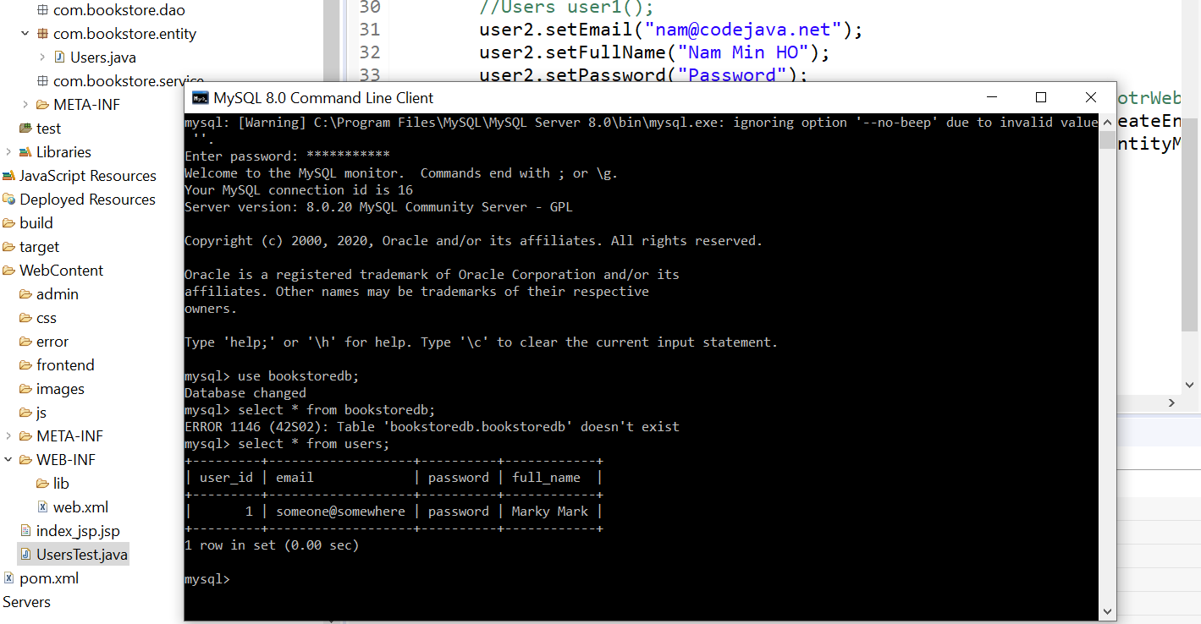

Figure 132:User2 Test

Confirmed that it works. I removed the “DTD” Statement at the beginning of the pom file, so now my errors in the markers tab disappeared. Seemed to help but I still get this: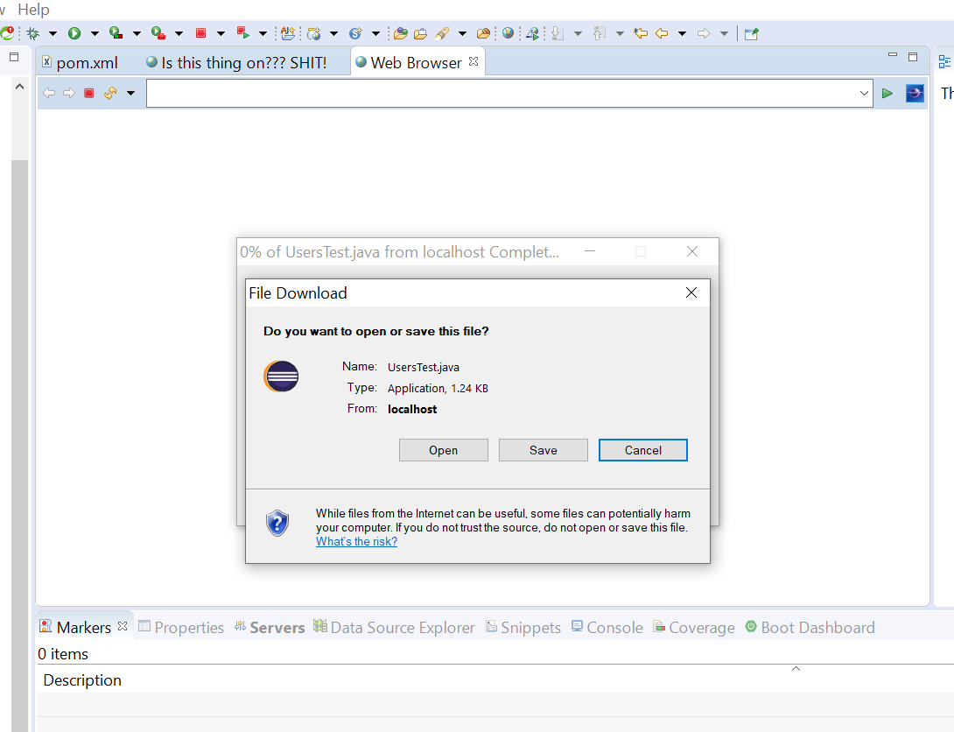

Figure 133:UsersTest file

05/31/20 7:00AM – Got my work cut out for me today! Let’s start here back to getting the download pane like above, this happens after the server prompts me if I want to restart, or continue without restarting. I started monitoring the TCP/IP connections:

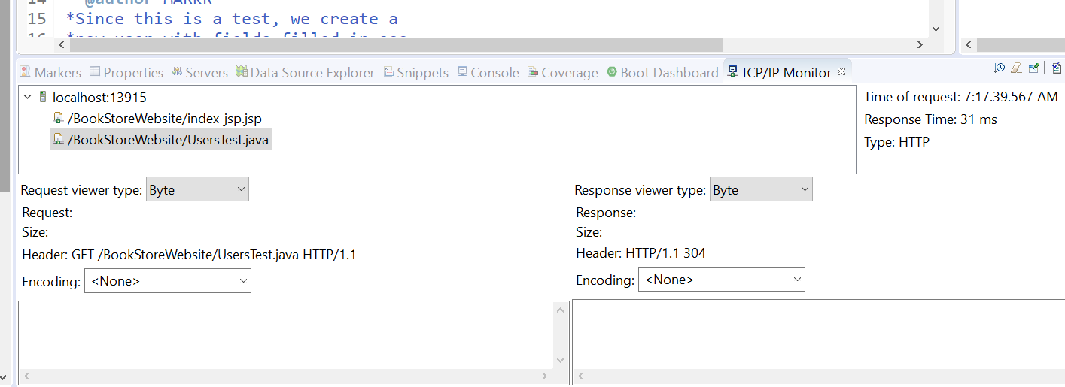

Figure : TCP/IP Requests

I noticed something, the encoding in the response says none, but in the files that work the encoding uses UTF-8:

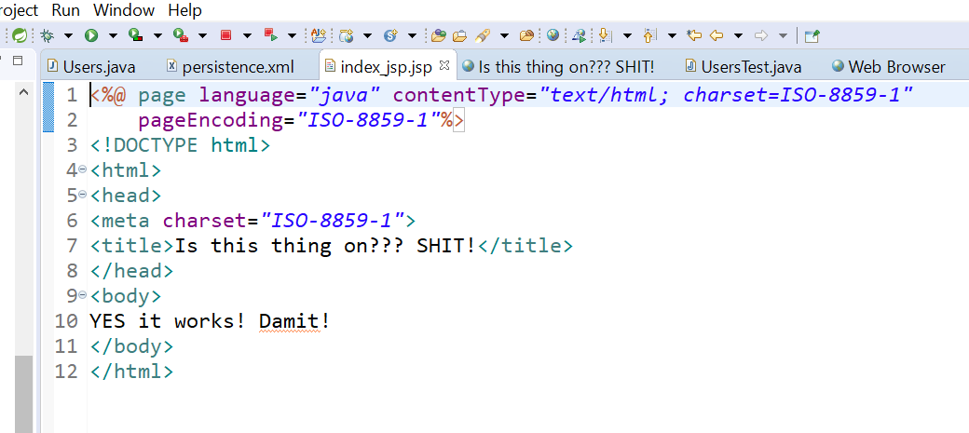

Figure 135: Encoding Header in the file index_jsp

Here is the Persistence file header:

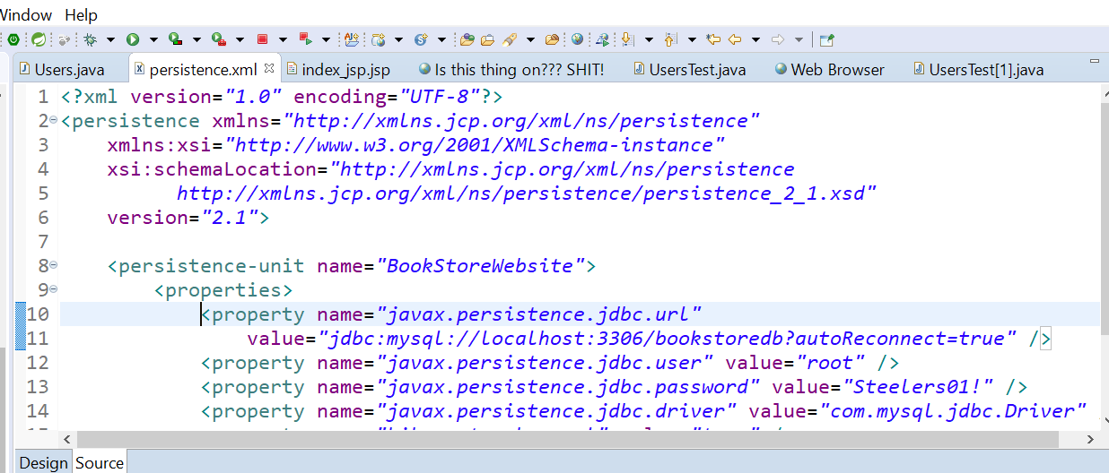

Figure 136:Persistence file encoding header

I might be on to something, change the file encoding in it’s properties:

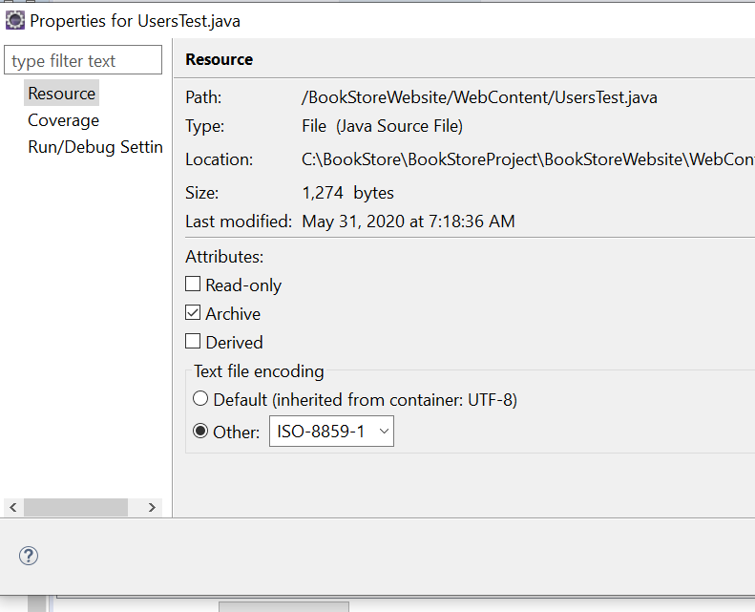

Figure 137:File Encoding Property changed to ISO-8859

I still get the download prompt, so I put a statement in the header, still nothing. Another thing, why do I have two WebContent Folders?

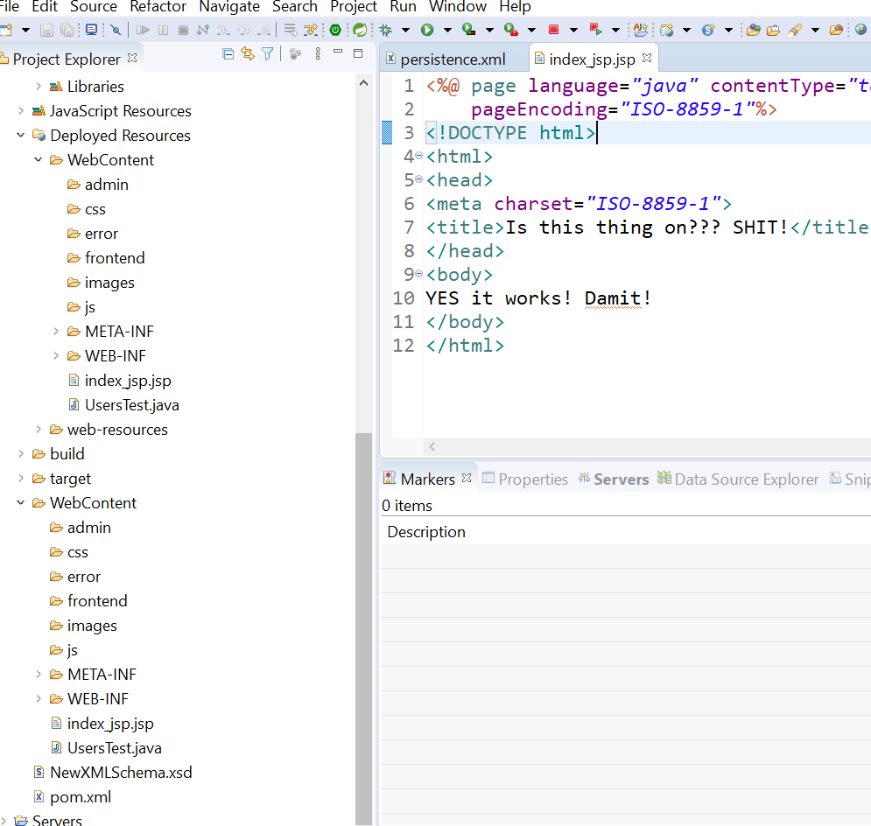

Figure 138: Two Web Content Folders

05/31/20 1:30PM – Well I tried everything I could think of to get the DB and Java Hibernate to talk to each other, and I mean EVERYTHING! Changed ports on the server, monitored the TCP/IP activity..etc, It has to be something stupid I’m missing! So,, I went and downloaded the complete project files to compare the persistence.xml files (I’m pretty sure that’s where I’m missing SOMETHING), and sure enough, he has several statements in the file that I don’t! I went through the videos again and never saw where they were added, maybe further in to the project? I am going to add the difference from HIS file to MINE. I don’t want to just copy his over and replace mine, although I may end up doing that if this doesn’t work! BTW, I ran across some good tutorials and saved them in a Hibernate Tutorials folder, JSP MySql folder, which has some Spring stuff in there too and a Hotel Management, Spring and Hibernate Tutorials, etc,,maybe I need to go through some of those to figure out where I went wrong on the E-Commerce Project.

So I opened both files, one wordpad, the other notepad. Here are the difference/added statements in the final project persistence file:

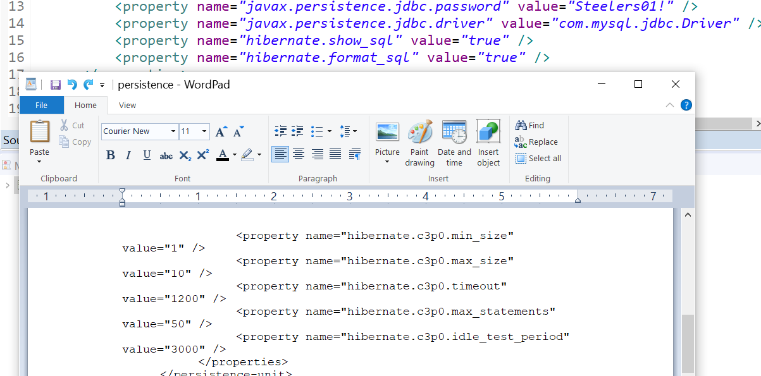

Figure 139: Added statements in Persistence file

The bottom one has property values that mine doesn’t. I already went through the tutorial, checked my file and the syntax, and no difference. I haven’t researched what exactly those statements are yet but they seem to just set property values for c3po whatever that is.

**10:30PM –** Well it has to be the mapping! That’s the only thing possible, it’s running but doesn’t interpret the Java file correctly. It asks do you want to save this file etc,,doesn’t run it,,,oh well see what I can come up with tomorrow.

**06/01/20 7:30AM** – Guess I’m going to try this one more time. Copy driver mssql-jdbc-8.2.2.jre8 to C:\Apache\apache-tomcat-9.0.35\lib. Then change the Java Path/Compiler to jre-8-1 in the BookStoreWebsite project. Also change the Java Version in use too.

Tried this: C:\BookStore\BookStoreProject\BookStoreWebsite\WebContent\WEB-INF\lib and added jdbc.8.2.2.jre8:

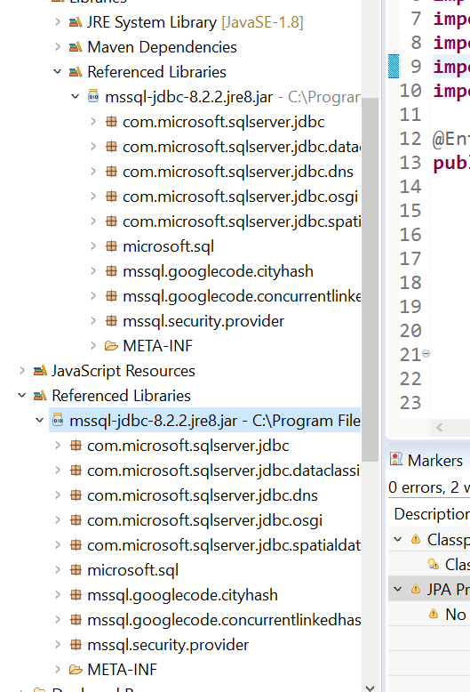

Figure 140: JDBC Driver Location 6/1/20 9:15AM

Let’s try this, I’ll exit out of Eclipse, go back in so it recompiles and see if I get any errors.

No good! My dumbass! That Driver is for Miscrosoft Server! WTF am I thinking! Trying this instead: C:\BookStore\BookStoreProject\BookStoreWebsite\WebContent\WEB-INF\lib

Driver mysql-connector-java-8.0.8-dmr just like in video. Recompile.

11:00AM – This makes no sense whatsoever! WTF! I can NOT think of anything else but to delete the whole DB and start over. WTF!

NOTHING! Except errors!

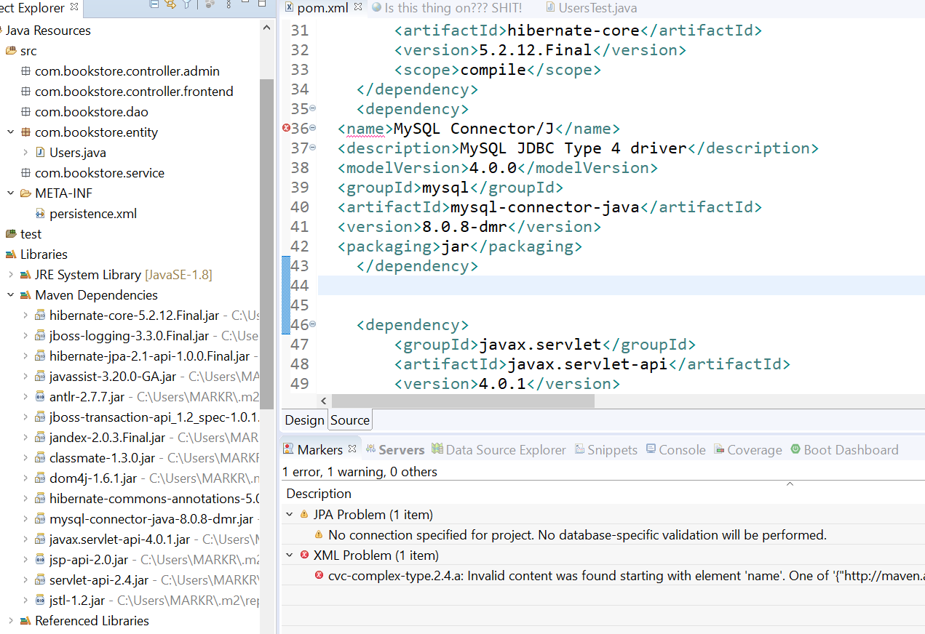

Figure 141: Name Error

XML doesn’t like the <name> Took that out, deleted the block of code abd copied from the Maven website, still nothing:

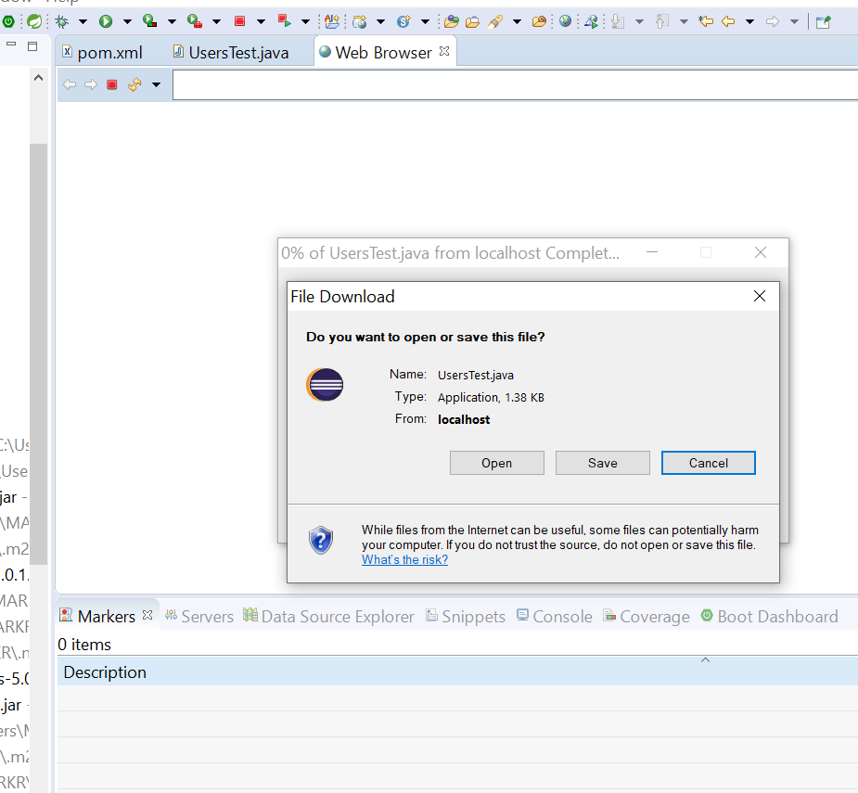

Figure : Connection Download again!

NOTHING!

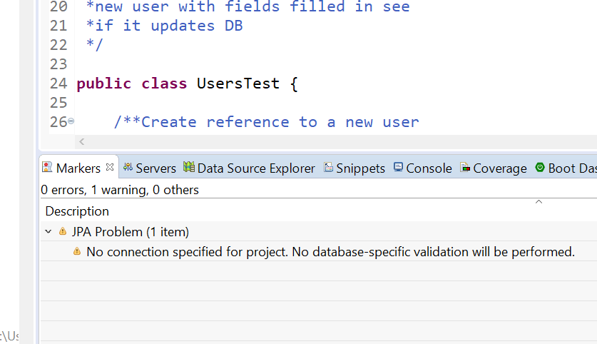

Figure :No Database Specified

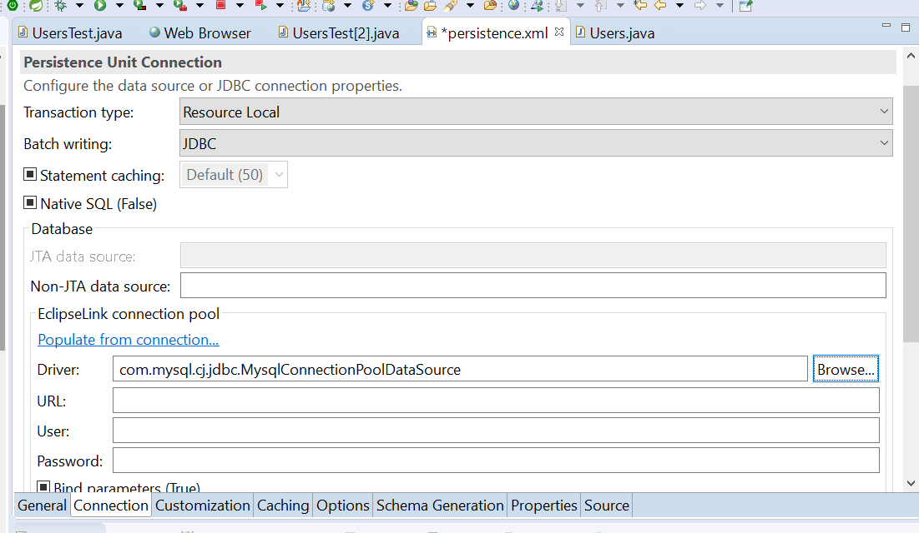

Figure : Nothing!

**06/02/20 8:00PM** – I think I actually got it right this time! I started over with a new project/folder called **NewBookStore**,Put the mysql-jdbc-connector in the Maven Dependencies Folder by right clicking project, then select Maven>Download Sources:

Extension 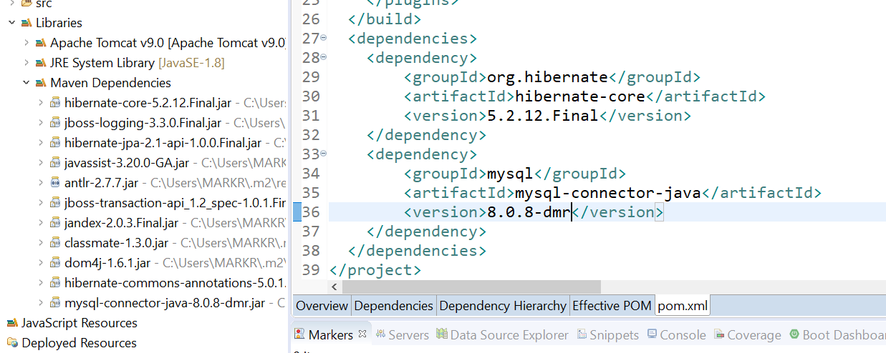

Figure 145: mysql- connector in correct folder

I hope it works this time DAMIT! Well I fucked up the one driver in the POM file, It had a public_draft extension. I think it’s deleted. It sucks trying to delete shit after it’s in those POM/Dependencies file.

11:00PM – I did it! LOL!

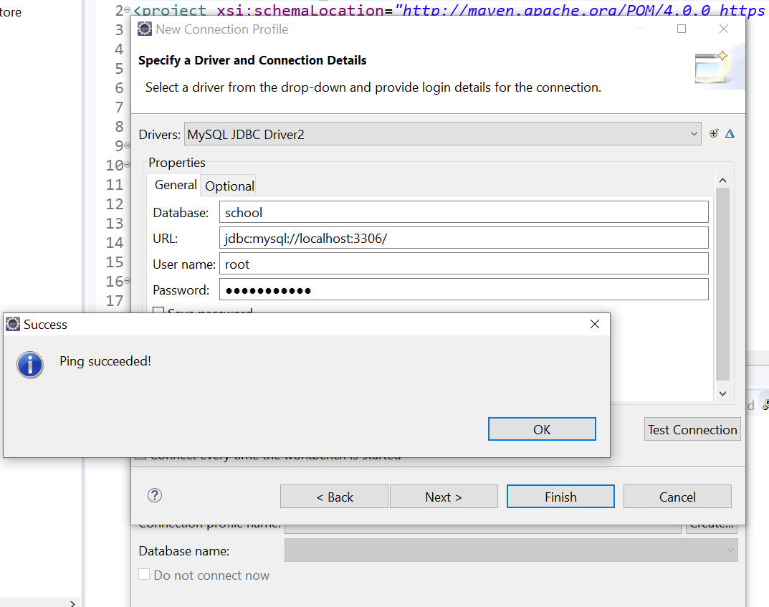

Figure :Got it working kinda!

YAY! A new toy to play with! Now that it’s working, I have to figure out how to get the Java Files from the tutorial to work with it. I have a feeling it’s not going to be to easy either. I’m not even sure how /what I did to get a ping! New -> menu🡪SQL File , played around with a bunch of settings that sounded like they made sense.

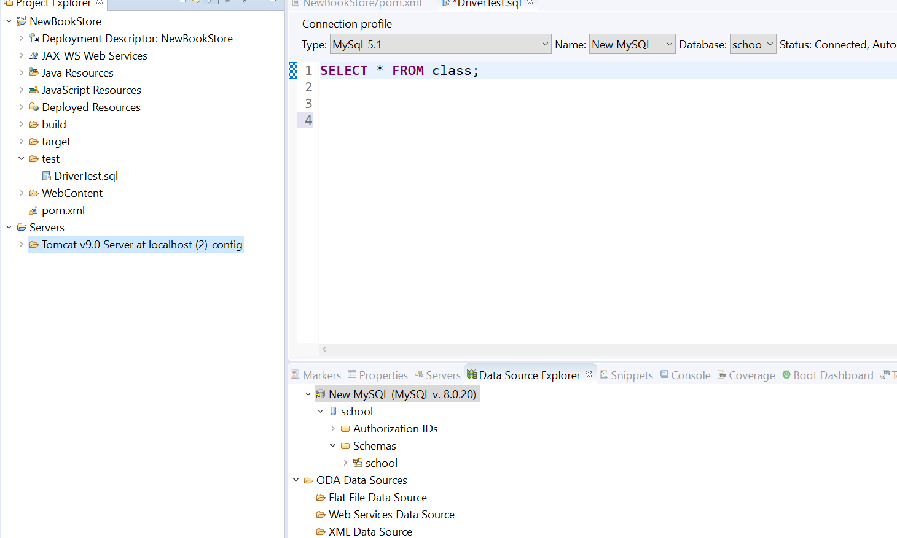

Figure 147:Finally have communication with the Database!

My next step is to get a handle on persistence, but here’s something, I found a button on the menu bar that executes the Sql Query:

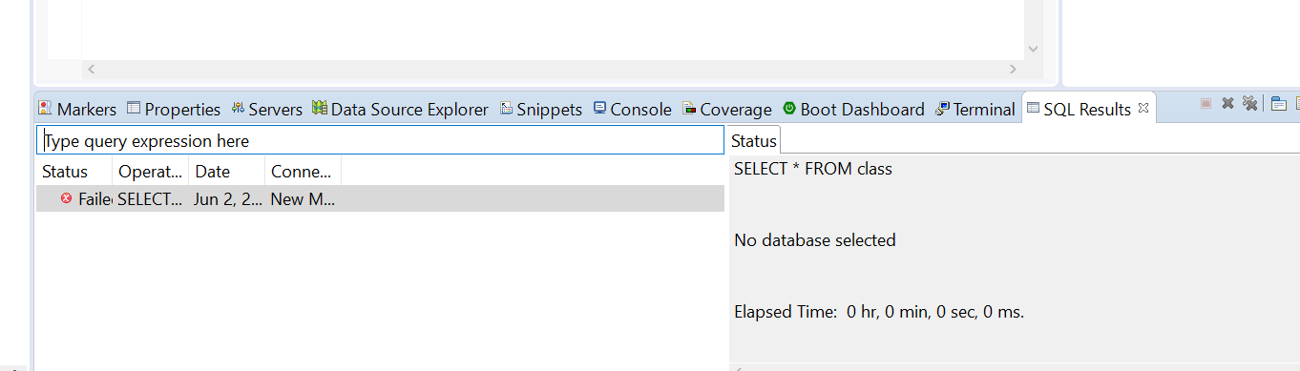

Figure 148: Well Well looky there!

Now I’m all excited! After three days of playing around and getting nowhere, I scrapped the whole thing, re-installed Eclipse, deleted the old project etc,,

06/03/20 11:00AM – Well I’m almost back to where I was! I sure hope the persistence works this time! Also learned a new command-connect (database name). Maybe that’s what I was doing all along! Not using the connect command to link up with the DB then execute commands:

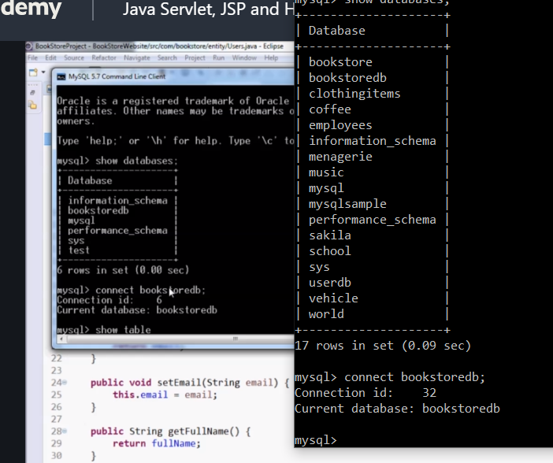

Figure 149: The connect database command.

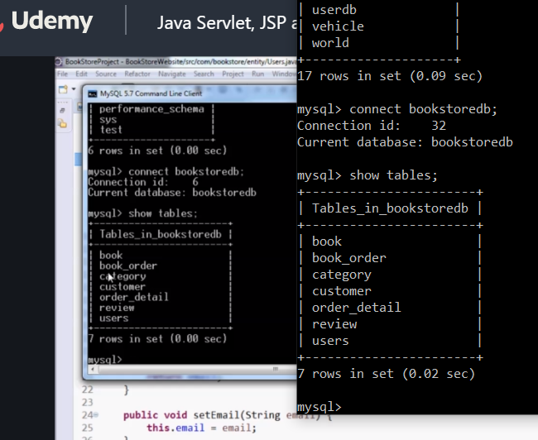

Figure 150:TaDa! Looking good so far!

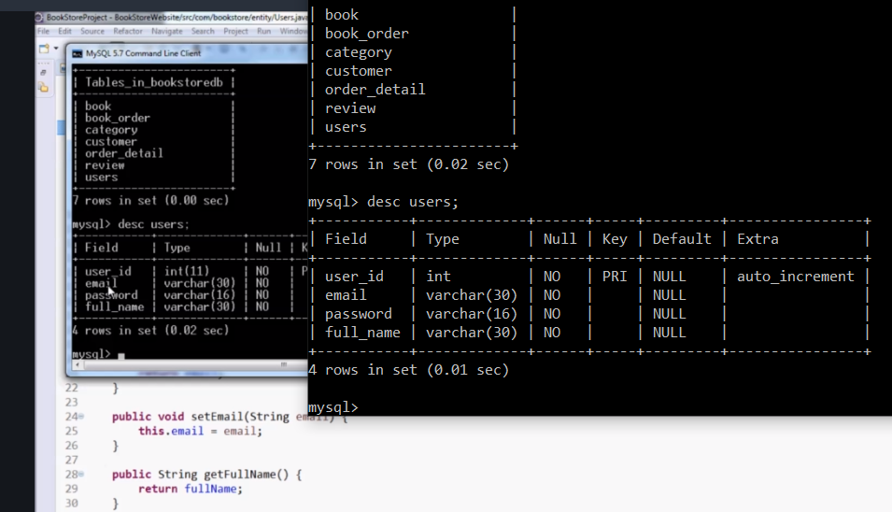

Figure 151:Users Table looks good!

The column names are different in the DB so we MAP them:

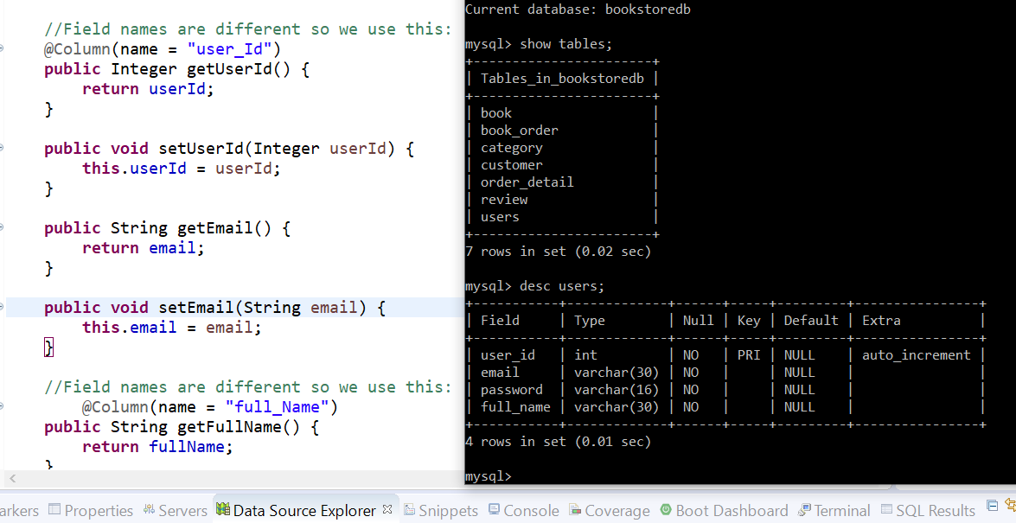

Figure 152:Map the different Column names

These annotations are needed to signify Primary Key and auto generated by Data Base:

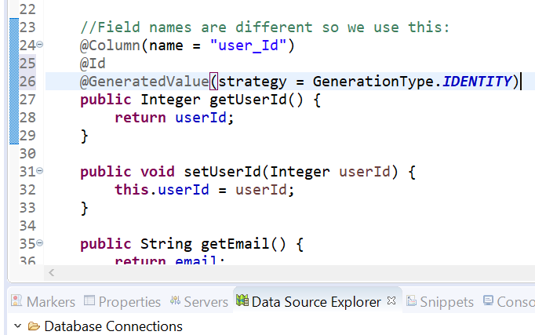

Figure 153:Mapping Primary Key and Auto generated identity

I’m on to making the persistence file in the META-INF directory:

This is the XML Schema for the persistence configuration file.

The file must be named "META-INF/persistence.xml" in the

persistence archive.

Persistence configuration files must indicate

the persistence schema by using the persistence namespace:

http://xmlns.jcp.org/xml/ns/persistence

and indicate the version of the schema by

using the version element as shown below:

<persistence xmlns="http://xmlns.jcp.org/xml/ns/persistence"

xmlns:xsi="http://www.w3.org/2001/XMLSchema-instance"

xsi:schemaLocation="http://xmlns.jcp.org/xml/ns/persistence

http://xmlns.jcp.org/xml/ns/persistence/persistence_2_1.xsd"

version="2.1">

</persistence>

Section 22 in tutorial explains this, and I bookmarked the Oracle Site also for further reading.



Figure 154:Field Mapping

06/04/20 9:00AM – So close!! Check this error out:

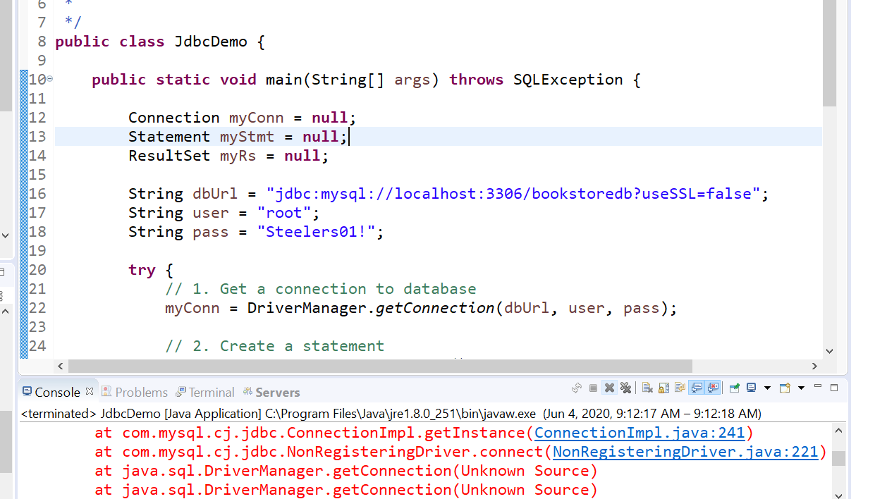

Figure 155: Error Registering Driver

I should be able to fix this pretty quick after researching it, I have a piece of code here that registers the Driver. Here is the actual error line 221:

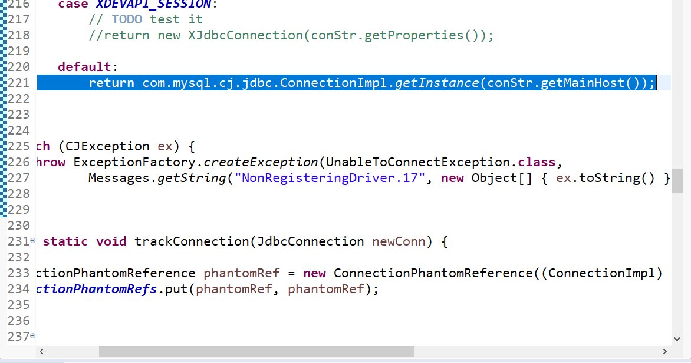

Figure 156: NonDriverRegister error.

YES! Finally got a little sumpin’ sumpin’ 😊

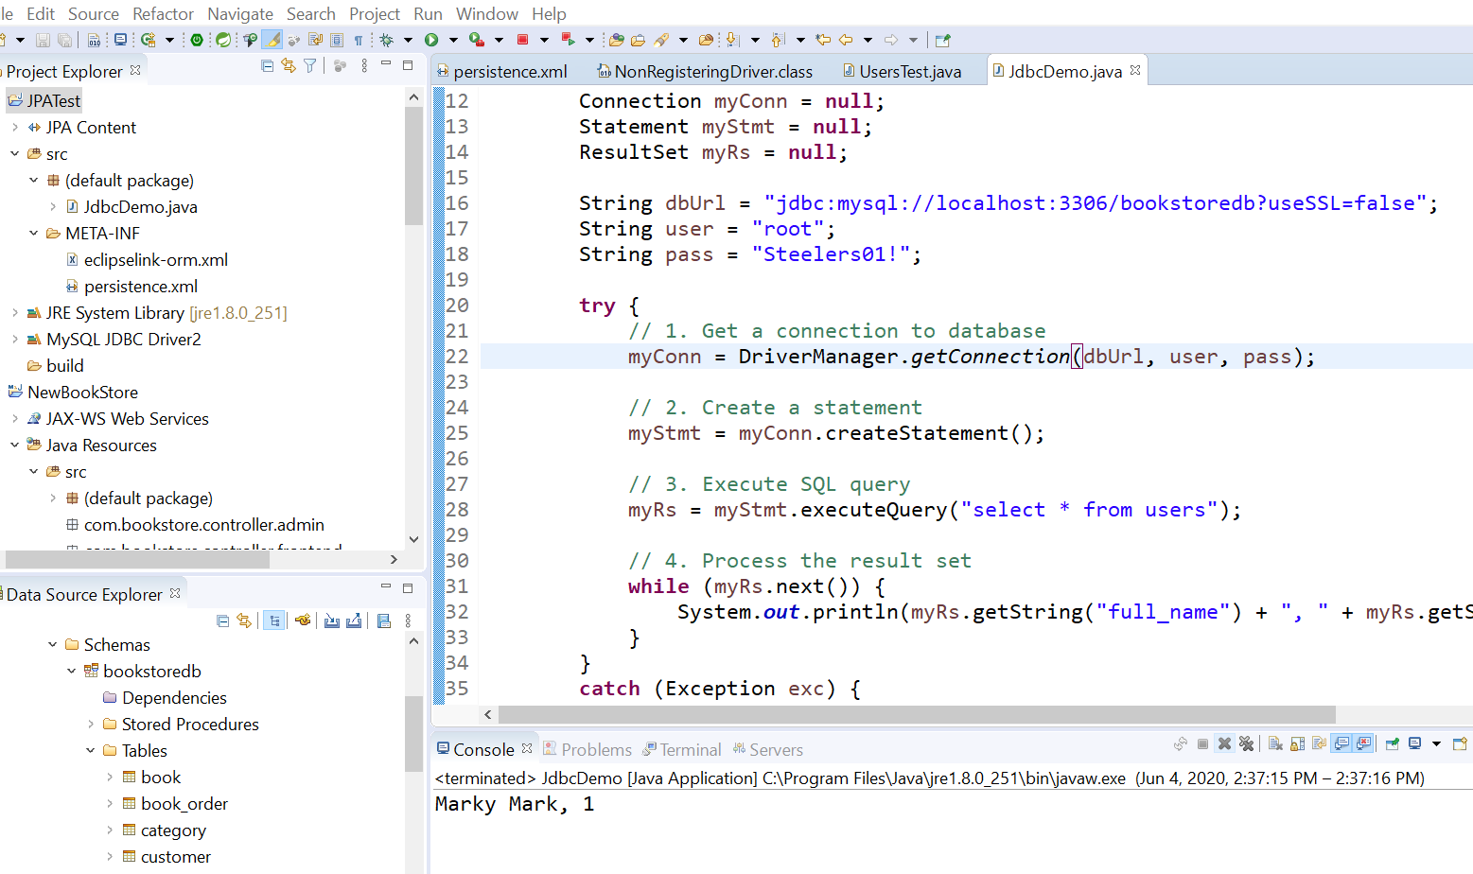

Figure 157:Succeessful Query!

**2:30PM** - Now if I can figure out how I did it and transfer it to other files I’ld be good! LOL I’m going to take snips of the settings before I start messing with it.

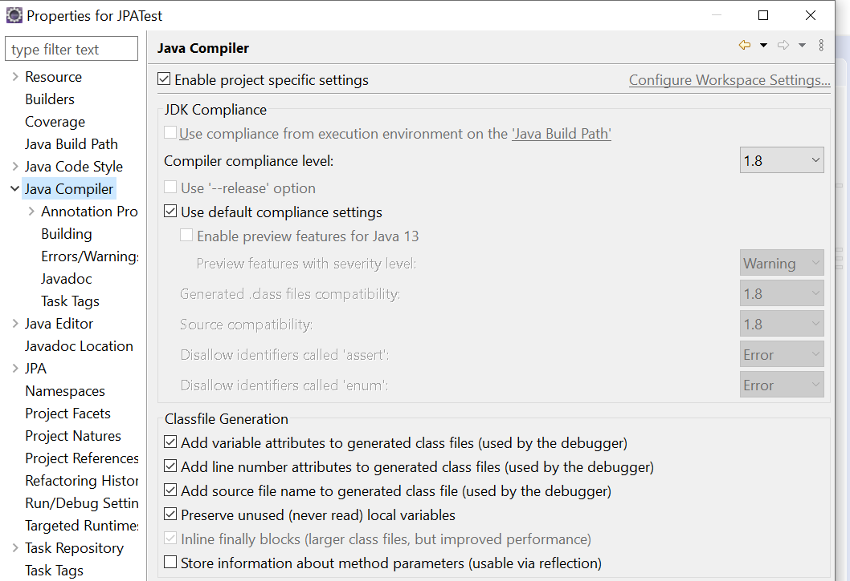

Figure :Compiler Setting 1.8

Right click on the Project file, select Properties and check the settings.

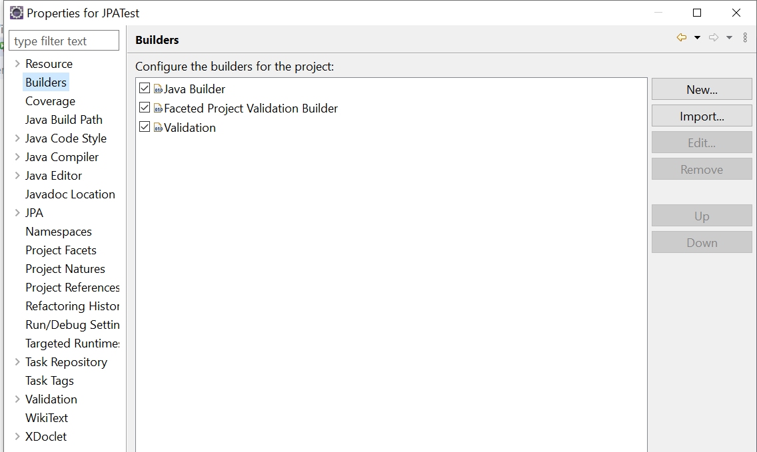

Figure :Builders Settings

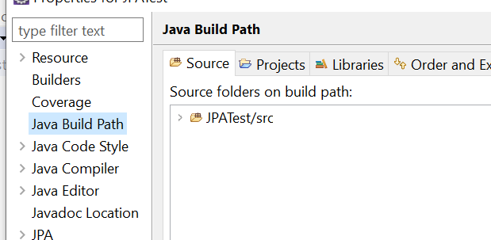

Figure :Build Path Source

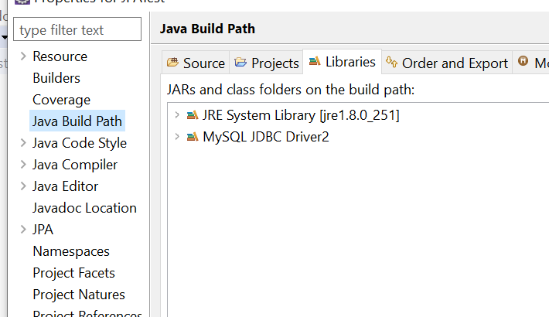

Figure :Build Path Libraries Tab

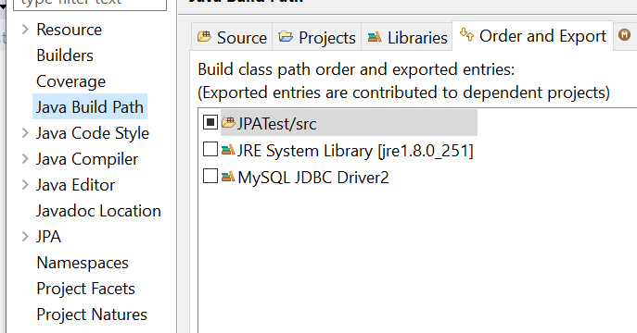

Figure :Order and Export Settings

Complier is 1.8, same as project Jdk/Jre, I played around with the JPA settings not sure if that’s what finally did it or not but I will soon find out.

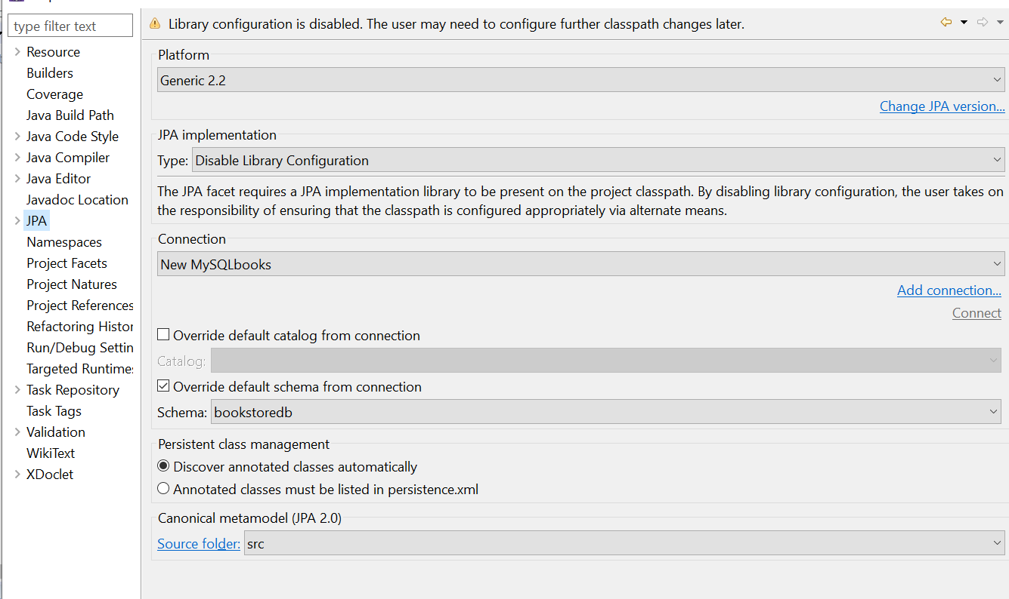

Figure :JPA settings

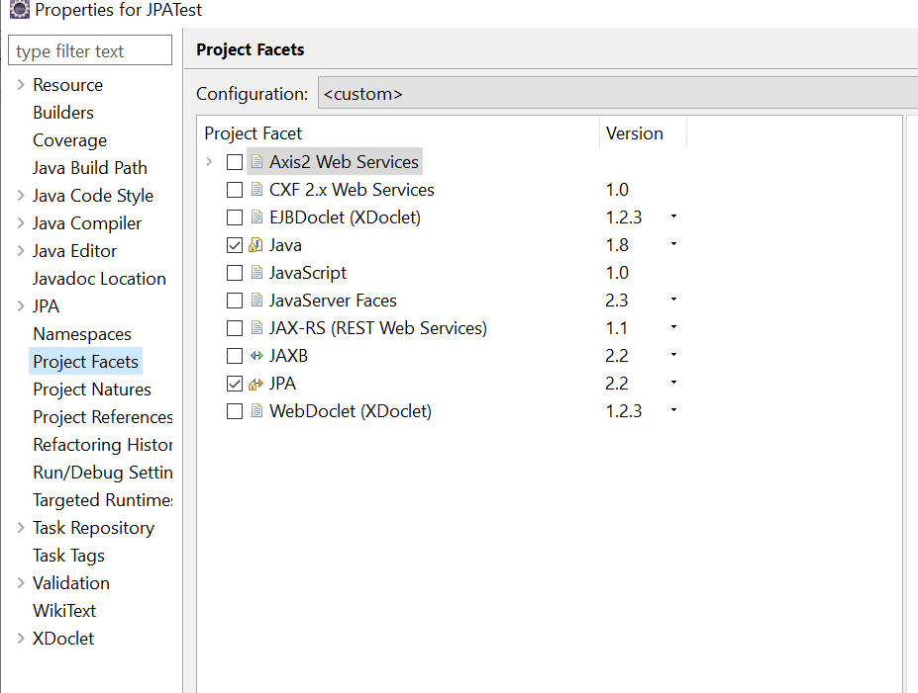

Figure : Facet Tab Settings

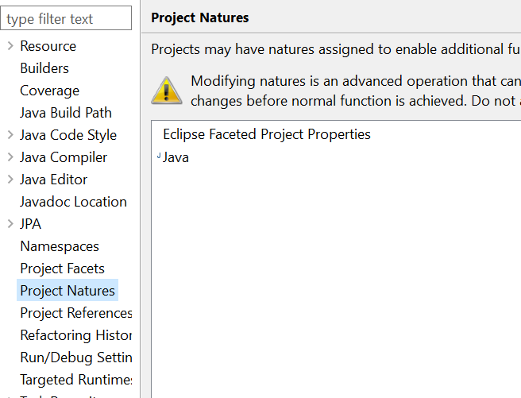

Figure 165: Not sure about this setting either.

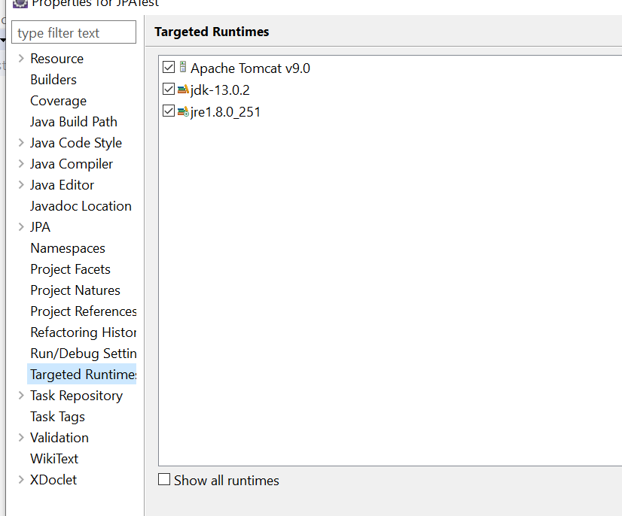

Figure : This ones interesting

I’m not sure if mixing jdk13 with jre1.8 is a good idea or not.

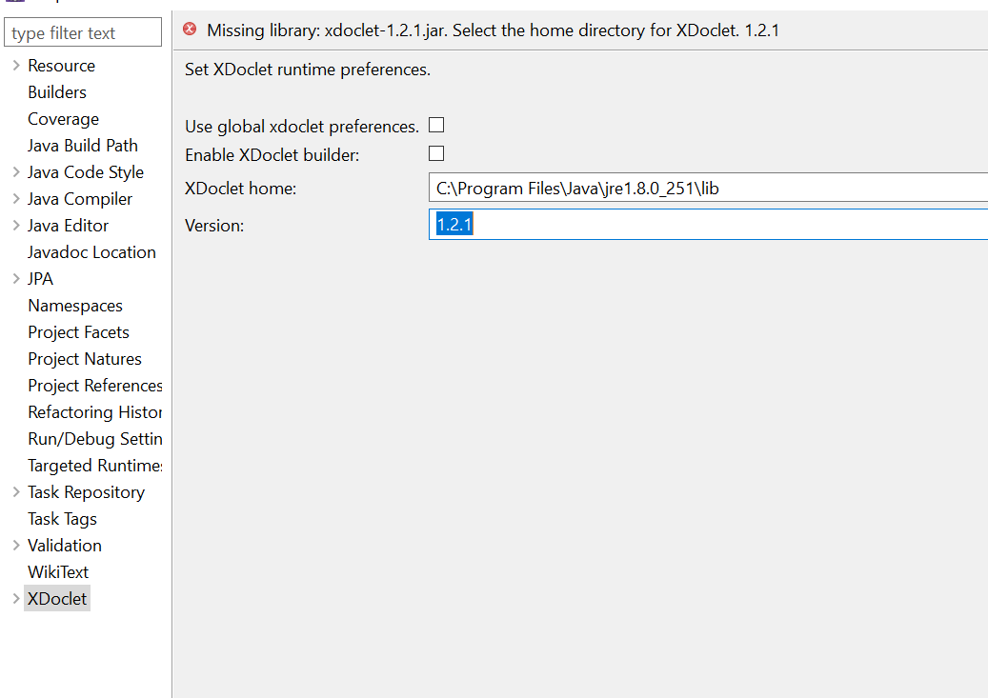

Figure : Not sure about this one either.

**06/05/20 8:00AM** – I discovered this today, the persistence file for the JPATest project has a few more lines in it:

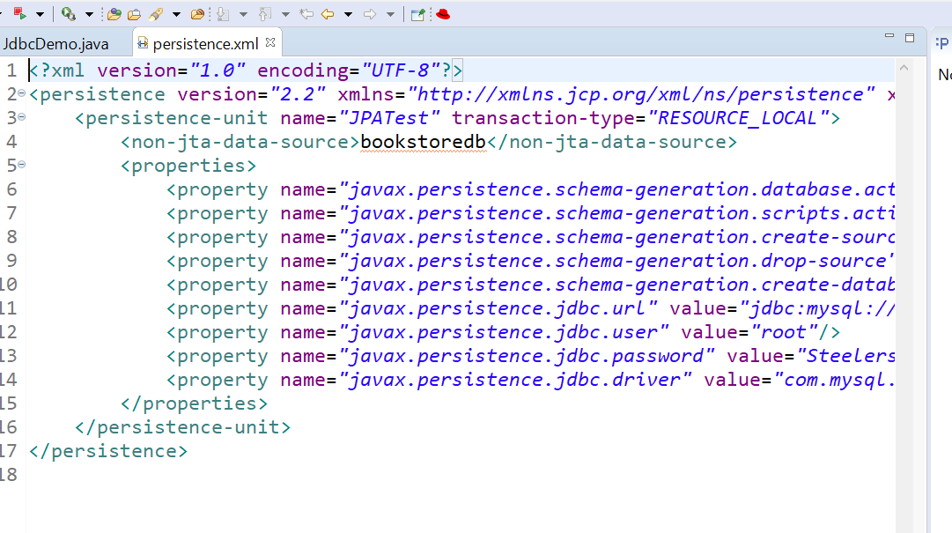

Figure 168:JPATest Persistence File

Notice the header lines compared to the NewBookStore persistence file:

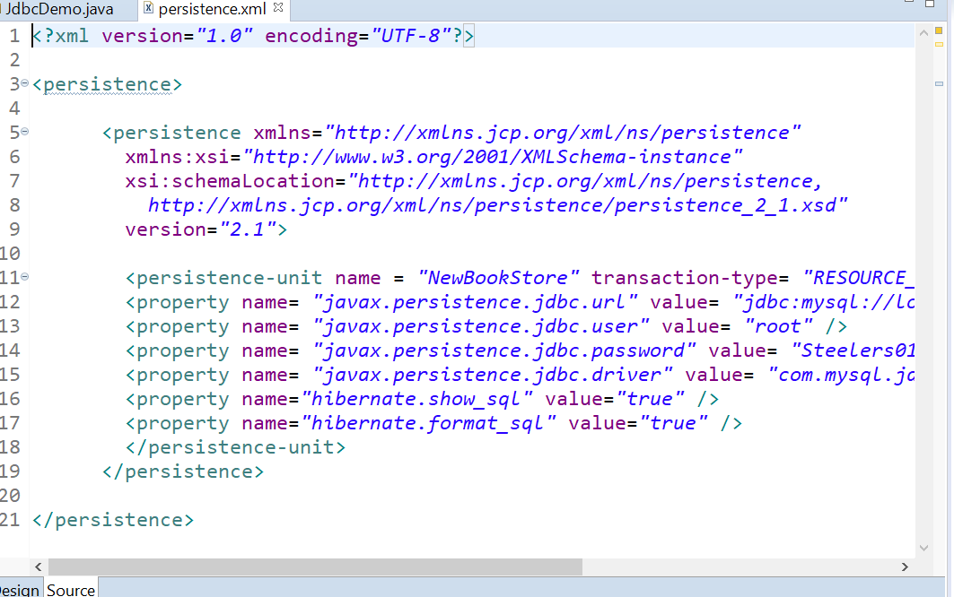

Figure 169:NewBookStore Website persistence file

What interests me is the non-jta-data-source statement in the header. I’m going to read upon that today. I think I added that in as one of the properties of the JPATest project. I need to read up on that and check out some tutorials today before I go further in the BookStoreWebsite project. I’m going to use the Hibernate In Action pdf with the Hibernate 5 XML Configuration Example from the Java Guides website. In case I hadn’t put this in the documentation yet:

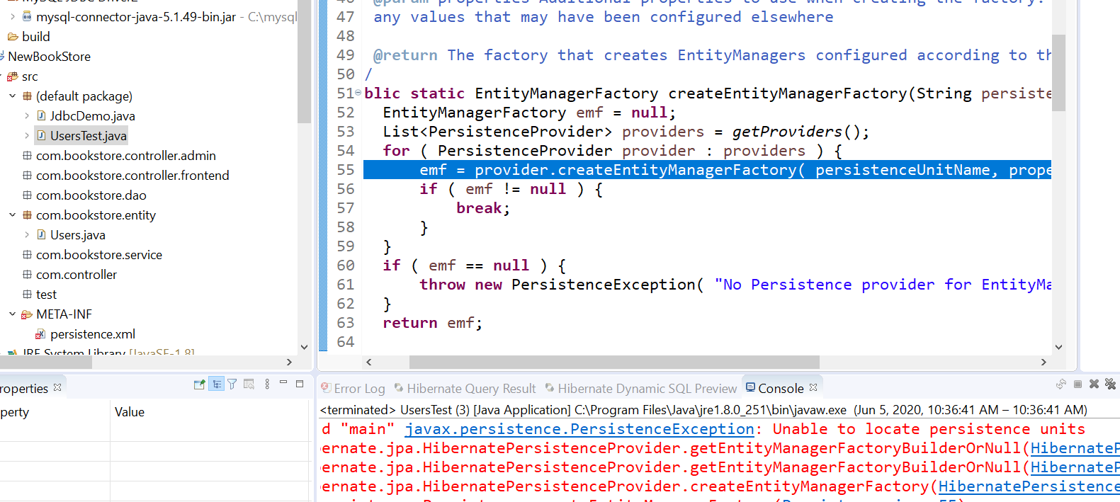

Figure :Persistence Unit Error and Entity Manager

OMG! It fucking worked! HAHA!

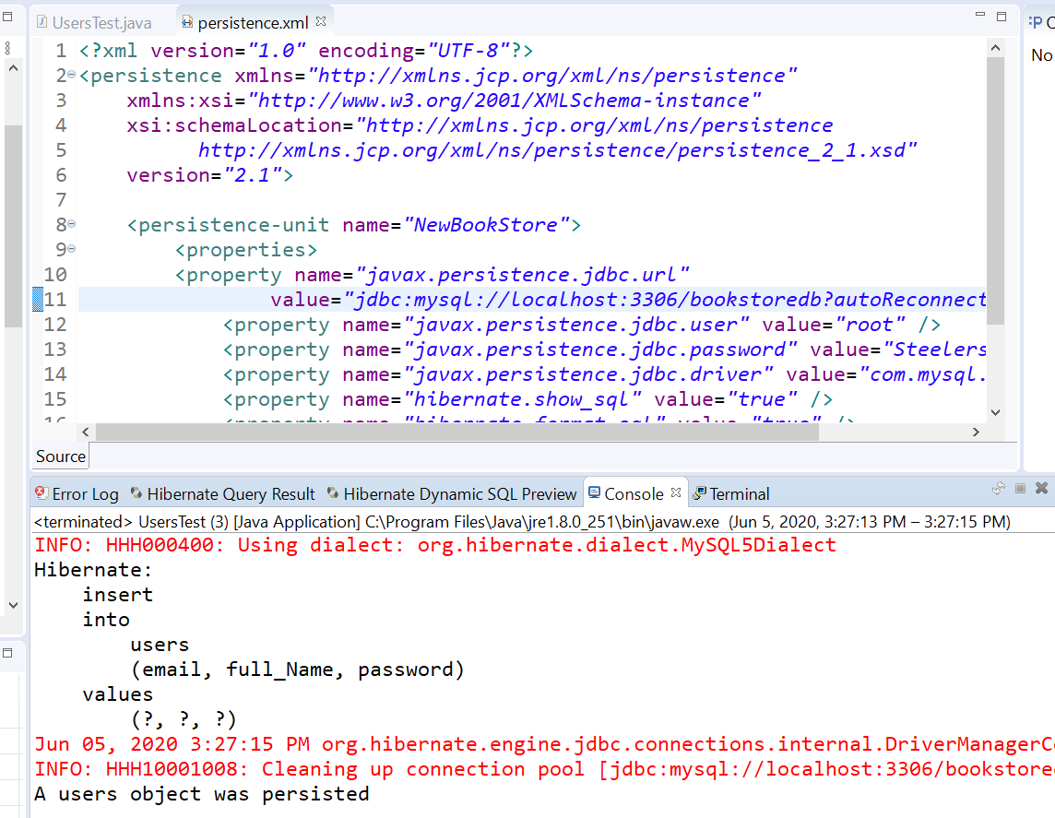

Figure 171:Finally the right combination!

I think it was the JDBC Driver version, they both have the same one and both work now:

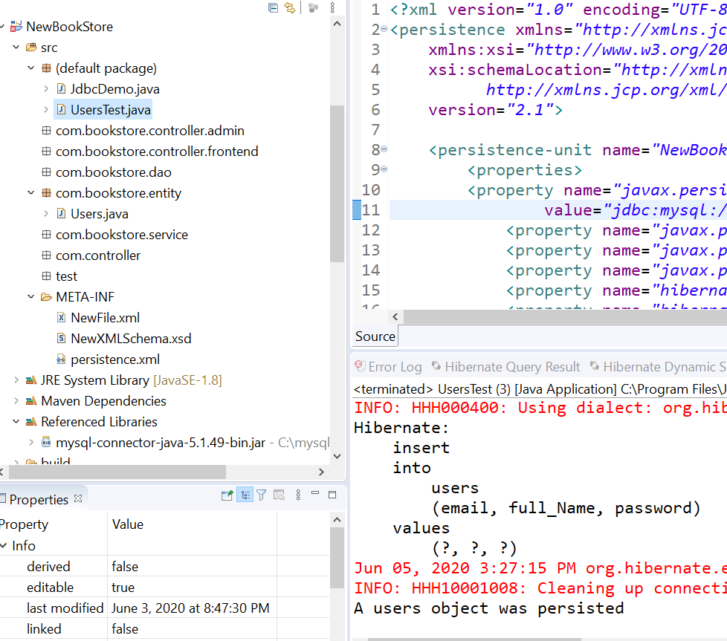

Figure 172:Finally some communication!

The mysql-connector file revision seems to work on both Projects. I think I got the project name and DB name right this time:

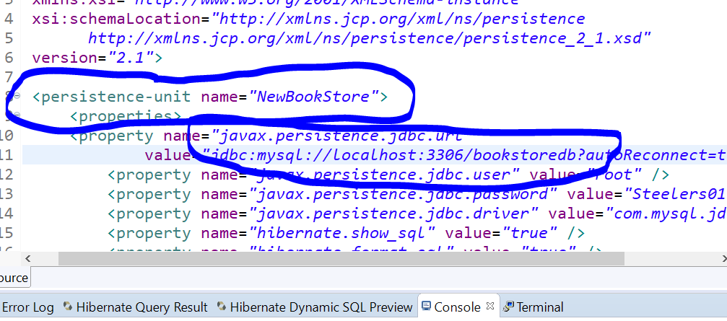

Figure 173:Project Name in persistence unit, database name on the server

Figure 174:Working files and project folder structure

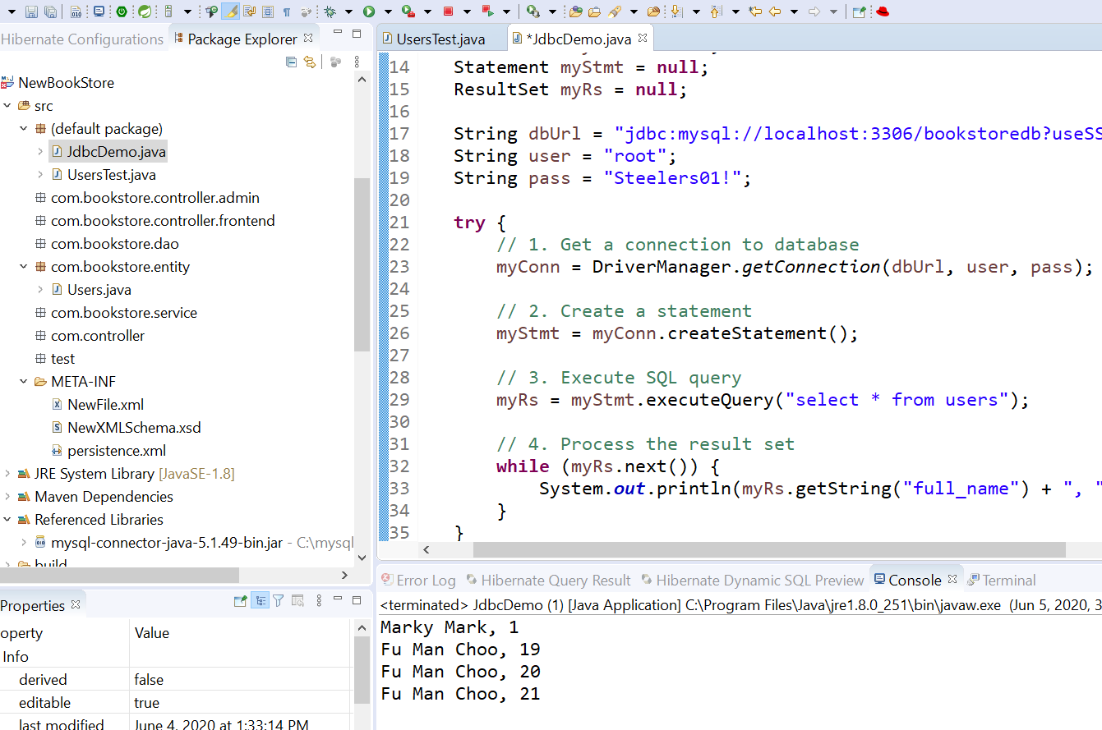

Users file has the methods to create a new user in the Users Table, and the JDBCDemo file takes the queries and prints to the console:

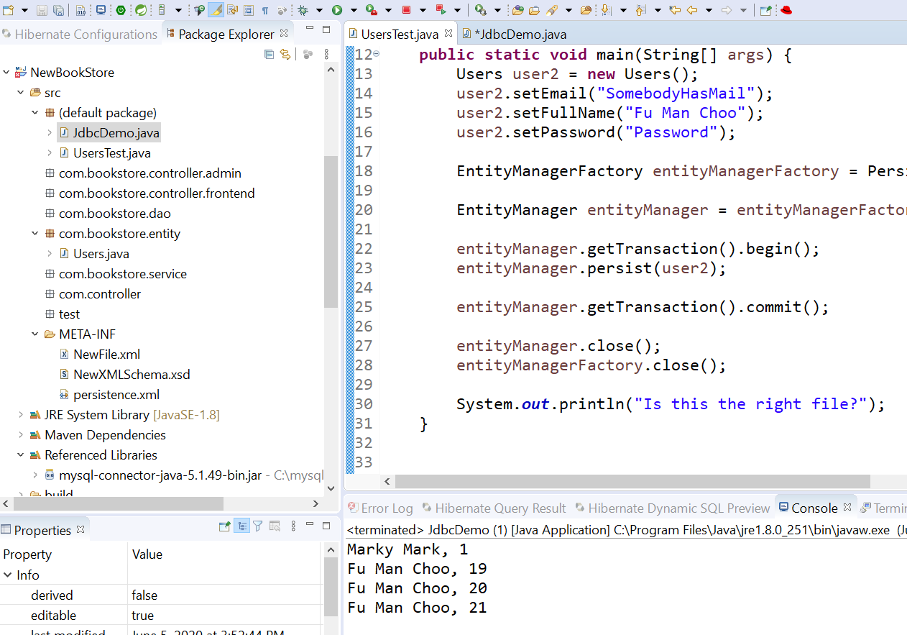

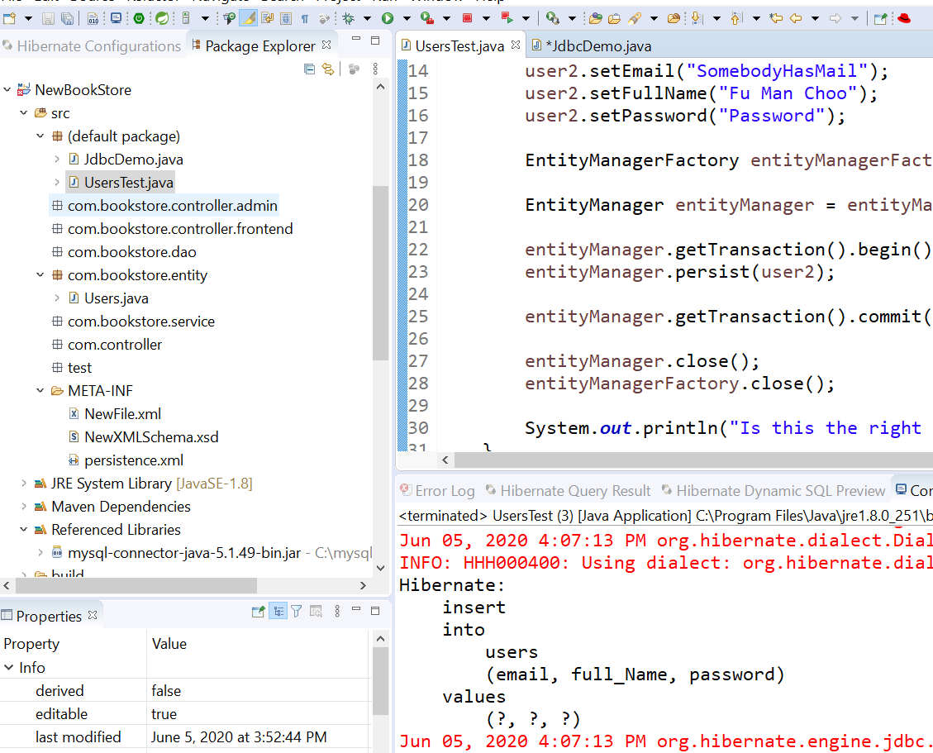



Figure : The SQL Statement

06/06/20 8:45 AM – Ok here’s the deal:

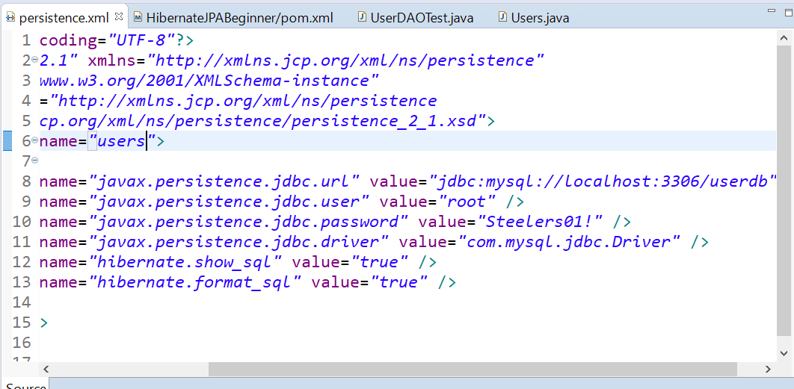

Figure : Database and Table Persist Settings

In the persistence file, the persistence unit is the TABLE you want to persist(Edit, update, etc,,). The localhost:3306/(This is the DB NAME you want the TABLE to update in). The POM file points to the artifacts, versions, etc,, that you want to use to PERSIST:

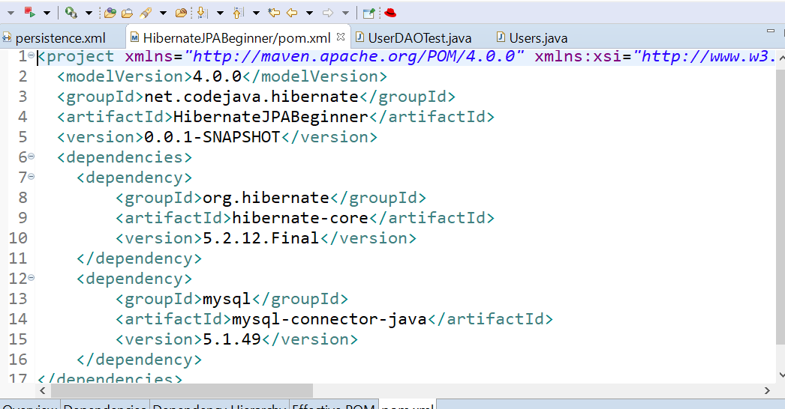

Figure :Correct artifact declarations.

The 5.1.49 mysql-connector file seems to work very well for me. Here is this particular projects DOA Mapping:

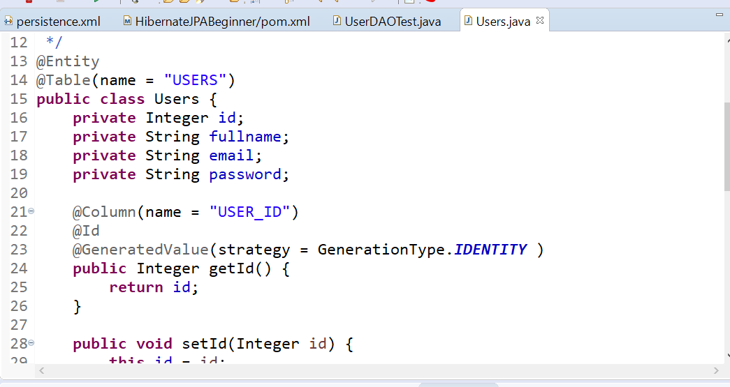

Figure :Mapping the Entity/Table to the DB

The correct DOA Test setup:

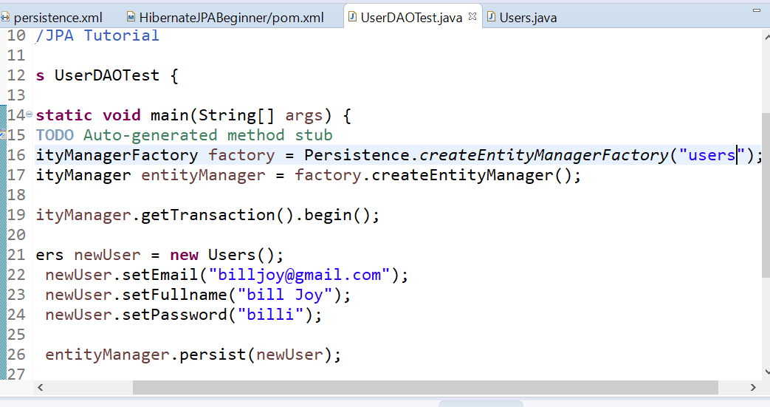



Figure :Persistence test(users Table in userdb Database.

Here we have the correct output after the files are set up properly:

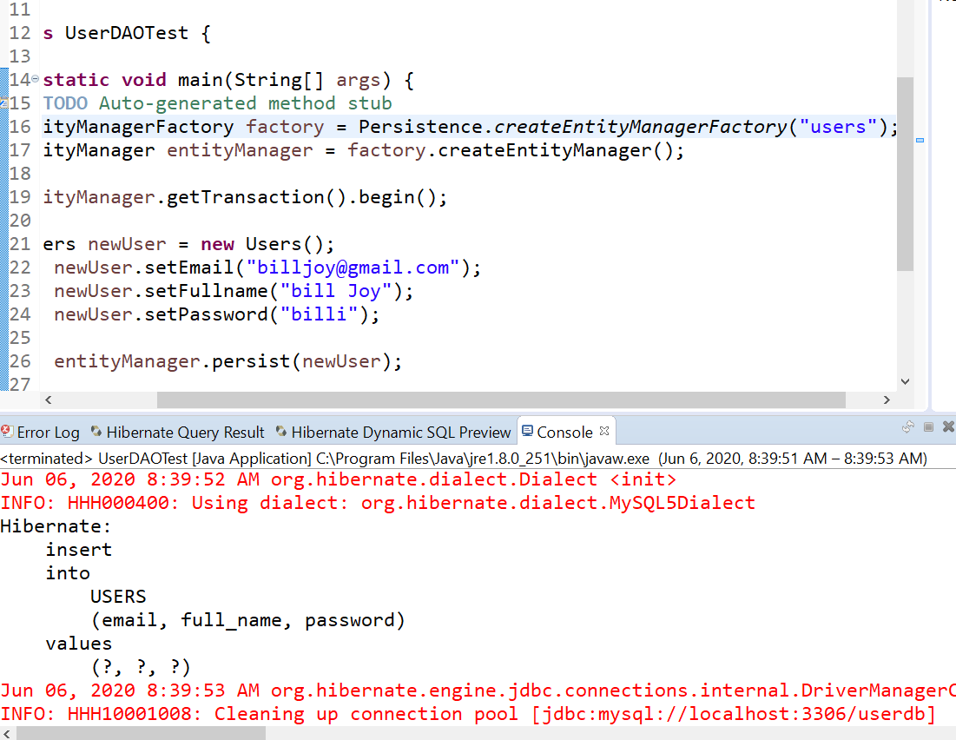



Figure : Correct DBase Statement/Output

Notice the hibernate.engine.jdbc statement through the Driver Manager and the connection pool to the DB Mapping. PERFECT! YAY! 😊 Here is the DB update in MySQL:

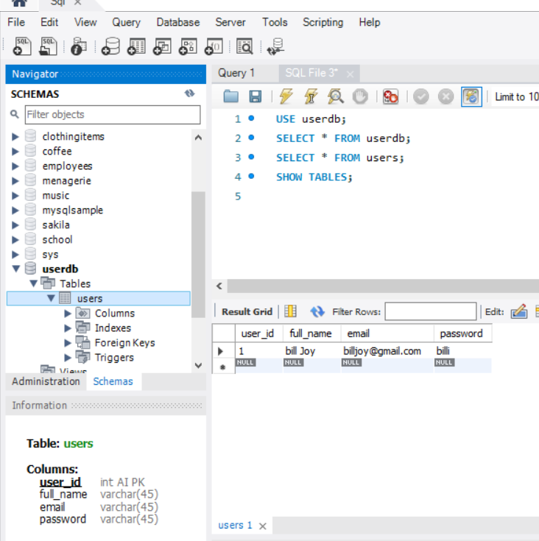

Figure 181: MySQL Update

So it’s a 5 step process and everything has to match up in the proper files.

1:00PM – We have a connection verified:

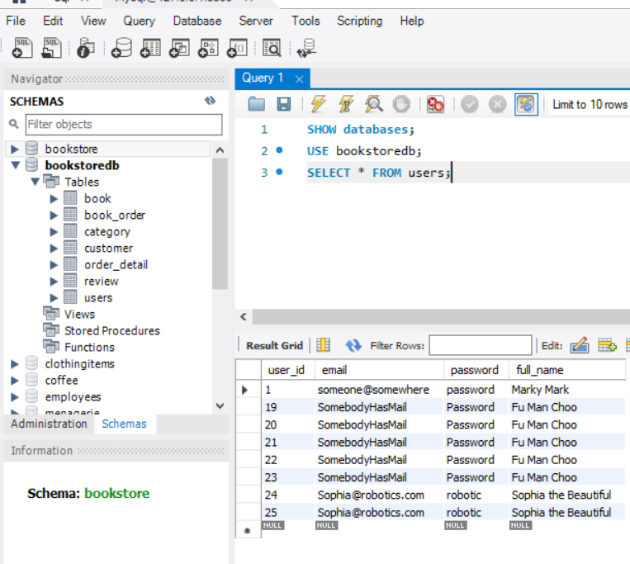

Figure 182: Connection Established

One thing I learned already, don’t use a question mark after the autoReconnect statement. LOL “*bookstoredb?autoReconnect=true"* />.

**06/07/20 12:00PM –** Section24 – Creating the Data Access Object (DAO) is pretty brutal. Have to be very careful when you right-click🡪Source🡪Create, going to have to read up on this part more for sure! The GenericDAO and the JPA DAO specifically, I kinda get it, make one Interface for the Objects that are similar? Definitely more studying on that.

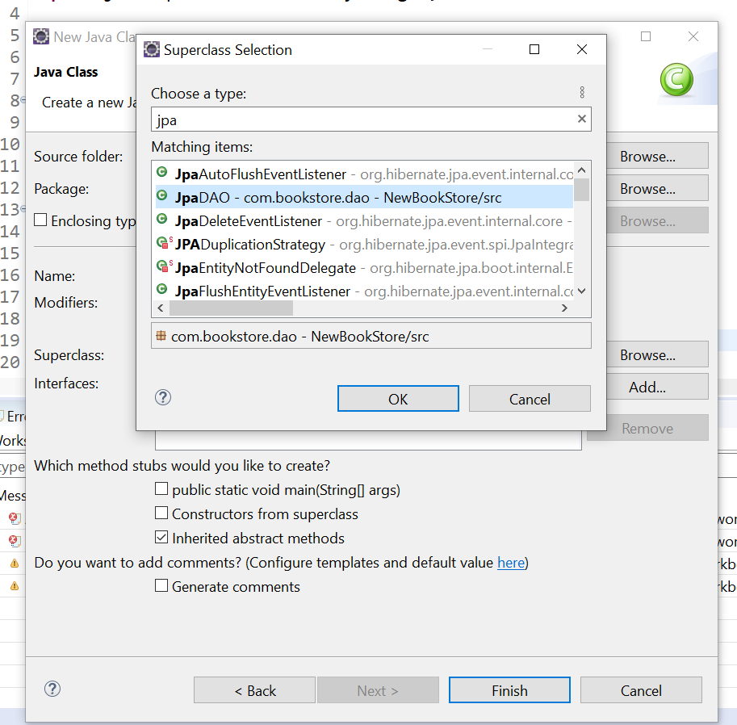

Figure :DAO Superclass

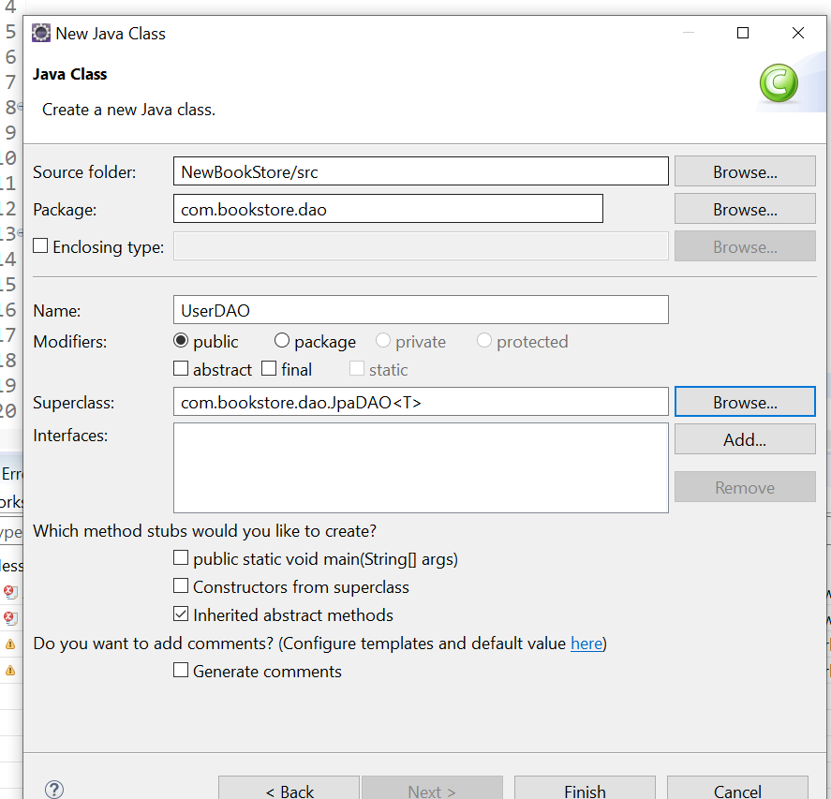

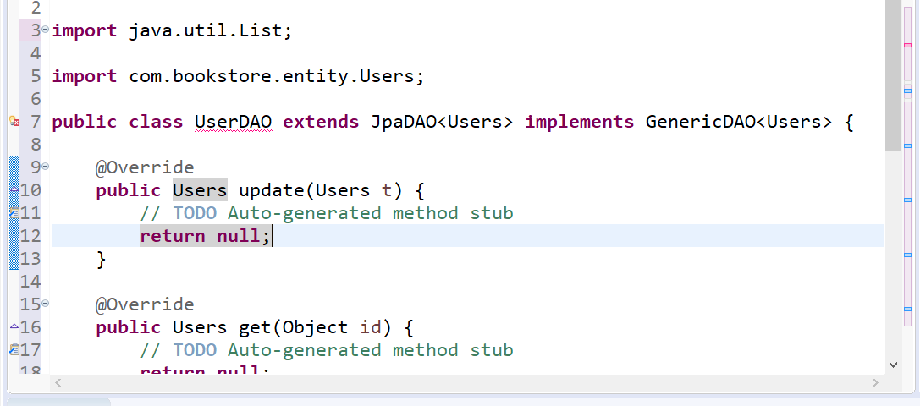

Figure :Add Unimplemented DAO

Automatically builds constructors, I think it’s add unimplemented DAO when you right click 🡪Source. This section of the tutorial needs more studying for sure!

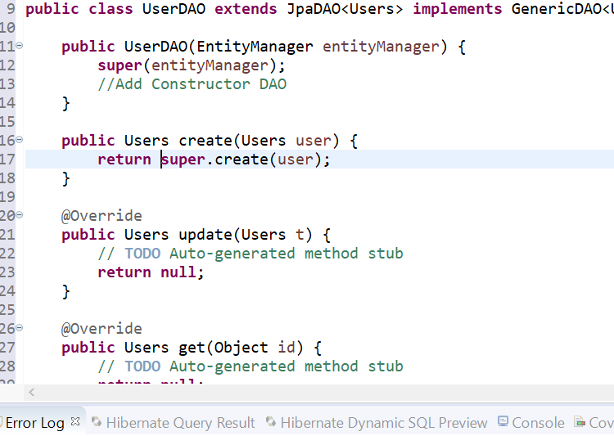

Figure :User DAO Entity

**06/08/20 – 6:30 AM** – Started a new workspace and project “Hibernate and Persist Tutorials” book. That way I get another perspective and learning path. Plus this project doesn’t use Eclipse, so it will be a good way to learn how Eclipse works on my own.

11:00AM – I screwed up the Hibernate Install I think, so I have this now:

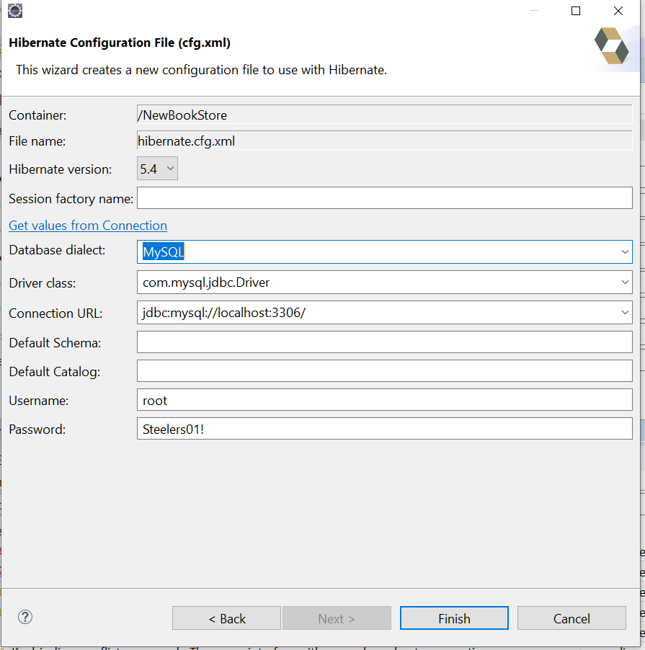

Figure 186: Hibernate Install Configuration

I hope it’s fixed now! LOL

11:30AM – Damit!It’s always something! Got a persistence file error, hope this fixes it:

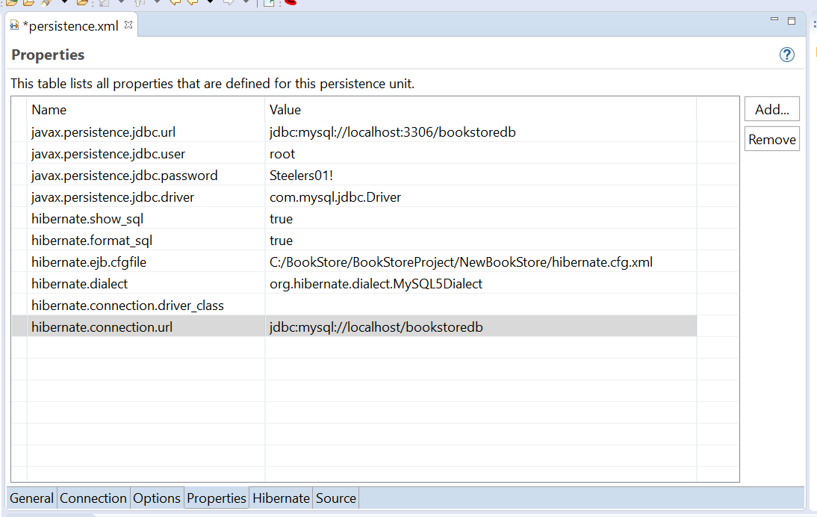

Figure 187: Persistence Hibernate Configuration

Ok I think this is it, at least the error went away!

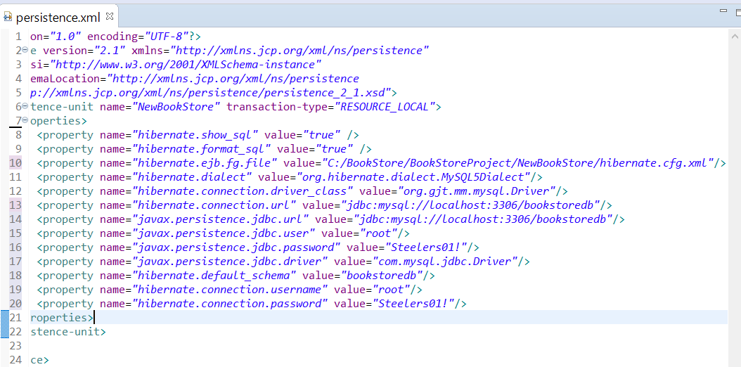

Figure :New Persistence

06/09/20 9:15AM – Well I learned something new already today..LOL In the Hibernate.CFG file, don’t name the database:

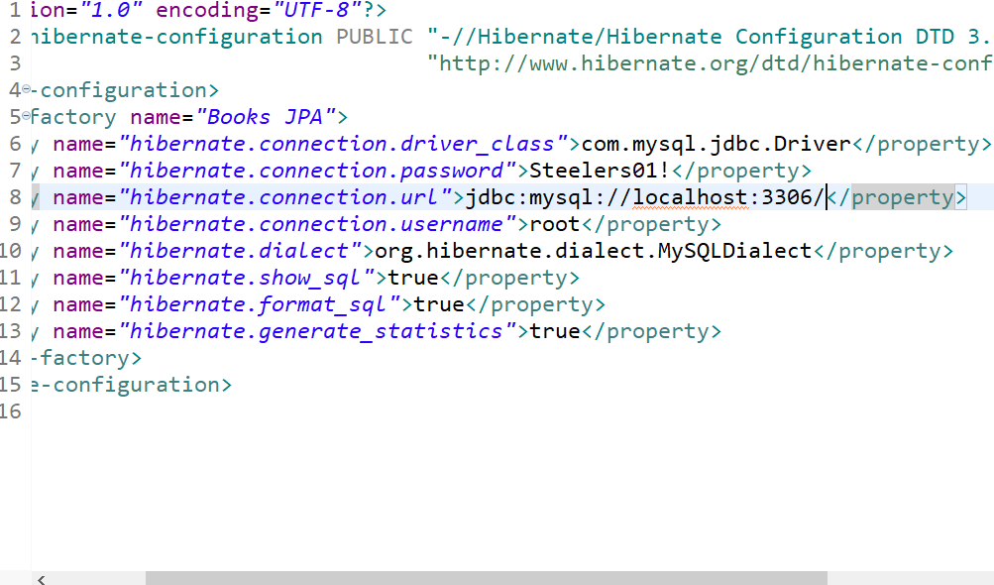



Figure :Hibernate Configurtion

Don’t put the Database Name in here, you get an error.

In Lecture 26 UserDAOTest it talks about creating/changing a user in the DB.

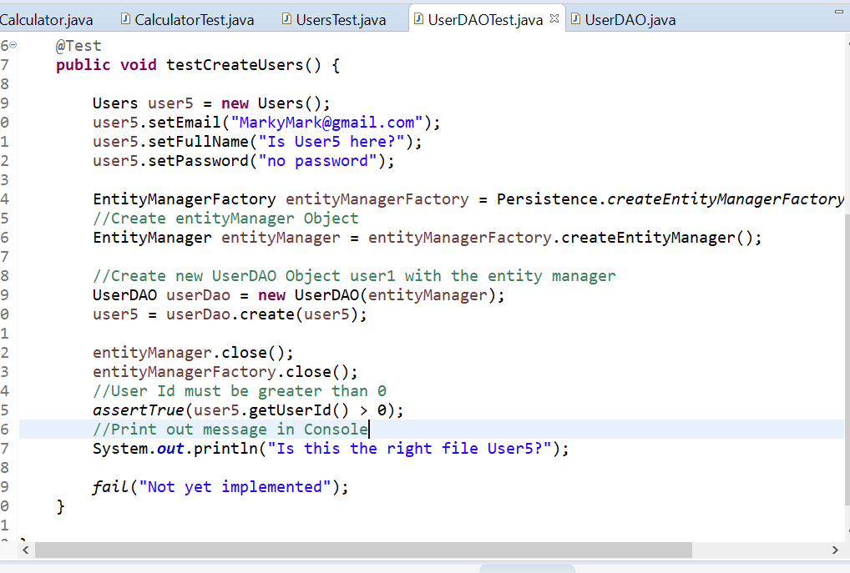

Figure : Testing Create User

Well that worked pretty good, just have to watch the syntax/typos of course. This error bothers me, it keeps coming up:

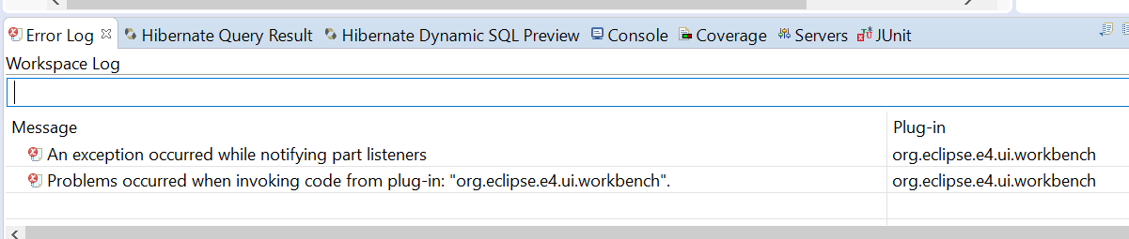

Figure :Error Log

I think it’s something to do with Hibernate. Figure it out later.

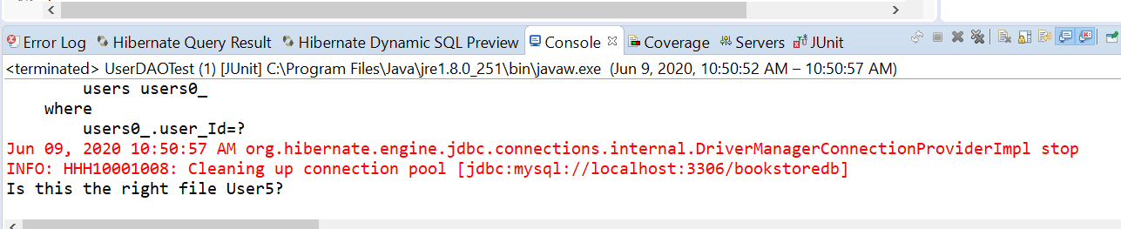

Figure : It does appear to be working.

Oh!! It doesn’t matter what user ID number you use, it just adds to the last ID number since it’s generated auto increment:

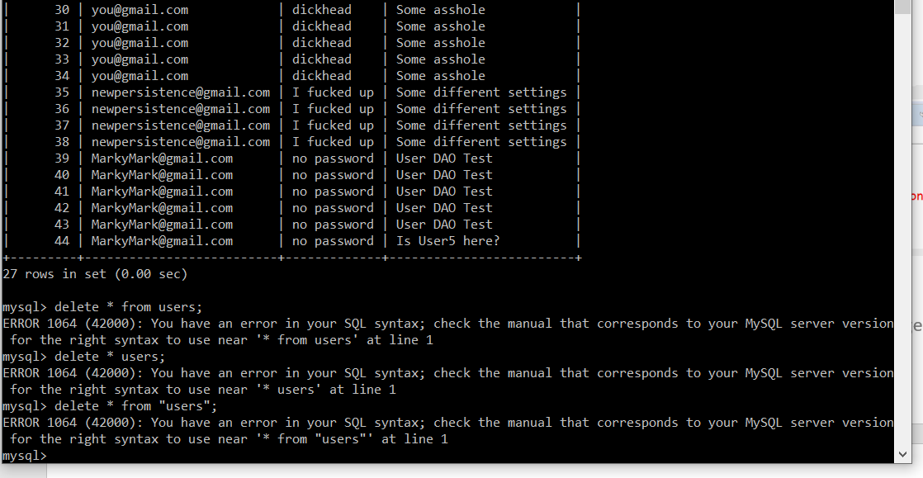

Figure : Update verified

UserDaoTest is pretty rough. You set up the class, create it, test it, then tear it down.

06/10/20 7:00AM – At least I’m starting out today on the right foot:

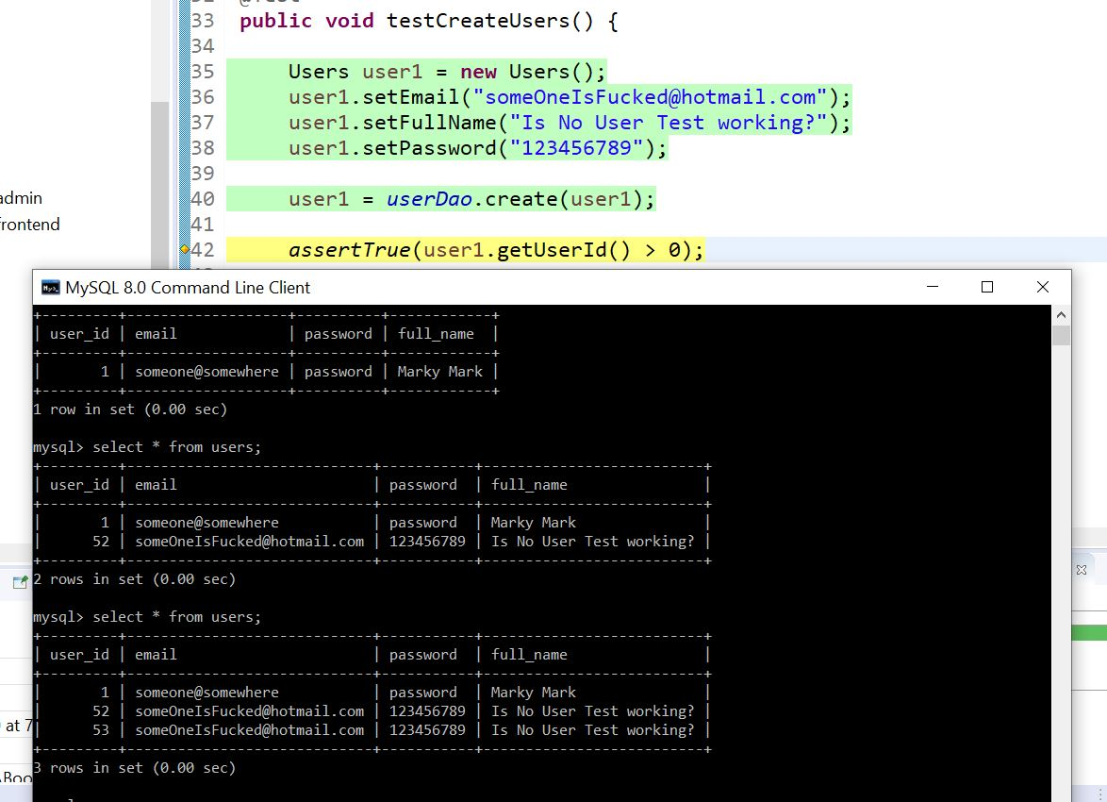

Figure : Update User is working.

**I’m definitely going to have to go over Lecture 26-code UserDAOtest.**

**06/11/20 10:30AM –** Now we’re getting into the meat of this project. Lecture 27, Section 8. Start the index.jsp file. Glad I have experience with Html and Web Design from years ago! It’ll come in handy now.

1:15PM – Here’s the HomePage code so far:

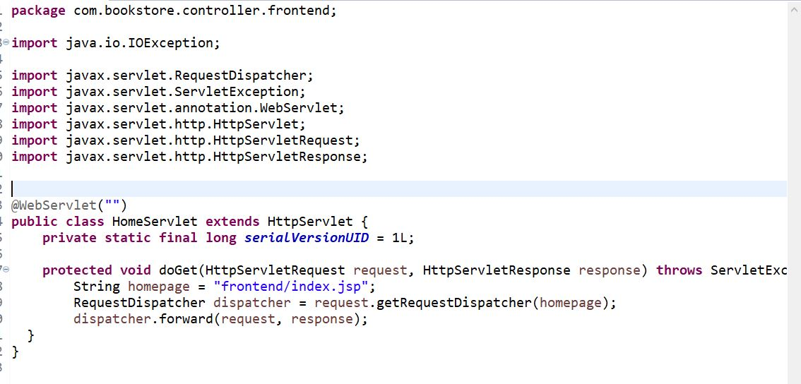

Figure :HomePage servlet code

06/12/20 – 1:00PM VERY IMPORTANT! I’m not sure how I missed this,

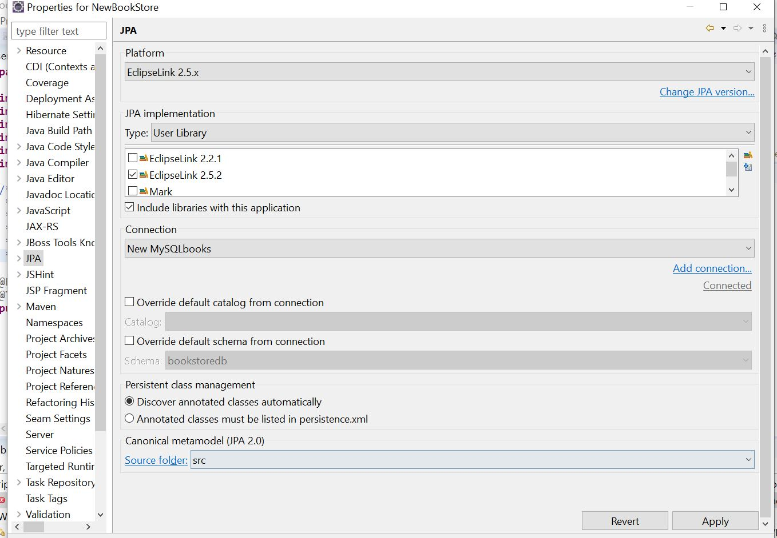

Figure : Current JPA Configs

4:00PM – WOW This is awesome! Check this out, it pretty much makes itself with the code:

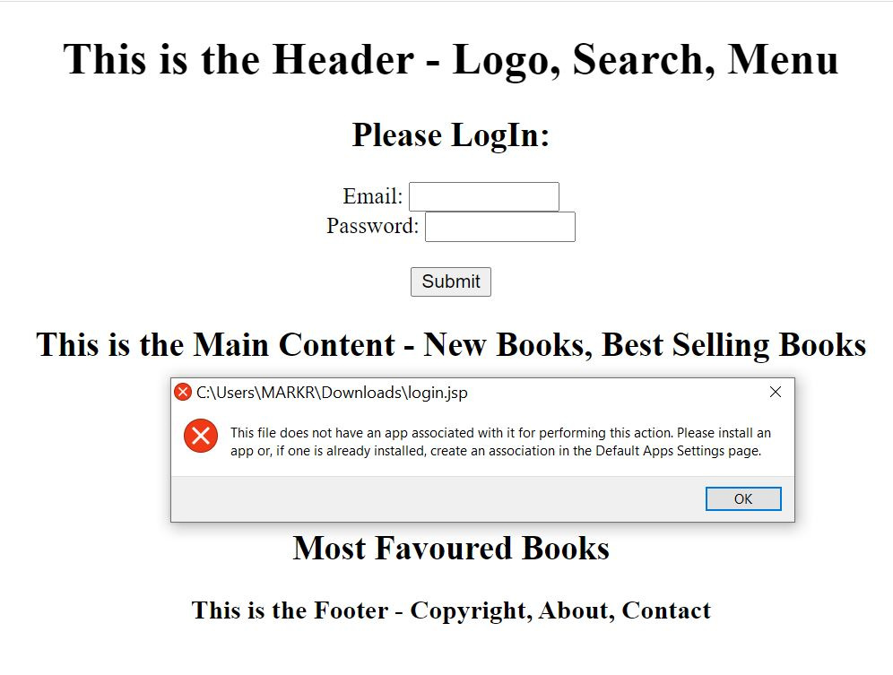

Figure :Basic Login Screen

There is also a little web browser button on the side bar to launch the page in your browser!This is going to be fun! Of course the code isn’t in there yet.

06/13/20 12:00PM – I have a lot of reference material/books about JSP,mainly Java Server Pages 3 by O’Reilly in the Documents Directory – Java Server Pages 3rd. Also JSP 2 Fourth Edition 2005 by Apress, but I can’t find the code for download. Java 8 EE Development with Eclipse is an excellent starting point.

06/15/20 7:00AM – Son-of-a-Bitch! I screwed something up and started getting server errors and nothing was working! I’m not even sure what I did! LOL. I uninstalled/reinstalled everything and finally back to the server working again. I kept getting an error that the 8080 port was already in use. Pretty sure it has something to do with the workspaces being shared, using the same port. The only project that seems to be working is the NEWBOOKSTORE workspace:

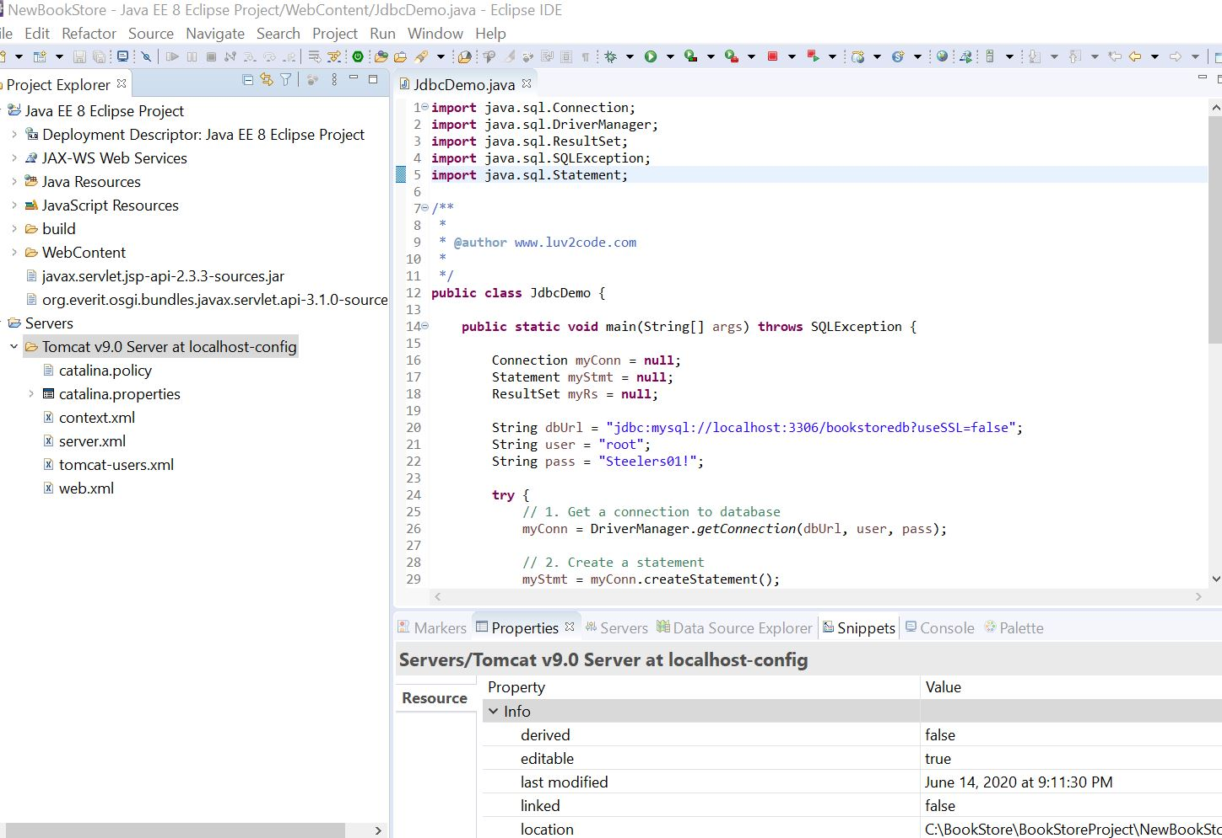

Figure : Server settings that are working.

This workspace is working perfectly. I think I deleted the original NewBookStore workspace and made this new one, DAMIT! Might have to start over again!

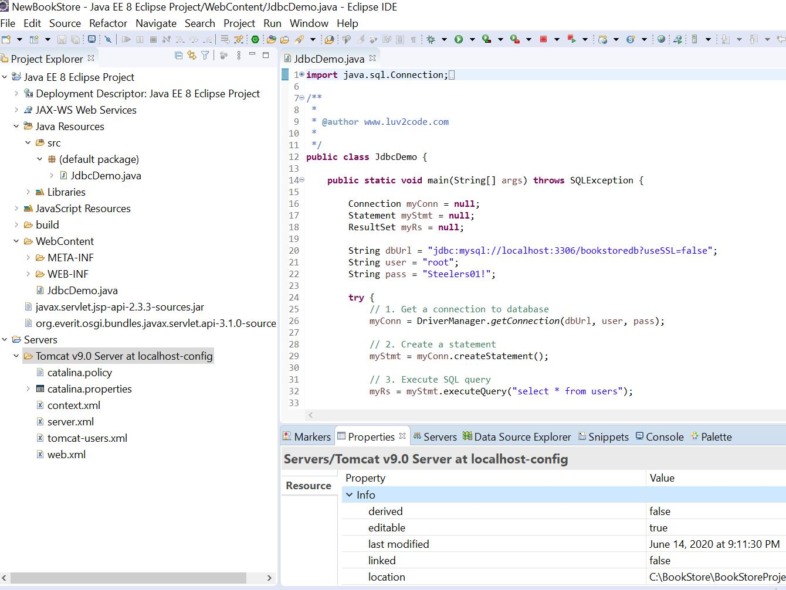

Figure: Local config file

The localhost-config file is the key I think. This project is using the port. I get the “download file” again when I run on server. Going to go back and fix that.

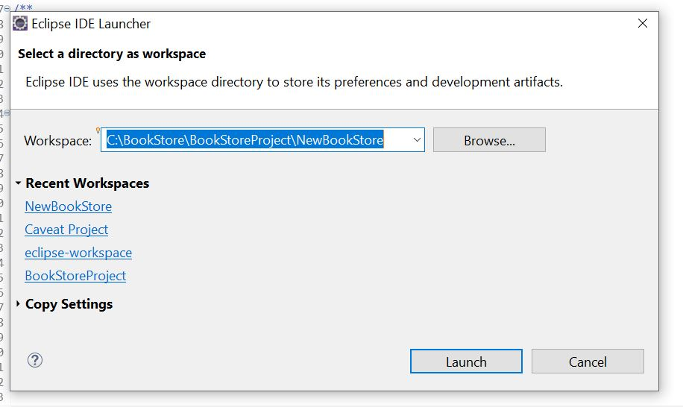

Figure : Correct Workspace with Server

Here’s where the working file is with the correct server config:

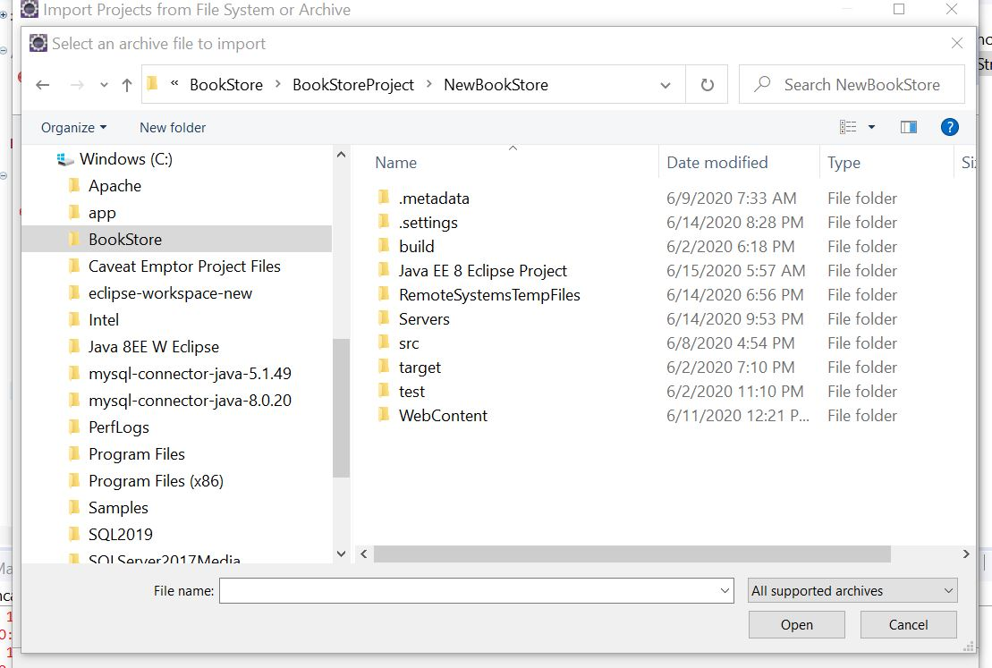

Figure :Working Location of current working Project

I tried importing the original Bookstore, but it’s gone! LOL Musta got lost with all the Install/Re-Installs. I need to figure out how to create a backup in Eclipse.

**11:00AM – Gotta watch the pom.xml file in the WebContent folder. Might be screwed up. Keep in mind the Section 2 folder in the Udemy e-Commerce Website has the pictures of each section and what files/folders are set up. Section 6 has the persistence, userstest, and hibernate XML files. Section 7 has the DOA structure files. Section 8 has the logos. Open that pom file and check out the dependency hierarchy:**

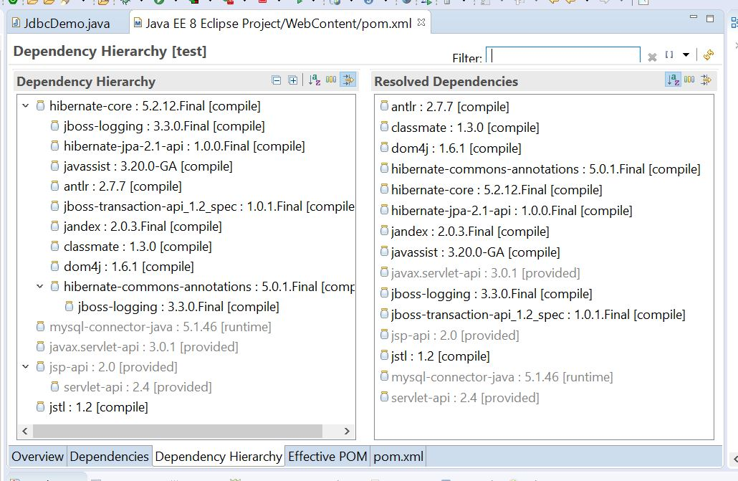

Figure : New Dependency file.

**I think I need to add the javax.servlet-api files in the POM from the Central Repository website.**

**1:30PM – BookStoreProject-NewBookStore Tomcat server doesn’t work.**

**7:00PM –** Here’s the BookStoreProject workspace – NewBookStore Server:

otice



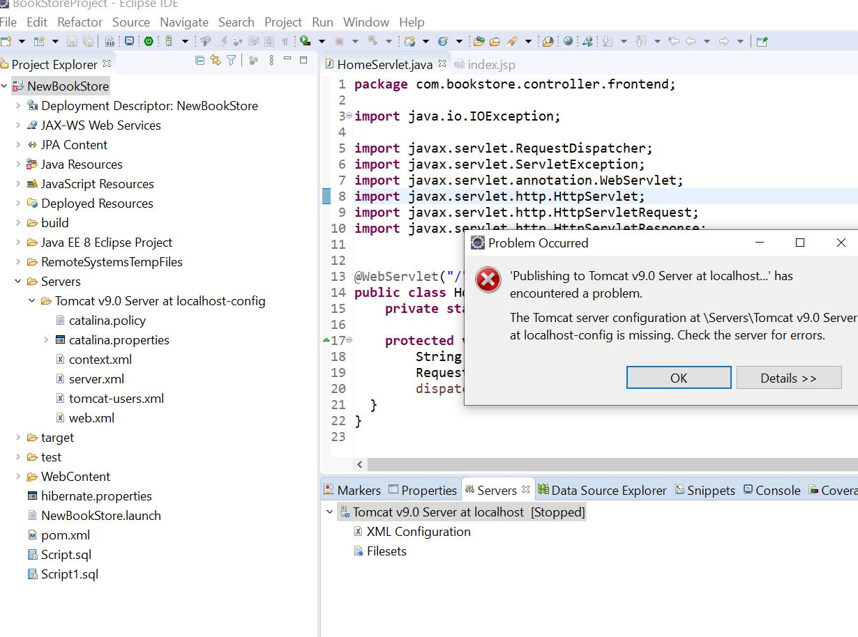

Figure : NewBookStoreServer Error

Here’s the current workspace:

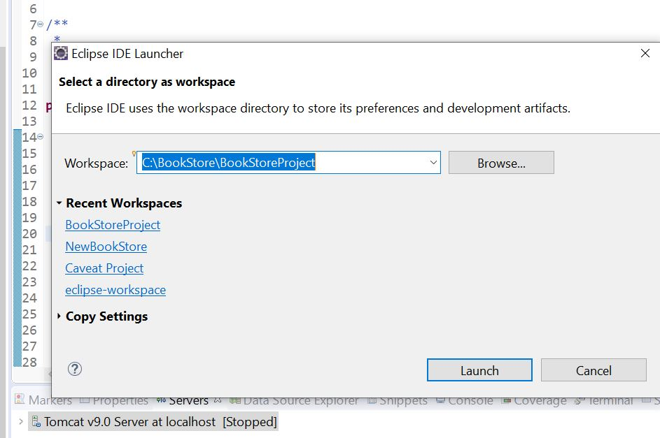

Now let me try the NewBookStore workspace see if that server works:

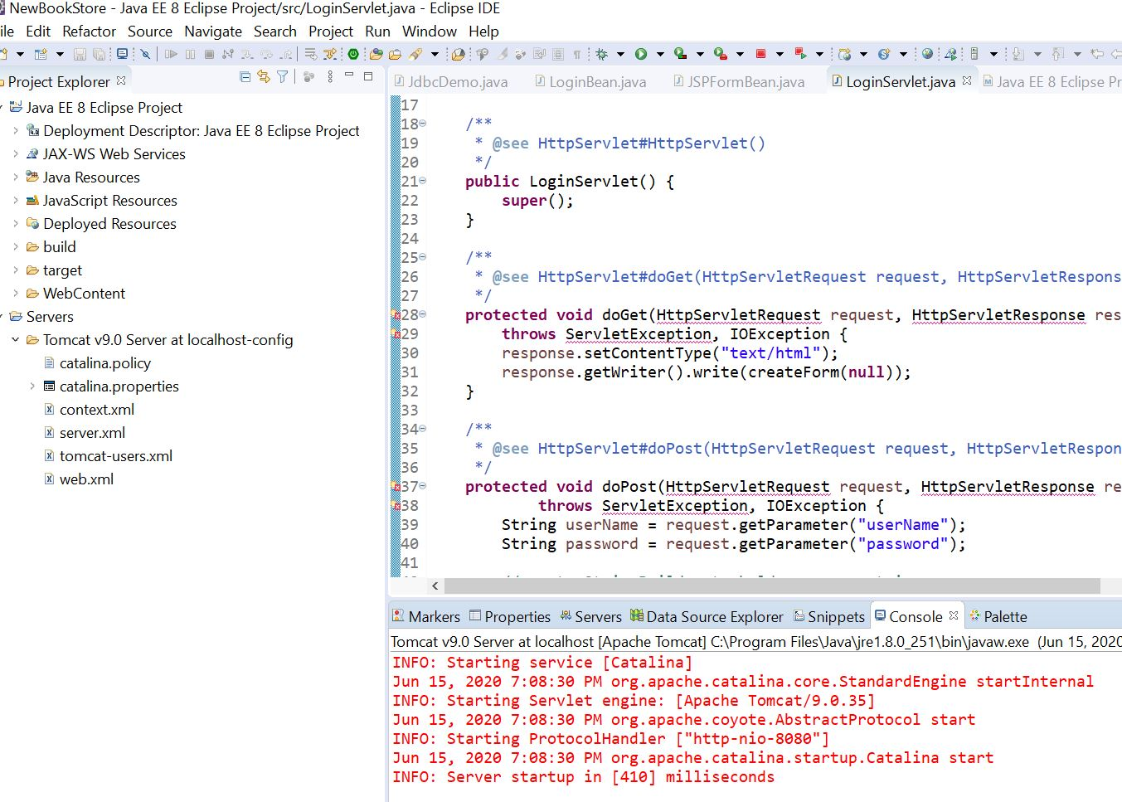

Figure :Server Works in this workspace

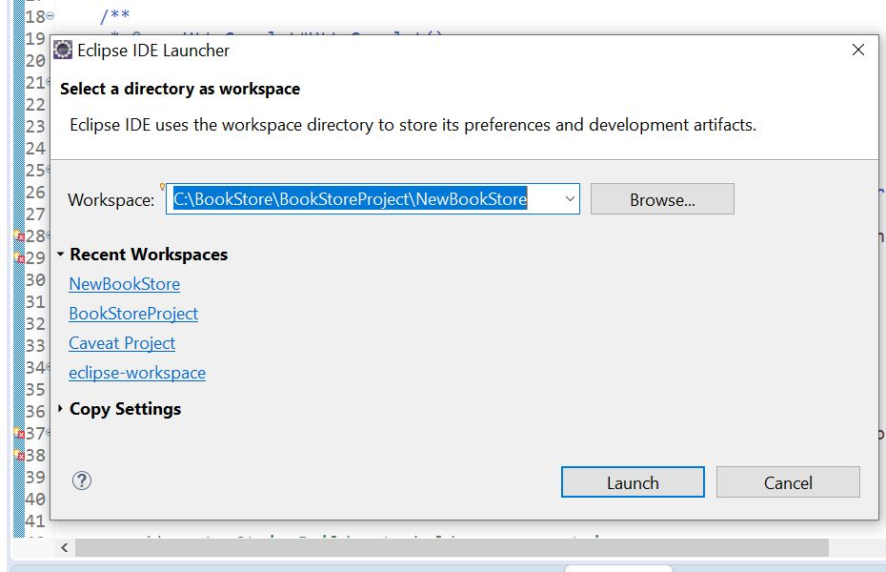

Figure :This Server Works in this Workspace/Project

Now I’ll try the Caveat Project from the EE 8 Eclipse book. It works here:

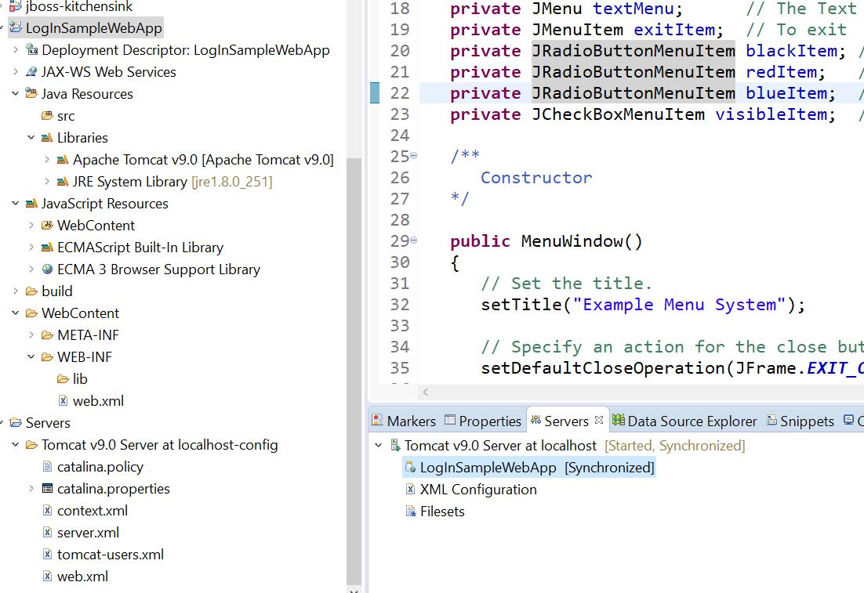

Figure :Works here

This is the server for the Caveat Project-LoginSampleWebApp:

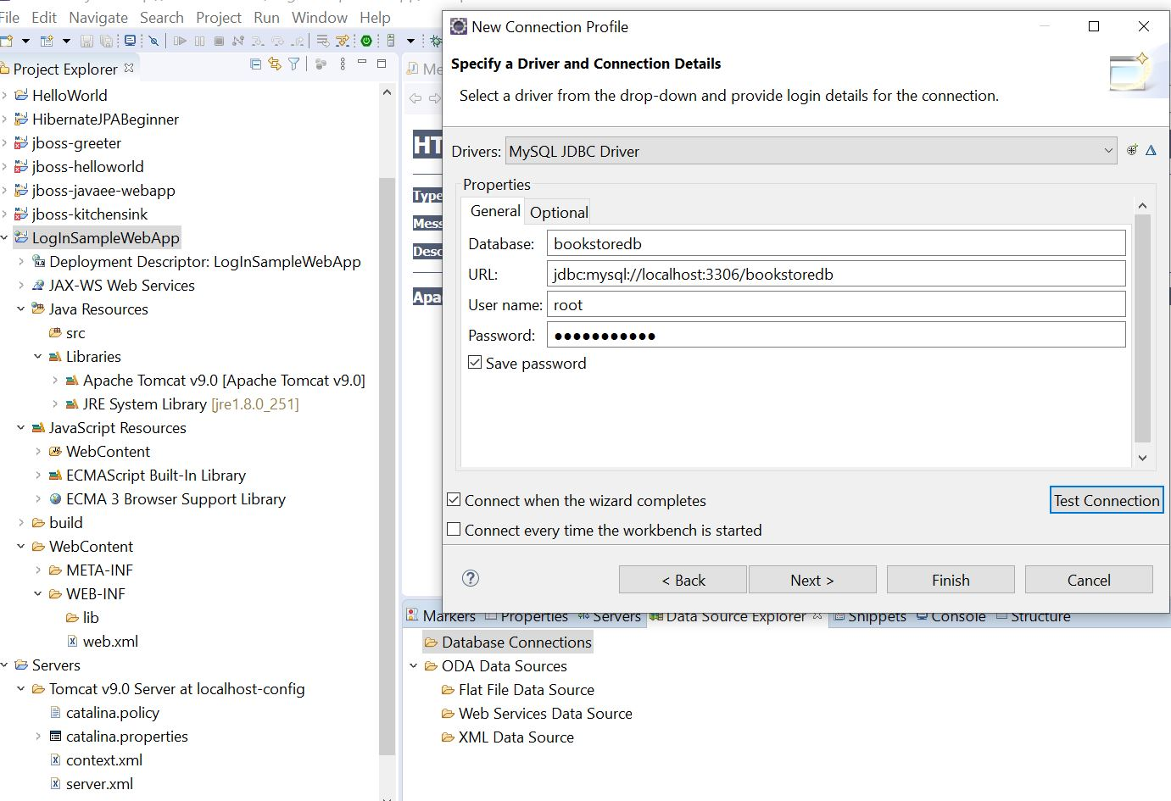

Figure :Database Driver Connection Details

Ok so it works here to in the Caveat Project-LoginSampleWebApp:

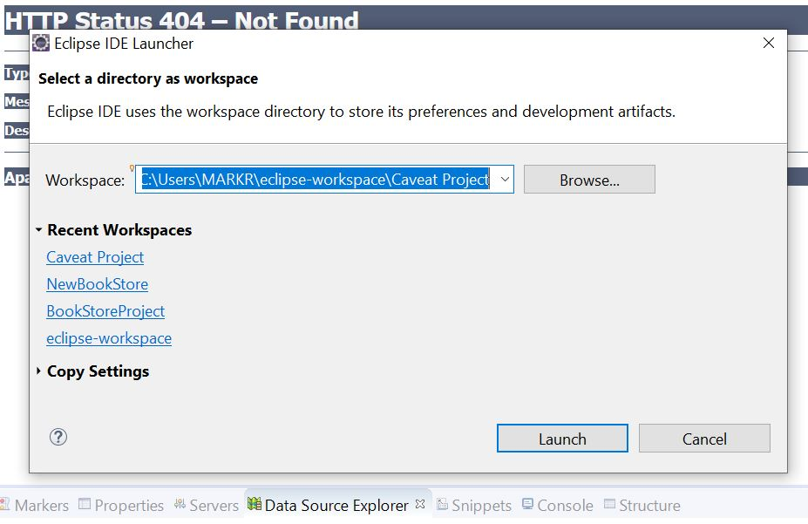

Figure : Eclipse-workspace is next

Eclipse Workspace Error:

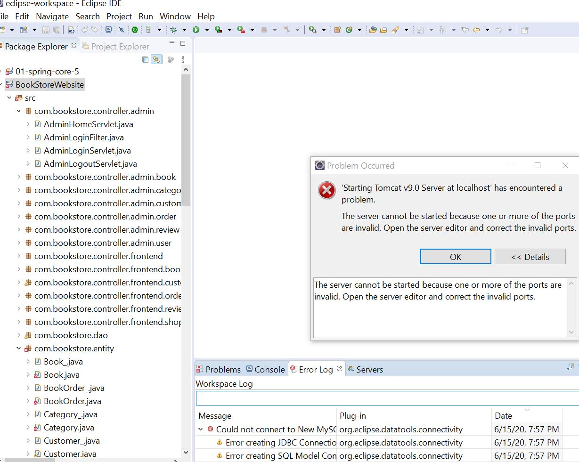

Figure : BookStoreWebsite error

**8:30PM** – well do I really care about this project? It’s all the complete files from the Udemy class, heck with it! I’ll use a working workspace. YES! It’s back to running! Had to delete the server and recreate it through the Properties Tab when you right-click the Project Name! YAY:

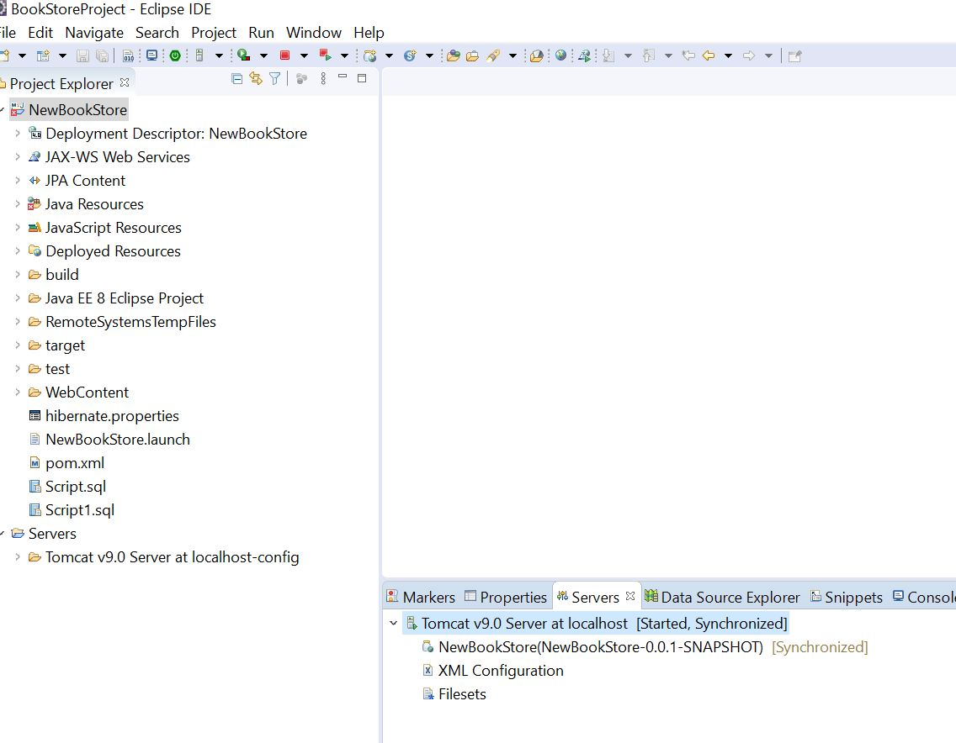

Figure : Working Server

**I get user_id error, no default value?? Hmmm…**

Istartedanother project in the same folder as BookStoreProject. I’m on page 88 in the Java EE 8 book since I can’t get online yet.

**06/16/20 10:00AM – Starting the day studying a username/password validation form in the Java EE 8 Development with Eclipse book.** Thisis my go to book for sure! Going to try it out in the LogInSampleWebApp. Damn can’t get the HTML right in the index page. Moving on to Using Java Beans in JSP page 85 it says. LogInBean.Java file. Have to pay attention were I save these files, they’re in: C:\Java8EEBookFiles.

Well I just learned something new! If you right click on the server in the Console view area, you get a sub-menu with Properties, click that and you get this:

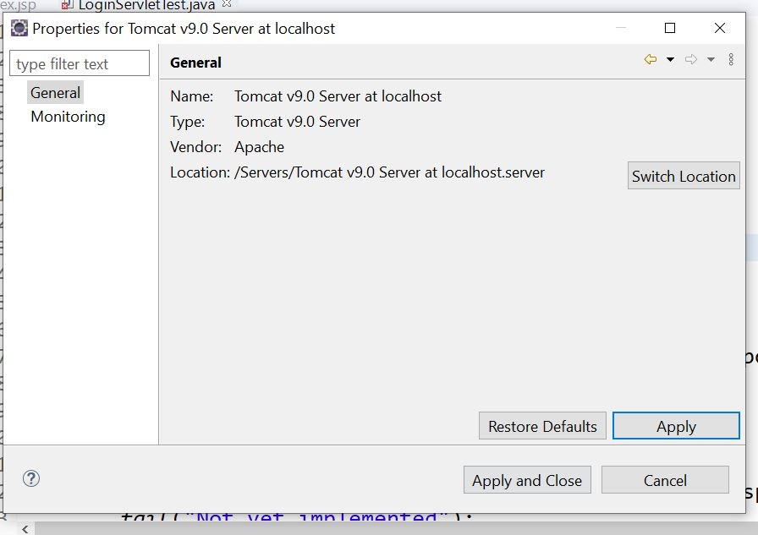

Figure :Server Properties Menu

The switch location button is where you tell it what server to use.

**06/18/20 – 1:00PM** Well today didn’t start out so well as usual! I could not figure out the JSP error in the LogInSampleWebApp. So,,I decided to work my way through a tutorial on Java Guides website. I found a descent login/verification form that checks a valid username/password combo in a database. It’s called LoginServletExample. Needless to say, I ended up having to re-install SQL again! HAHA! It took me a few times to get it right. Apparently you need to remove ALL the references to any SQL programs installed. It looks fine now. Created as new database called my_sqldatabase and added a username, password, userid. The Eclipse project is called LogInServletExample. Hopefully it works! HAHA! I need to learn that stuff anyways, httpServletRequest, Response, Session etc.. Also going to try the mysql 8.0.20 driver. I found out I was putting those in the wrong places! They should be in the WebContent-WEBINF-lib folder along with the servlet jsp’s and api’s. I copied all those into the Java Files and Folders on C:. We will see how this goes with the newer driver, hopefullly I can use this file all the time with some slight modifications for every project! 😊 I started with a JSP / XML Template. Maybe this header can be used in my other bookstore project! Shit I should go back and make the other project index the same as this one! We shall see!

**06/19/20 2:00PM** – FINALLY! Only took two freakin’ days to figure out! I had a curly bracket in the wrong place! Sonofabitch! LOL So my Java 8EE book tutorial is fixed! Finally! I can move on.

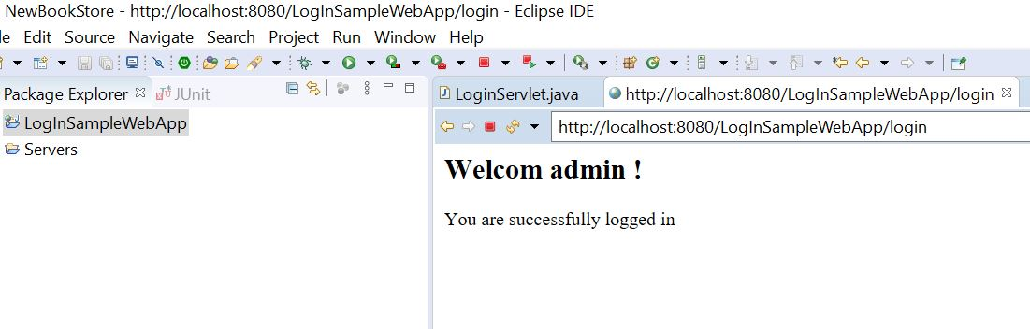

Figure 211: Finally a Successful Login!

I forgot to document where the { was! LOL The source code explanation is on page 100. Here’s some important info: *when you want to deploy it to test or production servers, you need to create a web application archive (WAR).*

Here is the address to test the server and file:

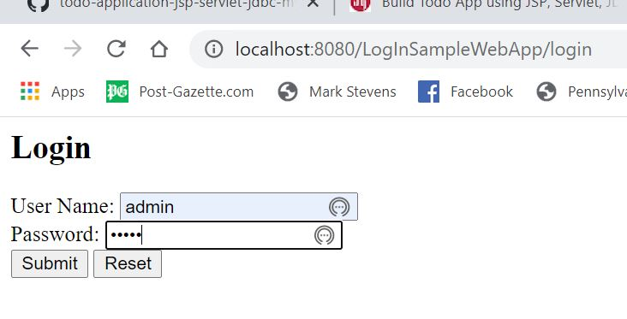

Figure 212: Web site Address

As I move on, here is another important concept:

***Views are JSF created as xhtml files. The controller is a servlet from the JSF library and models are managed beans (JavaBeans).***

***The fully completed project is in the NewBookStore workspace under LogInSampleApp.***

* ***Decide what type of new project you want to make***
* ***Add Dependencies to the pom file javax.servlets, j-unit, etc etc..***

Created a git-hub repository for project files.

06/20/20 6:00AM – Today I’m going to continue on with the setting up the database schema in MySql, from Chapter 4 of Java EE 8 Development.

7:00AM – Well I can see this is going to be a pain in the ass getting the EER diagram right with the relationships. I think this is right:

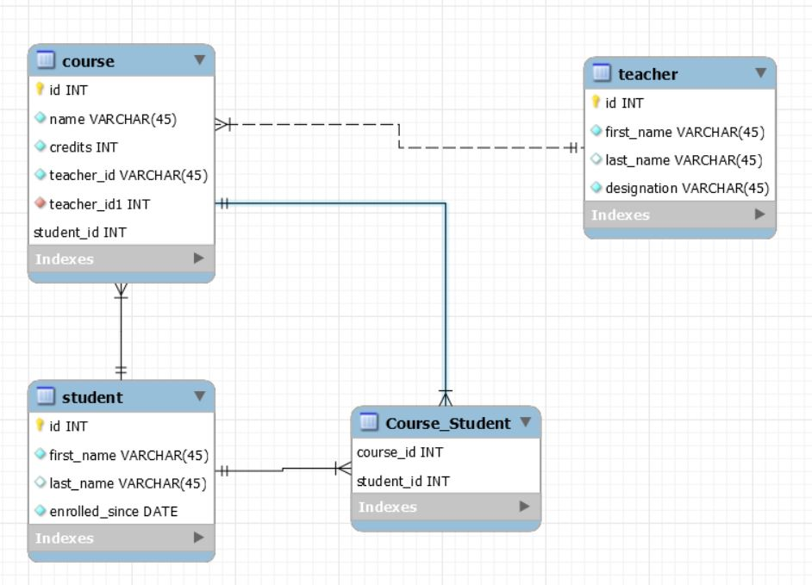

Figure :Course Management EER Diagram

I’m not sure if I exported this script right or not but,,Page 175. Now to add the dependency’s for Servlet and JSP. But not JSF yet.

**These are the pom file dependencies that are in so far:**

11:00AM – Damn dependencies! These are added in the pom file:













Com.sun.faces jsf-api-2.2.9.jar compile.

Maven:3.6.3 also.

Com.sun.faces.jsf-impl.2.2.16

Duh! Just had to right-click-copy qualified name! Hope it doesn’t mean it refers to the actual Java Project? Guess I’ll find out! Copied from the **maven_jsf_webb_app**

Junit 4.11 test also.

**Almost forgot! The SQL model file is course_management.mwb in the Udemy e-Commerce website folder. I saved a good pom file in the java files and drivers folder that has dependencies I think I need, maybe cut and paste into new projects?**

**I’m going to try something radical here, use the java connector 8.0.20-sources JDBC.**

I didn’t put the hamcrest-library-2.2 file or the content-maven-compiler-1.0.135 , or the two jboss files in yet.

Well the Beans are done and in a folder:

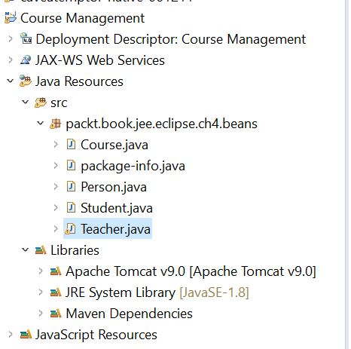

Figure :Bean Folder

Right click on the Project Folder to a JSP files in the Web Content Folder. Have to add the code for JSP form/submit..etc Like in Chapter 2 using JSTL section on page 91.

**Remember! This project is in the Caveat Project Workspace - Course Management**

**C:\Users\MARKR\eclipse-workspace\Caveat Project saved index too.**

**06/21/20 8:30AM –** Starting off the day with setting up an index.jsp file with xhtml and JSP 2.0 syntax. Going to copy over some code from the Sample project file that I know works. Have to be careful here. Getting an error because I haven’t created the login bean yet, at least I hope that’s what it is! LOL

*<jsp:useBean id="loginBean" class="packt.book.jee.eclipse.ch4.beans.LoginBean">*

Looks good so far!

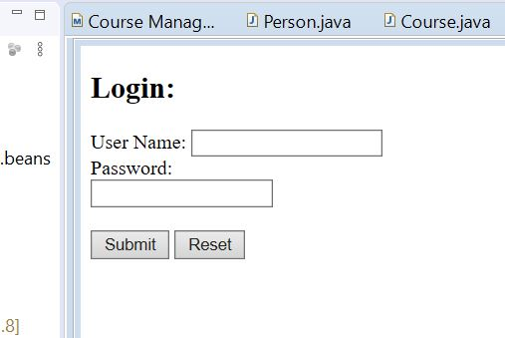

Figure :Login Base File

I needto save these files in the Java Files and Drivers folder to use as a starting point for all my projects. Here is the correct location login for the LogInSampleWebApp:

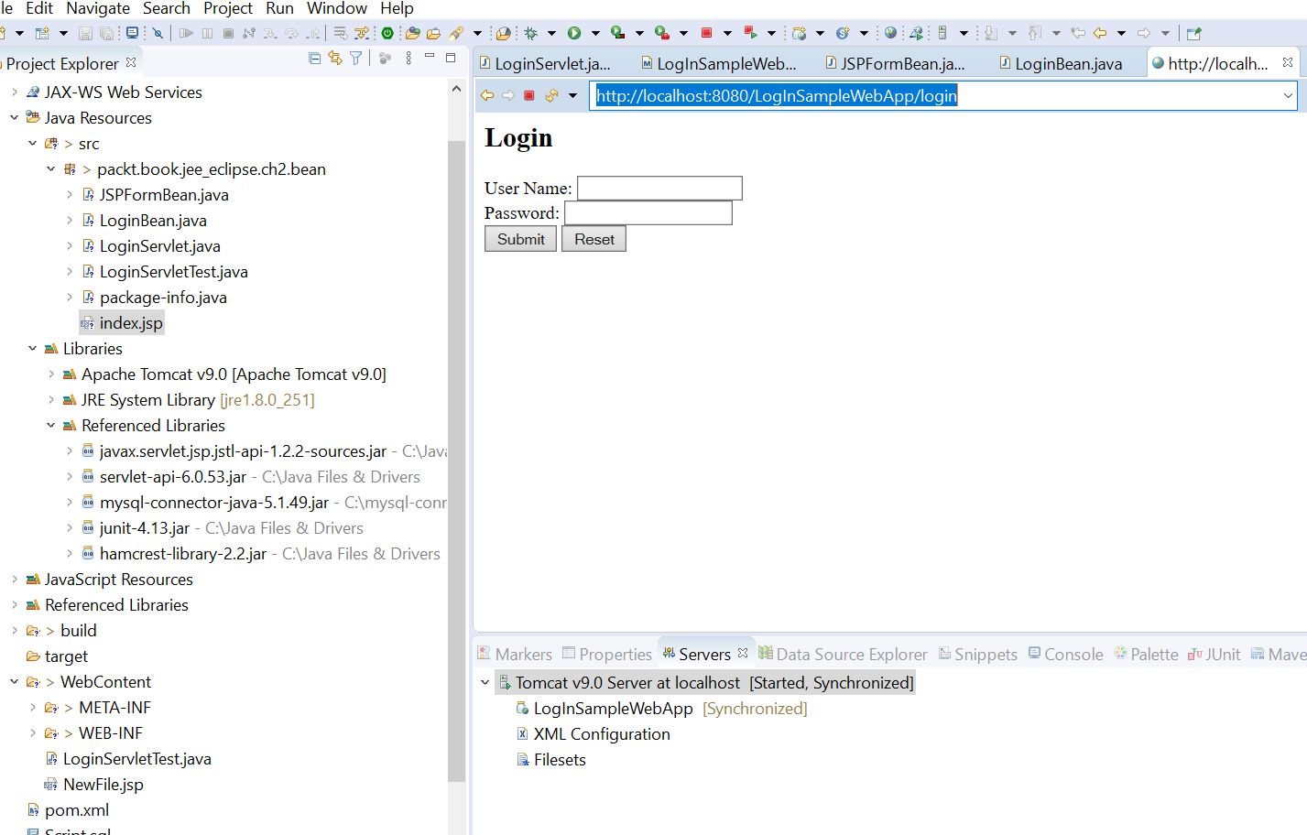

Figure : Working Login setup

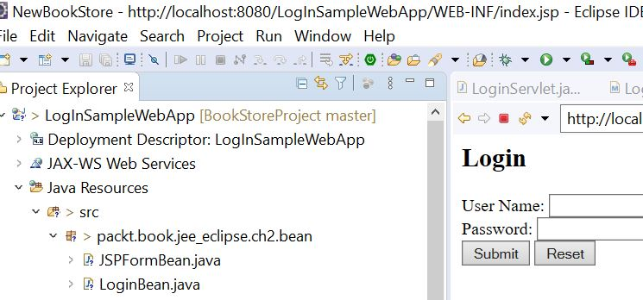

Figure : File location address for correct login

Where is that login coming from in the address? One of the servlets I’m sure. Here it is I think:

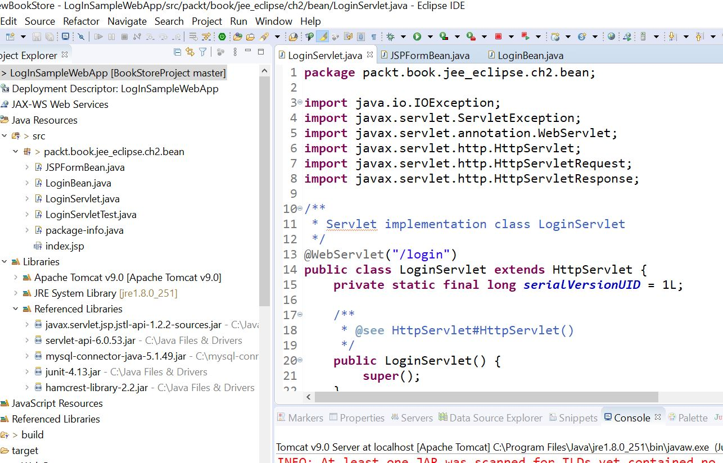

Figure : Is this where login comes from in the address?



I think I got it! LogInServlet file?

Yes it works great in the LoginSampleWebApp, the address defaults to login to get the correct user/password combo to pass using admin in both. The working file is here:

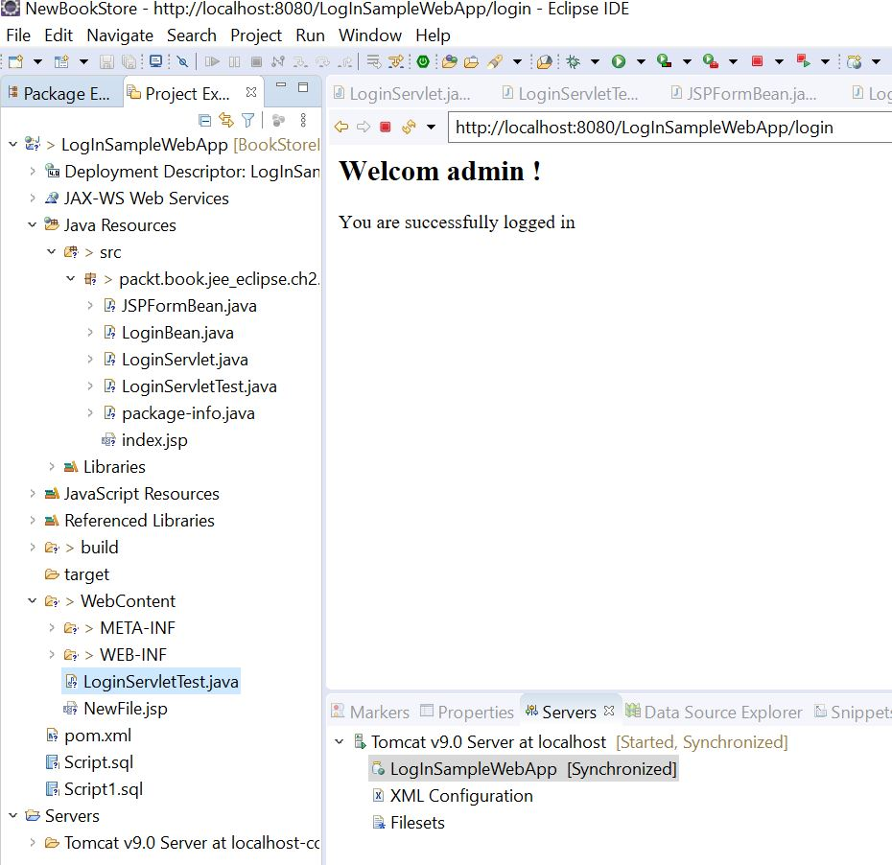



Figure :File location that work correctly



The file LoginServlet File under src works, the other one under WEB-INF doesn’t. I need the login file to open in the browser to get the messages. So after some more reading on forums and such, I think my server issues are from having several workspaces using the same server. Makes sense actually. From what I read you need to modify web xml files and stuff to make it work, hell with that. So I’m going to import the Caveat and maybe BookStore projects into one workspace. Hopefully I can just do that and let Eclipse update the necessary files.

3:30PM – That went ok. I took the server off every workspace, and moved the Course Management Project into the same workspace as LoginSampleWebApp. Attached the server back into the project and it seems to be going great so far! When I put the local address into the address bar, I add login to the end and it works fine. So does the Course Management project:

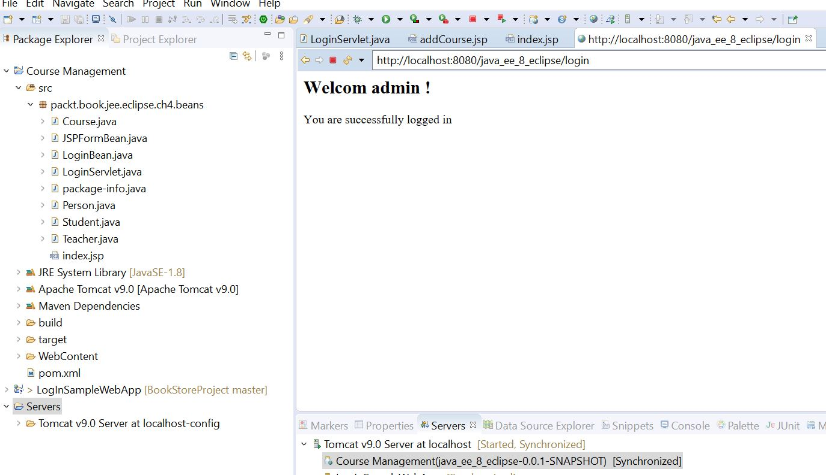

Figure : Course Management LoginServlet

Onto Server Faces now.

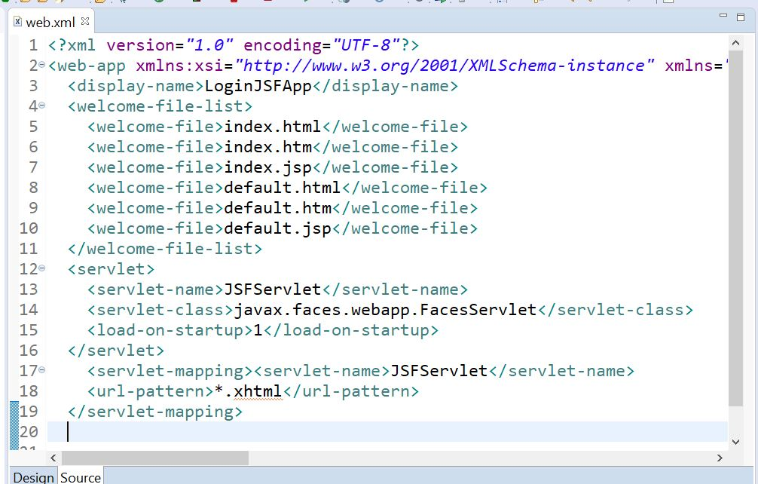

Figure : Web Xml File Edits

Interesting, xml mapping of the servlet. Not sure of the name is right, the downloaded servlet is in the WEB.INF folder. Should I name is exactly the same? We shall see I guess.(Page 107).

Next we create the JavaBean for the login. Check this out for the index xhtml page:

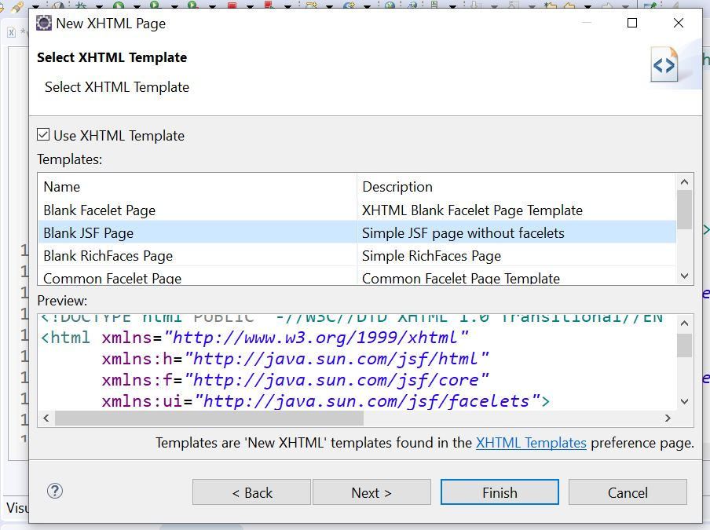

Figure : Auto-generated XHTML Java Server Face (JSF)

Notice how it declares the variables h=,f=,ui.

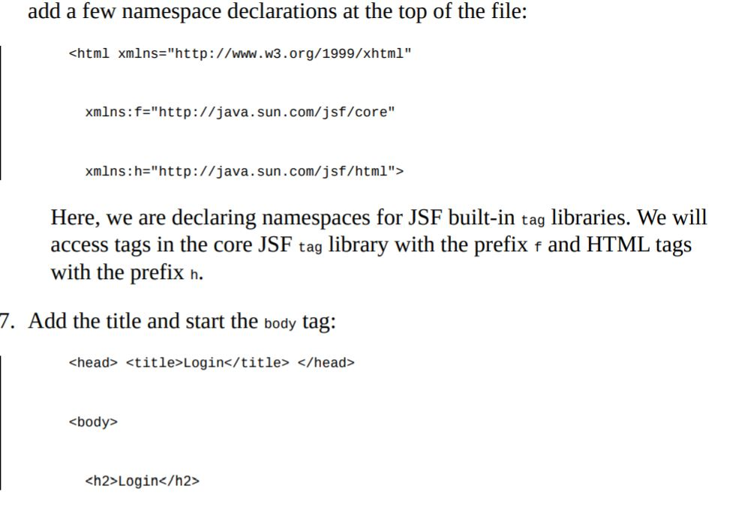

Figure : Namespace Declarations

That is from page 109 in the book. Have to keep this in mind, it might come in handy some day:

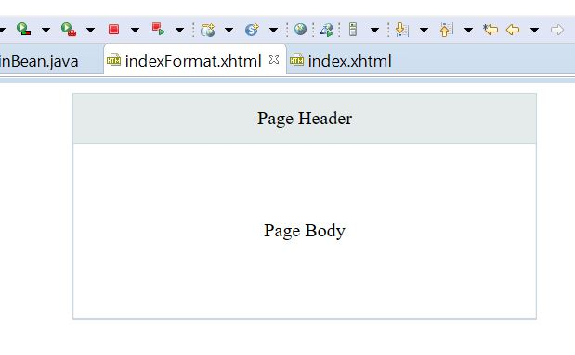

Figure :Template

**06/23/20 7:00AM** – Found this little paragraph at the end of this section:

*“JSF can do much more than what we have seen in this small example—it has the support to validate an input and create page templates too. However, these topics are beyond the scope of this book.”*

That’s where I need to get to eventually. Validating username/password against a database.

**8:00PM** – Wow! The database script section is really cool! The creating schema section will definitely be an area of intense study. Next section talks about using JDBC for database creation.

**06/24/20 7:00AM – It’s time to get a little more organized with my PDF books, here are the main ones I’ve found very useful:**

* **Java EE 8 Development with Eclipse – 2019**

This book is my go-to because it uses Eclipse as the IDE, MySql for the database, and Tomcat for the server. Projects include the Course Management one.

* **JSP The Complete Reference – 2001**

A little older, but still worth for reference, ideas, how-to.

* **Practical Database Programming with Java – 2011**

I find this book to be very useful also, although I’m missing Chapter 6 where a lot of the connectivity details take place, and it uses NetBeans not Eclipse.

* **JSP 2 4th Edition December – 2005**

Another great book!

* **Java Persistence with Hibernate – 2007**

I can’t wait to really dig into Hibernate and ORM with this one! First things first though.

These are all PDF files, so they are very portable. This list will be updated I’m sure as I progress.

Two worth mentioning on my Kindle app:

* **Spring 5 Recipes – 2017**

I’m not quite ready to dive into Spring for awhile, There’s enough on my plate.

* **Building Three Desktop Applications Using Java and MySql – 2019**

Another interesting approach to Java/MySql development. This one also uses NetBeans, but it has many typo’s/errors.I like the concepts and ideas it presents though!

There is a wealth of knowledge in these books if you ever have the time to sit down with them(several years most likely). I’ve skimmed over all of them to see what content is available. I have the spurce code for all of these downloaded somewhere..LOL! One day I’ll get those together into something that makes more sense with each book.

Here’s a few things for future reference:

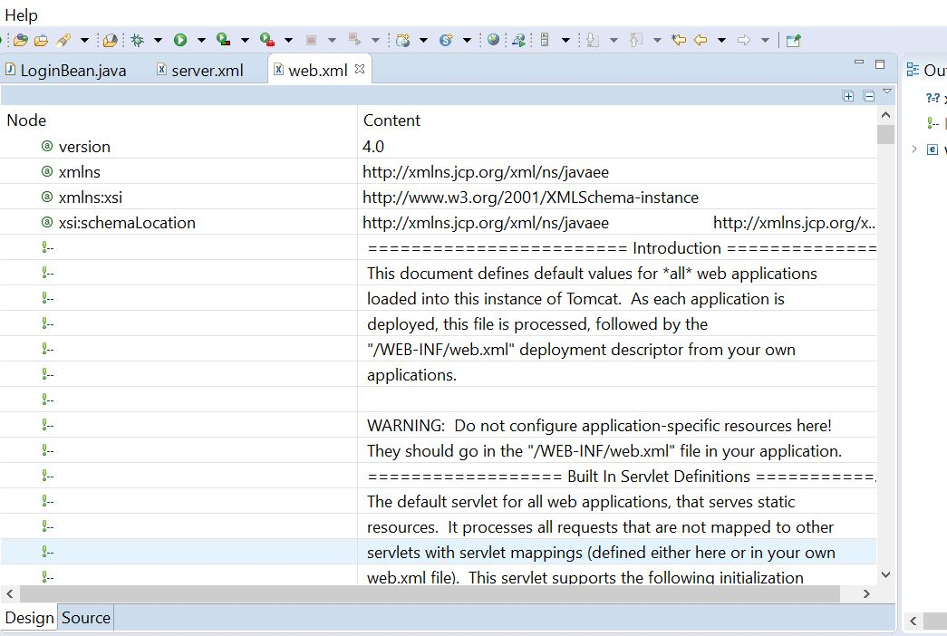

Figure :Web Xml file in the Project Server directory

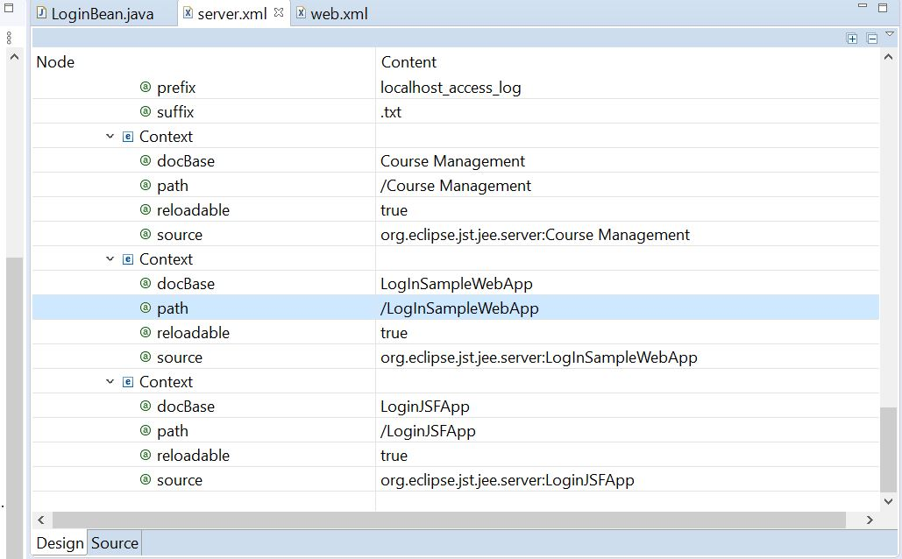

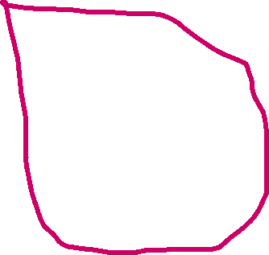

Figure : Server XML File

Notice the Content paths for each project, I changed the Course Management path to match the others.

**1:00PM** – Moving on to using JSP to add a course: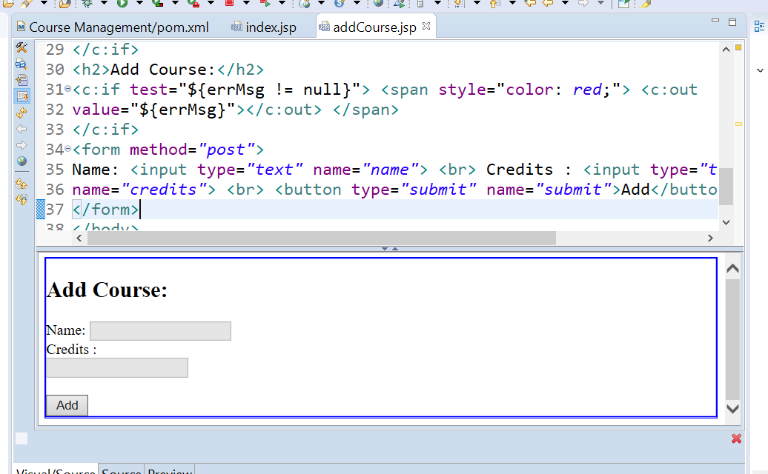

Figure : Add Course JSP file

It’s the same as in Chapter 2 *“Creating A Simple Web Application Using JSTL” Page 187 here.*

**8:00PM – Page 241** has setting up Maven dependency for JPA using EclipseLink.

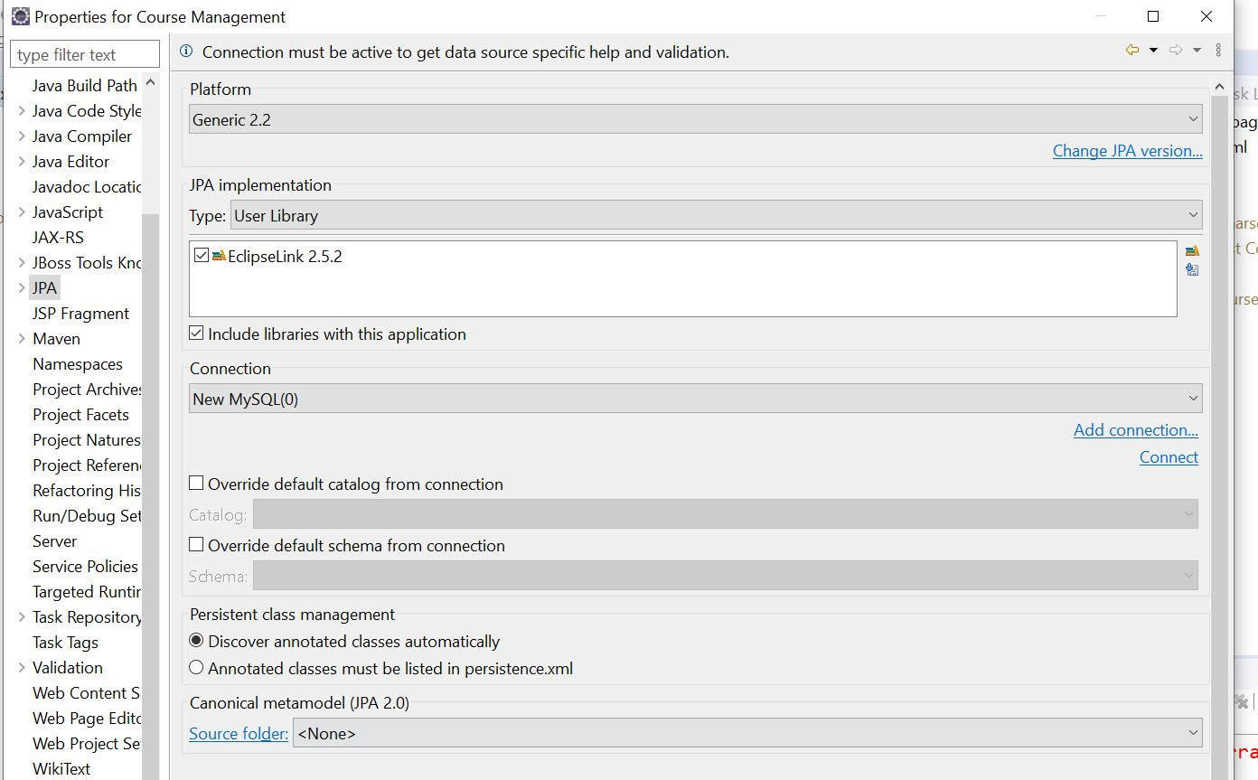

Figure : Location of JPA Configuration

After selecting convert to JPA in source menu, configure the properties.

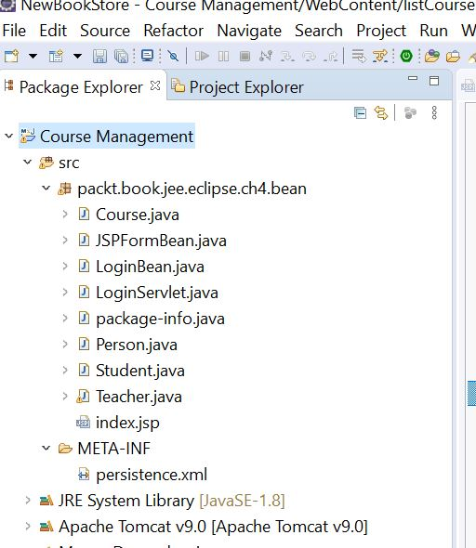

Figure :Persistence created

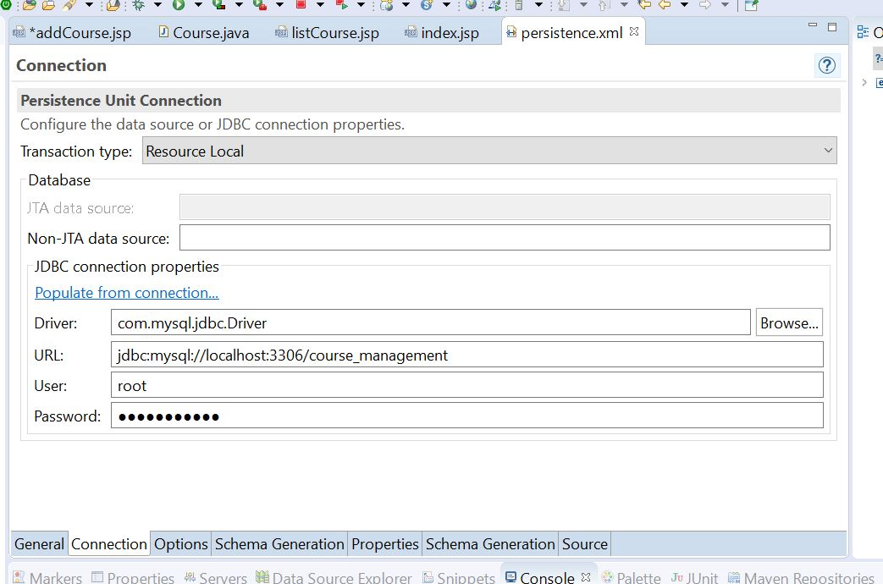

Figure :Resource Local with Driver/Database Schema

Page 246 Creating Entities-Mapping Beans to JPA entities.

06/25/20 5:30AM – Today is going to be a good day! First thing this morning after opening up the project in Eclipse to figure out the errors I was having, I noticed that the @id was potentially in the wrong place in the Course file:

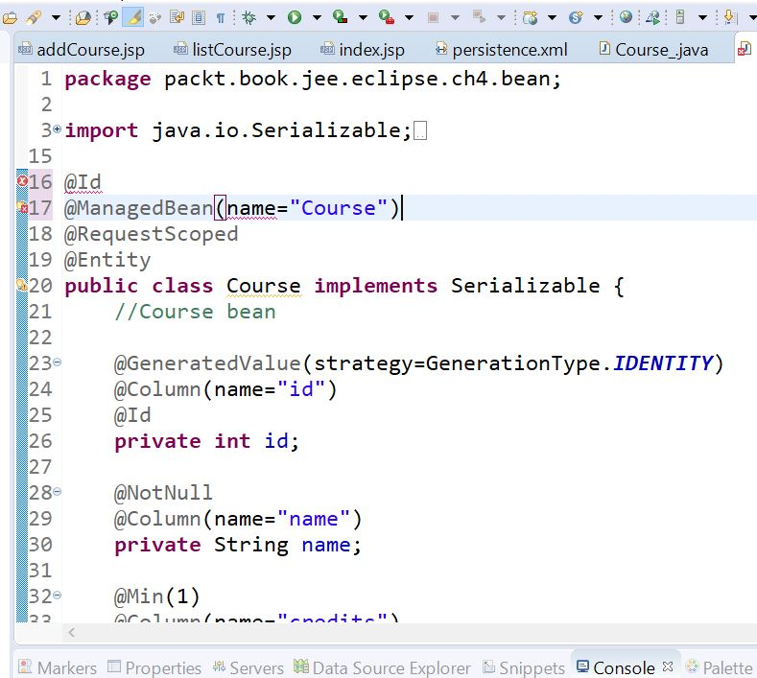



Figure :Id Entity declaration Error

I had the Id declaration above the Class, not the actual entity. Now to figure out the “name” error. Changed it to “value”, not sure if that’s right. **Bean value = Course?? Hmmmm..**

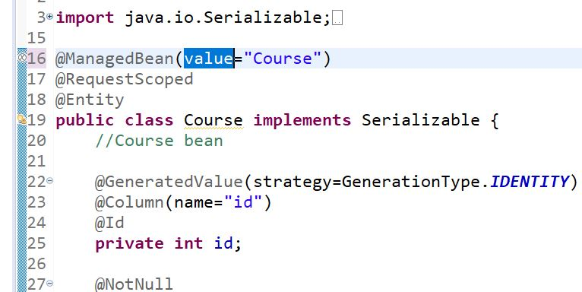

Figure : Changed Bean to "value'

I found the entity Error!

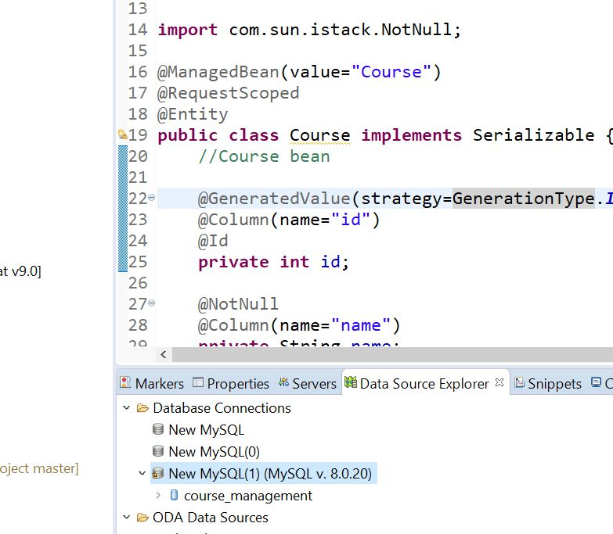

Figure :Error fixed

Fixed the Error by creating a new Database connection and logged in, Error solved! Silly me!

Having a problem getting the person class correct. Since person is the parent class of student and teacher. Page 247 explains this, we need to modify person since there is no person table, we want student and teacher to inherit the properties. Import all your dependencies also.

**Be careful where you place the ORM Mappings, some in Class, others in Fields.**

**Make sure you import these:**

***import*** *javax.faces.bean.ManagedBean;*

***import*** *javax.faces.bean.RequestScoped;*

*@ManagedBean(name="teacher")*

*@RequestScoped*

***import*** *javax.persistence.Column;*

***import*** *javax.persistence.Entity;*

***import*** *javax.validation.constraints.NotNull;*

Next you configure entity relationships by Window-->Open Perspective🡪JPA Menu.

Right Click on the persistence.xml file and update to JPA:

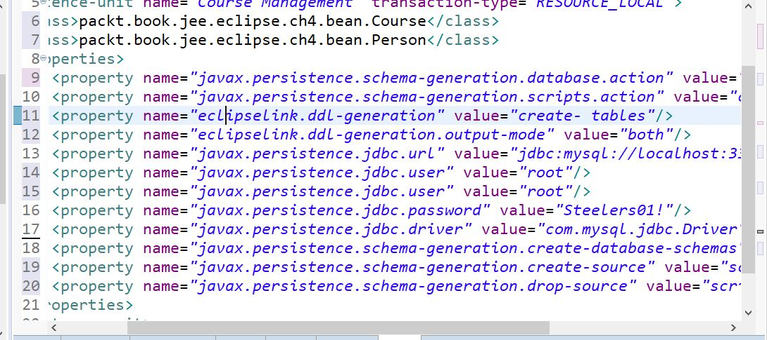

Figure :Persistence.xml File updated after ORM Mapping

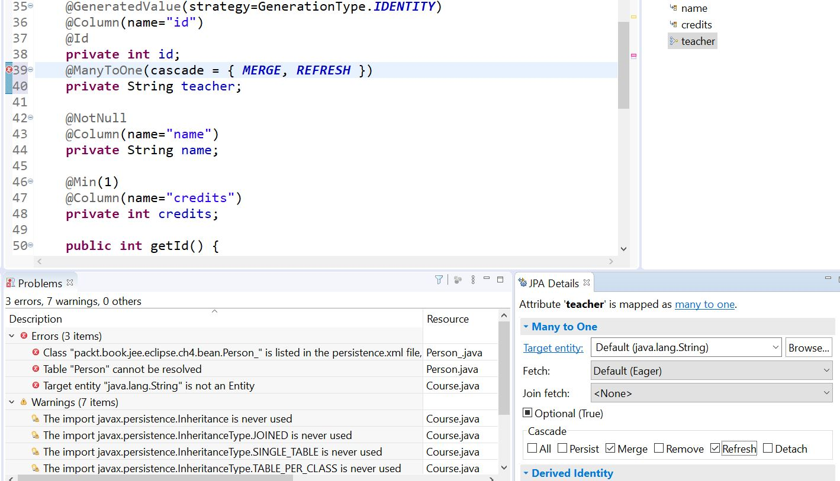

Figure :JPA Details Menu

06/26/20 6:00AM – Well this is going to be a long day I see! Trying to establish a good connection to the course_management database. I have the server running, and sent an SQL query through Eclipse:

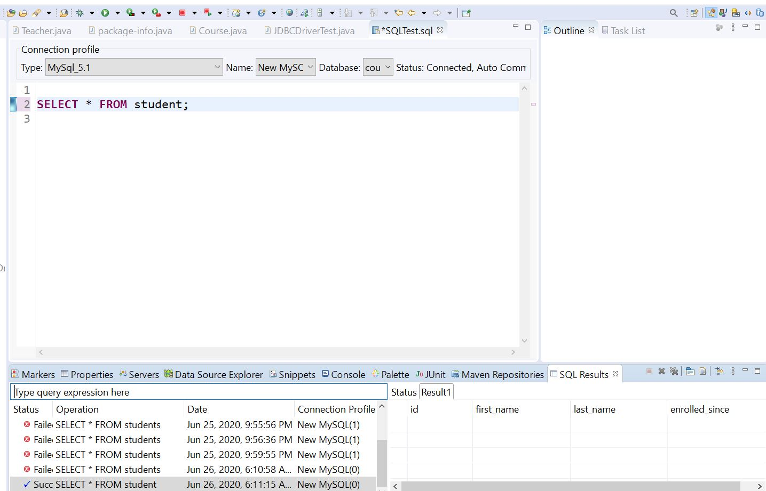

Figure : SQL Query success through Eclipse

Now to play around with adding/deleting etc,,I think I’ll put some student data in first and then query that. Hopefully add some more through Eclipse and JDBC.

Yippee! It’s working! Connection success printed to console! Now to get my statement syntax correct:

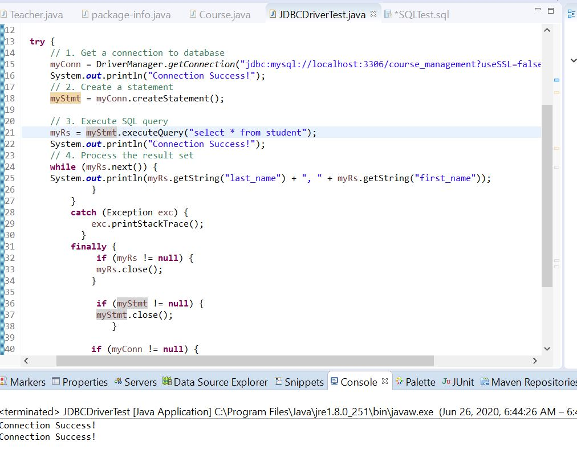

Figure : Successful message print out to console.

I used this statement:

"jdbc:mysql://localhost:3306/course_management?useSSL=false","root","Steelers01!" )

Finally! After Months! We have the JDBC Driver and the Result Set working!

**4:30PM** - WooHoo! Confirmed! I filled a record in the database through the SQL Server, then printed it out in Java with the JDBC Driver!

**Here are the working files before I start screwing with them,,LOL**

**JDBCDriverTest in the ch4.dao Package.**

**JDBCDriverTest2 in the ch4.db_tests Package.**

**Let the games begin! 😊**

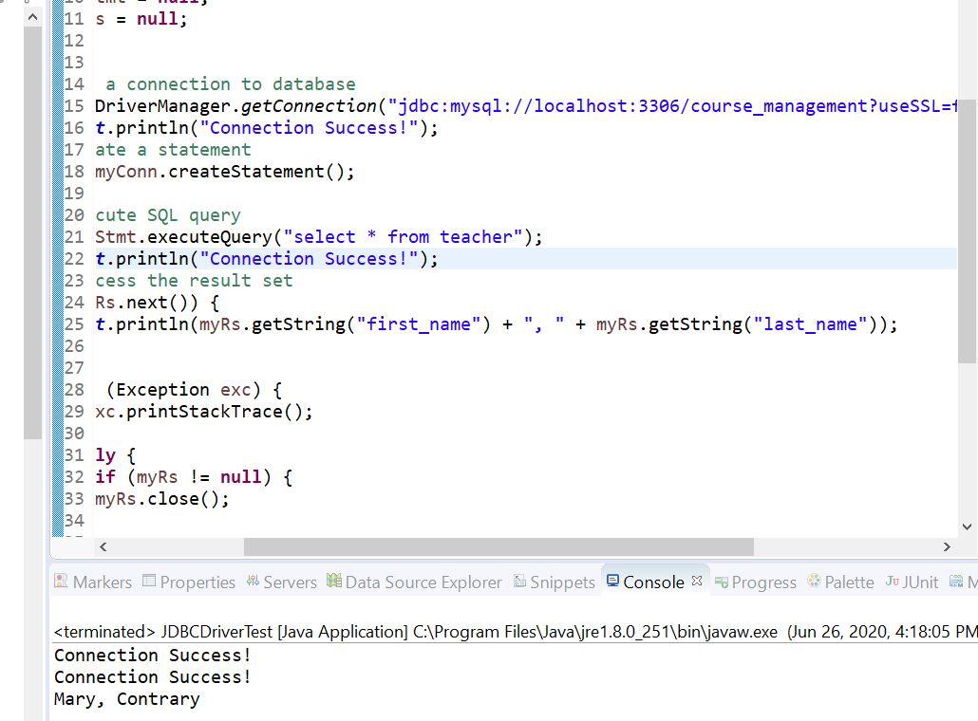

Figure : Query from the JDBC Driver in Java

YAY! 😊 Let the fun begin! Starting the User Interface for Adding Courses section, project named LoginJSFApp.

When you convert a JFA project to maven you get a ton of stuff as dependencies if you need it.

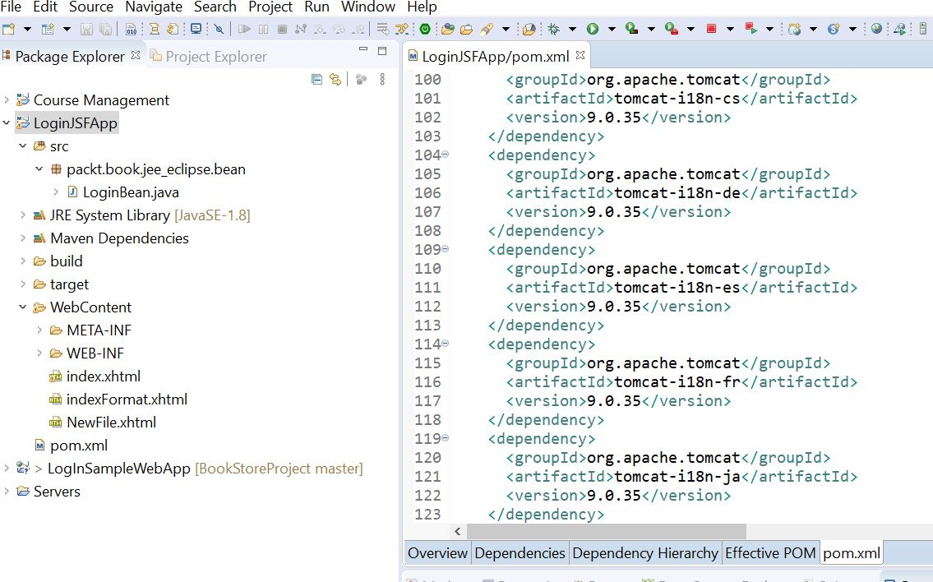

Figure : Maven Dependencies in pom file

9:30PM – Started the DatabaseConnectionFactory file for the Database Connection Pool section on page 200.

06/27/20 7:00AM – Interesting edits to the web.xml file:

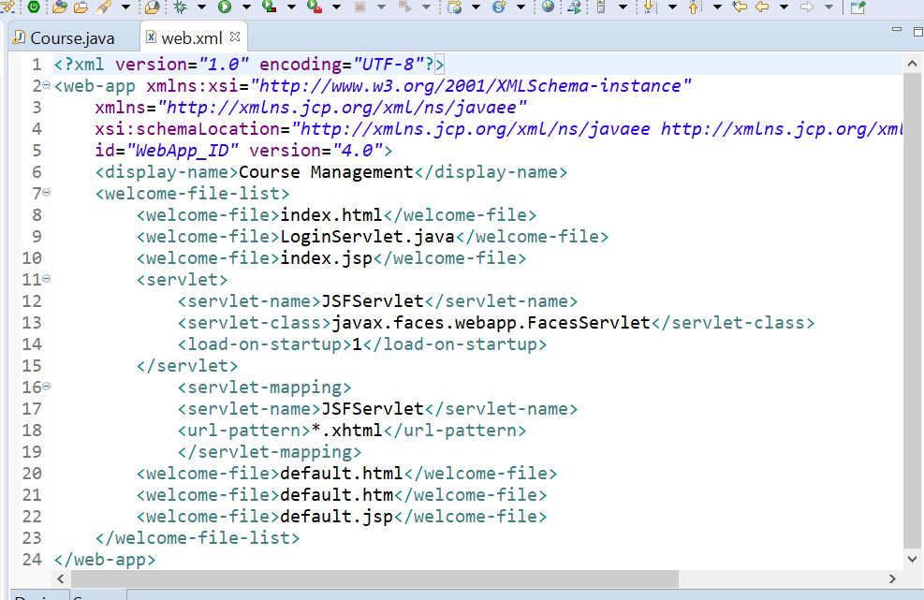

Figure : Web.xml edits

Chapter 4 adds these references in the web.xml, and create a ch4.jpa.bean folder.

Be careful with that Teacher bean! After the beans are made, create the JSF page with proper headings. All these are JSF managed Beans(discussed in Chapter 2 Java Server Faces).

***“****access tags in the core JSF tag library with the prefix* ***f*** *and HTML tags with the prefix* ***h***”

**9:00PM** – The course bean part of Chapter 4 is very good, explaining Managed Beans, Page 232. I got an error in the XML file after adding the servlets. Have to see about that.

Changing this: javax.faces.webapp.FacesServlet

To This: javax.faces-2.2.9

Still getting an error!

DI – Dependency Injection framework.

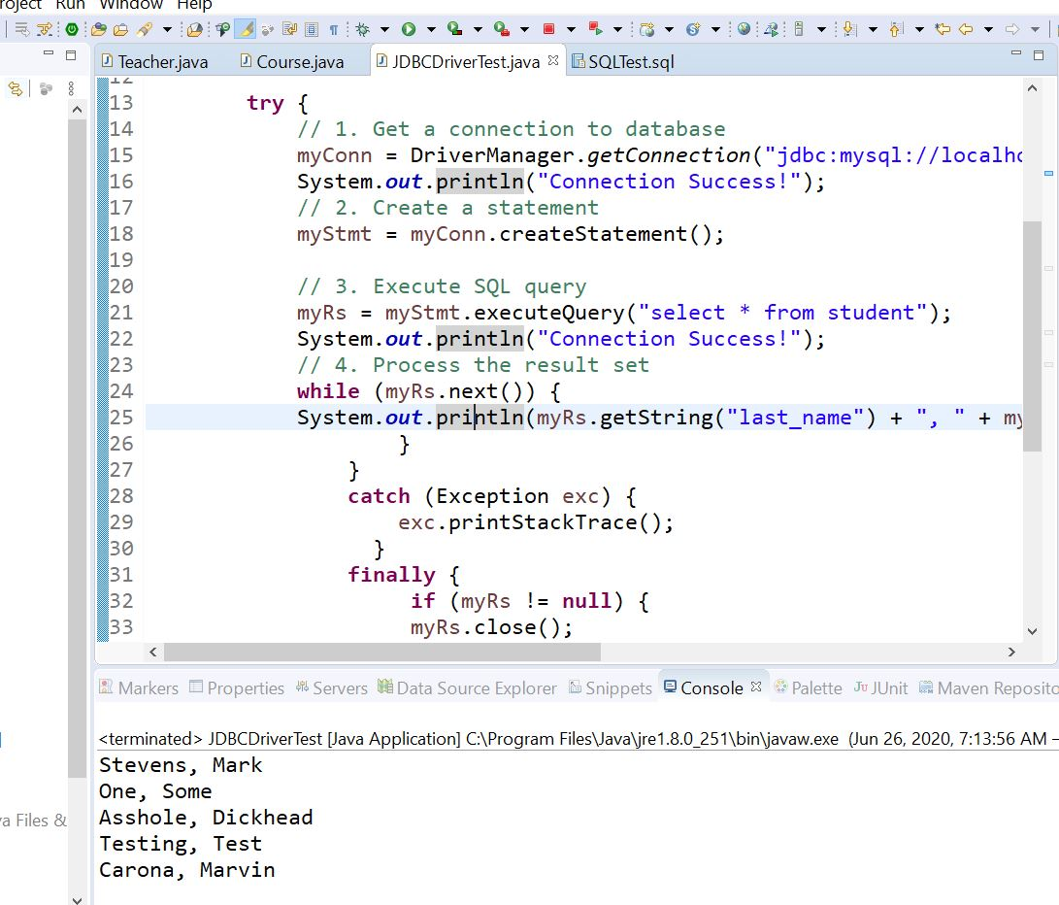

Figure : JDBC Driver and Result Set Test

I think I’ll create a new package called DB_Test, copy this file over to it and play around with CRUD statements.

I left off on Page 234-240 JPA concepts.

**06/28/20 7:00AM** - *“The following are the typical steps in creating a JPA application:*

*1. Create a* database *schema (tables and relationships). Optionally, you can create tables and relationships from JPA entities. We will see an example of this. However, it should be mentioned here that although creating tables from JPA entities is fine for development, it is not recommended in the production environment; doing so may result in a non-optimized database model.*

*2. Create persistence.xml and specify the database configurations.*

*3. Create entities and relationships.*

*4. Get an instance of EntityManagerFactory by calling Persistence.createEntityManagerFactory.*

*5. Create an instance of EntityManager from EntityManagerFactory.*

*6. Start a transaction on EntityManager if you are performing insert or update operations on the entity.*

*7. Perform operations on the entity.*

*8. Commit the transaction.”*

**9:30AM** - Today I’m going to start on setting up Maven Dependencies in JPA with Eclipse Link, Page 242. I’m going to use the LoginSampleWebapp project and copy the JDBCDriverTest file into it.

**4:00PM Well today sucks! Some reason, the MySql Server and Tomcat would not start for me! FUCK! Had to reload everything! Remind myself, there is also Case Studies to practice in the Java EE6 Tutorial files. Going to reinstall Eclipse to what the fuck! Might as well.**

**06/29/20 7:00AM –** I found an easy way for adding/changing Classpaths:

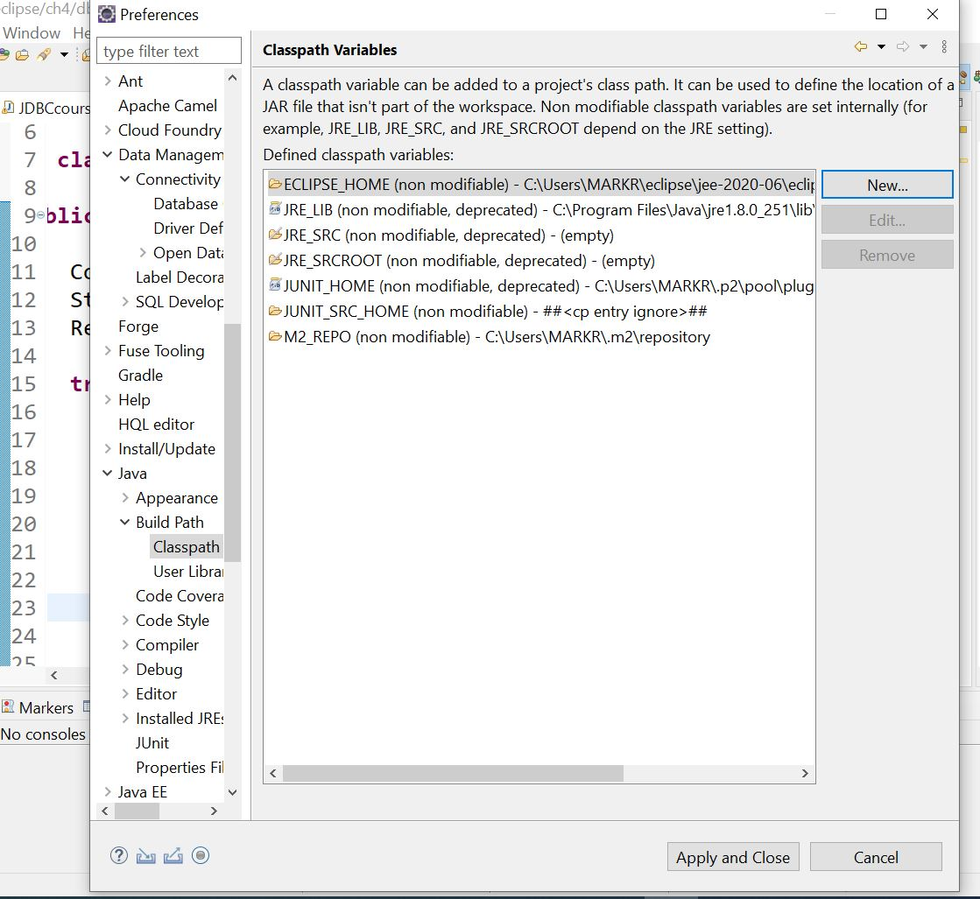

Figure :Classpaths under window preferences

And this for reference:

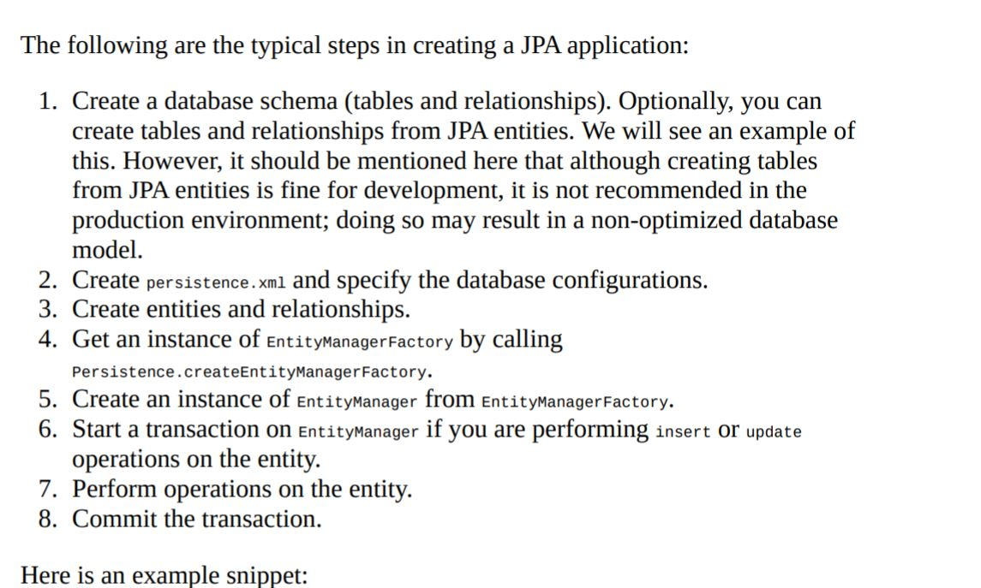

Figure :JPA Creation Example

I’m going to set up a new project called CourseManagementJPA from the tutorial on page 240.

**Some very important things about Inheritance and Mapping:**

*We are not only identifying the Person class as Entity, but we are also indicating that it is used for inheritance (using @Inheritance). The inheritance strategy decides how tables are mapped to classes. There are three possible strategies: SINGLE_TABLE: In this case, fields of parent and child classes would be mapped to the table of the parent class. If we use this strategy, then the fields of Person, Student, and Teacher will be mapped to the table for the Person entity. TABLE_PER_CLASS: In this case, each concrete class (non-abstract class) is mapped to a table in the database. All fields of the parent class are also mapped to the table for the child class.*

*For example, all fields of Person and Student will be mapped to columns in the Student table. Since Person is marked as abstract, no table will be mapped by the Person class. It exists only to provide inheritance support in the application. JOINED: In this case, the parent and its children are mapped to separate tables. For example, Person will be mapped to the Person table, and Student and Teacher will be mapped to the corresponding tables in the database.*

11:00AM – Well somethings all fucked up again! That’s on me, something in the dependencies ,pom etc.. I’m deleting the CourseManagementJPA and starting over, but this time using NEW--🡪JPA Project setting.

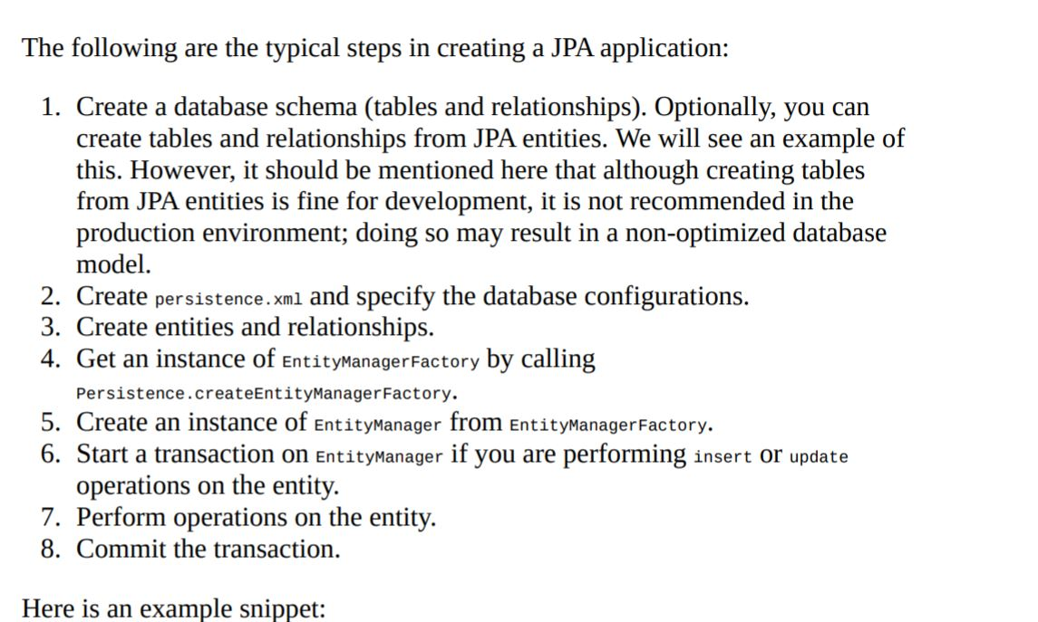

**Page 232 talks about managed beans in the CourseServiceBean file.**

**4:15PM – Finally! I might have something!**

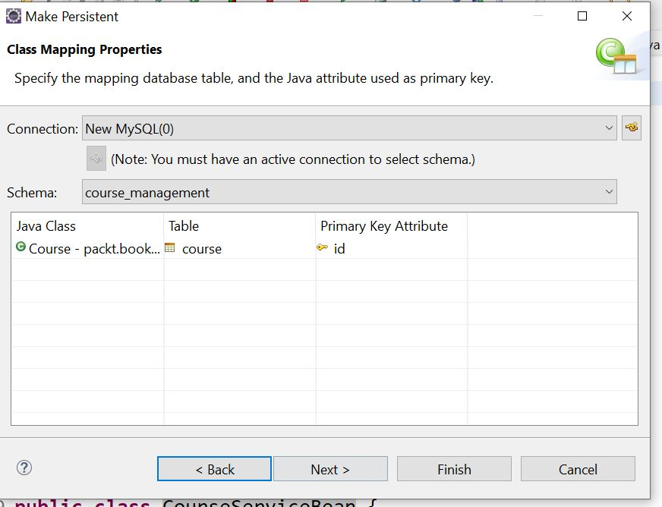

Figure :Class Mapping with Primary Key

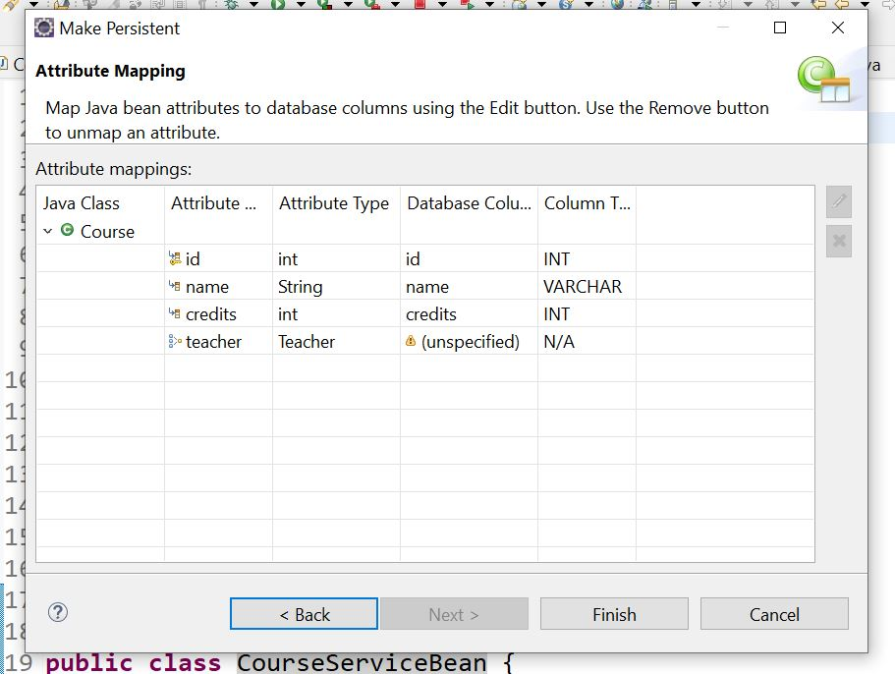

Figure :Mapping Attributes

Click the Pencil in the Upper Right:

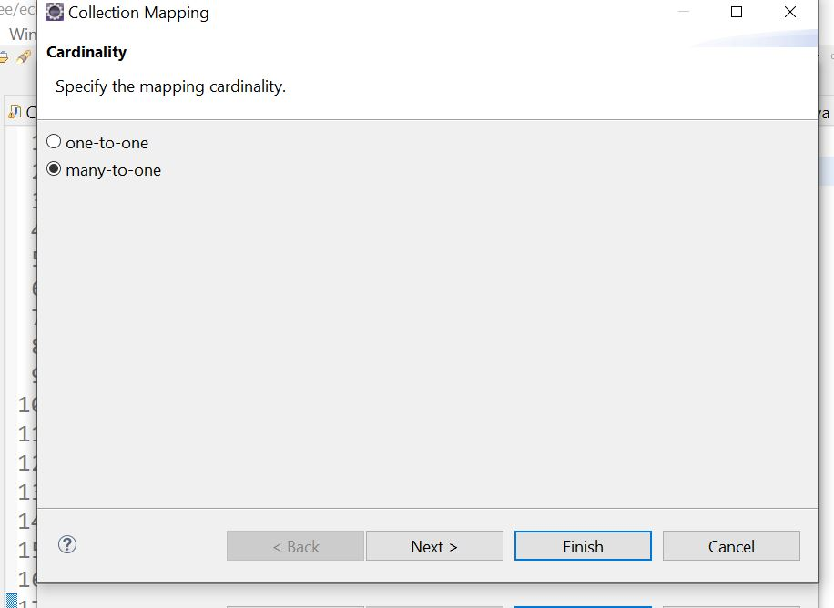

Figure : After Clicking the Pencil Icon

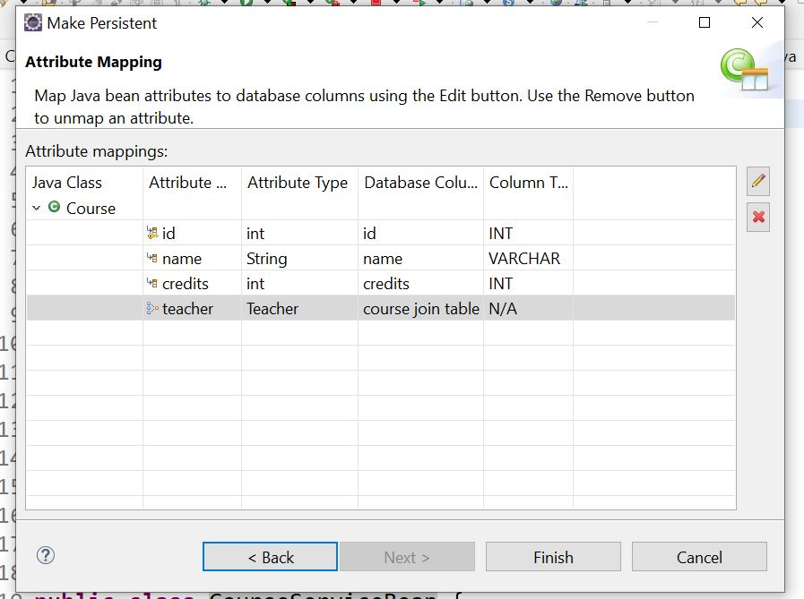

Figure :After selecting Tables/Columns to Join

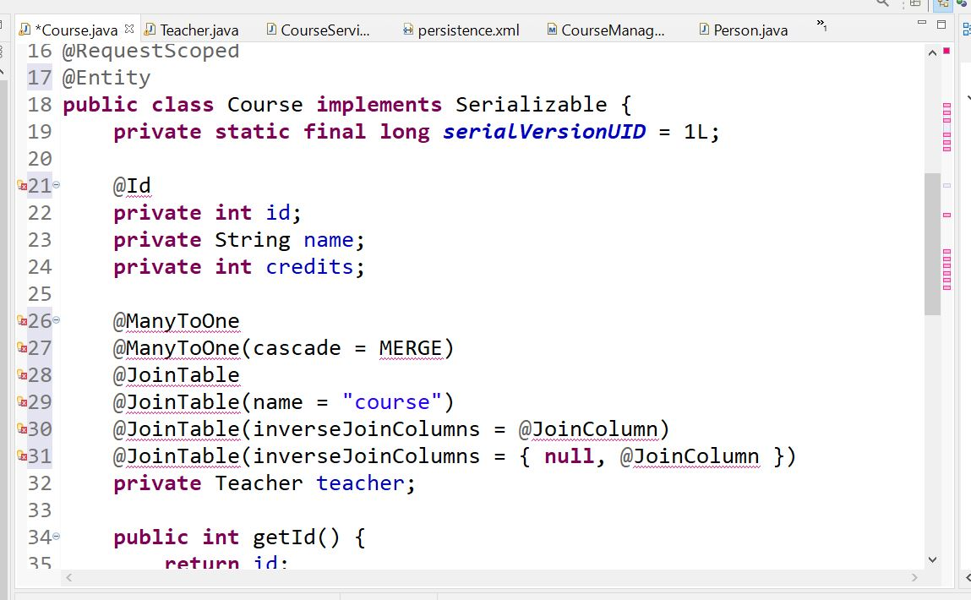

Figure : Wrong Persistence Mapping

Well I can see this is going to take awhile to figure out! Errors everywhere! LOL 😊

**06/30/20 6:30AM** – Well yesterday really sucked! I had to reload Eclipse after a software update, then it wouldn’t start. I discovered that the documentation says you should install it into a new directory, not on top of the old! I didn’t know that. So I installed version 2020-06(4.16.0). When updating the project to a JPA and addind Persistence annotations, I started having errors ecerywhere, so I deleted all the persistence notations. Everything appears to be fine now. My real problem is getting the transition to JPA correct, matching Java Entities to Tables and Fields in the Database. One-To-Many, One-To-One,, etc,,The software does it for you sure, but you still have to do it right. Going through tutorials and books only gets you so far. The steps involved are different but similar to what’s shown. It’s up to you to figure out the steps involved to achieve the outcome you want. I’ld like to document the steps I take but that would take forever probably, right now I’m kinda winging it. This will take awhile to get it right, as always! The CourseManagementJPA project will be my model to play with. I’ll start by converting it to a JPA project from the book. Oh! **One Important thing to note, the servlet-api-6.0.53.jar is referenced into the project as a library. It has the HttpServletRequest files in it.**

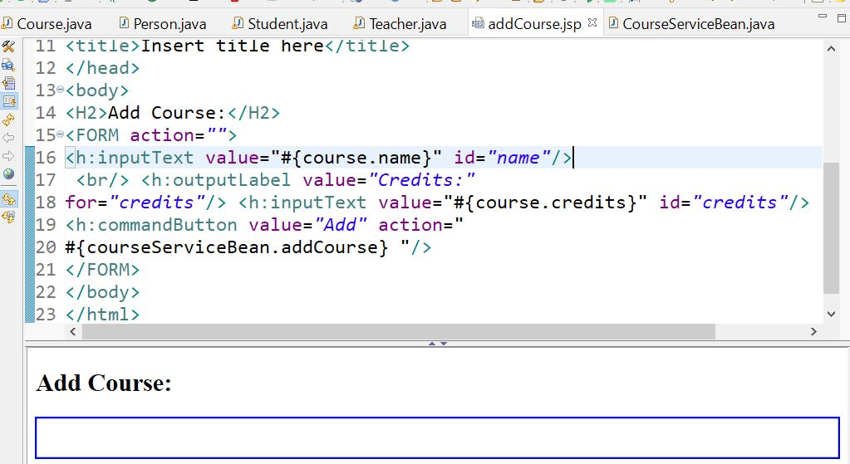



Figure :courseServideBean.addCourse Method

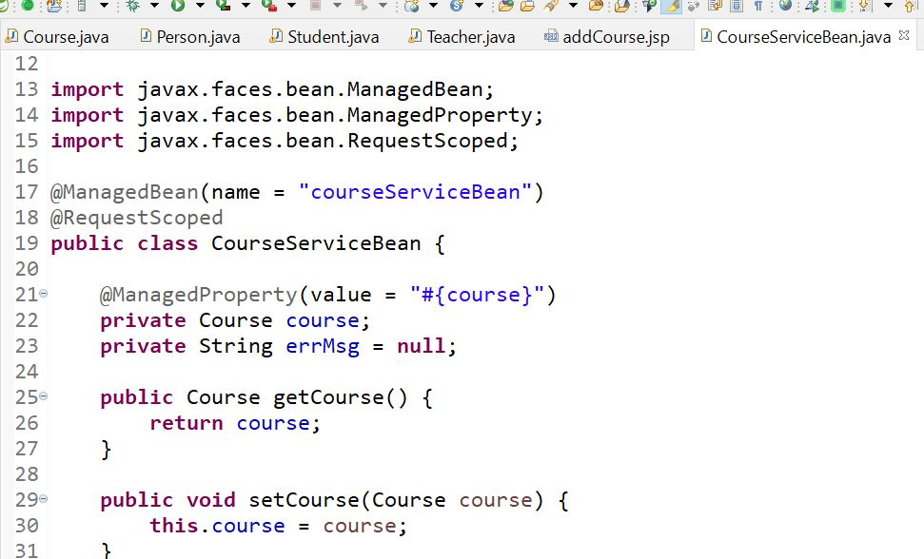



Figure :course ServiceBean file

I’m starting to see a pattern here,notice in the addCourse file it says #course.name, #course.credits. It’s asking for the name to add to the db in the name & credits columns.

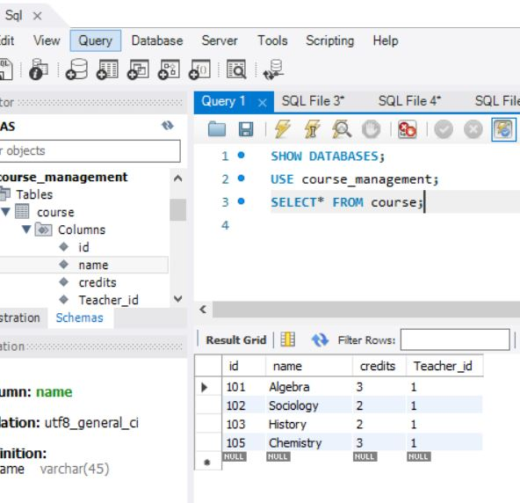

Figure :Course Table in SQL

The names are identical that’s good! Now to successfully map the persistence to them. Right click on the file you want to persist:

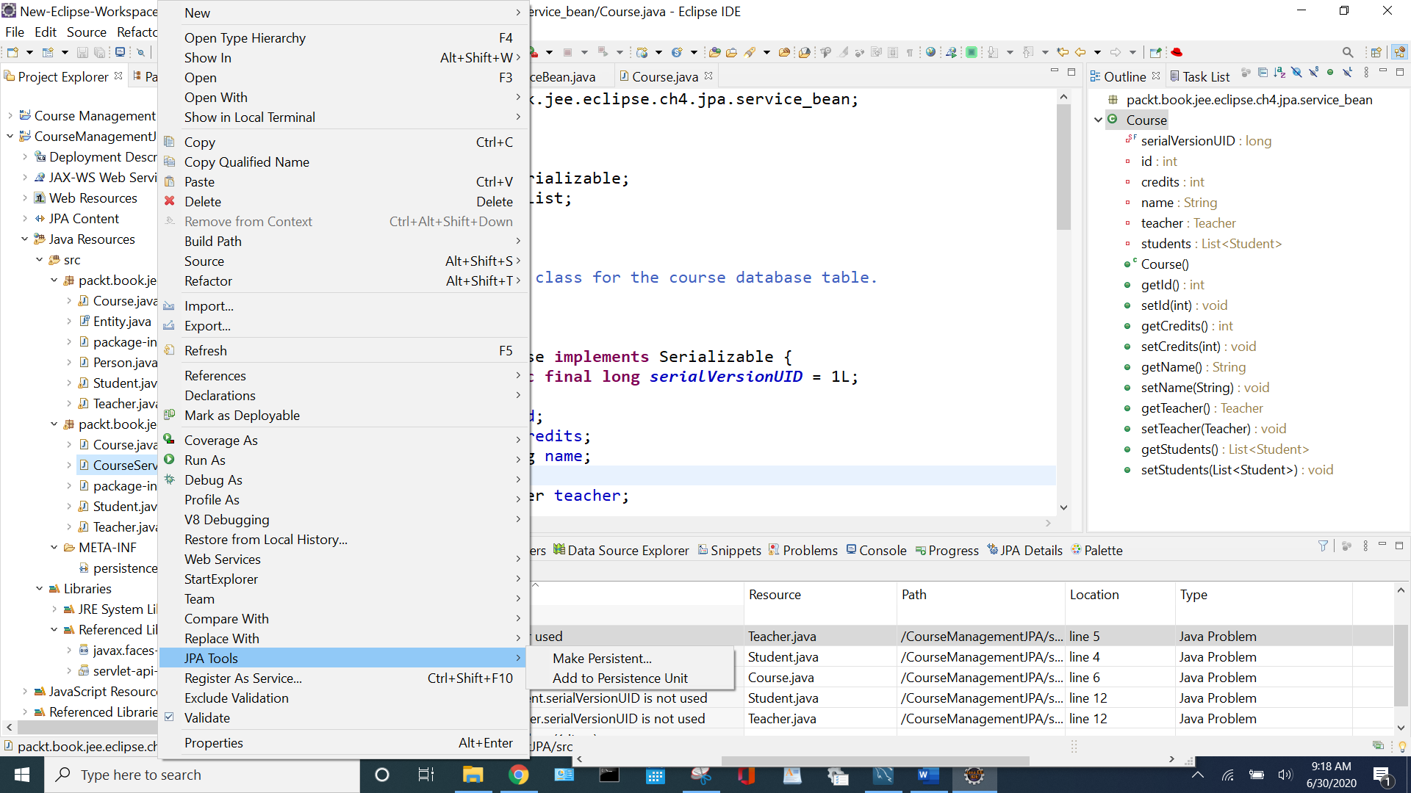

Figure :Right click-->JPA Tools--> Make/Add Persist

Here is the SQL file that has a relationship-course_student Table, student_id Column & student Table, id Column:

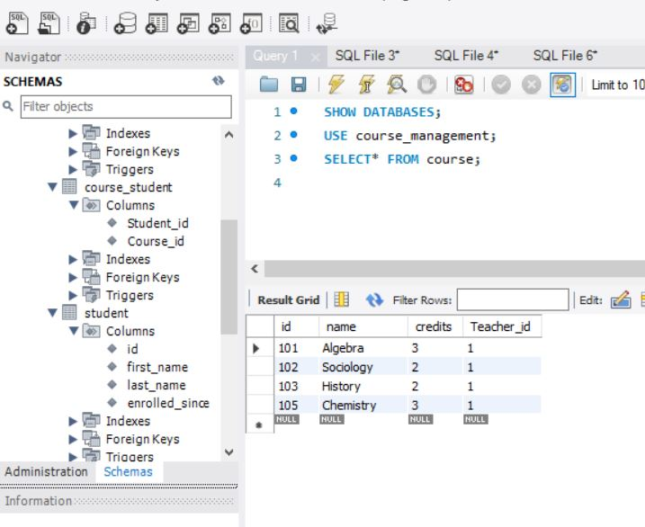

Figure : Relationship to student & course_student Tables

And here we go:

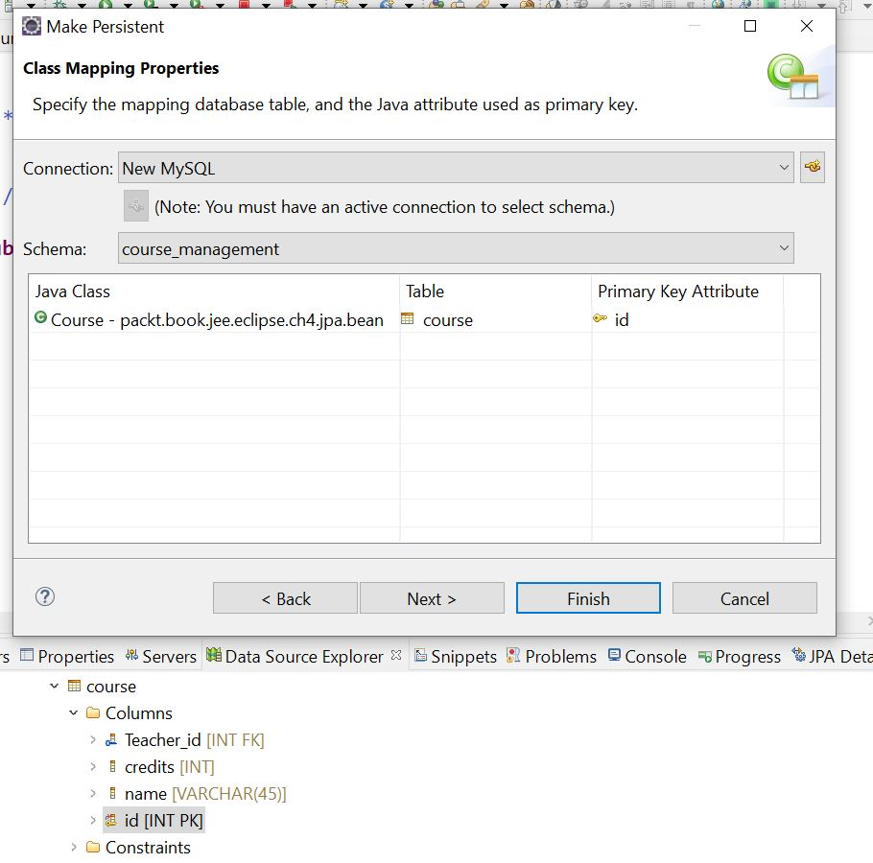

Figure :Course Class Map

Course id to Teacher id I hope! LOL

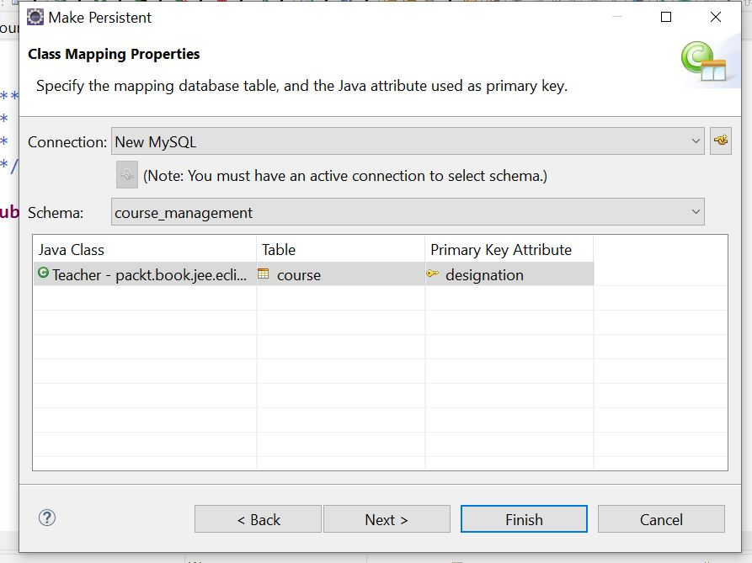

Figure :Wrong Primary Key(PK)

Wrong! I want Teacher Id to be PK. So Open up the table in SQL and modify it but it wasn’t right, the ID is PK not designation!

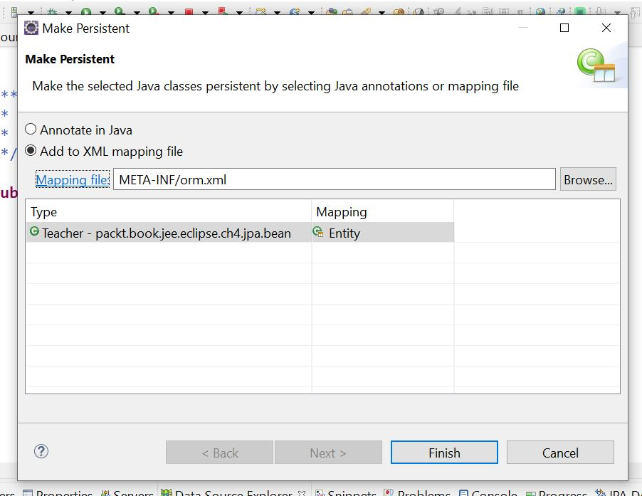

Figure : Teacher Mapping File Creation

And here it is! Check this out:

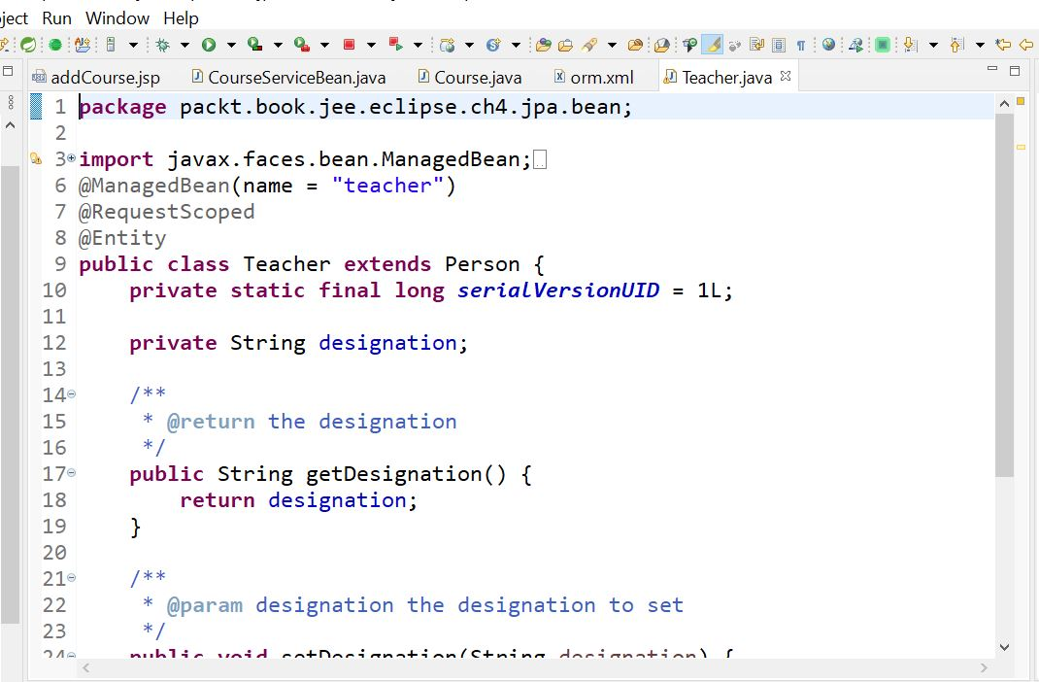

Figure :Teacher Designation

That’s why I can’t get Teacher ID I guess! Hmm,,,,Person Maps to Teacher maybe with ID?

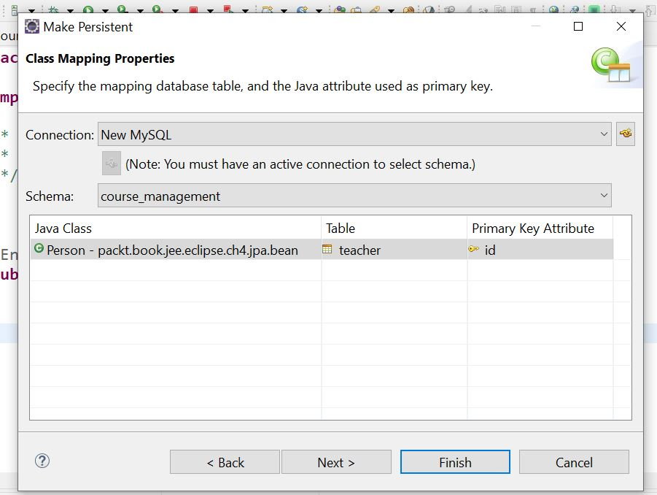

Figure :Map Person to Teacher Table using Id PK

Let’s see how that goes…

Errors everywhere, have to start over! Wasn’t too bad, just delete all the annotations in the files, the orm file, and the persistence file managed classes, back to the drawing board.

5:30PM – Deleted all the references to persist in the jpa.beans folder, and redoing them I noticed this was left out of course:

public void setTeacher(Teacher teacher) {

this.teacher = teacher;

}

Maybe that will help! LOL

**All JSF Beans are in RequestScope**! **Discussion in Chapter 2**

This is pretty wild! I made/ran the listCourse file:

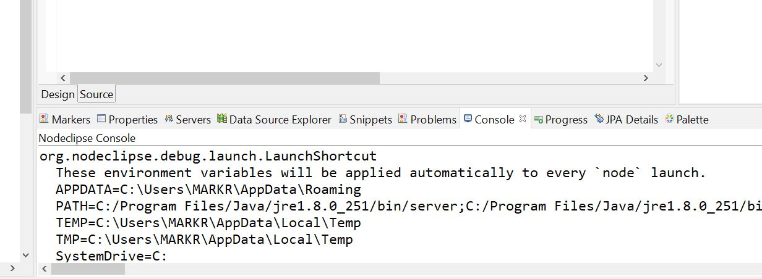

Figure : List Course XML file output

OMG! Another thing I discovered! Watching the JSP Servlet for beginners video on Udemy, he said add the Tomcat Server in the Libraries.

So here is the persistence XML file, notice I selected student and teacher as the classes to manage, **NO! Took them out.**

I’m opening the files from CourseManagementJPA-jpa.bean**. Page 246 Creating Entities**

**07/1/20 6:30AM –** I missed this yesterday somehow. You need the JPA Details view open to see the mapping choices:

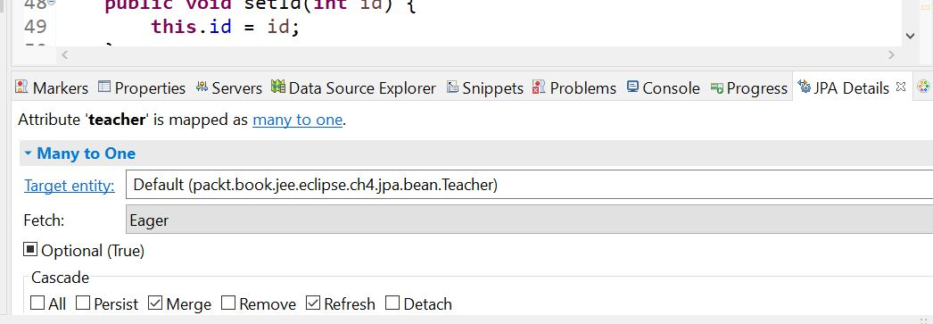

Figure :JPA Details Pane

Also make sure the Field is highlighted in the file:

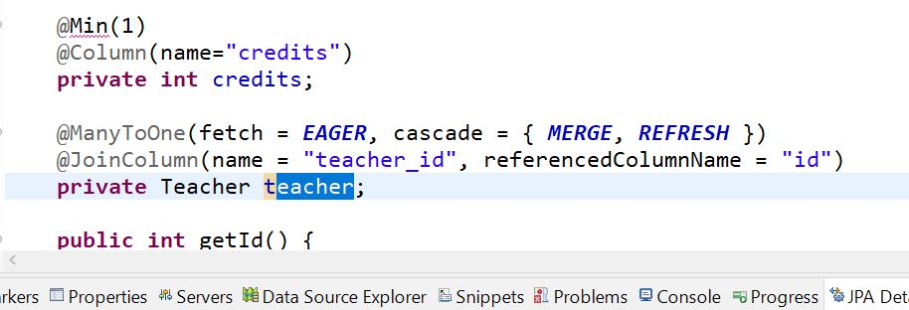



Figure : Teacher Field highlighted to see JPA Detail Pane

Code is added based on selections. Notice Column name and Referenced Column name

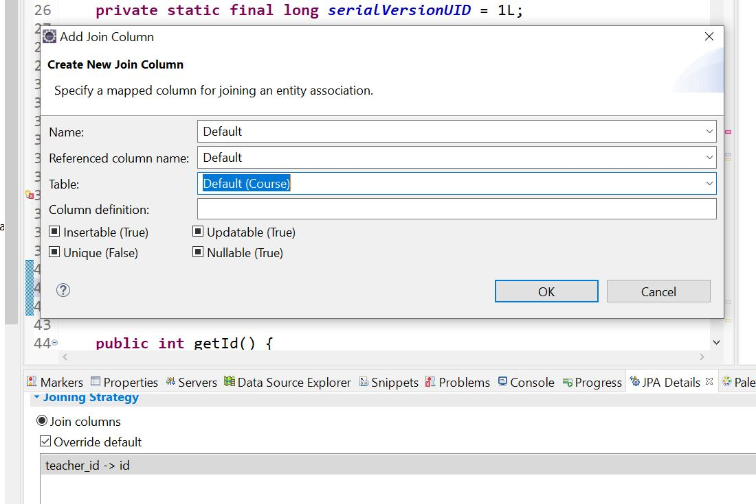

Figure :Override Default

Click on the Add on the right.

***We will now configure Course and Student entities for a many-to-many relationship (a course can have many students, and one student can take many courses).***

This is from the Configuring Many-to-Many Relationships. UniDirectional or BiDirectioinal.

“*many-to-many relationship also has one owning side and the other inverse side.* *From the configuration point of view, the inverse side is marked by the mappedby attribute to the @ManyToMany annotation.”*

Student is the owning side, Course as inverse. Many to Many relationship in a join table: @JoinTable.

This section is pretty hard to understand so if there’s problems it’s probably in here:

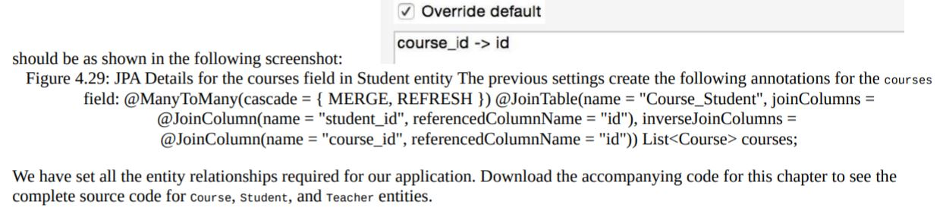

Figure : JPA Details, on page 255

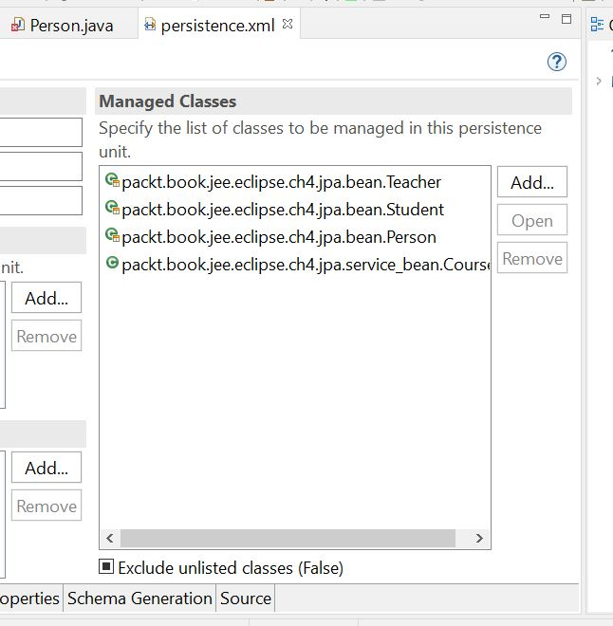

Figure : Managed Classes

Had to add person and Course manually, we will see I guess. Also fixed Course so it points to the correct folder. All you do is click add and search for the file.

**07/04/20 11:00AM –** Here we go again! Spent the last few days re-doing the whole laptop. Reloaded Windows and the Programs I needed. Pretty sure I got rid of the errors I was having all this time. Not sure if what I did last time to get the errors but, it’s all good now. Make sure the jre/compiler points to SE-1.8 in the project properties. So far everything’s great! Cruising right along! I even got a file called JdbcQuery to go along with the JdbcDemo file, and it works great to print the Courses out. My next phase is getting a Connection Pool going using a db.properties file:

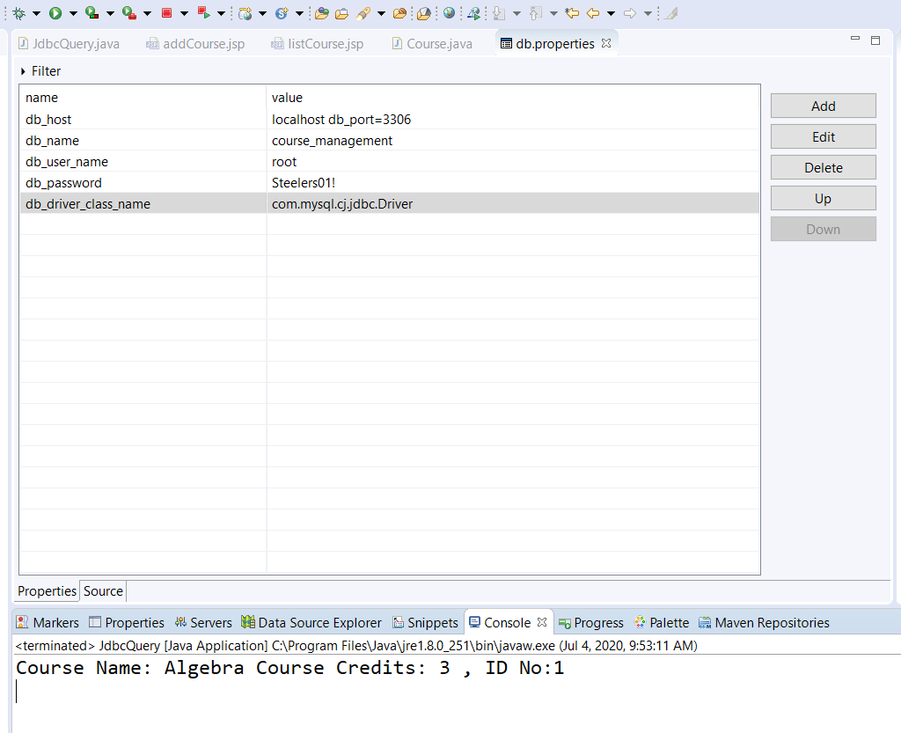

Figure : DBProperties file and JdbcQuery file print out

Right click and select New🡪File, just a plain old file.

**1:30PM – This part about Database Connection Pool on page 200 is pretty tough to follow along.**

**4:00PM – CourseDAO file needs looked at also Page 206.**

**07/05/20 - 9:00AM** I feel like I accomplished something already today! LOL I was poking around with the pom to check out the Data Pool section again, and found a wrong dependency for the tomcat-jdbc-jar-9.0.35 file is the correct one on the server. I’m curious to see if this works out, removing the mysql-connector 5.1.49 file reference and just going with the apache version?? Hmmm,,,also changed the connection factory:

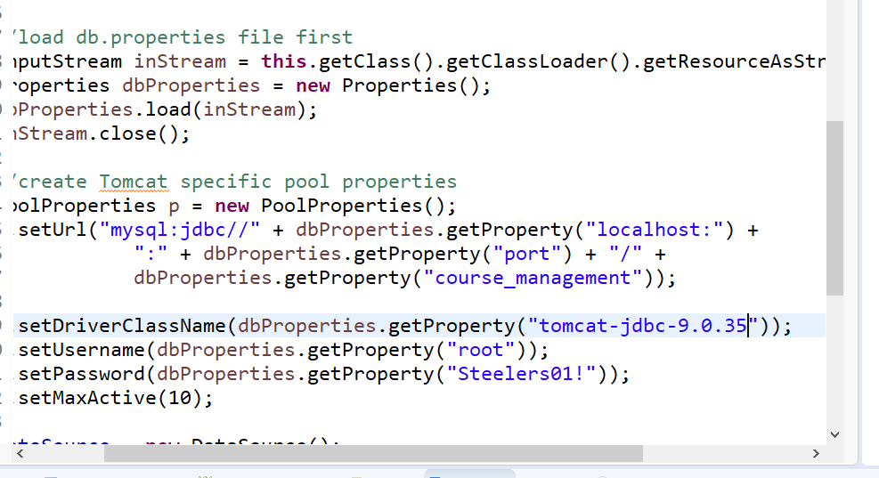

Figure : Connection Factory file

**Changed to the same file as in the pom, let’s see how that goes.**

**CONFIRMED! The com.mysql.jdbc.Driver works in the Connection Factory file, and the pom has that driver mapped, also the JDBCQuery and JDBCDemo files work! Finally put that issue to rest! 😊 Also check the db.properties file.**

**11:00AM – Confirmed the DatabaseConnectionFactory file is good.**

**Checking out the initServlet file. All good!**

**Onto the course DAO file Page 205.**

**All good there too.**

**1:15PM – I was getting a tag library error in the addCourse file, I found this on StackOverflow:**

*<dependency>*

*<groupId>jstl</groupId>*

*<artifactId>jstl</artifactId>*

*<version>1.2</version>*

*</dependency>*

*<dependency>*

*<groupId>taglibs</groupId>*

*<artifactId>standard</artifactId>*

*<version>1.1.0</version>*

*</dependency>*

**Added it to the pom file, and this in the xml file:**

*<web-app version="2.4" xmlns="http://java.sun.com/xml/ns/j2ee"*

*xmlns:xsi="http://www.w3.org/2001/XMLSchema-instance"*

xsi:schemaLocation="http://java.sun.com/xml/ns/j2ee http://java.sun.com/xml/ns /j2ee/web-app_2_4.xsd">

**Still get an error!**

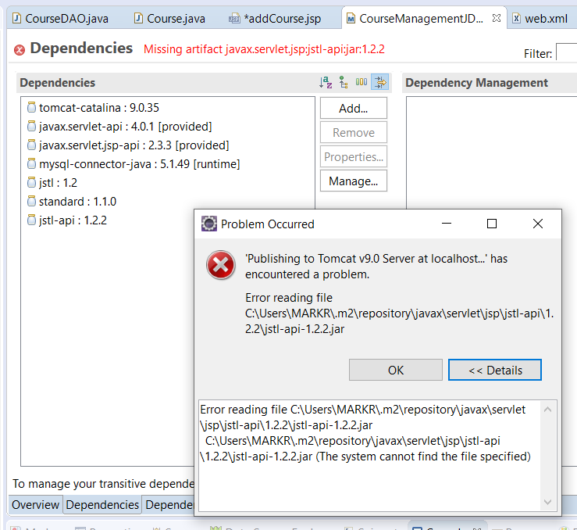

Figure : Jstl-api file error in POM Dependenies

Well that was a real pain in the ass! Guess I’m squared away now on that problem finally! After many hours on dicking around!

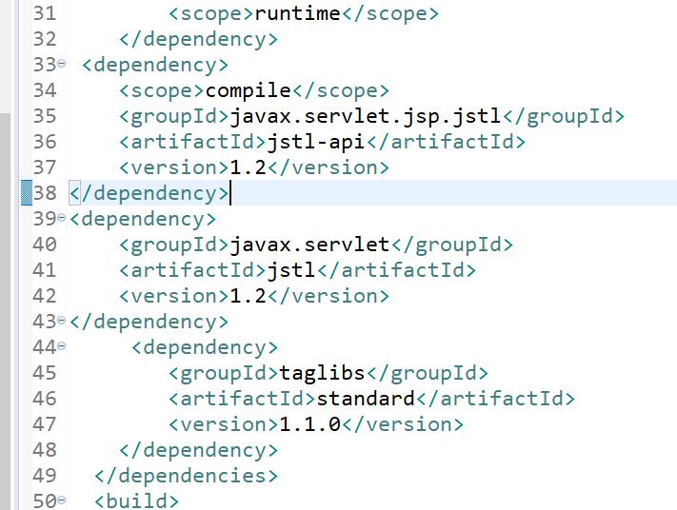

Figure : This is a fix so far!

I wonder if I used the wrong JSP template for the file? Hmmm…oh well.

Leaving off on page 214.

**07/06/20 7:00AM** – I’m going to try something today, take the JdbcQuery file, save it as JdbcInsert, and attempt to Insert a new Course into the table. Since I know this file works. I’m having a tough time getting the Java DB statements into the JSP files to update them through the server, so I figure I’ll start out manually through Java apps first. This may require further study into one of my JSP books, better yet an online Class that I already have! Just what I need, more shit to learn. ☹ I’m going to use the PDF Book ***“Beginning SQL Queries by Clare Churcher”***to start with. For JSP I’ll use ***“JSP 2 Fourth Edition, 2005”.***  So I got the easy part down, inserting in the SQL Server:

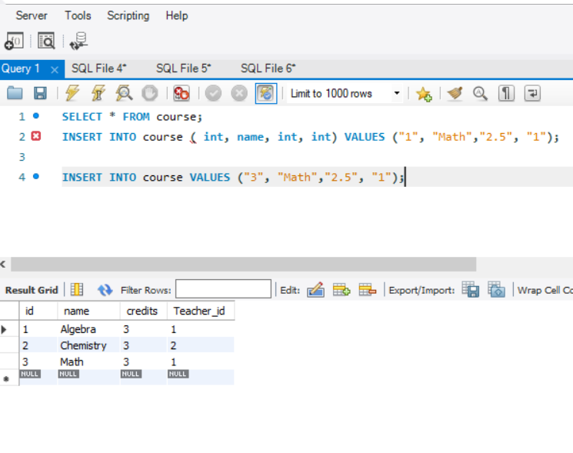

Figure :The correct INSERT statement in SQL

Notice on line 2 LOL, DUH! Now to translate that into the Java File. I’m going to try the handling transactions section on page 197.

11:00AM – Well the INSERT file from Eclipse worked, now to translate that into a java statement:

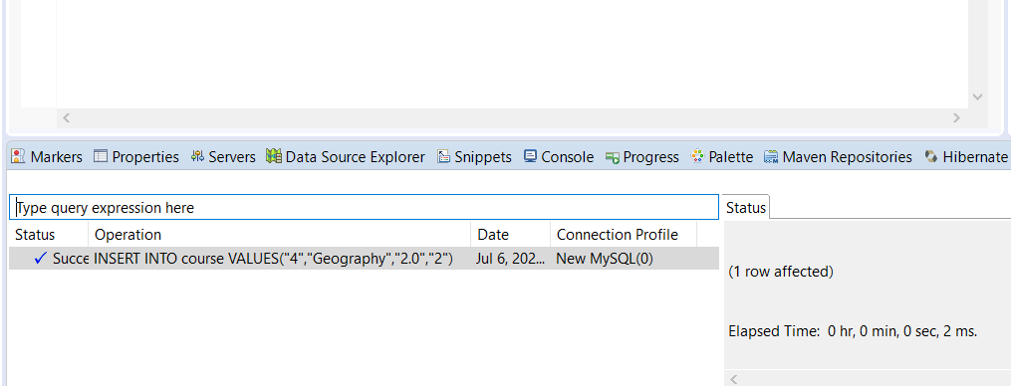

Figure : SQL statement from Eclipse

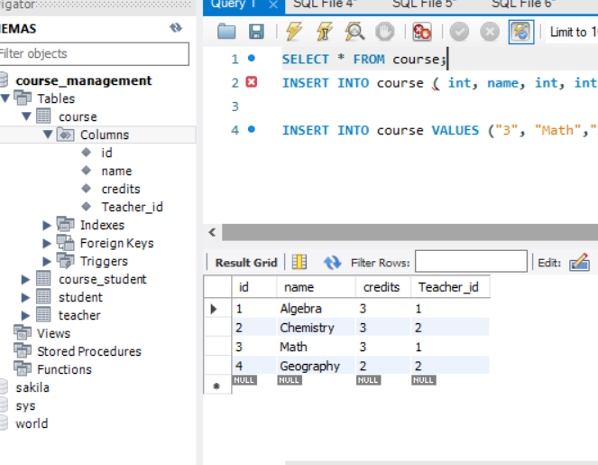

Figure :Verified the Java SQL statement inserted a new course in DB.

Ok so,, now to convert that into a java file!

Created a new file called jstlExample, from the book on page 394. That wasn’t working either after I was fiddling with it. I’m going to go through this tutorial “***JSP Servlet JDBC MySQL CRUD Example Tutorial” by* Author:** [**Ramesh Fadatare**](https://www.blogger.com/profile/14691512106162803120)**.**

07/07/20 7:30AM - Well a typo in the code caused a little confusion already! I noticed that the userDAO had a () in the variable declaration of the UserServlet file that was causing an error all through the file! So I started to go through it and noticed the error, removed the () and walla! It went away! The declaration doesn’t require an argument, it’s just saying hey we are making this new thing from that thing,,LOL Sure enough I was right! Guess I am learning! Can’t get frustrated and want to give up, I’m getting there. This cleared up the errors, I just removed the () at userDAO so instead of userDAO();

private UserDAO userDAO; 🡨 At the declaration here it’s wrong

public void init() {

userDAO = new UserDAO();🡨 At the constructor is right

}

Also, this statement at the beginning of the file declares the java tag library, with the “c:” designation: **“<%@ taglib uri="http://java.sun.com/jsp/jstl/core" prefix="c"%>”**

To lessen frustration, I stuck the master files in the workspace to compare them. There were some servlet code blocks commented out in the website tutorial and it didn’t say anything about them so I uncommented those, plus I had the wrong dependencies in the WEB-INF lib file:

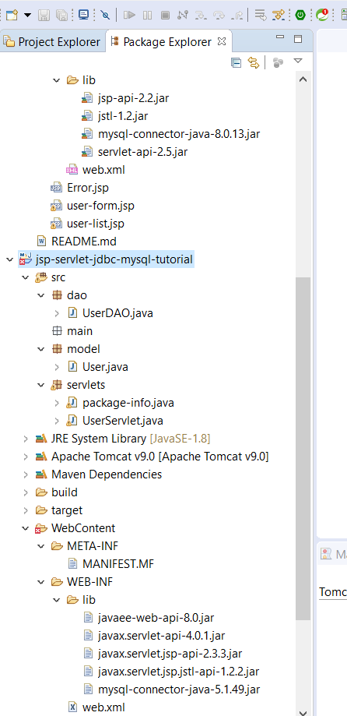

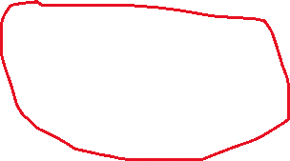

Figure : The wrong dependencies in the WEB-WNF lib directory.

Mine is the lower directory. I need to get these dependencies down they’re killing me! Which ones go with which kind of file. I’m just going to delete my project and move on after copying his dependencies into my Java Files and Drivers folder.

07/08/20 7:00AM – I copied the working dependencies into their own folder ***“servlet-jdbc-mysql files” .*** Tested everything again after changing the driver to the newest version: ***"com.mysql.cj.jdbc.Driver".*** Works great!

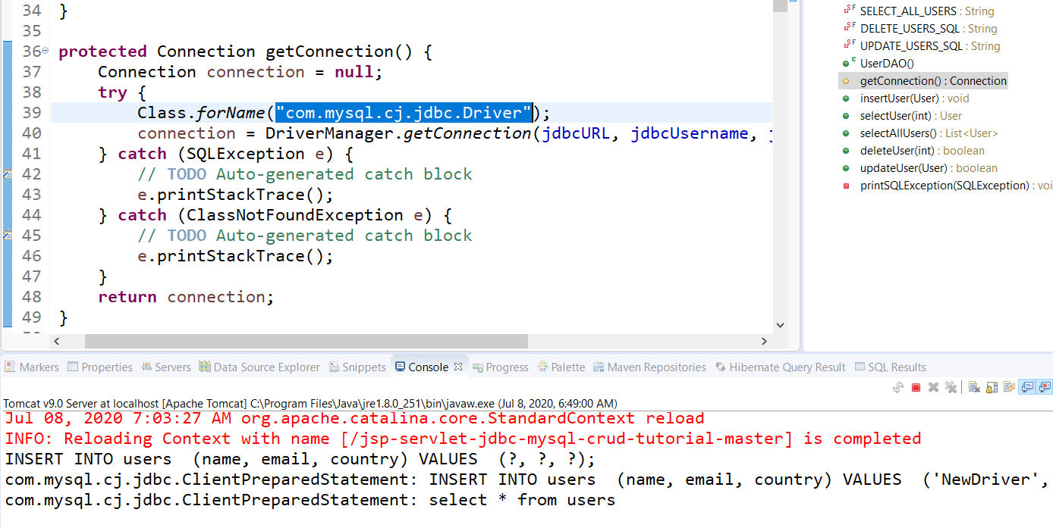

Figure :New Driver

I still need to understand the connection pool details yet. That was confusing. This also is a bit confusing, three user constructors in the one user file:

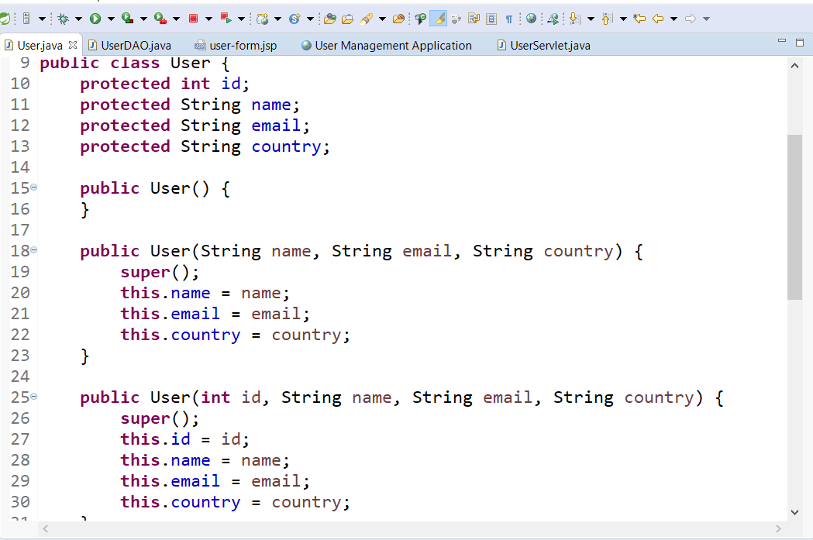

Figure :User file base

Three users, one master defines the basic user, one constructor defines a user that already exists without the auto-generated id, and the other defines a new user with the auto id. I think I’m beginning to understand this! Scary! 😊 Now that I have a known user base to start with, I can expand on it to other projects. Now I need to put together a working datapool connection file also. In time,,,The UserServlet file pulls everything together. I wonder if I can make another file that selects a user by ID#? On page 195 it explains that. Also need to go over **the connection pool section page 200** carefully, but that’s for another day.

I think I have a gameplan, on Page 211 it starts talking about getting courses from tables. And in the jsp-servlet-jdbc-mysql tutorial, it has the code to update the user form with CRUD statements, I just have to modify that for the course_management DB.

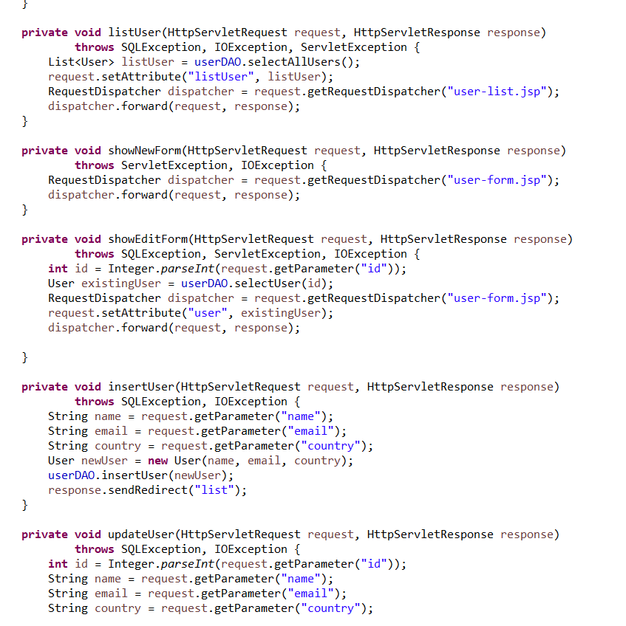

Figure :Code to update the database-UserServlet.java file

**9:00PM** – Instead of figuring out what all needs changed, drivers added, folders..etc,, I copied over the jdbc-mysql-crud tutorial since it’s working good and it’s close to what I need to do. Now to figure out how to change the package names and all that stuff. Guess I’ll start at the beginning again and work my way through it. Should be easy enough! LOL

07/10/20 – 7:30AM – Starting a new project and new documentation called: Course Management. Skip that!

**07/14/20 9:00AM** – Been a very rough few days. Had to reload again after problems. The good side is, the Udemy Java Servlets and JSP in 25Steps class gave me good insights as to how these files are set up with Maven Dependencies. Apparently I was doing it all wrong! LOL Here’s how this guy says to set them up, a Maven Project not a Dynamic Web one like I’ve been doing:

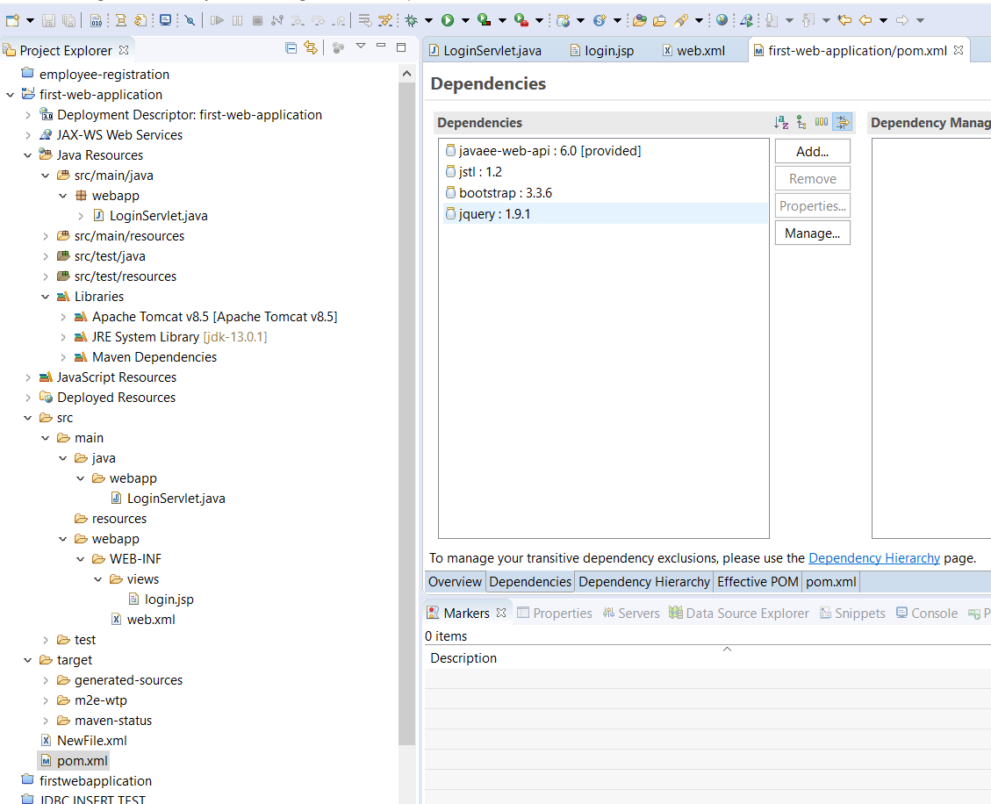

Figure : Maven Project Setup

***I’m going to start another Word file for the Java Servlets and JSP Udemy course called Udemy Servlets & JSP.***

double Amount = Double.parseDouble(txtMonth.getText());